**TRAFFIC MANAGEMENT SYSTEM**

**PHASE 3:DEVELOPMENT PART 1**

## **PROJECT OVERVIEW**

This documentation presents the details of our IoT traffic management system project. Our objective is to efficiently control traffic at a 4-way junction using an Arduino Mega, ultrasonic sensors, and traffic light signals.

## **COMPONENTS USED**

## List of components used in the project:

* Arduino Mega: The Arduino Mega microcontroller was chosen for its extensive I/O capabilities and enhanced processing power, ensuring comfortable and efficient implementation of the 4-way traffic management system.
* Ultrasonic sensors
* LEDs for traffic lights
* Jumper wires
* Breadboard
* Power supply

**WIRING DIAGRAM**

We provide a detailed wiring diagram to illustrate the connections between the Arduino Mega, ultrasonic sensors, and LEDs for the traffic lights. This diagram serves as a visual guide for setting up the project.

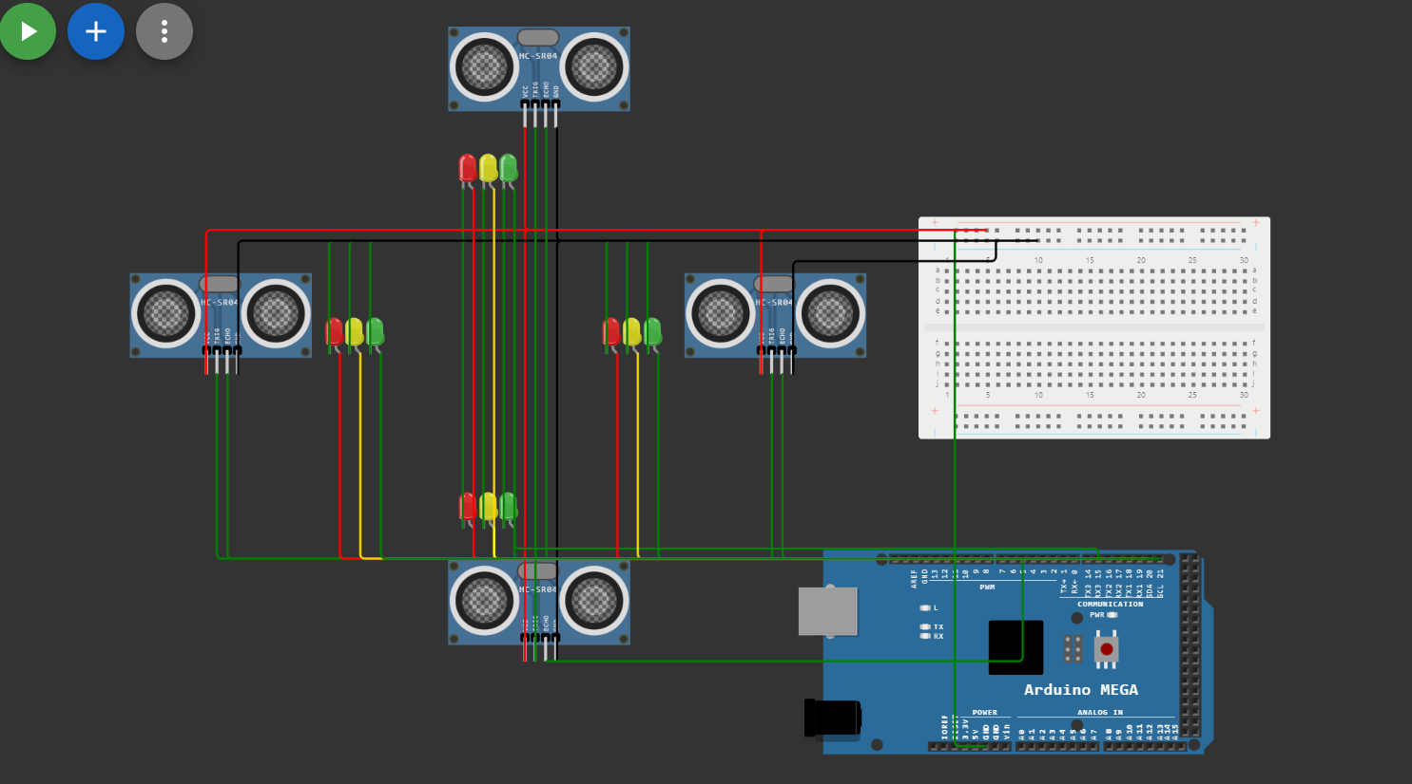

**CODE EXPLANATION**

Our Arduino code is responsible for controlling the traffic lights based on vehicle detection. It ensures smooth traffic flow by implementing a 30-second green light period, followed by a 5-second yellow light period, and a return to red lights.

**PROJECT EXECUTION**

To set up the project, follow the provided wiring diagram and upload the Arduino code to the Arduino Mega. The code will start executing, and the system will actively control traffic at the junction.

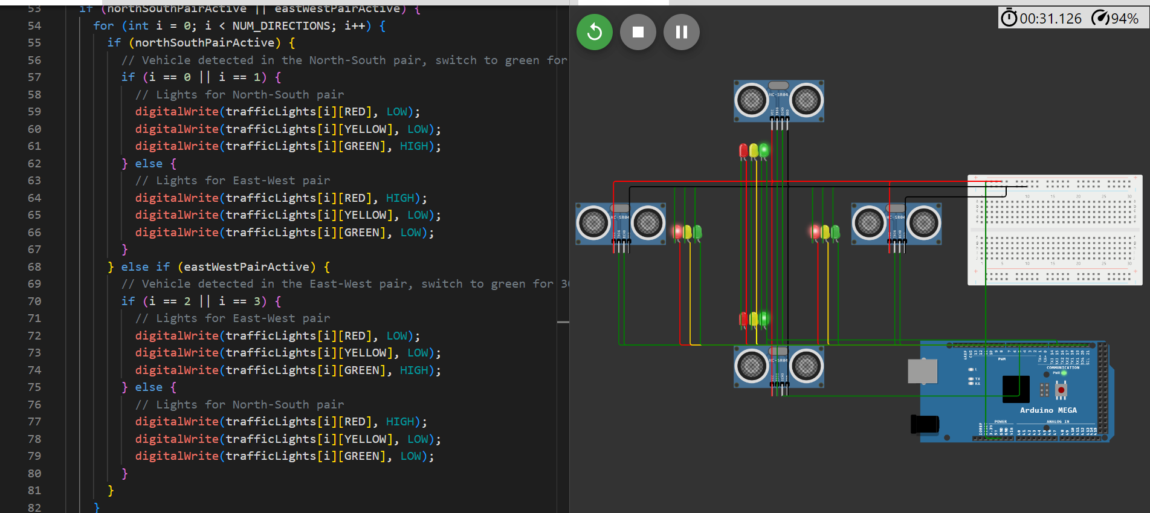

**TESTING AND RESULTS**

We tested the project in various scenarios, simulating traffic conditions at the 4-way junction. The system effectively responds to vehicle presence, ensuring safe and efficient traffic management.

**CONCLUSION**

In conclusion, this IoT traffic management system project demonstrates the successful use of the Arduino Mega, ultrasonic sensors, and LEDs to control traffic at a 4-way junction. The project provides a practical solution for enhancing road safety and traffic efficiency.