DSA0601 – Data Handling and Visualization

CO2 – AT2: Visualization Development Exercise — Solutions

Question 1 — Chart Selection (Directory of Visualizations)
For each scenario, the single best chart type and a short justification are given below.
# | Scenario | Best Chart Type | Justification
1 | Comparing the population of 8 countries in the current year. | Bar chart (Amounts) | Discrete categories with a single value each at one point in time — bar length lets readers compare magnitudes across countries at a glance.
2 | Showing how delivery times vary across 5 courier companies. | Box plot / Violin plot (Distribution) | The question is about variation/spread within each courier, not just an average, so a distribution chart is needed to show median, spread, and outliers per group.
3 | Showing the proportion of a household budget spent on rent, food, transport, and savings. | Pie chart / 100% stacked bar (Proportion) | The categories are parts of a single whole (the total budget) that sum to 100%, which is exactly what proportion charts communicate.
4 | Showing the relationship between hours studied and exam marks for 50 students. | Scatter plot (x-y Relationship) | Two continuous numeric variables per student — a scatter plot reveals correlation/trend between hours studied and marks.
5 | Showing average temperature for each month across 3 different cities at once. | Line chart / Temporal multi-series (Temporal) | Temperature is tracked over an ordered time axis (months) for multiple cities, so a multi-line chart shows trends and lets cities be compared over time.
6 | Showing which airports are directly connected by flight routes. | Network / Node-link diagram (Network) | Airports are nodes and routes are edges connecting them; a network graph is the only chart type built to show such connectivity/relationships.

Question 2 — Bar Plot (Amounts)
Horizontal bar plot of Downloads_Millions by App_Category, sorted ascending, with a single-hue color gradient and value labels.
Python
import pandas as pd
import matplotlib.pyplot as plt
import matplotlib.cm as cm
import matplotlib.colors as mcolors

df = pd.DataFrame({
"App_Category": ["Social Media", "Gaming", "Productivity",
"Finance", "Health & Fitness", "Education"],
"Downloads_Millions": [58, 46, 27, 19, 33, 24]
})
df = df.sort_values("Downloads_Millions", ascending=True)

norm = mcolors.Normalize(vmin=df["Downloads_Millions"].min(),
vmax=df["Downloads_Millions"].max())
colors = cm.Blues(norm(df["Downloads_Millions"]) * 0.7 + 0.3)

fig, ax = plt.subplots(figsize=(8, 5))
bars = ax.barh(df["App_Category"], df["Downloads_Millions"], color=colors)

for bar, val in zip(bars, df["Downloads_Millions"]):
ax.text(bar.get_width() + 1, bar.get_y() + bar.get_height()/2,
str(val), va="center", ha="left", fontsize=10, fontweight="bold")

ax.set_xlabel("Downloads (Millions)")
ax.set_ylabel("App Category")
ax.set_title("App Downloads by Category (Millions)")
plt.tight_layout()
plt.show()
R
library(ggplot2)

df <- data.frame(
App_Category = c("Social Media","Gaming","Productivity",
"Finance","Health & Fitness","Education"),
Downloads_Millions = c(58, 46, 27, 19, 33, 24)
)

ggplot(df, aes(x = reorder(App_Category, Downloads_Millions),
y = Downloads_Millions, fill = Downloads_Millions)) +
geom_col() +
geom_text(aes(label = Downloads_Millions), hjust = -0.2, fontface = "bold") +
coord_flip() +
scale_fill_gradient(low = "#c6dbef", high = "#08306b") +
labs(title = "App Downloads by Category (Millions)",
x = "App Category", y = "Downloads (Millions)", fill = "Downloads") +
theme_minimal()
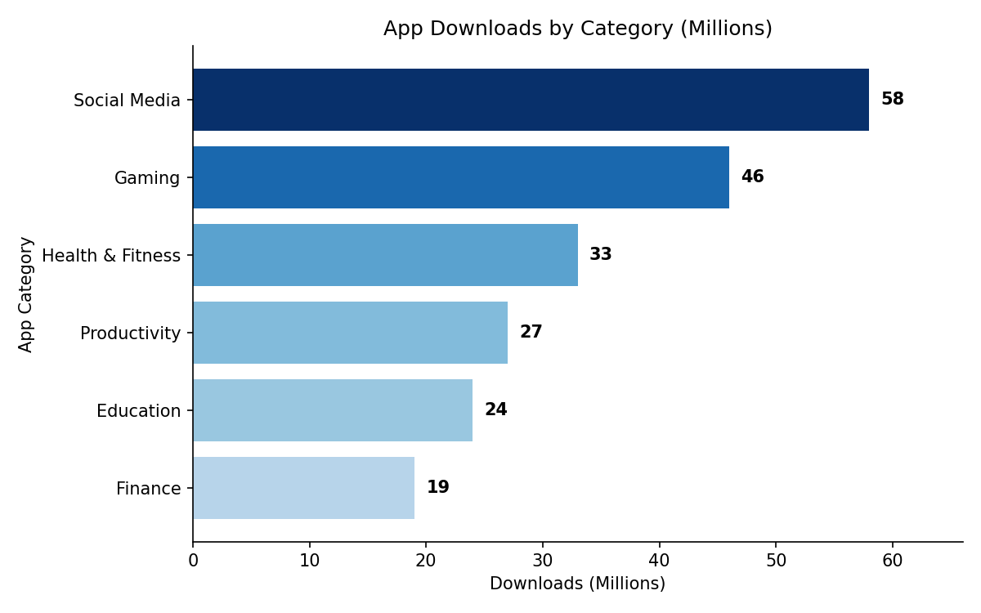
Interpretation: Social Media (58M) and Gaming (46M) dominate downloads, together accounting for more than the other four categories combined. Finance (19M) is the smallest category, suggesting either a smaller target audience or higher barriers to adoption (e.g., KYC/onboarding friction) compared to entertainment-oriented apps.

Question 3 — Grouped/Stacked Bars, Dot Plot & Heatmap (Amounts)
All four views are built from the same Device x Month website_traffic dataset.
Python
import pandas as pd
import matplotlib.pyplot as plt
import seaborn as sns

data = {
"Device": ["Desktop"]*4 + ["Mobile"]*4 + ["Tablet"]*4,
"Month": ["Jan","Feb","Mar","Apr"]*3,
"Visits_000s": [45,48,42,50, 80,88,95,102, 20,18,17,15]
}
df = pd.DataFrame(data)
month_order = ["Jan","Feb","Mar","Apr"]
df["Month"] = pd.Categorical(df["Month"], categories=month_order, ordered=True)

# 7. Grouped bar chart
pivot = df.pivot_table(index="Month", columns="Device",
values="Visits_000s").reindex(month_order)
pivot.plot(kind="bar") # grouped (default)
plt.title("Website Visits by Month, Grouped by Device")

# 8. Stacked bar chart
pivot.plot(kind="bar", stacked=True) # stacked=True
plt.title("Total Monthly Website Traffic, Stacked by Device")

# 9. Dot plot (ranked total traffic per device)
totals = df.groupby("Device")["Visits_000s"].sum().sort_values()
plt.hlines(y=totals.index, xmin=0, xmax=totals.values, color="grey")
plt.plot(totals.values, totals.index, "o", markersize=12)
plt.title("Total 4-Month Traffic by Device (Ranked)")

# 10. Heatmap
heat_pivot = df.pivot_table(index="Device", columns="Month",
values="Visits_000s")[month_order]
sns.heatmap(heat_pivot, annot=True, fmt=".0f", cmap="YlGnBu")
plt.title("Visits Heatmap: Device x Month")
R
library(ggplot2)
library(tidyr)
library(dplyr)

df <- data.frame(
Device = rep(c("Desktop","Mobile","Tablet"), each = 4),
Month = rep(c("Jan","Feb","Mar","Apr"), 3),
Visits_000s = c(45,48,42,50, 80,88,95,102, 20,18,17,15)
)
df$Month <- factor(df$Month, levels = c("Jan","Feb","Mar","Apr"))

# 7. Grouped bar chart
ggplot(df, aes(Month, Visits_000s, fill = Device)) +
geom_col(position = "dodge") +
labs(title = "Website Visits by Month, Grouped by Device")

# 8. Stacked bar chart
ggplot(df, aes(Month, Visits_000s, fill = Device)) +
geom_col(position = "stack") +
labs(title = "Total Monthly Website Traffic, Stacked by Device")

# 9. Dot plot (ranked total traffic per device)
totals <- df %>% group_by(Device) %>% summarise(Total = sum(Visits_000s)) %>%
arrange(Total)
ggplot(totals, aes(x = Total, y = reorder(Device, Total))) +
geom_segment(aes(x = 0, xend = Total, yend = Device), color = "grey60") +
geom_point(size = 5, color = "steelblue") +
labs(title = "Total 4-Month Traffic by Device (Ranked)", x = "Total Visits (000s)", y = "Device")

# 10. Heatmap
ggplot(df, aes(Month, Device, fill = Visits_000s)) +
geom_tile() +
geom_text(aes(label = Visits_000s), color = "black") +
scale_fill_gradient(low = "#ffffcc", high = "#006837") +
labs(title = "Visits Heatmap: Device x Month")
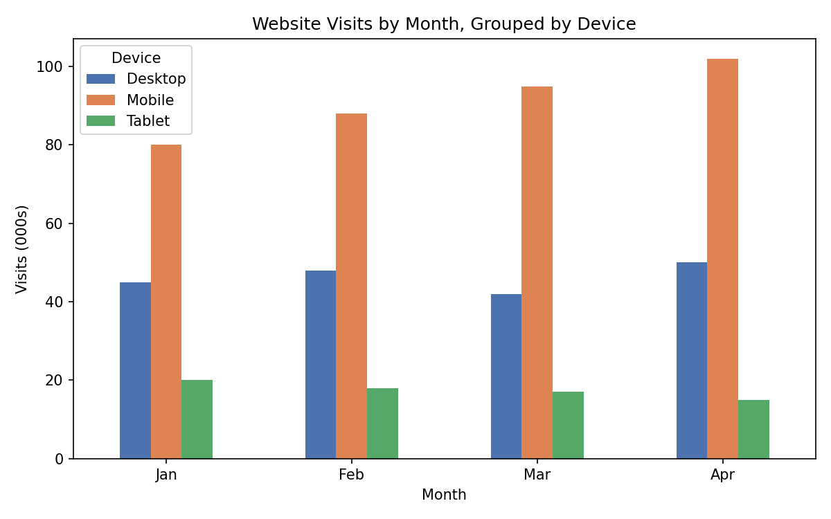
Interpretation: Mobile visits rise every month (80 -> 102, +27.5%) while Tablet visits decline every month (20 -> 15, -25%), and Desktop stays roughly flat (~42-50). Grouping makes it easy to compare devices within the same month.
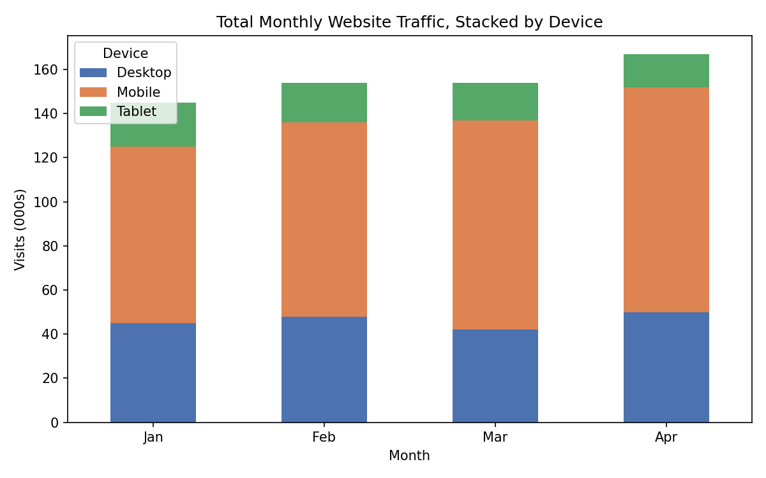
Interpretation: Total monthly traffic grows from ~145K in January to ~167K in April, and the stacked view shows Mobile is responsible for essentially all of that growth — its share of the stacked total visibly increases month over month while Desktop and Tablet segments shrink or stay flat.
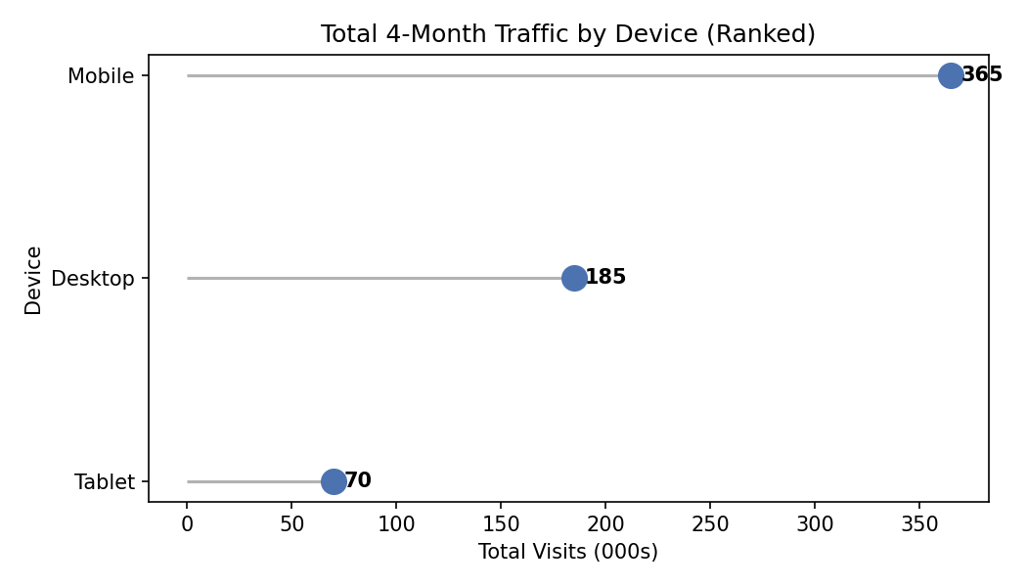
Interpretation: Mobile leads by a wide margin with 365K total visits versus Desktop's 185K and Tablet's 70K. The dot plot's ranked, minimal-ink layout makes this magnitude gap clearer than a bar chart would for just three categories.
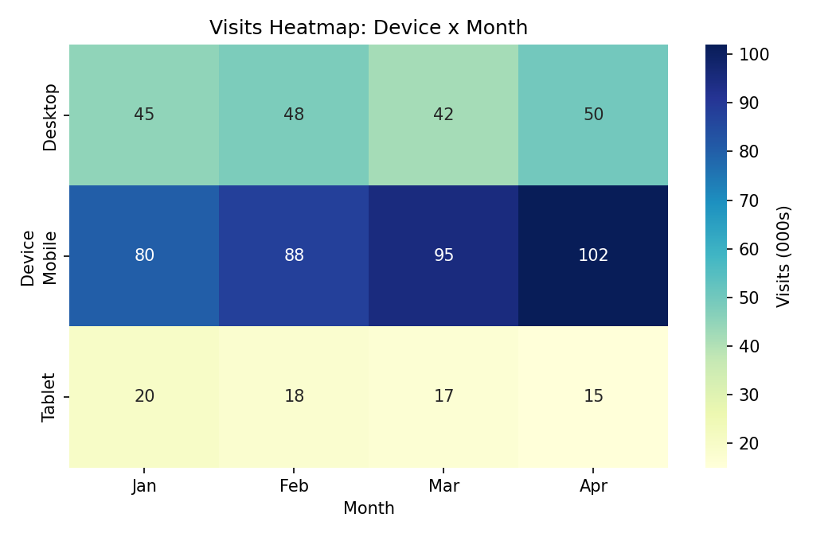
Interpretation: The heatmap's color intensity confirms the same story at a glance: a dark, intensifying band for Mobile across Jan-Apr, a stable mid-tone band for Desktop, and a lightening band for Tablet — useful for spotting the pattern instantly without reading exact numbers.

Question 4 — Violin & Ridgeline Plots (Distributions)
Synthetic delivery-time data for 4 routes, generated with random seed = 7 in both languages.
Python
import numpy as np
import pandas as pd
import seaborn as sns
import matplotlib.pyplot as plt
from scipy.stats import gaussian_kde

np.random.seed(7)
route_a = np.random.normal(32, 6, 50)
route_b = np.random.normal(28, 4, 50)
route_c = np.random.normal(40, 9, 50)
route_d = np.random.normal(35, 5, 50)

df = pd.DataFrame({
"DeliveryTime": np.concatenate([route_a, route_b, route_c, route_d]),
"Route": ["Route A"]*50 + ["Route B"]*50 + ["Route C"]*50 + ["Route D"]*50
})

# 11. Violin plot with embedded boxplot
sns.violinplot(data=df, x="Route", y="DeliveryTime", inner="box")
plt.title("Delivery Time Distribution by Route (Violin Plot)")

# 12. Ridgeline plot, ordered by mean (fastest at bottom)
# seaborn/matplotlib do not ship a ridgeline chart, so joypy.joyplot()
# is the standard choice; if unavailable, build overlapping KDE
# curves manually as below (equivalent output):
means = df.groupby("Route")["DeliveryTime"].mean().sort_values()
x_grid = np.linspace(df["DeliveryTime"].min()-5, df["DeliveryTime"].max()+5, 500)
for i, route in enumerate(means.index): # fastest mean first -> bottom row
vals = df.loc[df.Route == route, "DeliveryTime"]
density = gaussian_kde(vals)(x_grid)
plt.fill_between(x_grid, i*3, i*3 + density/density.max()*2.2, alpha=0.8)
plt.title("Ridgeline Plot: Delivery Time by Route (Fastest at Bottom)")

# Alternative (if joypy is installed):
# import joypy
# joypy.joyplot(df, by="Route", column="DeliveryTime",
# ylim="own", figsize=(8,6))
R
library(ggplot2)
library(ggridges)
library(dplyr)

set.seed(7)
route_a <- rnorm(50, mean = 32, sd = 6)
route_b <- rnorm(50, mean = 28, sd = 4)
route_c <- rnorm(50, mean = 40, sd = 9)
route_d <- rnorm(50, mean = 35, sd = 5)

df <- data.frame(
DeliveryTime = c(route_a, route_b, route_c, route_d),
Route = rep(c("Route A","Route B","Route C","Route D"), each = 50)
)

# 11. Violin plot with embedded boxplot
ggplot(df, aes(Route, DeliveryTime, fill = Route)) +
geom_violin(trim = FALSE) +
geom_boxplot(width = 0.1, fill = "white") +
labs(title = "Delivery Time Distribution by Route (Violin Plot)")

# 12. Ridgeline plot, ordered by mean (fastest at bottom)
route_order <- df %>% group_by(Route) %>% summarise(m = mean(DeliveryTime)) %>%
arrange(desc(m)) %>% pull(Route) # ggridges plots first factor level at TOP
df$Route <- factor(df$Route, levels = route_order)

ggplot(df, aes(x = DeliveryTime, y = Route, fill = Route)) +
geom_density_ridges(alpha = 0.8, scale = 1.2) +
labs(title = "Ridgeline Plot: Delivery Time by Route (Fastest at Bottom)") +
theme_ridges()
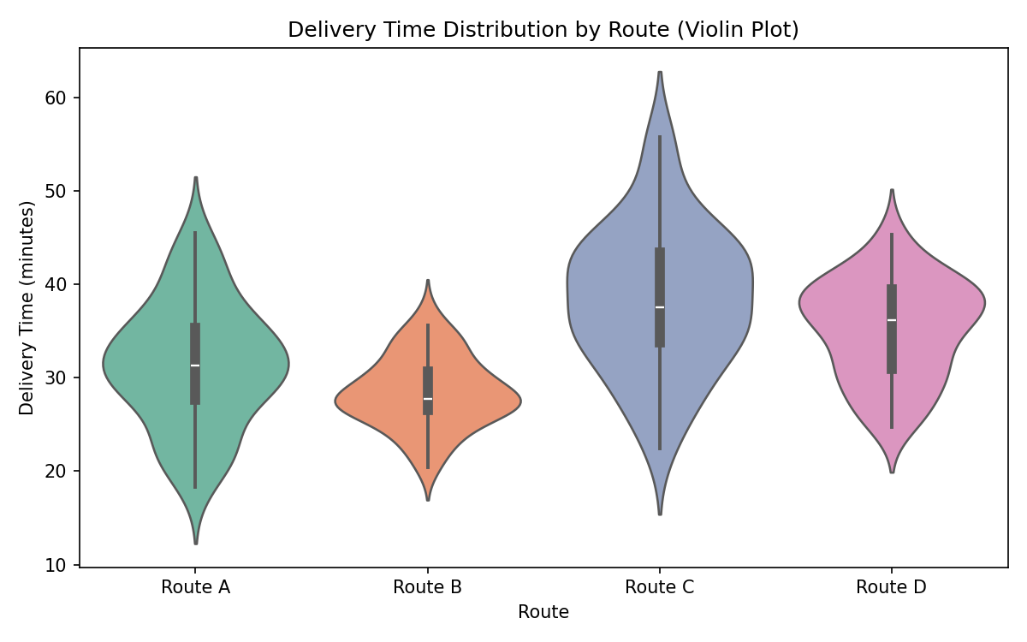
Interpretation: Route B is fastest and most consistent (narrow violin centred near 28 min), while Route C is slowest and most variable (wide, tall violin centred near 40 min with a long upper tail). Routes A and D sit in between with similar spread. The embedded boxplots confirm medians line up closely with the simulated means, as expected for near-symmetric normal data.
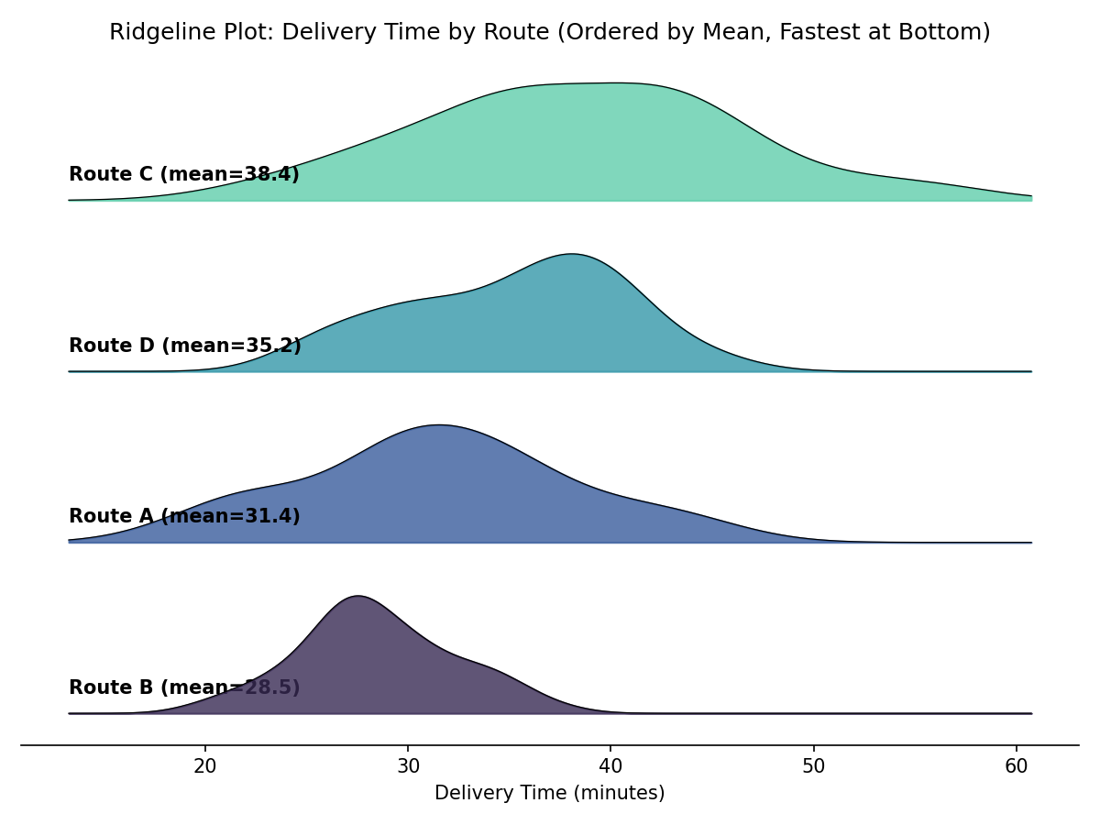
Interpretation: Ordering the ridges by mean delivery time (fastest at the bottom) turns the comparison into a readable staircase: Route B's peak sits furthest left, followed by Route A, then Route D, then Route C furthest right. Route C's ridge is also visibly flatter and wider, reinforcing that it is both the slowest and least predictable route — useful for a courier deciding which route to avoid for time-sensitive deliveries.

Question 5 — Histograms & Density Plots (Distributions)
Using the built-in Iris dataset's petal length column (20 bins, with a KDE overlay, overall and split by species).
Python
import seaborn as sns
import matplotlib.pyplot as plt

iris = sns.load_dataset("iris")

# 13 & 14. Histogram (20 bins) + KDE overlay, overall
sns.histplot(data=iris, x="petal_length", bins=20, kde=True, stat="density")
plt.title("Distribution of Petal Length (Histogram + KDE)")

# 15. Repeat, split/colored by species
sns.histplot(data=iris, x="petal_length", hue="species", bins=20, kde=True,
stat="density", common_norm=False, alpha=0.5)
plt.title("Distribution of Petal Length by Species (Histogram + KDE)")
R
library(ggplot2)

data(iris)

# 13 & 14. Histogram (20 bins) + KDE overlay, overall
ggplot(iris, aes(x = Petal.Length)) +
geom_histogram(aes(y = after_stat(density)), bins = 20,
fill = "steelblue", color = "white") +
geom_density(color = "darkred", linewidth = 1) +
labs(title = "Distribution of Petal Length (Histogram + KDE)")

# 15. Repeat, split/colored by species
ggplot(iris, aes(x = Petal.Length, fill = Species)) +
geom_histogram(aes(y = after_stat(density)), bins = 20,
position = "identity", alpha = 0.5) +
geom_density(aes(color = Species), linewidth = 1, alpha = 0) +
labs(title = "Distribution of Petal Length by Species (Histogram + KDE)")
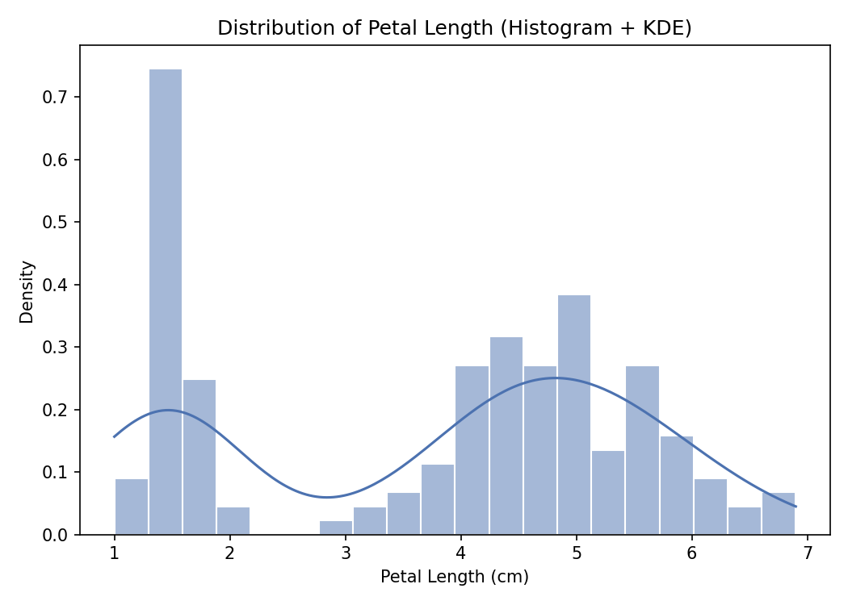
Interpretation: The overall petal-length distribution is clearly bimodal, not normal: a small, well-separated cluster of short petals (roughly 1-2 cm) and a broader cluster of longer petals (roughly 3-7 cm). This immediately hints that the 150 flowers are not one homogeneous population but a mix of distinct groups.
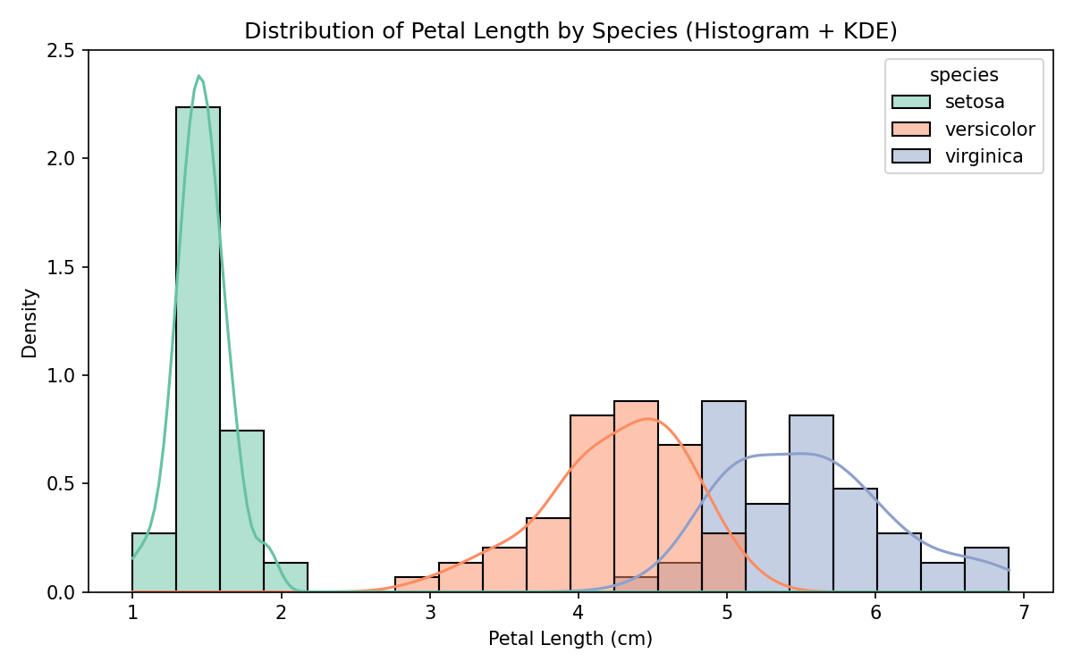
Interpretation: Splitting by species explains the bimodality directly: setosa forms the small, tightly clustered low-value peak (petal length ~1-2 cm) and is completely separated from the other two species, while versicolor and virginica occupy the longer-petal range with some overlap between them (versicolor centred ~4.3 cm, virginica centred ~5.5 cm). This shows petal length alone can perfectly separate setosa from the rest, but versicolor and virginica need an additional feature for full separation.
Submission checklist: Q1 chart-type justifications (no code) ✓ | Q2 bar plot in Python + R ✓ | Q3 grouped bar, stacked bar, dot plot, heatmap in Python + R ✓ | Q4 violin plot, ridgeline plot in Python + R ✓ | Q5 histogram + density (overall and grouped) in Python + R ✓ | Every chart has a title, axis labels, and a written interpretation ✓

