DSA0601 – Data Handling and Visualization
CO2 – Assessment Test 1 (AT1): Chart Construction Test — Model Answers

Question 1 — Healthcare Analytics
Dataset: 8 patients with Age, BMI, Blood Pressure and Disease Severity.

R Code (ggplot2)
library(ggplot2)

patients <- data.frame(
Patient = c("P1","P2","P3","P4","P5","P6","P7","P8"),
Age = c(24,32,41,48,56,65,38,29),
BMI = c(19.8,24.5,28.1,30.3,33.2,36.5,26.2,22.1),
BP = c(110,118,132,145,152,168,124,116),
Severity = c("Low","Medium","High","High","Critical",
"Critical","Medium","Low")
)

patients$Severity <- factor(patients$Severity,
levels = c("Low","Medium","High","Critical"))

ggplot(patients, aes(x = Age, y = BP,
color = Severity, size = BMI)) +
geom_point(alpha = 0.85) +
geom_text(aes(label = Patient), vjust = -1.3, size = 3,
color = "black", show.legend = FALSE) +
scale_color_manual(values = c("Low" = "#2ecc71", "Medium" = "#f1c40f",
"High" = "#e67e22", "Critical" = "#c0392b")) +
scale_size_continuous(range = c(4, 14)) +
labs(title = "Patient Risk Profile: Age vs Blood Pressure",
subtitle = "Color = Disease Severity, Size = BMI",
x = "Age (years)", y = "Blood Pressure (mmHg)",
color = "Severity", size = "BMI") +
theme_minimal(base_size = 12)

Output Chart
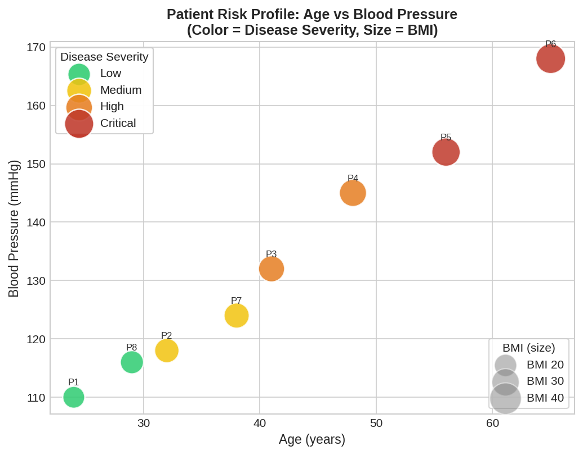

Justification of Aesthetic Mappings and Scales
- Position (x = Age, y = Blood Pressure): the two most clinically continuous, comparable variables are placed on the Cartesian axes, which is the strongest visual channel for showing a trend — here, that BP rises with Age.
- Color = Disease Severity: an ordinal categorical variable is best shown with a discrete, semantically meaningful palette (green → yellow → orange → red) so that severity reads instantly as an escalating traffic-light scale, matching clinical intuition.
- Size = BMI: BMI is a secondary continuous risk factor. Mapping it to point size (rather than a third axis) keeps the chart two-dimensional while still encoding a third variable — bubble size is well suited to a continuous, positive-valued quantity.
- Together the four channels (x, y, color, size) let a clinician spot the highest-risk patients (large, red, top-right) in a single glance — this is far more efficient than reading a table of eight rows and four columns.

Question 2 — Climate Science
Dataset: 12 months of Solar Radiation, Temperature and Rainfall.

R Code (ggplot2) — Cartesian Line Chart
library(ggplot2)

climate <- data.frame(
Month = factor(c("Jan","Feb","Mar","Apr","May","Jun",
"Jul","Aug","Sep","Oct","Nov","Dec"),
levels = c("Jan","Feb","Mar","Apr","May","Jun",
"Jul","Aug","Sep","Oct","Nov","Dec")),
Solar = c(180,200,240,280,320,300,260,250,240,220,190,170),
Temp = c(20,23,29,35,39,36,32,31,30,28,24,21),
Rainfall= c(25,18,12,8,5,65,150,170,120,85,45,30)
)

ggplot(climate, aes(x = Month, y = Temp, group = 1)) +
geom_line(color = "#e74c3c", linewidth = 1.2) +
geom_point(color = "#e74c3c", size = 3) +
labs(title = "Monthly Temperature Variation (Cartesian)",
x = "Month", y = "Temperature (°C)") +
theme_minimal(base_size = 12)
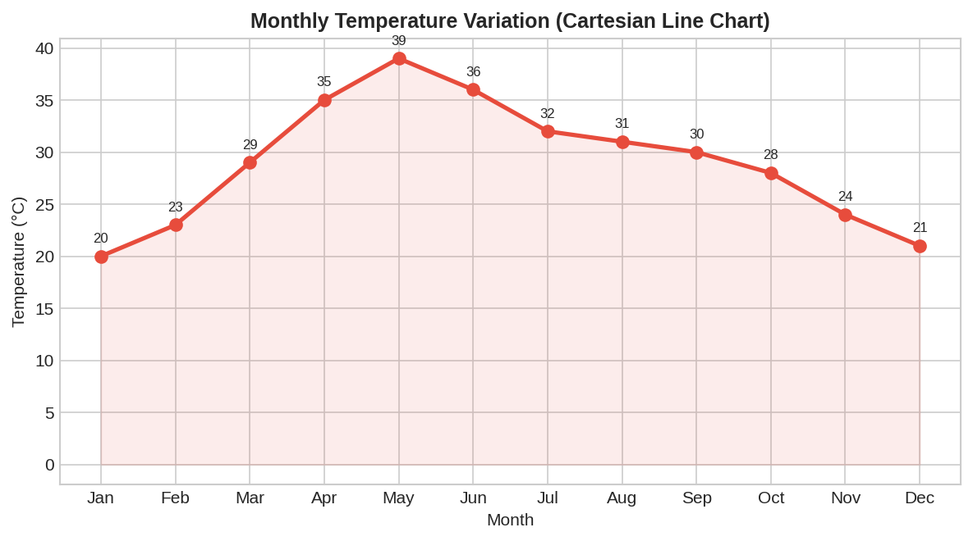

R Code (ggplot2) — Polar Coordinate Chart (Rainfall)
ggplot(climate, aes(x = Month, y = Rainfall, group = 1)) +
geom_col(fill = "#3498db", alpha = 0.75, color = "#2980b9") +
coord_polar() +
labs(title = "Annual Rainfall Distribution (Polar Coordinates)",
x = "", y = "Rainfall (mm)") +
theme_minimal(base_size = 12)
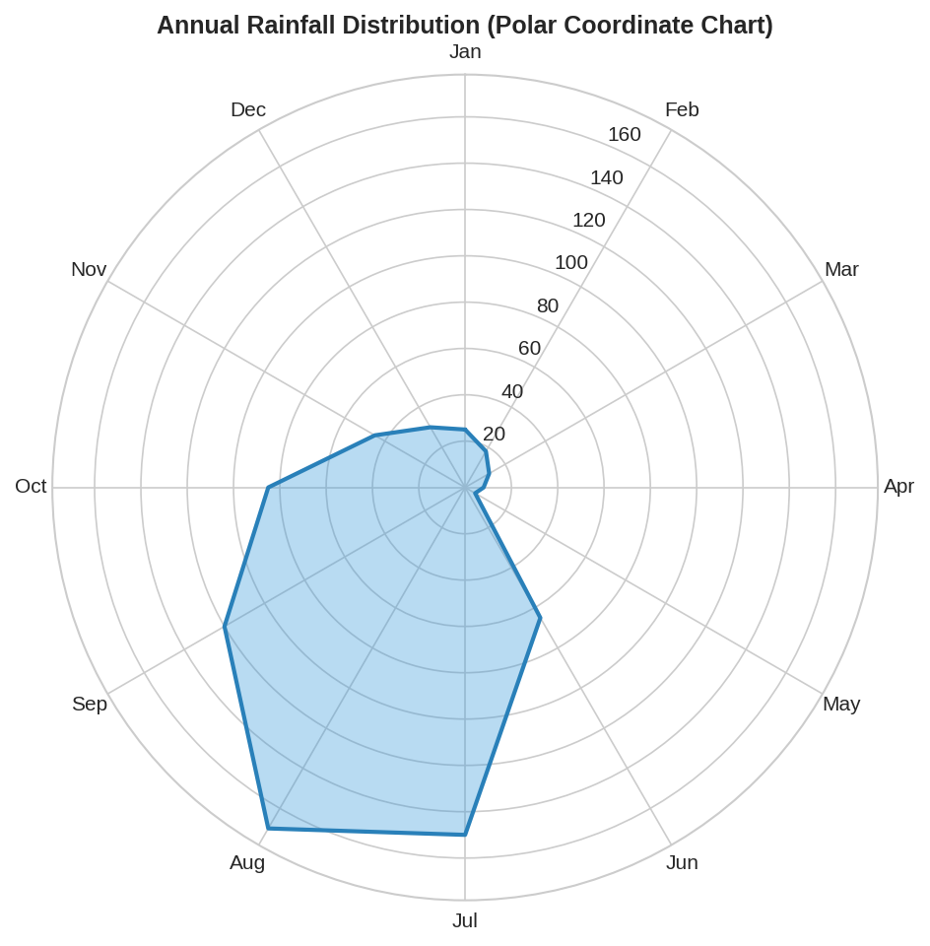

Cartesian vs Polar — Advantages & Limitations
Aspect | Cartesian | Polar
Trend reading | Excellent — a rising/falling line is instantly obvious (e.g. temperature peak in May). | Weak for trend, since values are wrapped around a circle and slope is harder to judge.
Cyclical pattern | Awkward — the Dec→Jan wrap-around is not visually continuous. | Strong — a 12-month cycle maps naturally onto 360°, so seasonal rainfall pattern (monsoon bulge) is visually intuitive.
Precise value comparison | Easy — equal spacing on a straight axis makes magnitude comparison accurate. | Harder — radial distance is less accurately judged by the eye than linear position (a known perceptual limitation).
Best use case here | Temperature, because we care about the shape of a smooth seasonal rise and fall. | Rainfall, because we care about which months form the recurring monsoon cycle.

Conclusion: Cartesian coordinates are preferred when accurate quantitative comparison and trend slope matter (temperature). Polar coordinates are preferred when the cyclical, seasonal nature of the data (rainfall/monsoon) is the primary message, even though exact values are harder to read.

Question 3 — Business Analytics & Marketing
Dataset: 5 products with Sales, Profit % and Market Share %.

R Code (ggplot2)
library(ggplot2)

products <- data.frame(
Product = c("A","B","C","D","E"),
Sales = c(210,185,260,145,120),
Profit = c(18,14,25,12,10),
Share = c(24,20,28,15,13)
)

products$Highlight <- ifelse(products$Share == max(products$Share),
"Highest Market Share", "Other")

ggplot(products, aes(x = reorder(Product, -Sales), y = Sales)) +
geom_col(aes(fill = Profit), color = "black", width = 0.65) +
geom_col(data = subset(products, Highlight == "Highest Market Share"),
aes(x = Product, y = Sales), fill = NA,
color = "#1abc9c", linewidth = 1.4) +
scale_fill_gradient(low = "#FFF3B0", high = "#B22222",
name = "Profit (%)") +
labs(title = "Product Sales (bar height) with Profit % (color)",
subtitle = "Teal outline = highest Market Share product",
x = "Product", y = "Sales (Rs. Lakhs)") +
theme_minimal(base_size = 12)
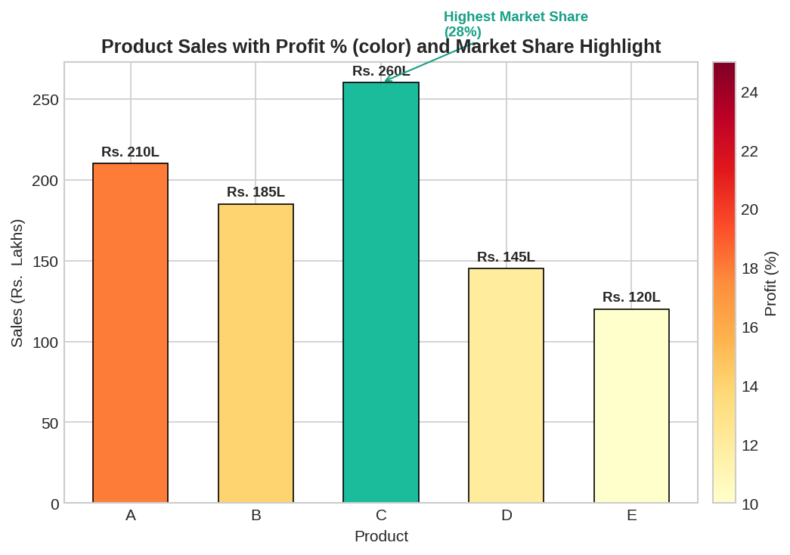

Why This Color Palette Improves Business Decisions
- A sequential (light-to-dark) palette on Profit % preserves the natural ordering of a quantitative variable — darker bars unambiguously mean 'more profitable', so a manager scanning the chart identifies high-margin products instantly, without reading numbers.
- Sequential palettes (unlike qualitative/rainbow palettes) do not introduce false categorical boundaries between similar profit values, avoiding misleading step changes.
- The contrasting highlight color (teal outline) on Product C breaks the sequential scheme deliberately — this pre-attentive 'pop-out' effect draws the eye to the strategically important fact (highest market share) even though it is already the tallest, darkest bar, reinforcing the message through redundant encoding.
- Together, bar height (sales), color (profit) and highlight (market leadership) let a decision-maker triangulate which product to invest further marketing spend in in one visual, rather than cross-referencing three separate tables.

Question 4 — Transportation Engineering
Dataset: Vehicles/hour recorded across 8 compass directions.

R Code (ggplot2)
library(ggplot2)

traffic <- data.frame(
Direction = c("North","North-East","East","South-East",
"South","South-West","West","North-West"),
Vehicles = c(980,760,1240,890,1420,1130,860,720)
)

traffic$Direction <- factor(traffic$Direction, levels = traffic$Direction)

ggplot(traffic, aes(x = Direction, y = Vehicles, fill = Vehicles)) +
geom_col(width = 0.9, color = "white") +
coord_polar() +
scale_fill_viridis_c(option = "plasma", name = "Vehicles/hr") +
labs(title = "Traffic Flow by Direction (Polar Coordinate Chart)",
x = "", y = "") +
theme_minimal(base_size = 12) +
theme(axis.text.y = element_blank())
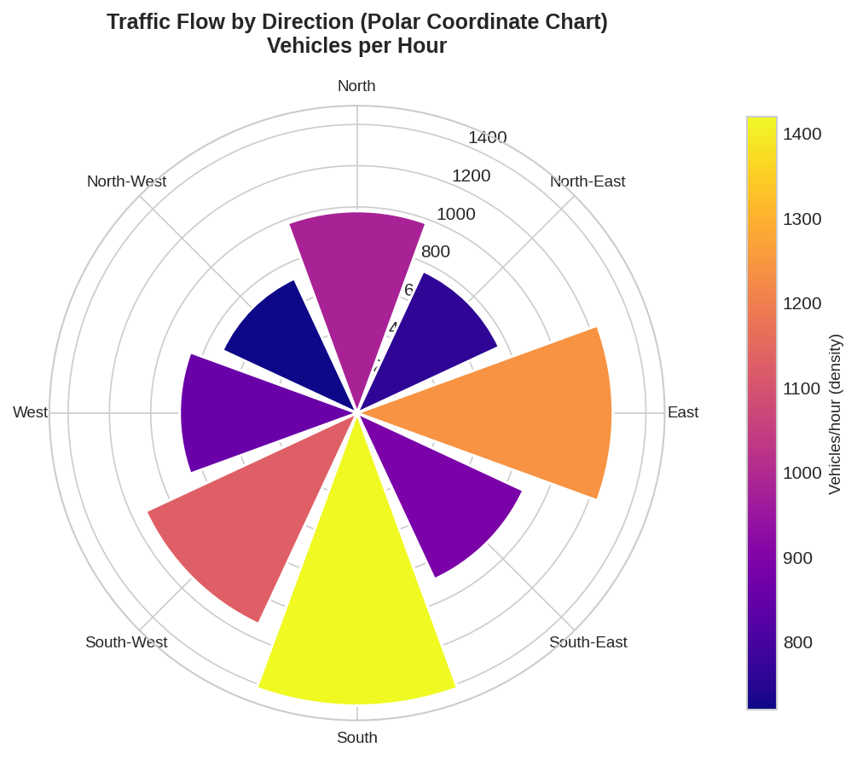

Why a Polar Chart Suits Directional Traffic Data
- Directions (N, NE, E, SE, S, SW, W, NW) are inherently angular/compass-based data — a polar layout maps each category to its real-world compass bearing, so the chart doubles as a mini compass rose that a traffic engineer can read the way they would read a map.
- A Cartesian bar chart would force an arbitrary linear ordering of directions (e.g. alphabetical or clockwise-as-a-line), losing the spatial adjacency between, say, North and North-West that is obvious in the real world but invisible on a straight axis.
- The polar layout immediately reveals the dominant traffic corridor (South and East, radiating furthest from the center), which is the key insight for signal-timing and lane-planning decisions — this pattern is far harder to spot from a row of vertical bars.
- Limitation to note: exact vehicle counts are slightly harder to read off a radial axis than a linear one, so the polar chart trades a little precision for a large gain in spatial intuitiveness — an acceptable trade-off for this directional use case.

Question 5 — Environmental Sustainability Dashboard
Dataset: 6 cities with AQI, Green Cover %, CO₂ Emission and Population.

R Code (ggplot2 + patchwork, 4-panel dashboard)
library(ggplot2)
library(patchwork)

cities <- data.frame(
City = c("A","B","C","D","E","F"),
AQI = c(48,82,135,165,72,95),
GreenCover = c(45,32,21,18,38,30),
CO2 = c(1.8,3.5,5.6,7.4,2.9,4.2),
Population = c(9,15,22,28,12,18)
)

cities$Category <- cut(cities$AQI,
breaks = c(-Inf,50,100,150,Inf),
labels = c("Good","Moderate","Poor","Severe"))

aqi_colors <- c("Good"="#2ecc71","Moderate"="#f1c40f",
"Poor"="#e67e22","Severe"="#c0392b")

p1 <- ggplot(cities, aes(GreenCover, AQI, size = Population,
color = Category, label = City)) +
geom_point(alpha = 0.85) + geom_text(vjust=-1.4, size=3, color="black") +
scale_color_manual(values = aqi_colors) +
labs(title = "Green Cover vs AQI (size = Population)") +
theme_minimal()

p2 <- ggplot(cities, aes(City, CO2, fill = Category)) +
geom_col(color = "black") +
scale_fill_manual(values = aqi_colors) +
labs(title = "CO2 Emission by City") + theme_minimal()

p3 <- ggplot(cities, aes(Population, AQI, color = Category)) +
geom_point(size = 4) + geom_smooth(method = "lm", se = FALSE,
color = "grey40", linetype = "dashed") +
scale_color_manual(values = aqi_colors) +
labs(title = "Population vs AQI") + theme_minimal()

p4 <- ggplot(cities, aes(reorder(City, AQI), AQI, fill = Category)) +
geom_col(color = "black") + coord_flip() +
scale_fill_manual(values = aqi_colors) +
labs(title = "City Ranking by AQI", x = "City") + theme_minimal()

(p1 | p2) / (p3 | p4) +
plot_annotation(title = "Environmental Sustainability Dashboard")
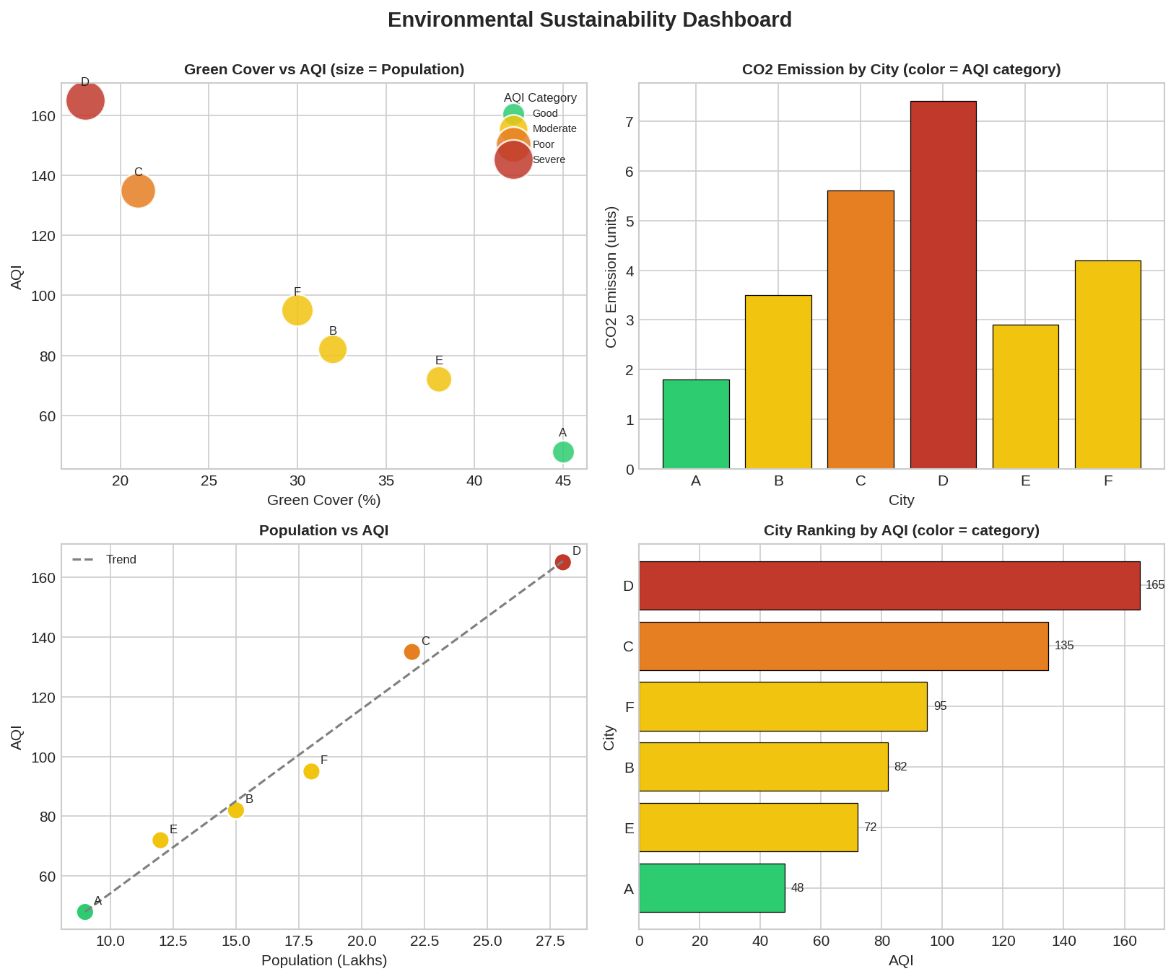

Design Justification
- Aesthetic mappings: Green Cover and Population are mapped to position/size on Panel 1 because they are the two variables most directly under a city planner's control or interest; AQI drives color across every panel so severity is instantly comparable between charts (consistent encoding = lower cognitive load).
- Scales: all continuous variables (AQI, CO2, Population, Green Cover) use linear continuous scales, since the underlying measurements are ratio-scaled and small differences (e.g. 48 vs 72 AQI) are meaningful and should map proportionally.
- Color palette for AQI categories: a discrete 4-level sequential/graded palette (green → yellow → orange → red) mirrors internationally recognized AQI color-coding (as used by CPCB/EPA), so the dashboard is instantly interpretable to anyone familiar with air-quality reporting, without needing to read a legend.
- Panel choice: bubble chart (relationship + 3 variables), bar chart (categorical comparison), scatter+trend line (correlation), and ranked horizontal bar (ordering) together cover the four core visualization tasks — relationship, comparison, correlation, and ranking — giving a complete sustainability picture from one dashboard.
- Every design choice prioritizes redundant, consistent encoding of AQI category (same colors everywhere) so the dashboard reads as one coherent story: cities with less green cover and higher population tend toward worse air quality and higher emissions (City D is the clear outlier requiring intervention).

