# README

## Notes on deliverable

### Team information

Group: 29

Members:

* Borean, Logan
* Jamaly, M A M Nasim
* McCadden, Deric
* McCrone, Brody
* Montes, Renato

### Project Overview

Title: **Trump Runner**

Description:

Trump Runner is a brain game combining memory recollection and political satire. Navigate Trump to the White House while avoiding hidden mines and collecting items such as spraytans, stars and birth certificates. The minefield is revealed for only a couple seconds at the beginning of each level.

### Code structure

The code is divided according to the language used:

* HTML: top level, in a single “index.html” file
* CSS: “style” subfolder, in a single “trumprunner.css” file
* JavaScript/jQuery: “js” subfolder
* PHP: “php” subfolder

#### The JavaScript/jQuery "js" subfolder

The “js” subfolder contains four subfolders of its own:

* Components: elements drawn on the pages that are not individual objects on the grid
* Entities: objects drawable on the grid along with their behaviour methods
* Libraries: unused
* Pages: scripts for initializing and viewing the various screens of the game
* Resources: resource managers through which the image and sound resources as well as the canvases are accessed

### Technologies used

* Languages and markup: HTML, CSS, JavaScript, jQuery, PHP.
* IDEs: Webstorm, phpStorm.

### Issues/Problems encountered

Product:

* Responsiveness could be better: by no means does it work on all devices. This also means elements do not always appear in their correct position.
* Log-in does not work appropriately: apostrophes are not well handled; unhelpful messages appear when something is wrong.

Process:

* Initial design could've been much more detailed in terms of intended code structure, using, for example, UML to list the scripts' methods.
* Tasks were not properly broken down initially, and misestimation of the time each task required continued throughout.
* There were communication problems involving who was working on what, even when present in the same room, largely solved with the use of Trello.

Team:

* Inexperience with CSS, JavaScript, jQuery and PHP.
* Inexperience with working in a coding project of 5 people, particularly in terms of merging other people’s code.

## User Guide

The game is started by opening the index.html file in a web browser, ideally Google Chrome or Mozilla Firefox either on a laptop or desktop or a Samsung Galaxy S5 phone, either locally or following the URL <http://www.trumprunner.lol>.

The game first presents a loading animation, showing the following main menu and background upon completion of the loading:



It is possible to play the game as a guest by instantly pressing **Play** on the main menu.

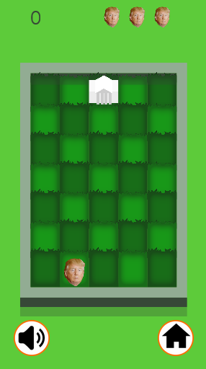 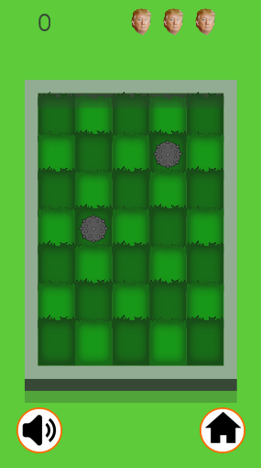

The grid is divided in four areas like an X, forming four triangles:

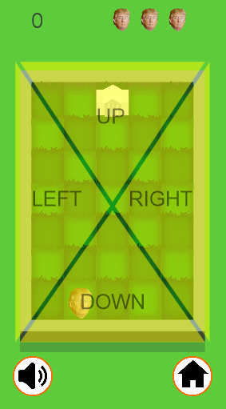

Press a triangle to move Trump, or use the arrow keys when on a laptop or desktop.

However, when playing as a guest, scores are not saved. An account must be made and the user must be logged in for the score to be saved.

To make an account, press the **Login** button, and then press **Register**. Enter your account information, then proceed to log in.

 

When logged in, the score obtained might be saved if it is among the high scores, and achievements for the user can be seen. Both user accounts and the achievements are stored in the database.

Achievements earned can be seen from the High Scores page.



## Network Graph

