International Journal of Web Engineering & Business Information Systems
Vol. 12 | Issue 2 | June 2026 | ISSN: 2456-XXXX
ProTech: A Containerised Django Marketplace for Professional Services
with Escrow Payments, RBAC, and Two-Sided Monetisation
An End-of-Year Master's Project in IT Innovation in Business
Manye Patrice
IT Innovation in Business — Master's Degree
Web Technology in Business · Web Application Development
Email: manye.patrice@university.edu | Repository: github.com/logandescapo-eng/protech1

Abstract
This paper presents ProTech, a full-stack professional services marketplace developed as an end-of-year master's project within the IT Innovation in Business programme. The platform connects clients with skilled service workers through a unified web application supporting discovery, booking, messaging, post-job reviews, and escrow-protected payments. Unlike an earlier PHP/MySQL prototype, the current system uses Django 5.2.15, PostgreSQL 15, Redis 7, Gunicorn, and Nginx via Docker Compose. Security is enforced through PBKDF2 hashing, CSRF middleware, ORM parameterisation, template auto-escaping, and a custom @user_type_required decorator. The escrow subsystem in escrow/services.py manages wallets, held funds, platform commission (default five percent), and auditable transactions using Decimal arithmetic and atomic database transactions. The paper covers architecture, business model, data design, DevOps, testing (seventeen automated tests, GitHub Actions CI), limitations, and future work.
Keywords: Django, marketplace platform, escrow payments, role-based access control, Docker Compose, PostgreSQL, Redis caching, two-sided markets, full-stack web development.

1. Introduction
The digital transformation of professional services has created substantial demand for platforms that connect clients with verified workers while reducing search friction, payment risk, and administrative overhead. Established marketplaces such as TaskRabbit, Thumbtack, and Upwork demonstrate that two-sided platforms can aggregate supply and demand at scale; however, local tradespeople often lack affordable channels to build reputation and receive secure online payments.
ProTech addresses this gap through an academically rigorous yet commercially informed implementation. Developed by Manye Patrice as the capstone for Web Technology in Business and Web Application Development, the platform serves clients who browse, book, and pay for services, and workers who manage profiles, accept jobs, and receive wallet-based payouts. The project evolved from a PHP/MySQL prototype into a Django-centred system aligned with enterprise web practice and the module rubric.
This article contributes four elements: (1) documentation of migration from PHP to domain-partitioned Django with a Jinja2 compatibility layer; (2) an internal escrow ledger design for marketplace trust; (3) explicit rubric-to-implementation mapping; and (4) a hybrid monetisation model grounded in two-sided market theory.

2. Related Work
Research on electronic commerce adoption emphasises perceived usefulness, ease of use, and trust as primary drivers of platform participation (Pavlou & Fygenson, 2006). Trust mechanisms—verified identity, reputation systems, and payment holding—reduce transaction risk (Edelman et al., 2012). ProTech operationalises these through role-separated dashboards, booking-linked reviews, and escrow holds released only upon job completion.
Platform economics literature formalises pricing on both sides of a market (Rochet & Tirole, 2003; Evans & Schmalensee, 2016). ProTech's design—free client access, worker commissions, optional subscriptions—follows asymmetric pricing common among services marketplaces.
Fielding (2000) and Fowler (2002) inform separation of presentation, domain logic, and persistence. Django's ORM, migrations, admin, and security middleware embody enterprise patterns. Docker Compose reflects reproducible DevOps practice. Security references OWASP Top Ten (2021): RBAC decorators, ORM queries, and PBKDF2 hashing address access control, injection, and cryptographic failures.

3. System Architecture
ProTech adopts a three-tier architecture deployed as four Docker Compose services: PostgreSQL (db), Redis (redis), Django/Gunicorn (backend), and Nginx (nginx). The presentation tier delivers server-rendered HTML via Jinja2 templates. The application tier partitions logic into users, bookings, reviews, and escrow applications. The data tier combines PostgreSQL 15 with Redis 7 for sessions and query caching. Django middleware enforces CSRF, authentication, and security headers on every request.
Tier | Technology | Responsibility
Presentation | Jinja2 + Nginx | UI rendering, static/media offload
Application | Django 5.2 + Gunicorn | Business logic, auth, admin
Persistence | PostgreSQL 15 | Users, bookings, escrow ledger
Cache / sessions | Redis 7 | Worker search cache, sessions
Orchestration | Docker Compose | Reproducible deployment
Table 1: Three-tier architecture and deployment components

4. Business Model
ProTech implements a hybrid model: transaction commissions at escrow release and tiered worker subscriptions for visibility. release_escrow() applies ESCROW_PLATFORM_FEE_PERCENT (default five percent). Tiered rates are specified for micro, standard, and commercial job bands. Subscription plans—Starter (free), Professional ($29/mo), Premium ($59/mo)—are documented but billing is not yet coded.
Plan | Price | Visibility | Commission discount
Starter | Free | Basic listing; capped bookings | None
Professional | $29/mo | Priority above Starter | −1% (4% effective)
Premium | $59/mo | Featured placement | −2% (3% effective)
Table 2: Worker subscription tiers (specified; billing planned)

5. Authentication and Security
Authentication uses Django sessions with a custom EmailBackend. Passwords are PBKDF2-hashed. Registration creates client Users or User+Worker pairs. Authorisation uses user_type and @user_type_required to separate client, worker, and admin flows.
Threat (OWASP) | Control | Implementation
Broken access control | RBAC decorator | users/decorators.py
Injection | ORM parameterisation | Django ORM
Cryptographic failures | PBKDF2 hashing | Django auth
CSRF | CsrfViewMiddleware | csrf_field() in templates
XSS | Auto-escaping | Jinja2 templates
Misconfiguration | Environment secrets | .env + .gitignore
Table 3: Security controls mapped to OWASP categories

5.1 Contrast with Prior PHP Prototype
The earlier PHP/MySQL prototype used bcrypt, MySQLi prepared statements, and PHP sessions in XAMPP. It lacked admin tooling, migrations, escrow, Docker deployment, automated tests, and caching. The Django rewrite consolidates these capabilities and replaces demo-mode URL bypasses with seed_demo and Docker entrypoint seeding.

6. Escrow Payment Subsystem
ProTech holds client funds in escrow until work is complete. Logic resides in escrow/services.py. Workflow: deposit to UserWallet → create Booking → fund_escrow() creates EscrowHold → release_escrow() on completion (fee deducted) or refund_escrow() on cancellation.
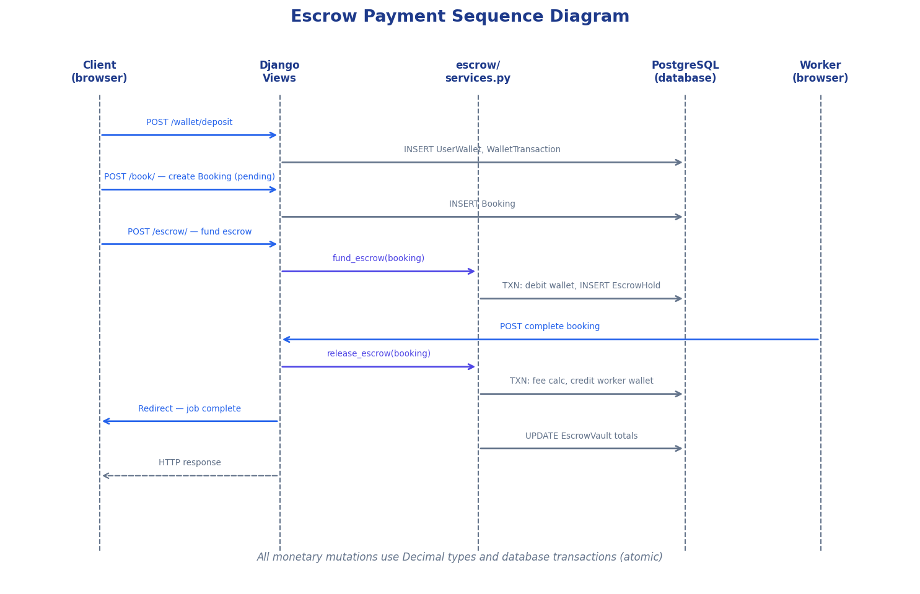
Figure 1: Escrow payment sequence diagram
users ──1:1── UserWallet
users ──1:1── Worker
users ──1:N── Booking ──1:1── EscrowHold
Booking ──1:1── Review
EscrowHold ── logs ── WalletTransaction
EscrowVault (singleton) — platform totals
Figure 2: Core entity relationships (textual ER summary)
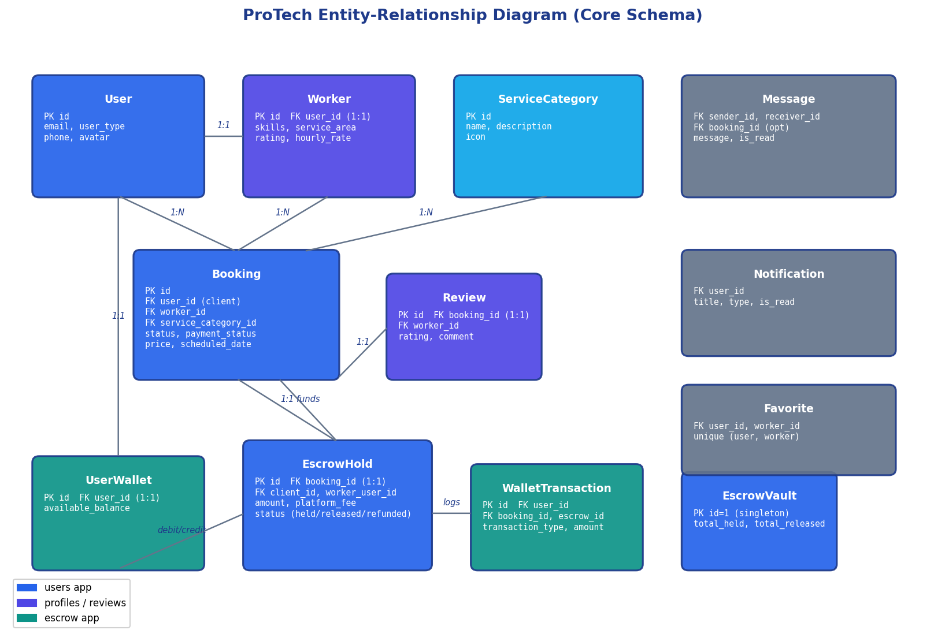
Figure 3: Entity-relationship diagram

7. Data Model and Booking Workflow
The schema centres on User, Worker, ServiceCategory, and Booking. Review attaches one-to-one to completed bookings. Message, Notification, Favorite, and WorkerAvailability support engagement.
Booking status | Actor | Escrow interaction
pending | Worker accepts/rejects | Client may fund escrow
confirmed / in_progress | Worker updates | Funds held if funded
completed | Worker marks done | release_escrow(); fee deducted
cancelled | Either party | refund_escrow() if held
Table 4: Booking states and escrow coupling

8. Implementation and DevOps
Code is organised by domain: users/, bookings/, reviews/, escrow/, protech_project/. cache_utils.py caches worker search (300s) and categories (600s). Logging writes to stdout and logs/django.log. docker-entrypoint.sh runs migrate, collectstatic, seed_demo, and Gunicorn.
Rubric requirement | Implementation | Evidence
Django + templates | Django 5.2 + Jinja2 | templates/, jinja2_env.py
Auth & RBAC | @user_type_required | users/decorators.py
Password reset | Django token flow | /password-reset/
Admin / CMS | Django Admin | /admin/
Docker + Redis | Four-service Compose | docker-compose.yml
Tests + CI | 17 passing tests | ci.yml
Logging | Per-app loggers | settings.py
Table 5: Academic rubric alignment

9. Testing and Evaluation
Unit tests validate models; integration tests cover login, RBAC, password reset, health endpoint, and escrow wallet debits. GitHub Actions runs flake8, migrations, full test suite, and /health/ check.
Metric | Result | Benchmark
Automated tests | 17 passing | Module requirement met
CI pipeline | Lint, migrate, test, health | GitHub Actions
Deployment | docker compose up --build | Single-command demo
Escrow commission | 5% default | Live in services.py
Cache | Redis / locmem (CI) | Environment-aware
Table 6: Evaluation metrics and outcomes

10. Limitations
ProTech uses demonstration wallet deposits, not a licensed payment provider. Subscriptions are specified but not billed. Messaging is not real-time. Browser E2E tests are absent. Growth projections are illustrative. Legacy Flask/PHP files remain for reference; Django is canonical.

11. Conclusion and Future Work
This paper presented ProTech as a production-oriented marketplace replacing a PHP prototype with Django, PostgreSQL, Redis, and Docker. The platform integrates discovery, booking, messaging, reviews, escrow, caching, logging, testing, and CI into a system suitable for master's assessment.
Future work prioritises Stripe integration, WorkerSubscription billing, WebSocket notifications, Selenium/Cypress E2E tests, geolocation matching, and two-factor authentication. The modular architecture supports these increments without fundamental restructuring.

References
[1] Django Software Foundation. (2024). Django Documentation (v5.2). https://docs.djangoproject.com/
[2] Docker Inc. (2024). Docker Compose Specification. https://docs.docker.com/compose/
[3] Edelman, B., Luca, M., & Svirsky, D. (2012). From niches to riches. Harvard Business School Working Paper.
[4] Evans, D. S., & Schmalensee, R. (2016). Matchmakers: The New Economics of Multisided Platforms. HBR Press.
[5] Fielding, R. T. (2000). Architectural Styles and the Design of Network-based Software Architectures. UC Irvine.
[6] Fowler, M. (2002). Patterns of Enterprise Application Architecture. Addison-Wesley.
[7] OWASP Foundation. (2021). OWASP Top Ten. https://owasp.org/www-project-top-ten/
[8] Pavlou, P. A., & Fygenson, M. (2006). MIS Quarterly, 30(1), 115–143.
[9] PostgreSQL Global Development Group. (2024). PostgreSQL 15 Documentation.
[10] Redis Ltd. (2024). Redis Documentation. https://redis.io/docs/
[11] Rochet, J.-C., & Tirole, J. (2003). Platform competition in two-sided markets. JEEA, 1(4), 990–1029.
[12] Marcotte, E. (2010). Responsive web design. A List Apart, 306.

