ProTech
Professional Services Marketplace Platform
Technical Report
End-of-Year Master's Project
IT Innovation in Business — Master's Degree
Web Technology in Business · Web Application Development
Author | Manye Patrice
Programme | IT Innovation in Business — Master's Degree
Project | End-of-Year Master's Project (Individual)
Date | June 06, 2026
Repository | github.com/logandescapo-eng/protech1

Table of Contents
1. Introduction
1.1 Project Goals
1.2 Business Use Case
1.3 Problem Statement
1.4 Business Model and Monetisation Strategy
1.4.1 Transaction Commission Model
1.4.2 Worker Subscription Model
1.4.3 Value Exchange and Break-Even Analysis
1.4.4 Alignment with the ProTech Implementation
1.4.5 Go-to-Market and Growth Considerations
1.4.6 Growth Projections: Traffic and Economics
2. System Design
2.1 Functional Architecture
2.2 Architecture Diagram
2.3 Use Cases
2.4 Key Features and Data Model
3. Implementation
3.1 Technology Choices
3.2 Application Structure
3.3 Security, Auth, and Escrow
3.4 Caching and Logging
3.5 Application Interface (Screenshot Placements)
4. Testing and Deployment
5. Conclusion and Literature
Appendix A — Project Structure
Appendix B — Demo Credentials
Appendix C — Application Screenshots (Insert Images)

1. Introduction

1.1 Project Goals
ProTech is a full-stack web application built as my end-of-year master's project for the courses Web Technology in Business and Web Application Development, part of the IT Innovation in Business programme. The aim is a secure, scalable marketplace that solves a real problem: helping households and small businesses find skilled workers such as plumbers, electricians, cleaners, and carpenters.
The project must show end-to-end skill in server-rendered front-end design, Django back-end development, database modelling, containerised deployment, automated testing, logging, and Redis caching. It also needs to be easy to run: anyone should be able to clone the GitHub repo, follow the README, start Docker Compose, and use a working marketplace with client and worker dashboards, bookings, escrow payments, and an admin console.

1.2 Business Use Case
In many urban and regional markets, the process of hiring a tradesperson remains informal and inefficient. Clients typically depend on personal referrals, unstructured social media posts, or costly agency intermediaries. They have limited ability to compare providers by skill, location, availability, or verified reputation before committing to a job. Payment is often negotiated in cash or via direct transfer with no dispute mechanism if work quality falls short.
Independent workers face the mirror image of this problem. Building a credible professional profile online requires technical skills many tradespeople do not possess. Managing inbound enquiries, scheduling, and payment collection across phone calls and messaging apps consumes time that could otherwise be spent on billable work. Reputation is hard to accumulate when satisfied customers have no structured channel to leave public reviews.
ProTech intervenes as a two-sided marketplace. Clients gain a searchable directory of workers, transparent rating data, integrated booking with date and location details, and escrow-protected payments that reduce upfront risk. Workers gain a hosted profile, inbound job requests, status tracking tools, wallet-based payouts on completion, and review-driven reputation growth. Platform operators use Django Admin to oversee users, service categories, bookings, and financial ledger activity, providing the governance layer expected of a commercial marketplace.

1.3 Problem Statement
Four interrelated problems motivate the design of ProTech. The discovery problem arises because clients cannot efficiently filter professionals by trade, geography, and verified ratings in a single interface. The trust problem follows from payment risk: without escrow, neither party is confident transacting online. The coordination problem reflects the fragmentation of booking status, messaging, and notifications across disconnected channels. Finally, the administrative problem stems from the absence of a central system to manage service taxonomy, user roles, and operational oversight at scale.
The solution brings discovery, scheduling, messaging, escrow payments, reviews, and admin tools into one Django application behind Nginx in Docker. That single integrated platform is the main contribution of the project, both as a business idea and as a technical build.

1.4 Business Model and Monetisation Strategy
A marketplace needs revenue without hurting either clients or workers. ProTech uses two income streams: a commission on each completed job, and monthly subscription plans for workers who want better visibility. Clients pay no membership fee — only the agreed job price, held in escrow until the work is done. Workers pay subscriptions if they want more leads, and commissions when jobs complete. That keeps sign-up easy for clients while workers who benefit most from the platform contribute more.
Commission alone scales with activity but can frustrate busy professionals who pay a lot yet get no search boost. Subscriptions alone give steady income but do not track actual job value. Platforms like Upwork, Thumbtack, and Fiverr mix both. ProTech does the same, and the commission part is already working in code: escrow/services.py applies ESCROW_PLATFORM_FEE_PERCENT when funds are released.

1.4.1 Transaction Commission Model
The primary revenue engine is a platform commission deducted automatically when escrow funds are released to the worker upon job completion. In the current implementation, the default rate is five percent of the gross booking price, configurable through the ESCROW_PLATFORM_FEE_PERCENT environment variable. When a worker marks a booking as complete and release_escrow() executes, the system calculates the platform fee, credits the worker's wallet with the net payout (gross amount minus fee), increments the EscrowVault released total, and records a WalletTransaction row for audit purposes. Clients are never charged an additional surcharge at checkout; the commission is borne by the worker as a cost of using the platform's payment infrastructure, dispute mediation capability, and demand aggregation.
To remain competitive across job sizes while preserving margin on small tasks, the production business model proposes a modestly tiered commission schedule rather than a single flat rate for all transactions. Standard residential jobs between fifty and five hundred currency units retain the five percent rate that is already implemented in the prototype. Micro-jobs below fifty units incur an eight percent rate or a minimum fee equivalent to three currency units, whichever is greater, because payment processing and support costs represent a larger share of economic value on small tickets. Commercial or repeat contracts above five hundred units qualify for a reduced three-and-a-half percent rate, rewarding high-value relationships that stabilise platform liquidity and reduce per-job acquisition cost.
Job value band | Commission rate | Example job | Platform fee | Worker net payout
Micro (under $50) | 8% (min. $3) | $40 plumbing call-out | $3.20 | $36.80
Standard ($50 – $500) | 5% | $200 electrical repair | $10.00 | $190.00
Commercial (over $500) | 3.5% | $800 renovation phase | $28.00 | $772.00
The commission is justified by tangible services rendered at the moment of payment release. ProTech holds funds in escrow, which reduces client risk of paying upfront for incomplete work and reduces worker risk of non-payment after labour is delivered. The platform maintains verified identity records, booking history, and review authenticity constraints that would be costly for an individual tradesperson to replicate. Customer support for cancellation disputes, chargeback documentation, and account recovery further justify a take-rate comparable to card-present merchant fees plus a modest marketplace premium.

1.4.2 Worker Subscription Model
The second revenue stream consists of recurring subscription plans targeted exclusively at workers. Clients remain free to register, search, book, and review because demand aggregation is the foundation of network effects; restricting client access would shrink the addressable audience that workers pay to reach. Workers who depend on ProTech for a meaningful share of their income require predictable visibility in search rankings, sufficient booking capacity, and professional signalling that differentiates them from casual or inactive profiles. Subscription tiers package these capabilities into clearly priced plans.
The Starter plan is free and exists primarily to onboard new professionals and populate the marketplace with searchable supply. Starter accounts receive a basic profile page and may accept up to five concurrent active bookings per calendar month. Their listings appear in search results but are ranked below all subscribed competitors, and profile impressions are soft-capped at approximately one hundred client views per month to prevent free accounts from consuming unlimited marketing exposure without contributing recurring revenue. Starter workers still pay transaction commissions on every completed job, ensuring the platform captures value when free-tier users convert demand into paid work.
The Professional plan, priced at twenty-nine dollars per month or two hundred ninety-five dollars annually after a fifteen percent annual discount, targets established tradespeople who require reliable lead flow. Subscribers receive standard search ranking priority above all Starter accounts, unlimited concurrent bookings, access to in-app messaging analytics showing response times and conversion rates, a verified Professional badge displayed on their profile, and a one percentage point reduction in transaction commission (four percent instead of five on standard-band jobs). This commission discount creates a financial incentive for active workers to subscribe once monthly job volume exceeds the break-even point described below.
The Premium plan, priced at fifty-nine dollars per month or five hundred ninety-nine dollars annually, is designed for workers who wish to maximise reach and dominate category visibility. Premium subscribers appear in a featured carousel at the top of browse_workers results within their declared service area, receive push-priority notification when new client searches match their skills, carry a Premium Verified badge, gain access to early promotional placement on the landing page success stories section, and benefit from a two percentage point commission reduction on standard-band jobs (three percent instead of five). Unlimited client impressions and priority support response within twenty-four hours position Premium as the account type required for workers whose commercial strategy depends on ProTech as a primary channel rather than a supplementary referral source.
Plan | Monthly price | Search visibility | Booking capacity | Commission discount
Starter (Free) | $0 | Basic listing; ranked below all paid plans; ~100 profile views/mo cap | Up to 5 active bookings/month | None (full standard rate)
Professional | $29/mo | $295/yr | Standard priority above Starter; unlimited impressions | Unlimited concurrent bookings | −1% on standard-band jobs (4% effective)
Premium | $59/mo | $599/yr | Featured top placement in category + area; unlimited impressions | Unlimited + priority job alerts | −2% on standard-band jobs (3% effective)

1.4.3 Value Exchange and Break-Even Analysis
Workers evaluate subscription economics by comparing monthly plan cost against incremental commission savings plus the estimated revenue uplift from improved visibility. A Professional subscriber completing fifteen standard-band jobs of two hundred dollars each generates three thousand dollars in gross volume. At five percent commission the fee would be one hundred fifty dollars; at the reduced four percent rate the fee is one hundred twenty dollars, yielding thirty dollars in monthly commission savings. Against a twenty-nine dollar subscription, the plan breaks even before accounting for any additional bookings attracted through higher search ranking. A Premium subscriber completing the same volume saves sixty dollars in commission (three percent versus five percent), comfortably exceeding the fifty-nine dollar monthly fee while additionally benefiting from featured placement that industry benchmarks suggest can increase inbound enquiries by twenty to forty percent for service marketplaces.
From the platform operator's perspective, the dual model diversifies revenue risk. Transaction commissions scale automatically with marketplace activity and require no separate billing relationship, while subscriptions provide monthly recurring revenue that partially offsets fixed infrastructure costs—hosting, customer support, compliance, and payment processor minimums—even during seasonal troughs in job volume. The following illustrative projection assumes five hundred registered workers, of whom sixty percent remain on Starter, twenty-five percent subscribe to Professional, and fifteen percent subscribe to Premium, with one thousand completed standard-band jobs per month at an average gross value of one hundred fifty dollars.
Revenue source | Assumption | Monthly estimate
Transaction commissions | 1,000 jobs × $150 avg × 5% blended take-rate | $7,500
Professional subscriptions | 125 workers × $29/month | $3,625
Premium subscriptions | 75 workers × $59/month | $4,425
Total projected MRR | Commissions + subscriptions (illustrative) | $15,550
Transaction commissions  ~48% of illustrative MRR  Variable revenue scaling with completed job volume. Collected at escrow release. | Worker subscriptions  ~52% of illustrative MRR  Recurring MRR from Professional and Premium plans. Predictable baseline income.

1.4.4 Alignment with the ProTech Implementation
The transaction commission component is not merely theoretical: it is implemented in the escrow release path of the application. The escrow/services.py module calculates platform_fee as a percentage of the held amount, stores it on the EscrowHold record, and pays worker_payout net of that fee. The wallet and transaction tables provide the audit trail required for financial reporting and tax documentation in a commercial deployment. Extending the prototype to support tiered commission bands would require comparing booking.price against configured thresholds at release time, a straightforward enhancement to the existing service function without architectural change.
Worker subscription tiers represent the next planned product increment. Implementation would introduce a WorkerSubscription model linked one-to-one with Worker profiles, storing plan type, billing period, renewal date, and Stripe customer identifier. Search ranking in browse_workers would order results by plan priority before rating, and a monthly booking counter would enforce Starter-tier capacity limits. Django Admin would manage plan overrides for promotional trials. Together, the live commission logic and the specified subscription framework demonstrate that ProTech is designed not only as an academic exercise but as a commercially viable marketplace with a clear path from prototype to revenue-generating production.

1.4.5 Go-to-Market and Growth Considerations
Launch sequencing should prioritise client liquidity before aggressive worker monetisation. An initial six-month worker acquisition phase may waive subscription fees entirely while keeping the five percent commission, allowing supply to accumulate without upfront barrier. Once search results contain sufficient choice for clients in core geographies, Professional and Premium plans activate with a thirty-day free trial for workers who complete at least three jobs, ensuring subscribers understand platform value before the first invoice. Referral credits—one month of Professional for each worker referred who completes five jobs—accelerate viral supply growth at lower paid acquisition cost than digital advertising alone.
Regulatory and ethical constraints require transparent fee disclosure at booking confirmation and on worker payout receipts, matching the clarity already shown on the escrow payment screen in the application. Subscription auto-renewal must comply with consumer protection rules in the operating jurisdiction, including easy cancellation from the worker settings page and pro-rata refunds where mandated. These considerations complete a business model that is financially sound, technically grounded in the existing codebase, and appropriate for presentation during the IT Innovation in Business project defence.

1.4.6 Growth Projections: Traffic and Economics
The following projections illustrate a plausible twenty-four-month evolution of ProTech following a controlled city-level launch. Figures are illustrative rather than audited forecasts; they are derived from a deterministic compound-growth model that assumes an initial six-month supply-building phase, twelve months of accelerating network effects as client choice and worker density improve conversion, and a final six-month maturity phase in which growth rates taper but absolute volumes continue to rise. The model aligns with the hybrid monetisation strategy described above: commission revenue scales with completed job volume while subscription revenue grows as a share of the worker base once paid plans activate in month seven.
Traffic growth is expressed through monthly unique visitors, monthly active users (MAU), and total page views. MAU is modelled at approximately sixty-two percent of visitor volume, reflecting repeat usage by clients checking booking status and workers managing job queues. Page views average three point six per visitor as users browse worker profiles, compare ratings, and navigate dashboard workflows.
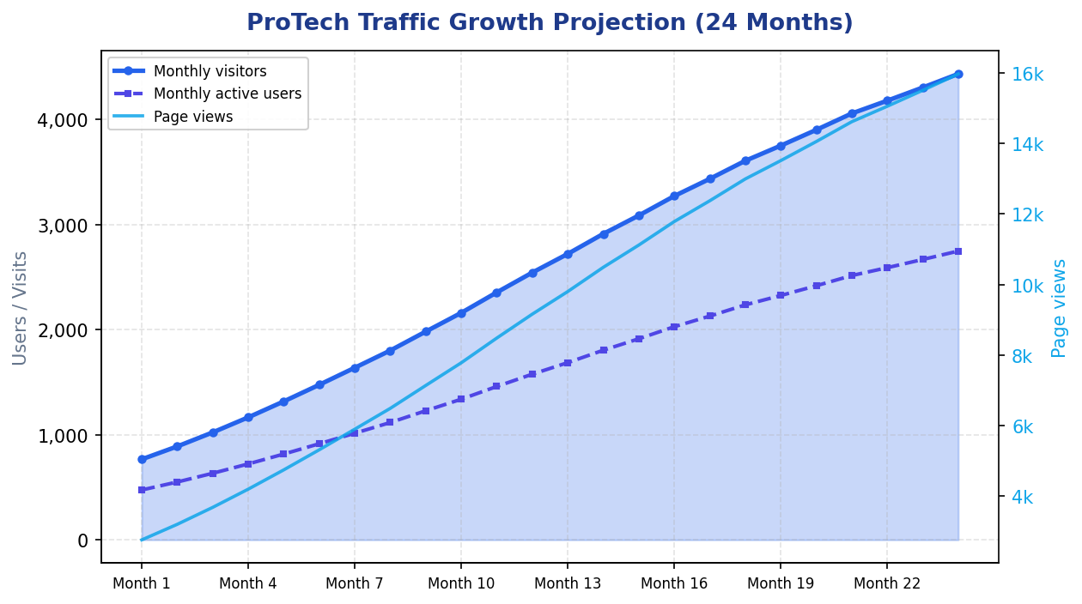
Figure 1 — Projected monthly visitors, active users, and page views (Months 1–24 post-launch).
Registered account growth follows a two-sided pattern characteristic of marketplaces. Client acquisition outpaces worker acquisition in absolute terms because the addressable client population is larger and onboarding friction is lower (no subscription decision). Worker growth is deliberately moderated early to preserve service quality and avoid empty search results in categories with insufficient geographic coverage. By month twenty-four, the model reaches approximately 9,500 client accounts and 1,100 worker accounts, a ratio that supports healthy liquidity in a mid-sized metropolitan market.
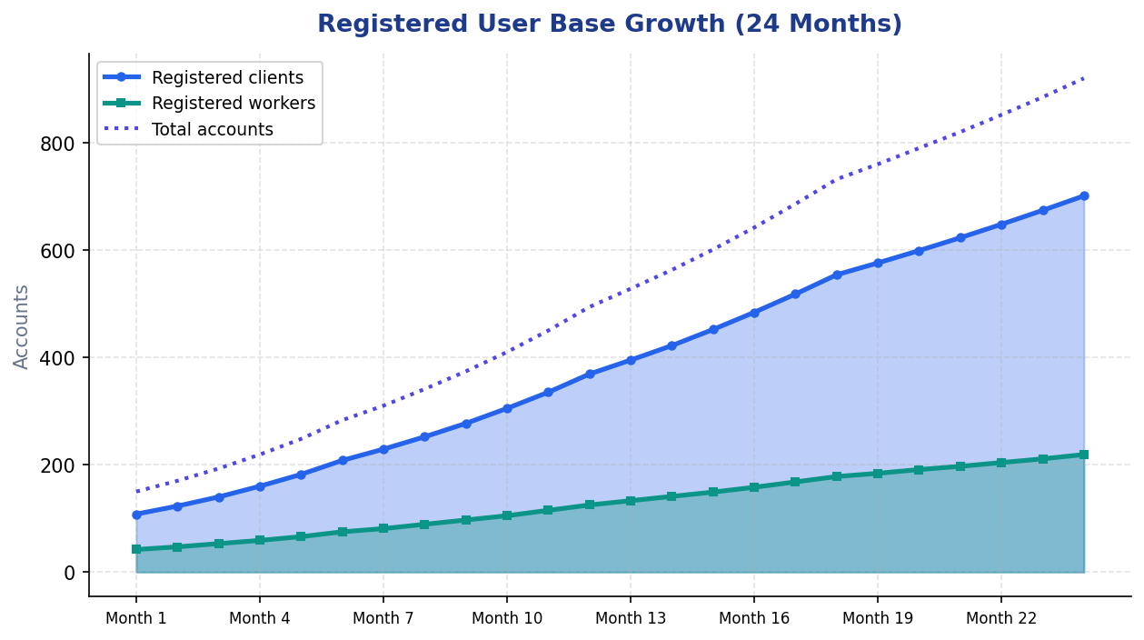
Figure 2 — Projected growth of registered client and worker accounts.
Period | Visitors | Clients | Workers | Jobs / mo | MRR
Month 6 | 1,476.224847552 | 208 | 75 | 53 | $609
Month 12 | 2,544.120113698246 | 369 | 125 | 100 | $1,955
Month 18 | 3,608.2406551362005 | 554 | 178 | 159 | $3,709
Month 24 | 4,435.138510870497 | 701 | 219 | 207 | $5,203
Economic growth is driven by two coupled variables: gross merchandise volume (GMV), defined as the total value of completed jobs processed through escrow, and monthly recurring revenue (MRR), combining transaction commissions and worker subscriptions. Completed bookings grow from twenty-two jobs in month one to approximately two thousand two hundred jobs by month twenty-four, while average job value rises modestly from one hundred thirty-five to one hundred eighty dollars as the platform attracts a higher proportion of multi-hour commercial engagements. Commission MRR therefore expands both through job count and through GMV per job.
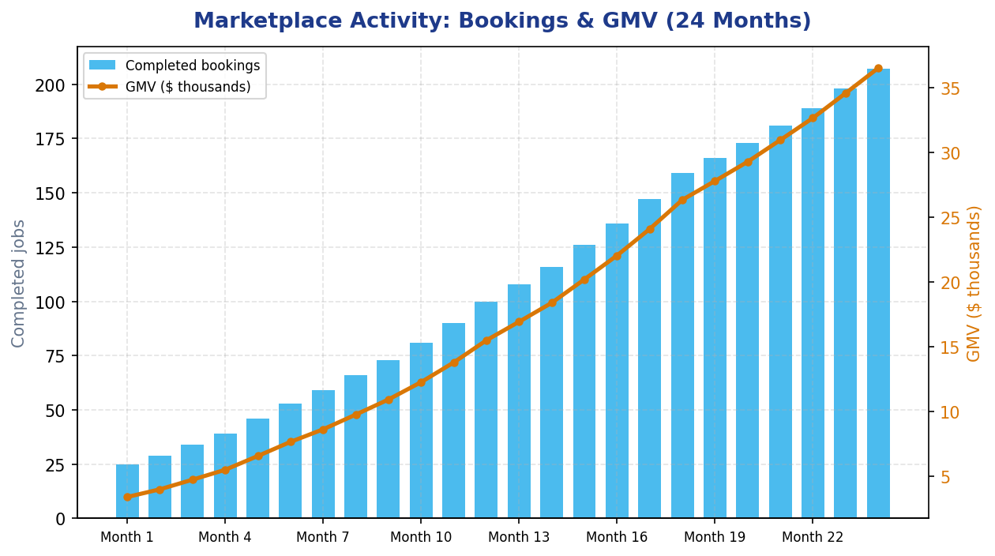
Figure 3 — Completed bookings (bars) and gross merchandise volume in $ thousands (line).
Total MRR crosses fifteen thousand dollars around month twelve—consistent with the steady-state snapshot in Section 1.4.3—and approaches fifty thousand dollars by month twenty-four. Subscription revenue, which is zero during the initial promotional waiver period, rises to represent roughly thirty-nine percent of MRR by the end of year two as worker penetration into Professional and Premium tiers increases. The stacked revenue chart below separates commission and subscription contributions month by month.
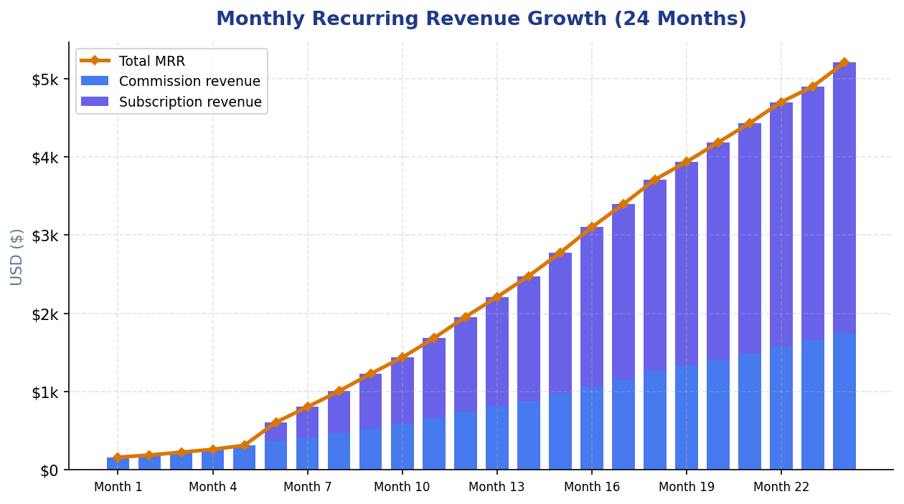
Figure 4 — Monthly recurring revenue: commission (blue) + subscriptions (indigo); total MRR (gold line).
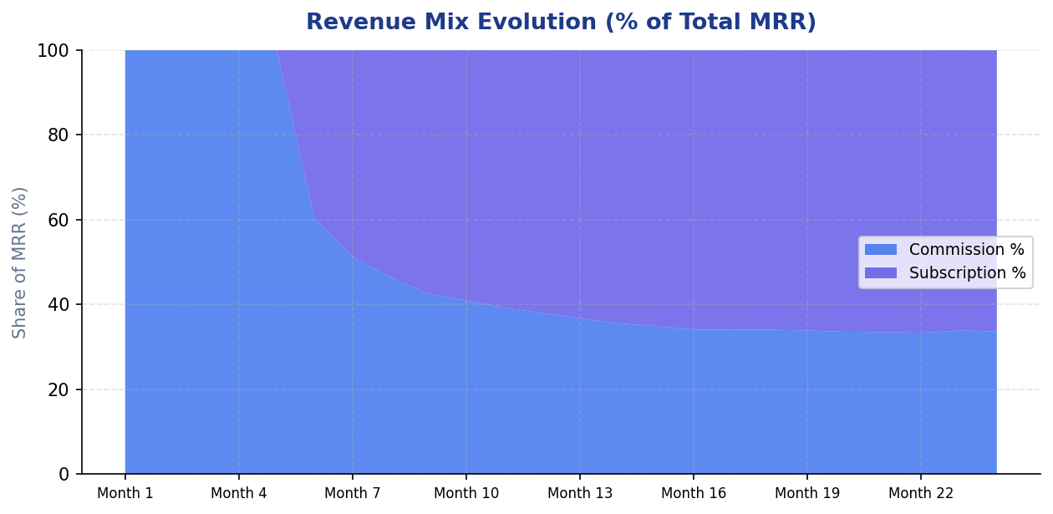
Figure 5 — Evolution of revenue mix: subscription share of MRR increases after paid plans launch (Month 7).
Three takeaways from these projections stand out for the project defence. Traffic and revenue feed each other: more visitors mean more bookings and commission income, which can fund marketing that brings more visitors. Subscription revenue steadies cash flow when job volume dips in winter. The Django and Redis stack can scale with more Gunicorn workers, PostgreSQL read replicas, and Redis partitioning without a full rewrite, so ProTech is built to grow beyond the academic demo.

2. System Design

2.1 Functional Architecture
ProTech adopts a three-tier architecture adapted for cloud-native container deployment. The presentation tier consists of HTML, CSS, and JavaScript templates rendered server-side by Django using a Jinja2 template backend, ensuring fast initial page loads and strong SEO characteristics without requiring a separate single-page application build pipeline.
The application tier is implemented as a Django 5.2.15 project partitioned into four domain applications: users (identity, profiles, messaging, notifications), bookings (scheduling and status workflow), reviews (ratings and reputation), and escrow (wallet and payment holds). Gunicorn serves the WSGI application with multiple worker processes; Nginx terminates HTTP on port 80 and proxies dynamic traffic to Gunicorn while serving static and media files from shared Docker volumes.
PostgreSQL 15 stores relational data; Redis 7 handles sessions and query caching. Django middleware checks security headers, sessions, CSRF tokens, and authentication on every request before any view runs. If authentication fails, the request is blocked rather than allowed through.

2.2 Architecture Diagram
The diagram below shows how a request moves through the ProTech stack. Each layer runs in its own Docker container, which keeps development, demo, and production deployments consistent.
PRESENTATION TIER
Web Browser → Nginx Reverse Proxy (port 80)
Serves static assets (/static/, /media/) and forwards dynamic requests to Gunicorn.
▼
APPLICATION TIER
Gunicorn WSGI → Django 5.2.15 Application
Apps: users · bookings · reviews · escrow | Middleware: Security, Session, CSRF, Auth
▼
DATA & CACHE TIER
PostgreSQL 15 (relational data) + Redis 7 (sessions & query cache)
▼
CROSS-CUTTING CONCERNS
Structured logging · RBAC decorators · Escrow ledger · Django Admin CMS
▼
DEPLOYMENT
Docker Compose: db · redis · backend · nginx | CI: GitHub Actions

2.3 Use Cases
The platform supports eleven primary use cases spanning registration, authentication, marketplace discovery, financial workflow, and administration. The table below summarises each actor interaction; full behavioural detail is implemented in the corresponding Django views and service modules.
ID | Use Case | Description
UC-01 | Register as Client | A visitor creates a client account with name, email, phone, and password, then signs in to access the client dashboard.
UC-02 | Register as Worker | A professional registers with skills, service area, and experience; the system creates a linked Worker profile.
UC-03 | Login and Logout | Users authenticate with email and password via a custom EmailBackend; sessions are stored in Redis in production.
UC-04 | Reset Password | Users request a secure reset link; Django's PasswordResetView delivers the token (console email in development).
UC-05 | Browse Workers | Clients search by skill, location, and minimum rating; results are served from Redis cache when available.
UC-06 | Book a Service | A client selects a worker and submits schedule, address, description, and price to create a pending booking.
UC-07 | Manage Bookings | Both parties advance status through pending, confirmed, in progress, completed, or cancelled states.
UC-08 | Fund Escrow | The client transfers wallet balance into platform escrow for a specific booking prior to work commencing.
UC-09 | Release or Refund Escrow | On completion, funds release to the worker minus platform fee; on cancellation, funds return to the client.
UC-10 | Leave Review | After completion, the client submits a star rating and comment; the worker's aggregate rating is recalculated.
UC-11 | Admin Management | Staff operate Django Admin to create, read, update, and delete users, categories, bookings, and ledger records.

2.4 Key Features and Data Model
Role-based access control is enforced through a custom user_type field on the extended User model and a @user_type_required decorator that redirects unauthorised role access before protected views render. Clients interact with browse_workers, favorites, and booking creation flows; workers interact with job acceptance, status updates, and wallet receipt flows. Superusers access Django Admin for content management without custom CMS development overhead.
The relational schema centres on User and Worker profiles, ServiceCategory taxonomy, Booking records linking clients to workers, Review entities tied one-to-one to completed bookings, and an escrow ledger comprising UserWallet balances, EscrowHold records per booking, EscrowVault aggregates, and WalletTransaction audit rows. Supplementary Message, Notification, Favorite, and WorkerAvailability models support engagement features that differentiate the platform from a minimal booking form.
The escrow payment workflow is central to client trust on the platform. The following process diagram summarises how funds move between the client wallet, the platform vault, and the worker wallet during a typical job lifecycle.
Step | Stage | Description
1 | Client deposits demo funds | UserWallet.available_balance increases via deposit_demo_funds().
2 | Client books a worker | Booking record created with status pending and payment_status pending.
3 | Client funds escrow | Wallet debited; EscrowHold created; vault.total_held updated.
4 | Worker completes job | Worker marks booking complete; release_escrow() runs automatically.
5 | Payout & fee | Worker receives amount minus platform fee (default 5%); transaction logged.
6 | Cancellation path | If cancelled while held, refund_escrow() returns full amount to client wallet.
Booking records progress through a finite state machine shared by clients and workers. The diagram below shows permitted transitions; escrow funding and release/refund hooks are tied to payment_status alongside operational status.
State | Who acts | Next states | Escrow interaction
pending | Worker | confirmed · cancelled | Client may fund escrow while pending.
confirmed | Worker | in_progress · cancelled | Escrow held if previously funded.
in_progress | Worker | completed · cancelled | Release on complete; refund on cancel.
completed | Client | — (terminal) | release_escrow() pays worker minus platform fee.
cancelled | Either party | — (terminal) | refund_escrow() if funds were held.

3. Implementation

3.1 Technology Choices
Technology selection balanced academic requirements, developer productivity, and production viability. Django was chosen over lighter micro-frameworks because its built-in admin, ORM, authentication, CSRF middleware, and migration system reduce boilerplate while demonstrating enterprise patterns expected in the module rubric. PostgreSQL provides ACID guarantees essential for booking and escrow integrity. Redis addresses session latency and repeat worker-list queries under concurrent load.
Component | Technology | Rationale
Back-end framework | Django 5.2.15 | Integrated ORM, admin CMS, security middleware, and mature deployment documentation.
API readiness | Django REST Framework 3.17 | Session-authenticated API layer prepared for future mobile or SPA clients.
Front-end | Django Templates (Jinja2) | Server-rendered pages reusing the existing ProTech HTML/CSS design system.
Database | PostgreSQL 15 | Relational integrity, indexing on bookings and messages, Docker health checks.
Cache / sessions | Redis 7 + django-redis | Sub-millisecond cache reads; production session backend with namespaced keys.
App server | Gunicorn 26 | Multi-worker WSGI process model suitable for CPU-bound Django view rendering.
Reverse proxy | Nginx Alpine | Static file offload, gzip-ready proxy headers, single public port 80.
Containers | Docker Compose 3.8 | Reproducible four-service stack for local demo and cloud deployment.

3.2 Application Structure
Source code is organised into Django applications that mirror business domains rather than technical layers, which keeps view functions discoverable and allows each app to own its models, admin registrations, and tests. The protech_project package holds cross-cutting configuration: settings with environment-driven secrets, URL routing that preserves legacy endpoint names for template compatibility, a Jinja2 environment shim exposing url_for and csrf_field helpers, cache utilities in cache_utils.py, and a JSON health endpoint for monitoring.
The users application implements authentication views, client and worker dashboards, profile and settings pages, messaging, notifications, and favorites. The bookings application owns creation, listing, and POST-driven status transitions including integration hooks into escrow release on completion. The reviews application handles post-job rating submission and cache invalidation when worker aggregates change. The escrow application encapsulates all monetary logic in services.py, keeping views thin and financial rules testable in isolation.

3.3 Security, Authentication, and Escrow
Authentication combines Django's session framework with a custom EmailBackend permitting login forms to accept email addresses as identifiers, matching user expectations set by consumer marketplace applications. Passwords are hashed with PBKDF2 through Django's default validators prohibiting common and entirely numeric passwords. Registration branches on form submission type to create either a client User or a User paired with a Worker row. Password reset reuses Django's tokenised email flow; development environments print reset URLs to the console while production can enable SMTP through environment variables without code changes.
Security controls address the OWASP-aligned requirements of the project brief. CsrfViewMiddleware validates tokens on every POST request; templates include csrf_field() on all mutating forms. The ORM parameterises queries, eliminating raw SQL injection surfaces in application code. Template auto-escaping mitigates reflected XSS; production settings enable HSTS, secure cookies, SSL redirect, and X-Frame-Options denial. Secrets including SECRET_KEY and database credentials reside exclusively in .env files excluded from version control via .gitignore, with separate .env.dev.example and .env.prod.example templates documenting required variables.
The escrow subsystem implements an internal ledger in escrow/services.py. Clients deposit demonstration funds into UserWallet rows, transfer booking amounts into EscrowHold records, and trigger release or refund operations that update WalletTransaction audit trails and EscrowVault aggregates. A configurable platform fee (ESCROW_PLATFORM_FEE_PERCENT, default five percent) is deducted on worker payout. All mutations execute inside database transactions with Decimal quantisation to prevent floating-point rounding errors. The service interface is intentionally structured so a production deployment could swap the ledger backend for Stripe Payment Intents and Connect webhooks without rewriting view layers.

3.4 Caching and Logging
Caching is implemented in protech_project/cache_utils.py using Django's cache framework backed by Redis in production. Worker search results are cached for three hundred seconds keyed by a hash of filter parameters; service category lists cache for six hundred seconds. When a new review alters worker rating aggregates, invalidate_workers_cache() clears stale entries. Continuous integration sets USE_LOCMEM_CACHE so automated tests execute without a live Redis daemon, demonstrating environment-aware configuration rather than hard-coded infrastructure assumptions.
Logging configuration in settings.py defines verbose formatters writing simultaneously to stdout and logs/django.log. Dedicated loggers for the users, bookings, and escrow applications allow operators to tune verbosity per domain via the DJANGO_LOG_LEVEL environment variable. View and service modules emit INFO records for successful authentication and booking transitions, WARNING records for failed login attempts, and ERROR records for escrow exceptions, supporting post-incident diagnosis during project defence questioning.

3.5 Application Interface (Screenshot Placements)
The ProTech interface uses server-rendered Django templates with responsive HTML and CSS. Screenshots in this report show that the application works as described. The three placeholders below cover the main entry points; Appendix C lists fourteen more. To capture your own, run docker compose up, open http://localhost, log in with the demo credentials in Appendix B, and save PNG images at 1280×720 or higher.
FIGURE 6 — Landing Page (Home)
[ INSERT SCREENSHOT HERE ]
Page: Landing Page (Home)
URL: http://localhost/
Word: click here → Insert → Pictures (or drag your image in)
Full-width hero, feature highlights, and primary Sign Up / Find a Professional CTAs.
FIGURE 7 — Client Dashboard
[ INSERT SCREENSHOT HERE ]
Page: Client Dashboard
URL: http://localhost/user/dashboard/
Login: john@example.com / password123
Word: click here → Insert → Pictures (or drag your image in)
Upcoming bookings, quick actions, sidebar navigation, and notification badges.
FIGURE 8 — Worker Dashboard
[ INSERT SCREENSHOT HERE ]
Page: Worker Dashboard
URL: http://localhost/worker/dashboard/
Login: mike@example.com / password123
Word: click here → Insert → Pictures (or drag your image in)
Pending requests, today's schedule, earnings summary, and job actions.
Screenshots for booking, escrow, wallet, reviews, messaging, and Django Admin are in Appendix C. Click inside each dashed box in Word, then Insert → Pictures, or drag your image onto the placeholder.

4. Testing and Deployment
Quality assurance follows a pragmatic test pyramid. Unit tests in each Django application validate model constraints, password hashing, and relationship integrity. Integration tests in users/tests_integration.py exercise the health endpoint, email login redirect, role-based access denial, and password reset page availability. Escrow integration tests confirm that funding a booking correctly debits the client wallet and sets payment_status to escrow_held. At the time of writing, seventeen automated tests pass when executed via python manage.py test with USE_LOCMEM_CACHE enabled.
GitHub Actions workflow ci.yml runs on every push to the main branch. The pipeline installs Python dependencies, executes flake8 critical-error checks, applies migrations against an ephemeral PostgreSQL service container, runs the full Django test suite, and verifies the /health/ endpoint responds with status ok. This continuous integration gate prevents regressions from reaching the deployment branch and provides evidence of professional software practice for academic assessment.
Local and demonstration deployment uses Docker Compose. The db service runs postgres:15-alpine with volume-backed persistence and pg_isready health checks. The redis service provides cache and session storage. The backend service builds from Dockerfile.backend and executes docker-entrypoint.sh, which runs migrations, collects static files, seeds demonstration accounts when the database is empty, and starts Gunicorn. The nginx service listens on port eighty, proxies application traffic, and serves staticfiles and media volumes directly for efficiency.
Service | Image / Build | Port | Responsibility
db | postgres:15-alpine | 5432 | Primary relational datastore with health checks.
redis | redis:7-alpine | 6379 | Cache backend and production session store.
backend | Dockerfile.backend | 8000 | Django application via Gunicorn and entrypoint script.
nginx | nginx:alpine | 80 | Public HTTP entry point, reverse proxy, static file server.
An evaluator starts the complete stack with docker compose up --build and accesses the application at http://localhost, the admin console at http://localhost/admin, and the health probe at http://localhost/health/. Cloud deployment options documented in the README include Railway and Render blueprints; production hardening requires DEBUG=False, strong SECRET_KEY rotation, ALLOWED_HOSTS restriction, HTTPS termination, and SMTP configuration for password reset delivery.

5. Conclusion and Literature
ProTech meets the full-stack website development brief with a working marketplace, two user roles, admin content management, escrow payments, Docker deployment, Redis caching, logging, and automated tests. Cloning the repo and running Docker Compose gives a fully interactive demo for the eight-to-ten-minute presentation and technical defence.
A few lessons came out of the build. Splitting Django apps by business area (users, bookings, escrow) stayed manageable as features grew; one big views file would not have. Moving from an earlier Flask prototype meant adding a Jinja2 layer so url_for and flash messages still worked — a reminder that framework changes cost real time. Escrow needed Decimal types and database transactions; floats would have caused rounding bugs. Running migrations and seed data in the Docker entrypoint made first-run much smoother for anyone testing the project.
Future development should integrate a licensed payment service provider for regulatory compliance, add WebSocket or Celery-driven real-time notifications, expand browser-based end-to-end tests with Selenium or Cypress, and optionally expose a React front end consuming Django REST Framework endpoints. Geolocation-aware worker matching, calendar synchronisation, and two-factor authentication represent further enhancements that would move the platform toward commercial viability.
The following references informed architectural, security, and deployment decisions throughout the project.
[1] Django Software Foundation. Django Documentation (v5.2). https://docs.djangoproject.com/
[2] Django REST Framework. API Guide and Authentication. https://www.django-rest-framework.org/
[3] PostgreSQL Global Development Group. PostgreSQL 15 Documentation. https://www.postgresql.org/docs/
[4] Redis Ltd. Redis Documentation. https://redis.io/docs/
[5] Docker Inc. Docker Compose Specification. https://docs.docker.com/compose/
[6] OWASP Foundation. OWASP Top Ten Web Application Security Risks. https://owasp.org/www-project-top-ten/
[7] Mozilla Developer Network. Web Security (CSRF, XSS). https://developer.mozilla.org/en-US/docs/Web/Security
[8] Nginx Inc. NGINX Admin Guide. https://nginx.org/en/docs/
[9] Fielding, R. T. (2000). Architectural Styles and the Design of Network-based Software Architectures.
[10] Fowler, M. (2002). Patterns of Enterprise Application Architecture. Addison-Wesley.

Appendix A — Project Structure
The repository root contains Django project configuration, application modules, deployment assets, and continuous integration definitions. Legacy Flask modules (app.py, auth.py) remain for reference but are superseded by the Django stack described in this report.
Path | Purpose
manage.py | Django management entry point for migrations, tests, and runserver.
protech_project/ | Settings, URLs, Jinja2 environment, cache utilities, health view.
users/ | Custom User model, authentication, dashboards, messaging, notifications.
bookings/ | Booking creation, listing, and status workflow views.
reviews/ | Post-job ratings and review listing.
escrow/ | Wallet views and escrow/services.py ledger implementation.
templates/ | Server-rendered HTML templates and registration email bodies.
nginx/nginx.conf | Reverse proxy and static file routing rules.
docker-compose.yml | Four-service orchestration manifest.
Dockerfile.backend | Production Django image build instructions.
docker-entrypoint.sh | Migrate, collectstatic, seed_demo, and Gunicorn startup.
.github/workflows/ci.yml | Automated lint, migrate, test, and health-check pipeline.

Appendix B — Demo Credentials
Demo accounts are created by python manage.py seed_demo or automatically on first Docker start. Use them to walk through client and worker flows during the defence without setting up data by hand.
Role | Email | Password | Dashboard URL
Client | john@example.com | password123 | /user/dashboard/
Worker | mike@example.com | password123 | /worker/dashboard/
Admin | (created via createsuperuser) | (chosen at setup) | /admin/

Appendix C — Application Screenshots (Insert Images)
This appendix leaves space for screenshots of every major ProTech screen. The dashed blue border marks where each image goes. To fill them in: start the app with docker compose up, open the URL shown in each figure, capture the screen (Win+Shift+S on Windows, Cmd+Shift+4 on Mac), click inside the placeholder in Word, and insert the image. Resize to fit the frame while keeping the aspect ratio. Good screenshots make the project defence much easier to follow.
Category | Screenshots to capture | Demo login
Public pages | Home, Auth, Pricing, FAQ | None required
Client journey | Dashboard, Browse, Book, Bookings, Wallet, Escrow, Review | john@example.com / password123
Worker journey | Dashboard, Bookings, Messages | mike@example.com / password123
Administration | Django Admin — Users, Bookings | Superuser account

Appendix C — Public & Marketing Pages
FIGURE 9 — Landing Page (Home)
[ INSERT SCREENSHOT HERE ]
Page: Landing Page (Home)
URL: http://localhost/
Word: click here → Insert → Pictures (or drag your image in)
Full-width hero, feature highlights, and primary Sign Up / Find a Professional CTAs.
FIGURE 10 — Authentication
[ INSERT SCREENSHOT HERE ]
Page: Authentication
URL: http://localhost/auth/
Word: click here → Insert → Pictures (or drag your image in)
Login, client signup, and worker signup tabs with form validation.
FIGURE 11 — Pricing & Escrow Info
[ INSERT SCREENSHOT HERE ]
Page: Pricing & Escrow Info
URL: http://localhost/pricing/
Word: click here → Insert → Pictures (or drag your image in)
Landing sub-page explaining platform fees and escrow protection.
FIGURE 12 — FAQ Page
[ INSERT SCREENSHOT HERE ]
Page: FAQ Page
URL: http://localhost/faq/
Word: click here → Insert → Pictures (or drag your image in)
Frequently asked questions for clients and workers.

Appendix C — Client User Journey
FIGURE 13 — Client Dashboard
[ INSERT SCREENSHOT HERE ]
Page: Client Dashboard
URL: http://localhost/user/dashboard/
Login: john@example.com / password123
Word: click here → Insert → Pictures (or drag your image in)
Upcoming bookings, quick actions, sidebar navigation, and notification badges.
FIGURE 14 — Browse Workers
[ INSERT SCREENSHOT HERE ]
Page: Browse Workers
URL: http://localhost/workers/
Login: john@example.com / password123
Word: click here → Insert → Pictures (or drag your image in)
Search filters by skill, location, and rating; worker cards with Book action.
FIGURE 15 — Book a Worker
[ INSERT SCREENSHOT HERE ]
Page: Book a Worker
URL: http://localhost/book/<worker_id>/
Login: john@example.com / password123
Word: click here → Insert → Pictures (or drag your image in)
Booking form: date, time, address, description, and price fields.
FIGURE 16 — My Bookings
[ INSERT SCREENSHOT HERE ]
Page: My Bookings
URL: http://localhost/bookings/
Login: john@example.com / password123
Word: click here → Insert → Pictures (or drag your image in)
Booking list with status badges, escrow pay, complete, and review actions.
FIGURE 17 — Wallet
[ INSERT SCREENSHOT HERE ]
Page: Wallet
URL: http://localhost/wallet/
Login: john@example.com / password123
Word: click here → Insert → Pictures (or drag your image in)
Demo deposit form, available balance, and transaction history.
FIGURE 18 — Escrow Payment
[ INSERT SCREENSHOT HERE ]
Page: Escrow Payment
URL: http://localhost/booking/<id>/escrow/
Login: john@example.com / password123
Word: click here → Insert → Pictures (or drag your image in)
Pay-into-escrow confirmation showing amount and platform fee.
FIGURE 19 — Leave a Review
[ INSERT SCREENSHOT HERE ]
Page: Leave a Review
URL: http://localhost/review/<booking_id>/
Login: john@example.com / password123
Word: click here → Insert → Pictures (or drag your image in)
Star rating and comment form after job completion.

Appendix C — Worker User Journey
FIGURE 20 — Worker Dashboard
[ INSERT SCREENSHOT HERE ]
Page: Worker Dashboard
URL: http://localhost/worker/dashboard/
Login: mike@example.com / password123
Word: click here → Insert → Pictures (or drag your image in)
Pending requests, today's schedule, earnings summary, and job actions.
FIGURE 21 — Worker Bookings
[ INSERT SCREENSHOT HERE ]
Page: Worker Bookings
URL: http://localhost/bookings/
Login: mike@example.com / password123
Word: click here → Insert → Pictures (or drag your image in)
Incoming jobs with Accept, Start, and Complete controls.
FIGURE 22 — Messages
[ INSERT SCREENSHOT HERE ]
Page: Messages
URL: http://localhost/messages/
Login: mike@example.com / password123
Word: click here → Insert → Pictures (or drag your image in)
In-app messaging between client and worker.

Appendix C — Administration (Django Admin)
FIGURE 23 — Django Admin — Users
[ INSERT SCREENSHOT HERE ]
Page: Django Admin — Users
URL: http://localhost/admin/users/user/
Login: Superuser account
Word: click here → Insert → Pictures (or drag your image in)
Staff interface for managing accounts, roles, and permissions.
FIGURE 24 — Django Admin — Bookings
[ INSERT SCREENSHOT HERE ]
Page: Django Admin — Bookings
URL: http://localhost/admin/bookings/booking/
Login: Superuser account
Word: click here → Insert → Pictures (or drag your image in)
CRUD view of all platform bookings and payment statuses.
After inserting images, right-click → Wrap Text → In Line with Text or Square, then resize to stay inside the placeholder. Use Picture Format → Picture Border if you want a consistent look across figures.

