Logan Farwick

IT3045C

Prof. Nicholson

30 November 2021

Assignment 13 Lab Report

This program is as stated, it works without any modification from me or anyone else. It currently runs almost twice as fast in parallel, as is shown in the screenshot below:

For this assignment, while the program works, the assignment is to modify the parallel end of things, and to change the way it works. Currently, it runs on three threads, and the assignment is to up that to four threads. To do so, you must edit a couple lines of code, and add a few more.

For starters, I modified the ‘widthOneThird’ variable, renamed it to ‘widthOneFourth’ and then changed the way it is calculated to divide the width by 4 instead of 3, all on line 60. We then repeat these steps but with the ‘heightOneThird’ variable on line 61 and make it ‘heightOneFourth’.

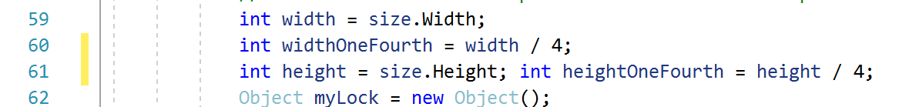

Next, you must add another rectangle and bitmap. To do so, mimick the previous ones made, and add them a line below. Also, you must edit the ones made before to match the new variable names.

Next, we must add another Action, so you must duplicate one of the three that are on lines 76-121. You must also change the bitmap being used to ‘bitmap04’.

We then must add another Rectangle, ‘targetRectangle04’, off the basis of the first three above it. Also, you must modify the first three above it and the ‘sourceRectangle’ on lines 140-143 to fit the new terminologies. After doing so, you must also add another ‘CopyRegionIntoImage()’ with the modifications being ‘bitmap04’ and ‘targetRectangle04’.

Finally, we must save ‘bitmap04’:

Now the code has been fully modified, and we can show the difference in the speed of the program.

We have cut off around 200 milliseconds, and have been able to do so by increasing the efficiency of the program by adding a 4th thread. Doing so, has made it so the same amount of work is being done, but by splitting it up even more so, we are reducing the time needed for each section of the threading in total.

Also, we can see the changes made to the image,

Original:

New:

And here are the slices of the above image to showcase the threads

