**Text Box contents**

1. The gatepost and the trees are nearly all that’s left of the world of 106 Pennywell Road where I lived and played. The gatepost still stands, still bears the faint traces of the painted number. The maples are bigger than they were fifty years ago but still recognizable. The two trees nearest the gatepost were the easiest to climb, and my friend and I spent many hours perched there.

The gravel driveway circled the house, a remnant of the house’s grander days. Once we had a car, we drove in and branched to the right, parking the car in a layby towards the back of the house. Behind the front gateposts, I would sketch a hopscotch grid in the gravel; I became very adroit at singling out my game stone from all the surrounding rocks.

Today it is all gravel where the house stood, and cars and taxis use it as a parking lot.

1. Past the two comfortable trees, a big grassy yard was fenced in. Three further trees edge Pennywell Road; Linscott Street climbs up the eastern flank of the yard. This yard was called the Green Gate, and we shared it with the family from downstairs, 108. A half-built playhouse stood between two trees; it lacked most of the qualities and amenities of playhouses in my storybooks and was always damp.

On the eastern side of the Green Gate, along Linscott Street, there was a little plantation of evergreen trees, fenced in with wire. I believe this was some money-making scheme on the part of a member of the school board, but even as a child I could not understand who would buy evergreen trees in Newfoundland. We were not supposed to go in there, but if the little chicken-wire gate stood ajar as sometimes happened, we would sneak inside. It smelled fresh in there, and it was easy to play being in the forest – but because it was deeply illicit to be there, only one of us at a time ever entered.

1. Dad built two swings and a seesaw inside the Green Gate, and we all spent hours on the swings in particular. The Green Gate was also home to many of our running games: tag, frozen tag, baseball. The boys played soccer and sometimes ball hockey (though the surface was very unsatisfactory for that). Along the northern fence of this yard, Dad planted a very successful flower border, and spent a lot of time cosseting his flowers. We always knew he was a farmer’s son.
2. Next to the Green Gate was a tussocky wilderness known (correctly) as the Thistle Yard. It was swampy, except for a small and lumpy hillock towards the east. It was hard to play any games there; running was difficult and it was indeed full of thistles – but it served as scenery for the games of cowboys we played alongside. It took little imagination to turn thistles into cacti.
3. To the north of the Thistle Yard a small slope rose to a little path, with a larger hill rising to the soccer pitch beyond. On this path we galloped endlessly as cowboys. Down the hill we rolled, somersaulted, tobogganed. The car was parked back here and in a deluxe snowstorm it could be completely covered, allowing us the opportunity to dig tunnels through the drifts that piled up against it.
4. We played in the soccer pitch only occasionally. It was almost too big for us. The field was surrounded by a single-bar fence, however, and we did somersault over and dangle under that fence, the closest we came to any kind of monkey bars. There was a fairly ramshackle grandstand to the north of the soccer pitch and we climbed up and down its steps and seats. I don’t remember many organized games there. Steps built into a slope would take us up yet another hill to a second soccer pitch, but we almost never went that far afield. As we got older, we occasionally tobogganed down that second hill; it was bigger than our own little local slope.
5. To the west of the house lay the “tennis court.” In our time, it was utterly dilapidated; a pothole-strewn wreck of old asphalt. In this general area we played “Old Mother Witch,” a running game that we could have played in the Green Gate but never did (<http://halloween-party-fun.com/games/oldmotherwitch.htm>). For some reason it was also ironclad that if we played our versions of Grandmother’s Footsteps (<http://www.playgroundfun.org.uk/GameRules.aspx?gameVersionID=45&random=1>) or Mother May I? (<http://www.gameskidsplay.net/games/mental_games/mother_may_i.html>) or Simon Says (<http://en.wikipedia.org/wiki/Simon_says>), it was on the tennis court. Perhaps because they were playground games, we chose to play them in the closest thing we had to a playground space. Our cowboy games were media-related, our baseball games conformed to externally set rules, but these games in the tennis court came straight out of children’s oral culture. Presumably they were passed on to us by older kids in the neighbourhood; I don’t remember (which is probably as it should be!)
6. To the south of the tennis court, there was a changing house known grandly as the Pavilion. It had a main floor doorway and a set of external steps up to the second floor (presumably in the cause of segregating the sexes but as I never saw the inside, I do not know). On the bigger flight of stairs we played Shipwreck; the details of this game now completely escape me, nor can I account for its provenance.
7. Finally, to complete the loop we return to our front door, which stood at the side of the house. A few steps led up to our door and my friend and I would affix one end of a skipping rope to the newel post and take turns skipping. There were only two of us, and the boys wouldn’t skip on any account, so we had to compromise in this way.

To the side of our entryway was a separate shed called the oilhouse where our domestic heating oil was delivered into big tanks, to be carried bucket by bucket up the twisting back stairs to fill the insatiable demands of the kitchen stove and the hall heater. At the foot of those stairs was the coal room, and a little oilyard was fenced in, ostensibly to keep children out of all this risky and dirty territory. Any play inside the oilyard was utterly forbidden, so our games there were quiet and furtive – and often short.

**Photo captions**

* 106 Pennywell Road taken from the Green Gate looking west. The door in the centre of the picture was our main entrance. The middle gable window on the front of the house was my bedroom window.
* Coady’s farmhouse on Pennywell Road (date and photographer not known) – our home in its previous identity. I wish I had seen this picture as a child. The house seems to be one dwelling rather than two at this point and it is not clear how much of the back part of the building has been added. The bay windows and verandah had been dismantled by our time (possibly because of problems with leaks). Photo courtesy of Shane O’Dea, St. John’s, Newfoundland.
* The Green Gate, taken from a bedroom window, looking east. Note the swings and seesaw, and the little evergreen plantation at the back of the fenced-in garden. This photograph was taken by me with the camera I received for Christmas the year I was 9. The houses of Linscott Street are in the background.
* The Green Gate, taken from a bedroom window, looking southeast. The gravel driveway is in the bottom right corner of the photo. This photograph was taken by me with the camera I received for Christmas the year I was 9.
* The Thistle Yard (foreground) and Green Gate (middle ground) taken from the hill by the soccer pitch, looking south. The houses of Pennywell Road are in the background and the Southside Hills lie beyond. This photograph was taken by me with the camera I received for Christmas the year I was 9.
* Two photos of the apple trees between our house and the tennis court, looking west from the kitchen window. This artistically matched pair of pictures was captured by my mother sometime between 1951 and 1954.

**]**

**Additions to the cowboy collection**

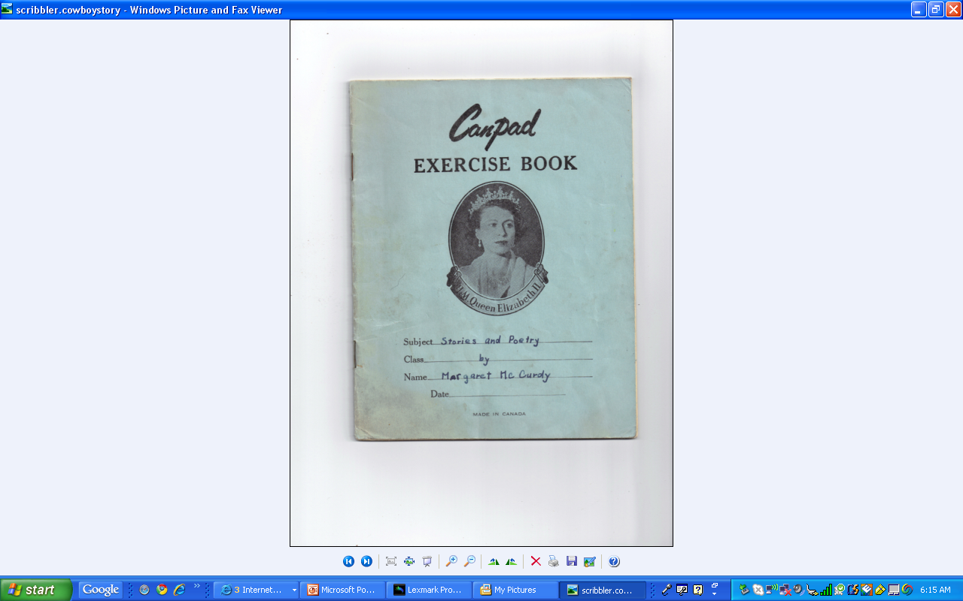

.

In 1960, at the age of 12, I wrote a collection of stories and poems for a present for my parents on their 17th wedding anniversary.

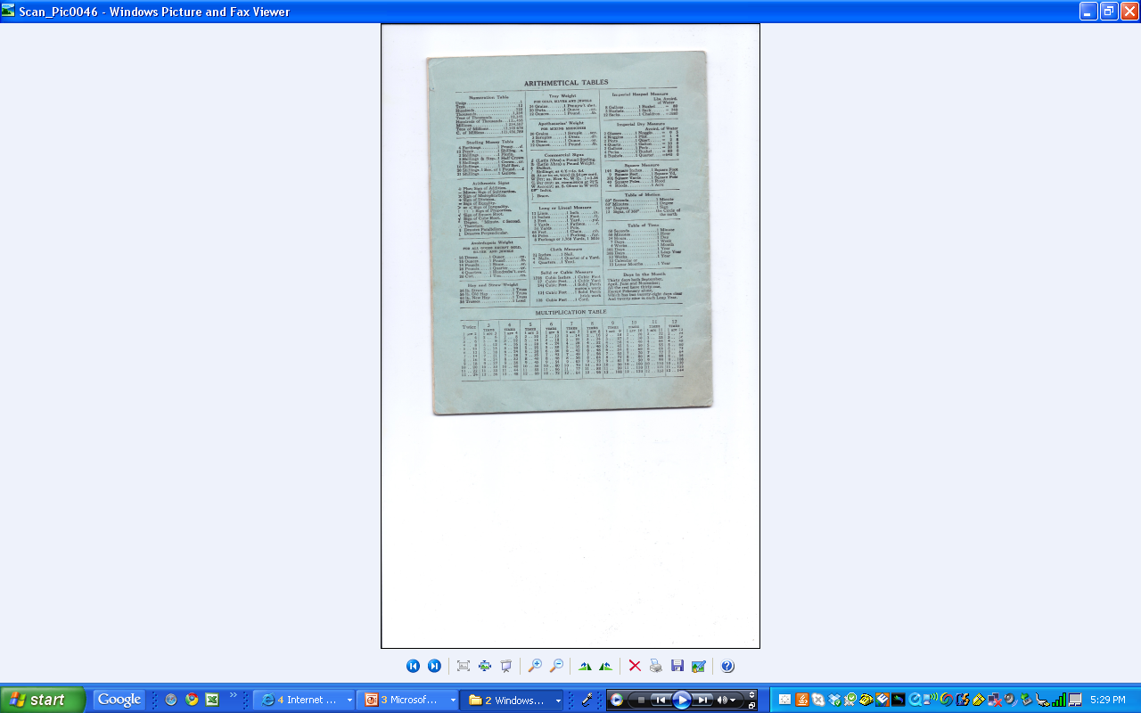

The exercise book was made in Canada but carried a picture of the Queen on the front, and, on the back, the tables of weights and measures were all British rather than North American.

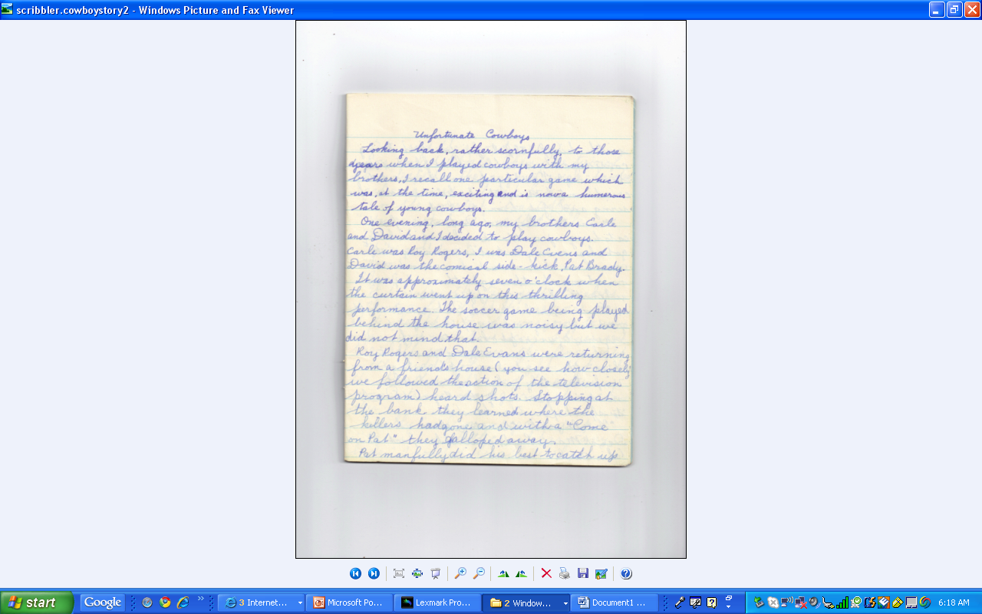

One story was based on the American world of Roy Rogers and Dale Evans, and describes my brothers and me playing our cowboy games along the path at the edge of the Thistle Yard: “Meanwhile Roy and Dale were fast catching up with the bandits. They got close enough to their enemies to crawl on hands and knees and then on stomachs through the wet grass when the ‘bads’ disappeared.”

The story was written with my school fountain pen in washable blue ink (the only ink we were allowed to use). My understanding of the importance of page design was clearly non-existent.

**The complete story**

**Unfortunate Cowboys**

Looking back, rather scornfully, to those years when I played cowboys with my brothers, I recall one particular game which was, at the time, exciting and is now a humerous tale of young cowboys.

One evening, long ago, my brothers Earle and David and I decided to play cowboys. Earle was Roy Rogers, I was Dale Evens, and David was the comical side-kick Pat Brady.

It was approximately seven o-clock when the curtain went up on this thrilling performance. The soccer game being played behind the house was noisy but we did not mind that.

Roy Rogers and Dale Evans were returning from a friend’s house (you see how closely we followed the action of the television program) heard shots. Stopping at the bank they learned where the killers had gone and with a “come on Pat” they galloped away.

Pat manfully did his best to catch up with his faithful friends but being considerably smaller his efforts were to no avail. Finally he sat down and cried until Mum took him under her wing and put him to bed.

Meanwhile Roy and Dale were fast catching up with the bandits. They got close enough to their enemies to crawl on hands and knees and then on stomachs through the wet grass when the “bads” disappeared.

“Come on,” whispered Dale and with great cunning and carefulness and ingenuity we crept closer to our friends.

Soon we were close enough to hear the wicked men planning. Unfortunately, lack of candidates made it necessary for Roy and Dale to speak for the bandits.

“We’ll rob the stage at er-uh-er Dead Man’s Rock,” said the first bandit (alias Earle).

“O.K.” said the second one (me).

Roy looked at Dale. Then the two of them leaped on the gang, and, single-handed, each conquered at least five.

“I’m the smartest,” boasted Roy.

“You’re not, I am,” insisted Dale.

“I am!”

“You’re not! I am!”

“I am!”

“I am!”

Whereupon the two justice-seekers fell into a fist fight. The suspence was at its height as to who was going to win when some ambitious soccer player sent the ball soaring over the fence right into the middle of our fight. It knocked the breath out of us and for a few moments we sat glaring at each other.

Finally Earle managed to gasp: “I guess we both caught as many bads.” I nodded breathlessly.

A roll of thunder brought us both to our feet. The football players glanced at the sky in consternation, but Roy and Dale, capturers of several thousand bandits, heeded them not as they dashed blindly to the house amid the rain that followed. Frightened and trembling, we reeled into the house where we were scolded roundly for playing in the wet grass and sent to bed.

(spelling as in the original)