Capillary migration of large confined drops in super-hydrophobic wedges

Experiments conducted in the drop tower start with the volume of fluid resting under gravity on a horizontal, hydrophobic surface. A similar surface is held above and just slightly in contact with the droplet as depicted by Fig. 1. Following the release of the experiment and a short re-orientation period, the trailing and leading edge menisci initial locations, identified in Fig. 2 as *Xo,t*and *Xo,l* respectively, are measured by the known geometry of the system. The droplet location is then tracked by these same menisci as a center of mass approximation has not yet been determined. Relevant parameters and fluid properties are given in Table I.

|  |  |  |  |  |  |  |  |  |  |
| --- | --- | --- | --- | --- | --- | --- | --- | --- | --- |
| TABLE I. Test parameters (left) and fluid properties (right) for drop tower experiments conducted using distilled water. | | | | | | | | | |
| Test | *V* (mL) | *α* (°) | *Xo,t*  (cm) | *Xo,l* (cm) |  | *σ*  (mN/m) | *ρ* (kg/m3) | *θstatic*  (°) | *μ* (mPa s)1 |
| 1 | 3 | 1.2 | 22.6 | 27.2 |  | 72.15 | 968.8 | 151 | 0.9 |
| 2 | 4 | 3.8 | 3.7 | 6.4 |  |  |  |  |  |
| 3 | 6 | 3.8 | 3.6 | 7.5 |  |  |  |  |  |
| 1. Engineering Tool Box | | |  |  |  |  |  |  |  |

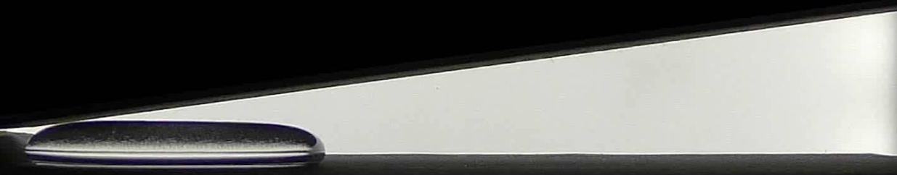

FIG. 1. A droplet of known volume is deposited on a super-hydrophobic surface and held in place by gravity prior to micro-gravity testing.

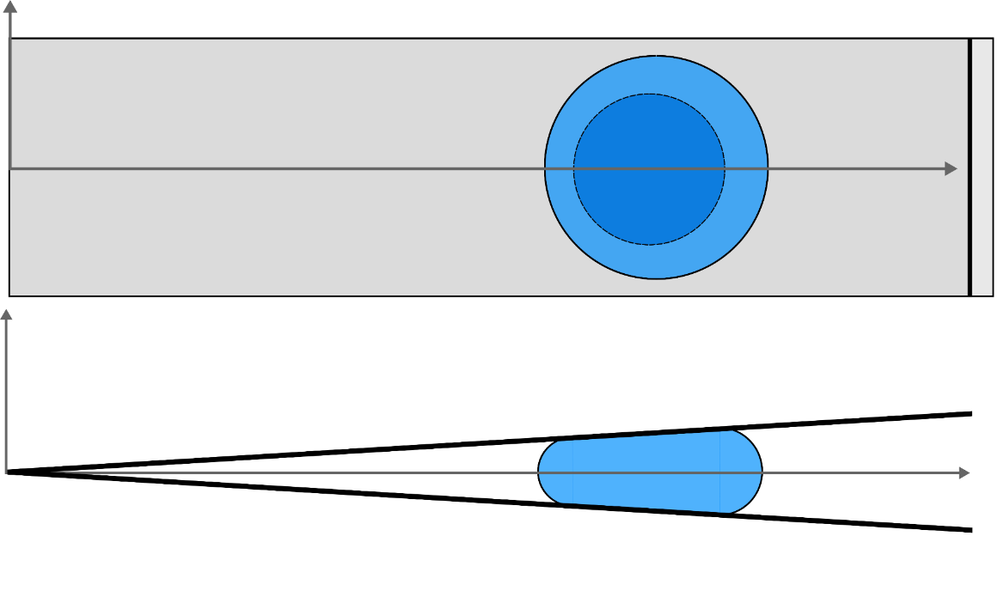

*Xo,l*

*Xo,t*

*x*

*y*

FIG. 2. Immediately following the initiation of the drop test, the droplet reforms into a wedge like shape where the leading and trailing menisci are recorded as *Xo,t*and *Xo,l*.