**Hysteresis:**



**To: excel sheet**

* Measured and averaged the advancing and receding angles for top and bottom of droplet.
* Computed the difference in the cosines of each angle (Ave. ad. for top/ bottom; Ave. rec. for top/ bottom).
* Finally divided by the cosine of the average between the advancing and receding (static CA?)

1.5 degrees 2mL

7.6 degrees 4mL

**Threshold vs Center of Volume**

**Volume Adjustment**

Assuming: droplet can be separated into two main sections: (1) inner, sliced cylinder and (2) outer pinched/squeezed torus represented as conical frustum.

**Volume of a sliced cylinder: [1]**

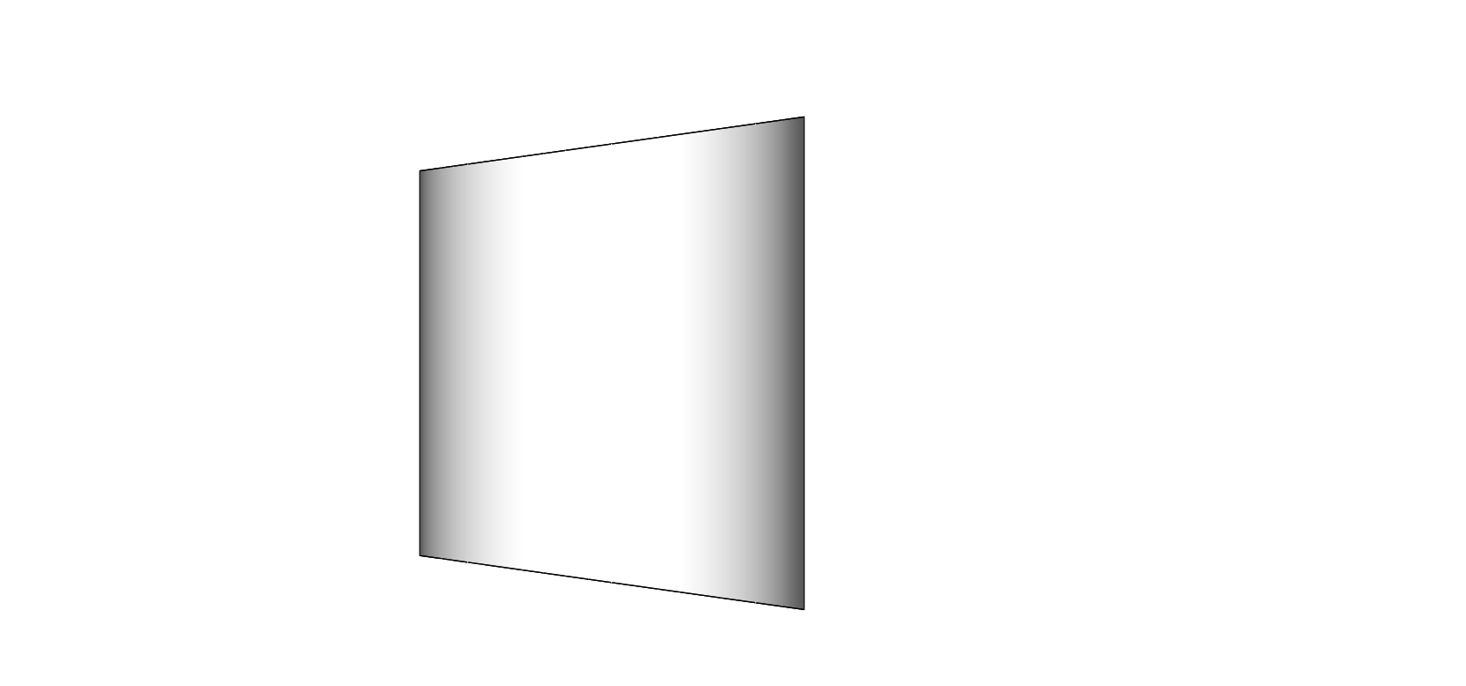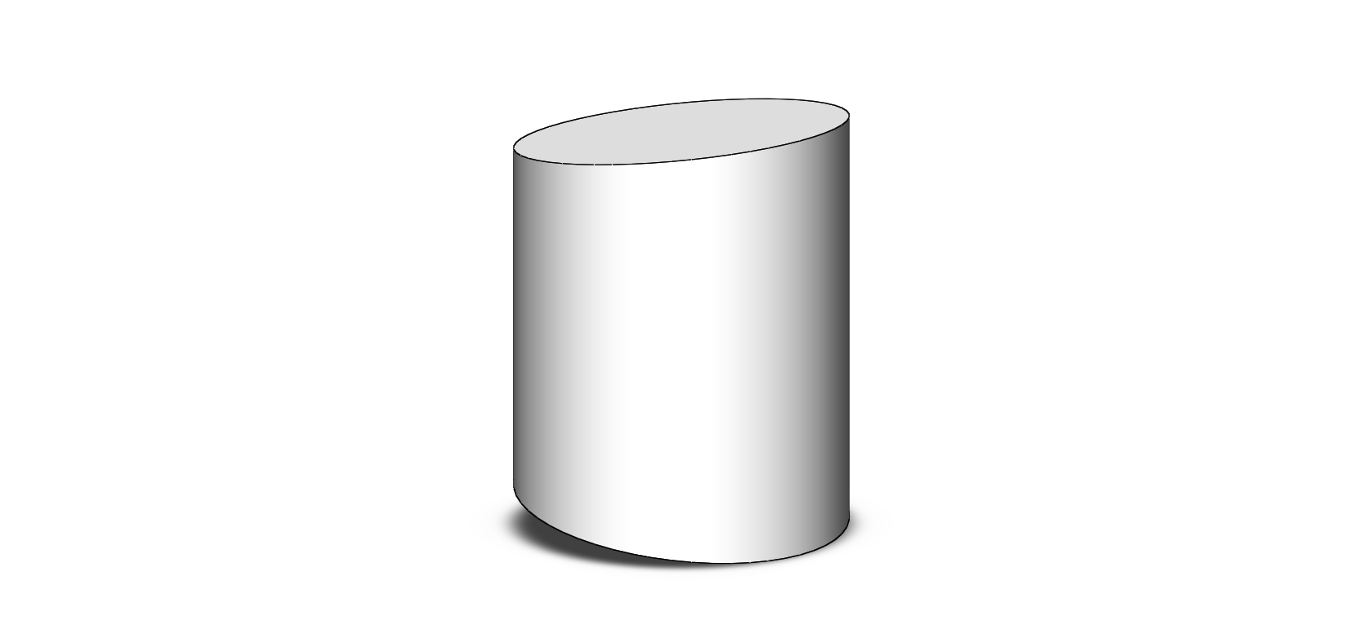

2*r*1

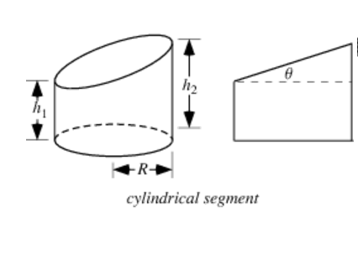

* x = distance from wedge vertex to cylinder centerline

**Volume of a conical frustum[2]:**



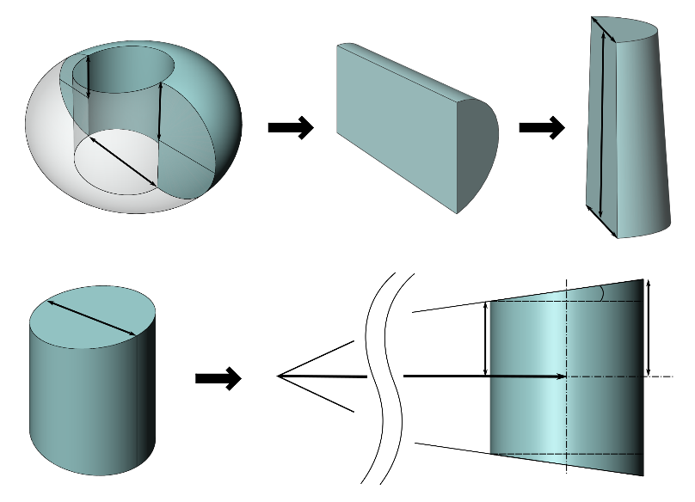

2r­1

x(t)

α

r­2

r­1

2r­3

2r­2

πr­3

2r­3

r­2

r­1

A half-torus can be represented as a conical frustum sliced in half vertically (or in a partial section as accounted for) with height =

* R1 = *r*1
* R2 = *r*2
* h = (arc length for one half of torus)
* (Top and bottom correction factor for contact angle)
* (Only accounting for a vertical cut of cone see figures above)
* (For *β <* : breaks down as droplet gets close to inscribe location)

Note:

**Substituting and simplifying**



**Total volume including cylinder and torus:**

**Using results in cubic polynomial for dependent variable r3**

Exact

**Using *V*torus_approx in limit of results in quadratic for dependent variable r3**

Approximate

**Approximate: solving for r3 in terms of x, β, α, and V and taking the positive value.**

* *see plot below for* ***exact r3*** *vs.* ***approx. r3***

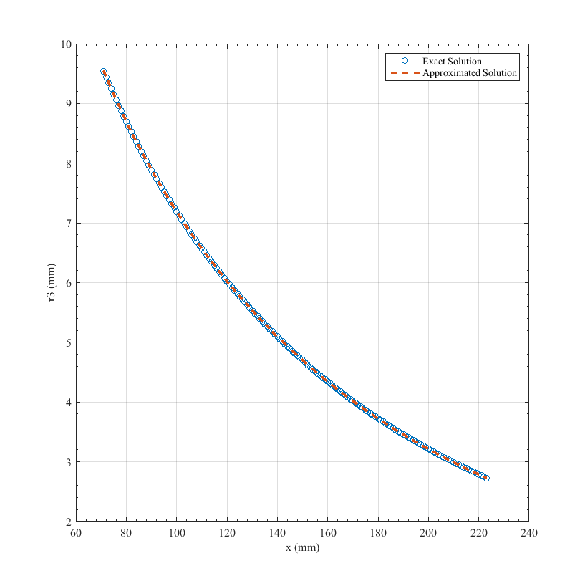

V = 2mL

α = 2°

β = π/2, θ = 180°

x0 = 71mm (distance to capillary height @ α = 2°)

xfree drop = 223mm

**Velocity/Re**

**To: excel sheet**

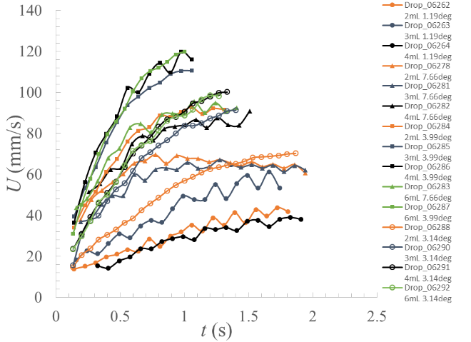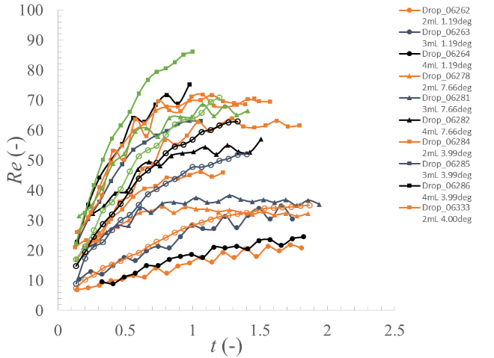

**Skipping every 4 frames**

**Free-Drop data eliminated, log-log slope values for x0 = 0.**



1. http://mathworld.wolfram.com/CylindricalSegment.html
2. http://mathworld.wolfram.com/ConicalFrustum.html