CIS 41A - Lab 3: loops and if statements

This assignment is a combination of textbook P4.55 and P4.52.

Write a program that turns a rectangular color image into a round black and white image.  
Here's an input image and the output image  
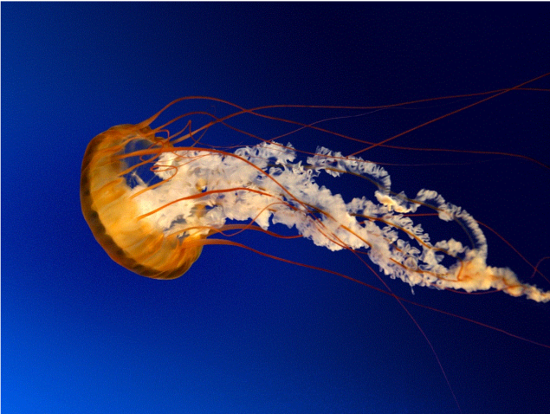 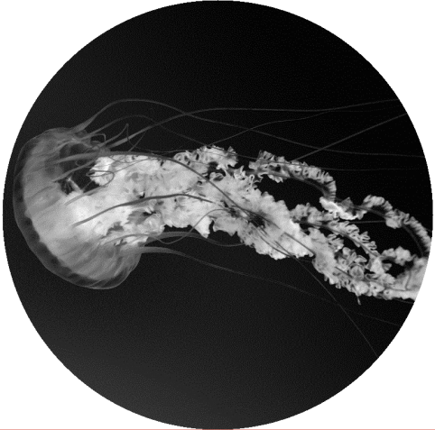

The images given for this lab are: the same queen-mary.gif that is in module 3 exercise, and a jellyfish.gif shown above. They're in the lab3.zip file.

Suggested steps for your program

1. Read in the image.
2. Find the height and the width of the image. Then use the smaller of the height and width to calculate the radius of the output image. In the example above, the height is smaller than the width, therefore the circular image has the same diameter as the height.
3. Walk through each pixel of the image, and for each pixel that's:  
   - farther from the center of the image than the radius, set the color of the pixel to white.  
    The formula for calculating distance of a pixel from the center of the image is:

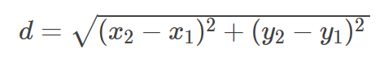

where (x1,y1) is the current location of the pixel and (x2, y2) is the center location of the image

- closer or equal to the radius, set the color of the pixel to gray.

The formula for calculating the grayscale value of a pixel is:

gray = 0.2126 x red + 0.7152 x green + 0.0722 x blue

where red, green, blue are the RGB values of the pixel.

Once the grayscale value is calculated, store it in place of the red, green, and blue values of the pixel.

1. Draw the image.