#1.

Code Snippet:

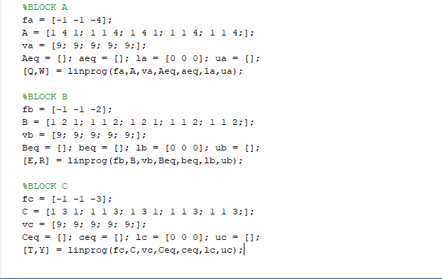

First time ever using MATLAB and first-time linear programming. From the tutorial I got online it said to generate an optimization linear program I needed to use vectors and a matrix. The one vector “f (character)” is used to define the objective function. Thus, using the matrix capital “(character)” is there to generate functions to where the vector “v(character)” is used to generate the constraints of the matrix. “(“Capital character, and “v(character)” are used to define what is being equaled to. “l(character) and u(character)” are generated data that is used to calculate the data. [“character”, “character”] are used to capture data and display in MATLAB. This is the workstation of the data down below.

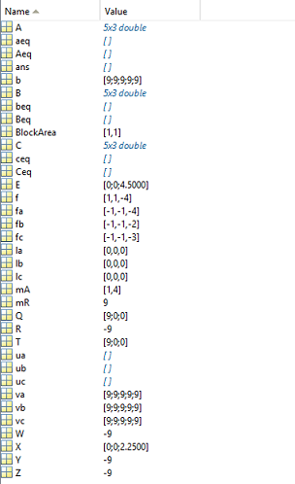

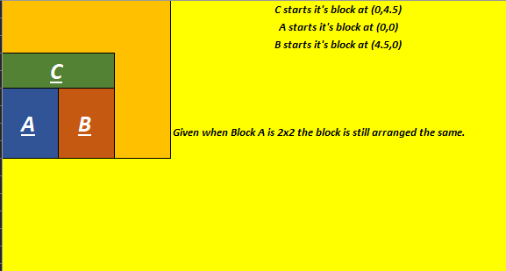

#2.

Overestimated Linear Approximation

[height, width]

[width, height]

M = MAX (height, width)

wi ­\* hi ≥ Ai

hi = ∆Iwi + ci *y = mx + c*

∆I = (hi min – hi max) / (wi max – wi max )

ci = hi max - ∆Iwi min

Overestimated Linear Constraints

xi + zi hi + (1 – zi) wi ≤ xk + M (xik + yik)

[hi = ∆iwi + ci]

yi + ziwi + (1-zi) hi ≤ yk + M(1 + xik – yik)

xk + zkhk+ (1 -zk)hk ≤ xi + M(1-xik + yik)

yk + zkwk + (1 -zk) hk ≤ yi + M(2 – xik – yik)