Mensuration Final GIS Workflow
Stand Outline
- Created polygon geodatabase feature class and then traced polygon of stand
Baseline
- Created line feature class and then drew a baseline
- Create a bearing angle field in attributes table
- Use calculate geometry attributes tool to calculate a bearing line into the previously created field
Cruise Lines
- Added points using generate points along line tool at 4 chain spacing as points for cruise lines
- Using modify, added a parallel line at ~1250ft spacing off of original baseline
- Added points using same tool as earlier to create a pair of parallel points
- Calculate geometry to get xy values for points (one field for each)
- Join attribute tables using ObjectID field
- Use XY to point tool to create perpendicular to baseline lines to serve as cruise lines
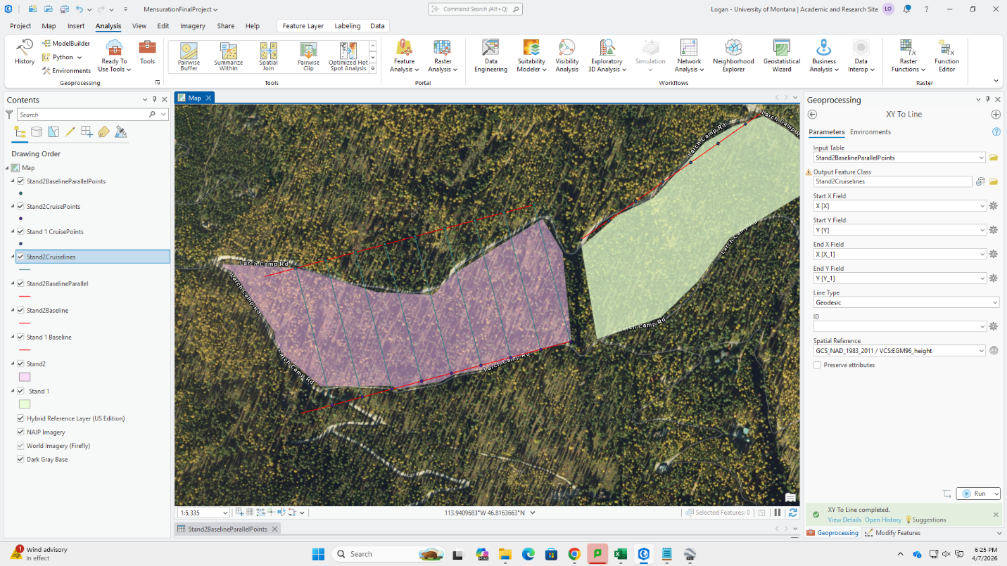
Plot Centers
- Once again using the generate points along a line tool, create points at 4 chain (264ft) intervals to serve as plot centers.
Field Maps Use
- Export as a webmap to AGOL
- Download to your own content
- It should now show up in field maps for navigation

