Balloon Simulator

Engineer’s Manual

# Acknowledgements

This project was designed with love and care by the following members of Team NoName

Vasyl Onufriyev - Project Manager & Developer

Jacob Potter – Developer

Cody Hawkins – Developer

Nelson Su – Developer

Logan Pettit – Developer

# Table of Contents

Acknowledgements 2

Table of Contents 3

Introduction 4

What is Balloon Simulator? 4

How do I get started? 4

What if I want to customize what is available/visible? 5

Configuration Information 6

Section 1: User Interface Elements Configuration 6

Section 1.1: Color Area Configuration 6

Section 1.2: Radius Slider and Buttons Configuration 6

Section 1.3: Data Box Configuration 8

Section 1.4: Wind Slider Configuration 8

Section 1.5: Graph Configuration 9

Testing 11

Section 1: Configuration Testing 11

Section 1.1: Color wheel tests 11

Section 1.2: Right Panel UI tests 11

Section 1.3: Left Panel UI tests 12

Section 1.4: Radius slider value configuration testing 13

Section 1.5: Wind slider value configuration testing 13

Section 1.6: Inflate and Deflate buttons 14

Section 1.7: Export paths 14

Section 2: UI Testing 15

High-Level Organization Diagram 16

Low-Level Feature Diagram 17

Detailed Script Diagram 17

# Introduction

Thank you for downloading and using Balloon Simulator as part of your classroom’s curriculum. We hope that you will find our software easy to use and reliable. This software was designed as part of a classroom project in CS4500 in the Fall of 2019 and released for public use by its developers.

## What is Balloon Simulator?

Balloon Simulator is an open source project with the objective of providing a product to schools that is easily accessible and supports the advancement of S.T.E.M education in primary and secondary education. The goal of Balloon Simulator is to give students an insight into the physical properties of matter and physics by simulating a balloon filled with helium, whose properties can be tweaked and recorded to look for relationships between various properties of geometric shapes and physical forces.

## How do I get started?

Getting started with balloon simulator is easy. Simply download one of our precompiled packages, extract it, and run the BalloonSim application.

## Mac/Windows support

We offer support for Mac and Windows systems you can find under the builds folder.

**Windows:** Builds/Windows/ here you can choose you grade level package and download it. From there you unzip the package and run BalloonSim.exe

**Mac:** Builds/Mac/ here you can choose your grade level package and download it. From there unzip the package and run BalloonSim.app

To exit, simply hit the “esc” key on the top left of your keyboard.

Balloon simulator comes preconfigured for various grade levels. These are as follow:

K – 2

* Color wheel that adjusts balloon color
* Radius slider that adjusts the balloon’s radius when adjusted

3 – 5

* Everything from K – 2 EXCEPT color wheel PLUS
* Data boxes which display the metrics about the balloon

6 – 8

* Everything from 3 – 5 PLUS
* Graphing functions that allow plotting points on a graph
* Wind Slider which allows an additional force to be applied to the balloon

## What if I want to customize what is available/visible?

Go to the location where you downloaded this package, go to the folder named *BalloonSim_Data*, then go to the folder named Config. Inside, there is a file named *config.json*. Inside, you can adjust which elements will be accessible to the users. Simply adjust the values inside to your desired values. Refer to configuration information for details about each value.

Full Windows Path:  
%path_to_downloaded_package_folder%/BalloonSim_Data/Config/config.json

Full Mac Path:

%path_to_downloaded_package_folder%/Contents/Config/config.json

# Configuration Information

In this section, there will be information provided on each value of the configuration file. The configuration file can be located at:

Full Windows Path:  
%path_to_downloaded_package_folder%/BalloonSim_Data/Config/config.json

Full Mac Path:

%path_to_downloaded_package_folder%/Contents/Config/config.json

## Section 1: User Interface Elements Configuration

### Section 1.1: Color Area Configuration

**“colorWheel” Possible Values:**

true - Enables the color area

false - Disables the color area

The configuration file contains values that reference the color wheel option to change the color of the balloon. The *colorWheel* value is set to true by default for the kindergarten – second simulation configuration. All other configurations have a default of false, turning the feature off.

### Section 1.2: Radius Slider and Buttons Configuration

The configuration file contains values that reference the radius sliders properties named *minRadius*, *maxRadius*, and *radiusSlider*. Starting with the *radiusSlider*, the value can be true or false. A true value will provide the radius slider UI in the simulation and is set to true for every configuration. A false value will remove the radius slider from the UI and disable any change in radius of the balloon from the slider. The *minRadius* value is set to a minimum of 50 meters for a realistic visual when comparing the balloon to the rope. The *minRadius* value can be changed to anything greater than 50 and less than 400 with regard that the *minRadius* value is less than the *maxRadius* value. The *maxRadius* value has similar constrains, the *maxRadius* can be anywhere greater than 50 and less than 400 with regard that the *maxRadius* is greater than the *minRadius*. In the case that the *minRadius* value is greater than the *maxRadius* value or, the *maxRadius* value is less than the *minRadius* value, the default values will override the changes and set *minRadius* to 50 and *maxRadius* to 400. The UI also provides inflate and deflate buttons for incremental increase of the balloon radius. A false value will disable this feature.

#### Section 1.2.1 Radius Slider Configuration

**“radiusSlider” Possible Values:**

true - Enables the radius slider

false - Disables the radius slider

**Details:**

When *radiusSlider* is set to false it will disable the radius slider UI element but, allow for you to still change the balloon radius by using the inflate and deflate buttons if they are set to true. If the *InflateDeflateButton* and *radiusSlider* properties are set to false, the switch box to switch between changing the radius and changing the wind will be disabled and only the wind slider will be available for user. This feature is by default set to true for all configurations of the simulation and values are in meters.

**“minRadius” Possible Values:**

Whole number values 50 – 399

*Constraint:*

*Must be less than maxRadius*

**Details:**

Changes the minimum radius of the balloon in meters.

**“maxRadius” Possible Values:**

Whole number values 51 – 400

*Constraint:*

*Must be greater than minRadius*

**Details:**

Changes the maximum radius of the balloon in meters.

#### Section 1.2.2 Inflate and Deflate Buttons Configuration

**“inflateDeflateButton” Possible Values:**

true - Enables the inflate / deflate buttons

false - Disables the inflate / deflate buttons

**Details:**

Disabling the *inflateDeflateButton* property will cause the inflate and deflate buttons to be removed from the UI. The radius slider will still be available for the user to change the radius of the balloon if it is set to True. Giving the *InflateDeflateButton* property a value of false and the *radiusSlider* property a value of false will cause the switch box UI element for changing between the wind and radius sliders to disappear and only the wind slider will be available for the user. This feature is by default set to true for all configurations and values are in meters.

**“inflateIncrement” Possible Values:**

Whole number

*Constraint:*

>= 1 AND < *maxRadius*

**“inflateIncrement” Possible Values:**

Whole number

*Constraint:*

>= 1 AND < *maxRadius*

**Details:**

The configuration file contains the values *inflateIncrement* and *deflateIncrement*, which refer to the change in meters of the radius. Each time either button is pressed it will change the value of the radius to the set values of *inflateIncrement* or *deflateIncrement*. The default value provided is 10 which corresponds to 10 meters. These values can be customized however the user likes with a few constraints. The value of *inflateIncrement* and *deflateIncrement* must be greater equal to 1 and less than the *maxRadius* value.

### Section 1.3: Data Box Configuration

**“dataBox” Possible Values:**

true - Enables the data box

false - Disables the data box

**Details:**

The databox feature provides real time data to the user from changes in the physics of the balloon through use of the sliders or buttons. By default, the *dataBox* property is set to false for kindergarten – second grade configuration and set to true for the rest of the configurations.

### Section 1.4: Wind Slider Configuration

**“windSlider” Possible Values:**

true - Enables the wind slider

false - Disables the wind slider

**Details:**

The wind slider applies wind to the balloon changing the data in the databox dynamically and providing a visual for the wind. Giving the *windSlider* a false value will cause the wind slider to be removed from the user’s UI and the switch box feature for switching between the radius slider and wind slider will be removed as well. Only the radius slider, inflate button, and deflate button will be provided they all have a value of true. By default, the *windSlider* feature is set to true for only the sixth – eighth grade configuration.

**“minWindSpeed” Possible Values:**

Whole number values 0 – 4

*Constraint:*

*Must be less than maxWindSpeed*

**Details:**

Increases minimum wind speed of balloon in meters/second

**“maxWindSpeed” Possible Values:**

Whole number values 1 – 5

*Constraint:*

*Must be greater than minWindSpeed*

**Details:**

Increases maximum wind speed in meters/second

### Section 1.5: Graph Configuration

**“graph” Possible Values:**

true - Enables the data collection/display area

false - Disables the data collection/display area

**Details:**

The graph provides real time recording for users to track the current physics data at the moment of pressing the record button in a graphical format. Providing a true value for *graph* will show the graph in the bottom right corner of the users UI. Disabling the graph will remove the graph from the users UI. By default, the graph is set to true for only the sixth – eighth grade configurations.

**“recordButton” Possible Values:**

true - Enables the data collection button

false - Disables the data collection button

*Constraint:*

*graph* must be true to be visible

**Details:**

The record button allows users to record real time physics data of the balloon on the graph feature. This features value of true is dependent on the graph property also being true. Disabling this feature will cause the graph to be disabled and both features removed from the UI. If this feature is enabled while the graph is disabled, the *recordButton* will be relabeled from record to export and the data from pressing export will be exported to a CSV (comma separated values) file. If the graph and *recordButton* are both set to true, the real time data will be provided in a visual graph that can be magnified and exported to a CSV. By default, the graph and record button features are set to true for only the sixth – eighth grade configurations.

**“csvExportPath” Possible Values:**

Export path string starting at the base of the program’s installation

**“imageExportPath” Possible Values:**

Export path string starting at the base of the program’s installation

# Testing

## 

## Section 1: Configuration Testing

### Section 1.1: Color wheel tests

**When**: Set *colorWheel* value to false

**Then**: The color wheel UI element will be removed from the user interface.

**Result**: Pass

**When**: Set *colorWheel* value to true

**Then**: The color wheel UI element will be present in the user interface.

**Result**: Pass

### Section 1.2: Right Panel UI tests

**When:** Set *radiusSlider* value to true, *windSlider* value to true, *InflateDeflateButton* value to true

**Then:** The right panel will display all of its UI elements including the *radiusSlider* panel, *windSlider* panel, *inflateDeflateButton* panel, and the switch box panel for switching the wind and radius sliders.

**Result:** Pass

**When**: Set *radiusSlider* value to false, *windSlider* value set to true, *inflateDeflateButton* value set to false

**Then**: The *radiusSlider* UI panel and the switch box for switching to the wind and radius panel will be removed from the user interface. Only the wind slider will be displayed and the *radiusSlider* and *inflateDeflateButton* will not be available.

**Result**: Pass

**When**: Set *radiusSlider* value to false, *windSlider* value set to true, *inflateDeflateButton* value set to true

**Then**: The *radiusSlider* slider bar will be removed from the user interface. The wind slider, switch box for the wind and radius panels, and *inflateDeflateButton* will be available and *radiusSlider* will not be available.

**Result**: Pass

**When:** Set *radiusSlider* value to false, *windSlider* value set to false, *inflateDeflateButton* value set to true

**Then:** The *radiusSlider* bar, *windSlider* bar, and the switch box for swapping the wind and radius panels will be removed from the user interface. Only the *inflateDeflateButton* will be available for use.

**Result:** Pass

**When:** Set *radiusSlider* value to true, *windSlider* value set to false, *inflateDeflateButton* value set to true

**Then:**

**Result:**

**When**: Set *radiusSlider* value to true, *windSlider* value set to false, *inflateDeflateButton* value set to true

**Then**: The *radiusSlider* UI panel will be displayed with the *inflateDeflateButton* on the panel. The switch box for switching between the *windSlider* will disappear and the *windSlider* will not be available.

**Result**: Pass

**When:** Set *radiusSlider* value to true, *windSlider* value set to false, *inflateDeflateButton* value to false

**Then:** The *radiusSlider* UI panel will be displayed and the switch box for switching between *windSlider* and *radiusSlider* will be removed. The *inflateDeflateButton* UI element will be removed from the screen. Only the *radiusSlider* will be available for use on the right panel.

**Result:** Pass

**When:** Set *radiusSlider* value to false, *windSlider* value set to false, *inflateDeflateButton* value to false

**Then:** The right panel will be completely disabled. The *radiusSlider, windSlider,* and *inflateDeflateButton* will not be available in the user interface as well as the switch box for swapping between the wind and radius slider.

**Result:**

### Section 1.3: Left Panel UI tests

**When:** set *graph* value to true, set *recordButton* to true

**Then:** graph will be provided for the user as well as the record button to record data on the graph

**Result:** Pass

**When:** set *graph* value to false, set *recordButton* to true

**Then:** graph will be removed from the user interface and the record button will be labeled as an export button to export the data to a CSV

**Result:** Pass

**When:** set *graph* value to true, set *recordButton* to false

**Then:** graph and record button are removed from the user interface

**Result:** Pass

**When:** set *graph* value to false, set *recordButton* to false

**Then:** *graph* and *recordButton* are removed from user interface

**Result:** Pass

### Section 1.4: Radius slider value configuration testing

**When:** *maxRadius* is set to 500

**Then:** Radius slider maximum in the user interface is set to default 400

**Result:** Pass

**When:** *maxRadius* is set to 300

**Then:** Radius slider maximum in the user interface is set to 300

**Result:** Pass

**When:** *maxRadius* is set to 30*, minRadius* is set to 50

**Then:** Radius slider maximum in the user interface is set to default 400

**Result:** Pass

**When:** *minRadius* is set to 40

**Then:** Radius slider minimum is set to default 50

**Result:** Pass

**When:** *minRadius* is set to 60

**Then:** Radius slider minimum is set to 60

**Result:** Pass

**When:** *minRadius* is set to 410, *maxRadius* is set to 400

**Then:** Radius slider minimum is set to default 50

**Result:** Pass

### Section 1.5: Wind slider value configuration testing

**When:** *minWindSpeed* is set to -1

**Then:** Wind speed slider minimum is set to default 0

**Result:** Pass

**When:** *minWindSpeed is set to 4, maxWindSpeed is set to 3*

**Then:** Wind speed slider minimum is set to default 0 and maximum set to default 5

**Result:** Pass

**When:** *minWindSpeed* is set to 3, and *maxWindSpeed* is set to 3

**Then:** Max wind speed value of slider is set to default 5, and minimum wind speedvalue of slider is set to 0

**Result:** Pass

**When:** *maxWindSpeed* is set to 6

**Then:** Wind speed slider max is set to 5

**Result:** Pass

**When:** *maxWindSpeed* value is set to 4, and *minWindSpeed* value is set to 2

**Then:** The maximum of the wind speed slider is set 4 and the minimum of the wind speed slider is set to 2

**Result:** Pass

### Section 1.6: Inflate and Deflate buttons

**When:** *inflateIncrement* valueset to 11

**Then:** Inflate button increases radius by a value of 11

**Result:** Pass

**When:** *deflateIncrement* value set to 11

**Then:** Deflate button decreases radius by a value of 11

**Result:**

**When:** *inflateIncrement* value set to 401

**Then:** Inflate button value set to default 10

**Result:** Pass

**When:** *deflateIncrement* value set to 401

**Then:** Deflate button value set to default 10

**Result:** Pass

**When:** *inflateIncrement* value set to 0

**Then:** Inflate button value set to 10

**Result:** Pass

**When:** *deflateIncrement* value set to 0

**Then:** Deflate button value set to 10

**Result:** Pass

### Section 1.7: Export paths

**When:** *imageExportPath* is changed from Exports to Exportsimage

**Then:** Image will be exported to Exportsimage after pressing export button on magnified graph

**Result:** Pass

**When:** *csvExportPath* is changed from Exports to Exportcsv

**Then:** CSV will be exported to Exportcsv after pressing export button on magnified graph

**Result:** Pass

# Section 2: UI Testing

**When:** Radius slider moved up

**Then:** Balloon size radius, radius data, surface data, volume data, and force data all increase

**Result:** Pass

**When:** Radius slider moved down

**Then:** Balloon size radius, radius data, surface data, volume data, and force data all decrease

**Result:** Pass

**When:** Wind moved up

**Then:** Wind speed is increased, and more wind is exerted on the balloon

**Result:** Pass

**When:** Wind slider moved down

**Then:** Wind speed is decreased, and less wind is exerted on the balloon

**Result:** Pass

**When:** Magnify button is pressed

**Then:** The graph is increased in size over the UI

**Result:** Pass

**When:** Magnify button is pressed after activating larger graph

**Then:** The graph is decreased in sizer over the UI

**Result:** Pass

**When:** Record button is pressed

**Then:** A point is placed on the graph

**Result:** Pass

**When:** Export Button is pressed

**Then:** Screenshot of the graph is exported to the export link

**Result:** Pass

**When:** Modify radius, button is pressed

**Then:** Radius modification panel is shown on the screen

**Result:** Pass

**When:** Modify wind, button is pressed

**Then:** Wind modification panel is shown on the screen

**Result:** Pass

# High-Level Organization Diagram

The following diagram depicts what scripts are attached to which objects and which items have in-editor controls which can only be modified through the unity editor.

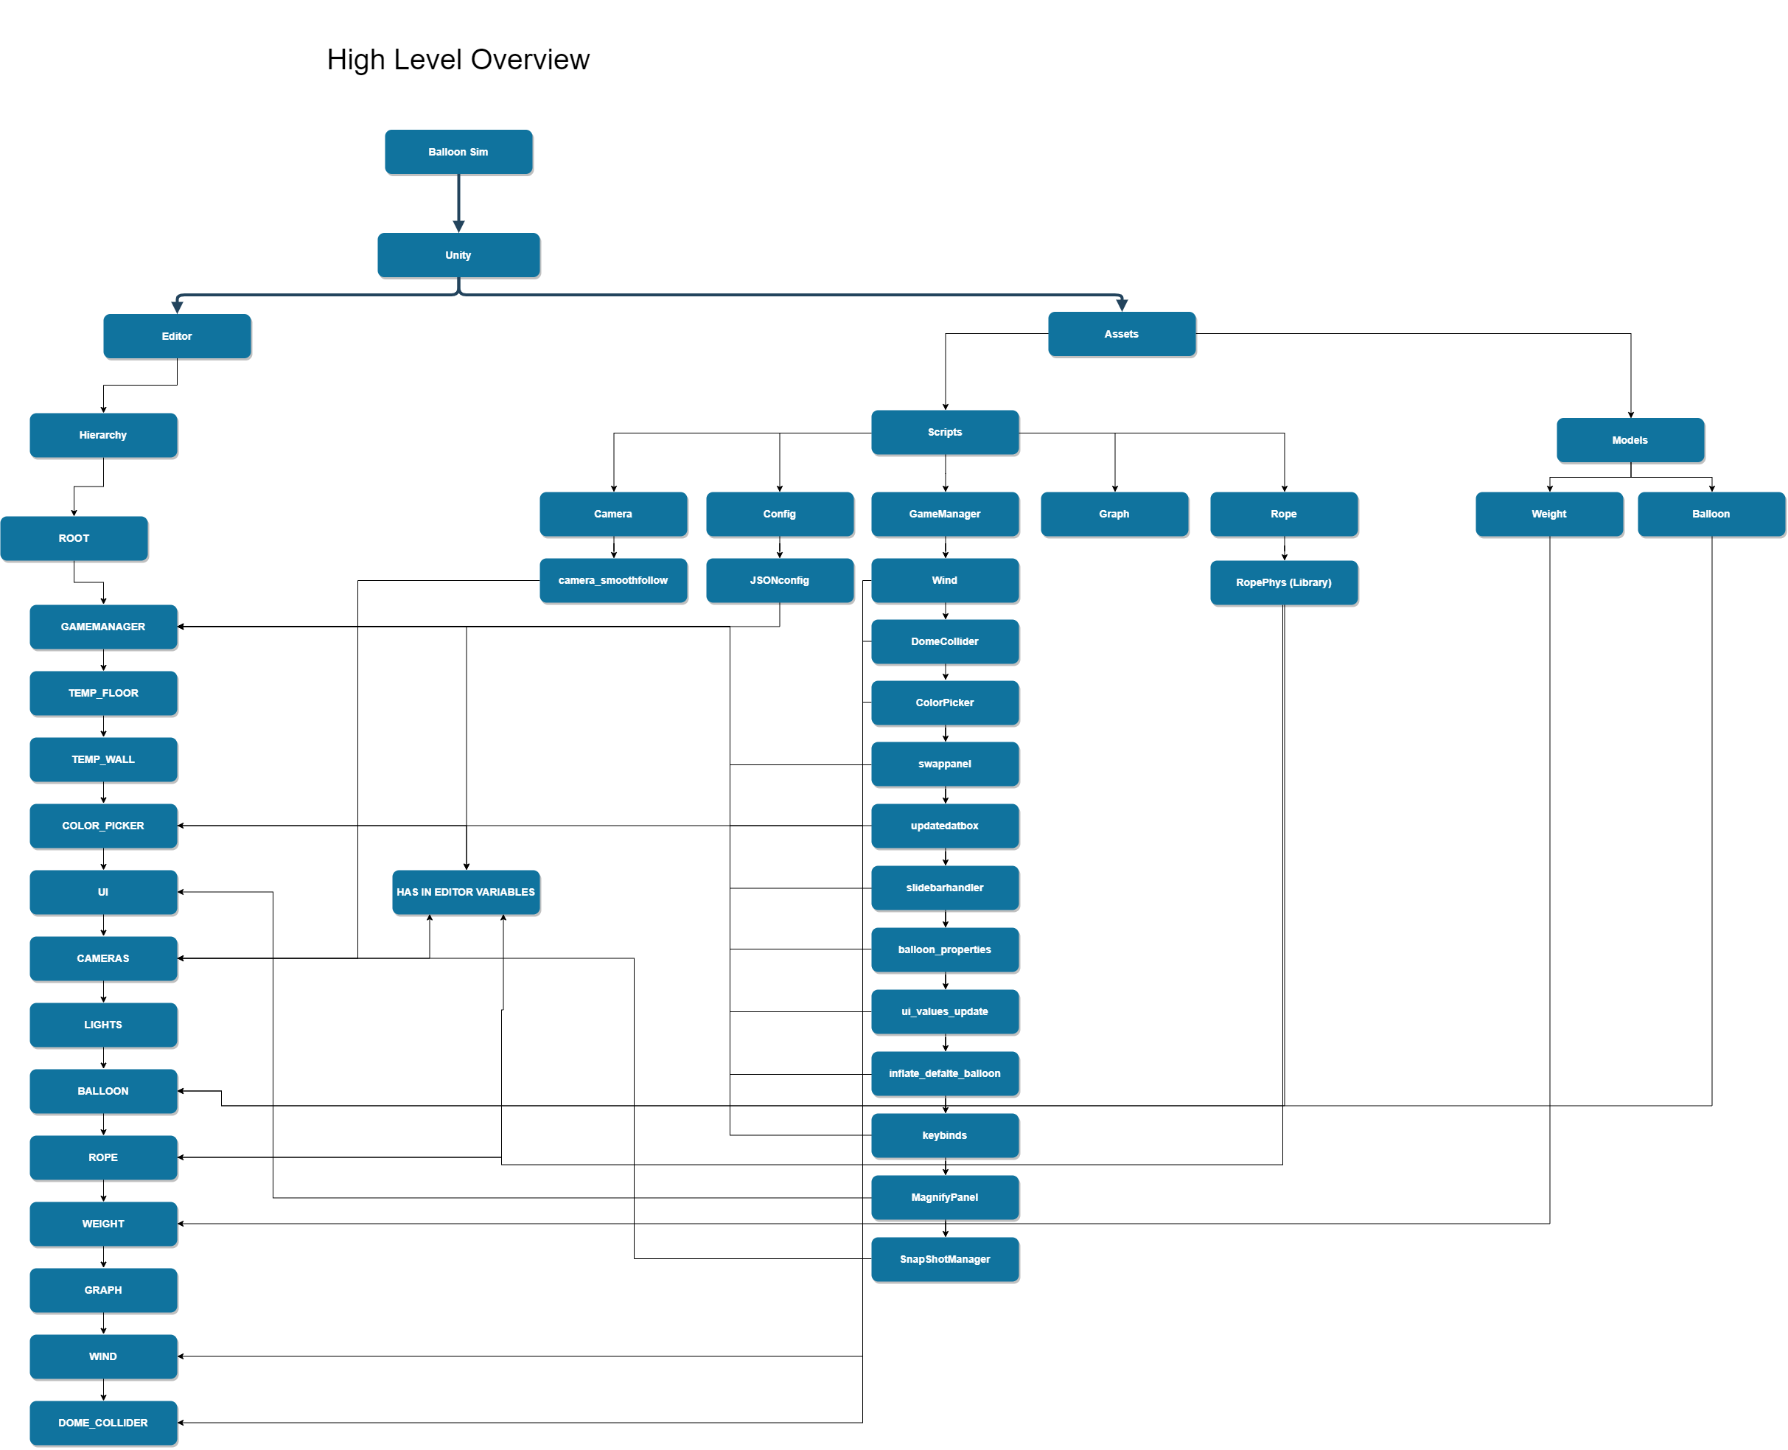

# Low-Level Feature Diagram

The following diagram was the original design features diagram. Red items were removed from the final product.

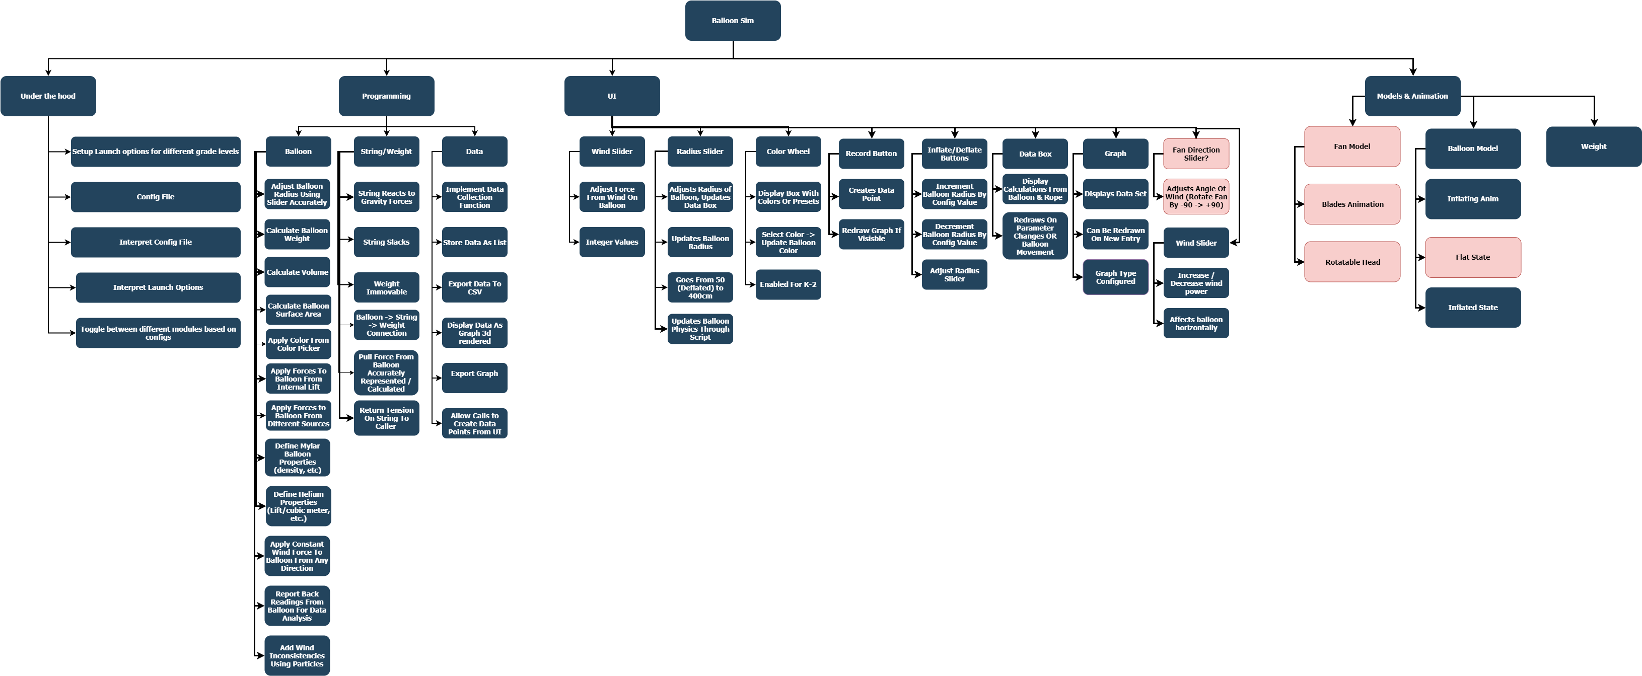

# Detailed Script Diagram

The following diagram details the function of each non-deprecated script currently in use

