Bound-saturation auditing of a parameterisation:
a methodological diagnosis of FO-LQI $→$ FO-PIDF conversion
for a non-ideal 48 V Buck converter
Anonymous author(s)
Abstract
A previous FO-LQI $→$ FO-PIDF optimisation campaign for a non-ideal 48 V Buck converter spent more than 1800 evaluations without reaching robust feasibility, and attributed this failure to clipping of the proportional gain at a parameterisation bound. We propose a bound-saturation audit that separates structural from pathological saturation, and apply it to a reconstructed chain whose projection reproduces the exact identity proposition to within $5.4×{10}^{−16}$. Over 4096 samples of the decision box, $\log_{10}k_{p}$ never reaches its bound: clipping does not explain the failure. A preregistered confirmatory campaign (hash-frozen protocol, three arms, six metaheuristics, thirty paired seeds, 540 cells) on a switched simulator that reproduces discontinuous conduction yields no robustly feasible controller: 0/30 seeds per method and per arm, Wilson interval $[0;$11.4 %$]$. The parameterisation specified by the brief does not even reach nominal feasibility; freeing the setpoint weight $b$ makes it reachable in 159 of 180 cells, without robustness. A physical diagnosis identifies a controller-independent obstruction: at minimum duty ratio, the converter in discontinuous conduction settles below the minimum-voltage threshold in 13 of the 17 uncertainty cases. We further show that controllers feasible with respect to all six constraints can sustain a limit cycle that these constraints do not detect. These results concern a simulated model and a finite set of cases; they are neither a robustness certificate nor a proof of infeasibility.
Keywords: Buck converter; fractional-order control; FO-LQI; FO-PIDF; metaheuristics; parameterisation audit; discontinuous conduction; reproducibility.

Introduction
Fractional-order controllers promise finer tuning than their integer-order counterparts, at the price of extra degrees of freedom that are readily handed to metaheuristics. For a power converter, this promise meets three implementation realities: sampling and delay, actuator saturation and anti-windup, and the rational approximation of fractional operators.
This study starts from a documented failure. An FO-LQI $→$ FO-PIDF campaign on a non-ideal 48 V Buck converter spent more than 1800 evaluations across six algorithms without ever reaching robust feasibility. The diagnosis retained at the time blamed clipping of the projected proportional gain at the bound $\log_{10}k_{p}=−4$, reached by $79 \%$ of the candidates.

Methodological question.
When a parametric search fails, how can one tell whether the failure comes from the algorithm, from the parameterisation, or from the problem itself? We answer with a three-step protocol: a bound-saturation audit that separates structural from pathological saturation; joint probes in controller space, which test whether the feasible region is reachable independently of the parameterisation; and a preregistered confirmatory campaign that measures the failure with appropriate statistics instead of assuming it.

Contributions.
- A bound-saturation audit of the parameterisation, which shows here that clipping of $k_{p}$ is not the cause of the earlier failure.
- A reconstructed and verified FO-LQI $→$ FO-PIDF chain: the projection reproduces the exact integer-order identity and measures its error outside that domain.
- A preregistered three-arm confirmatory campaign whose negative results are reported in full, sterile seeds included.
- The identification of a controller-independent physical obstruction (the voltage floor at minimum duty ratio) and of a blind spot in the specification (limit cycles invisible to the constraints).

Method

System, mission and invariants
The converter is a non-ideal asynchronous Buck converter that is physically of integer order, supplied by a fixed source $V_{in}=48$ V, with $L=100 μ$H, $C=100 μ$F, $R=10 Ω$, $r_{L}=0.1 Ω$, $r_{C}=0.05 Ω$, $R_{on}=0.05 Ω$ and a freewheeling diode with affine law $v_{D}=V_{f}+r_{d} i_{D}$, $V_{f}=0.42$ V, $r_{d}=0.020 Ω$. Fractional order belongs exclusively to the controller.
The imposed mission is $24→1→46$ V, with transitions at $0.108$ and $0.216$ s and end at $0.324$ s, a $+0.5$ A load step between $0.054$ and $0.090$ s, and initial conditions $\left(i_{L},v_{C}\right)=\left(2.4 A,24 V\right)$ in all circumstances. The controller is sampled at $T_{s}=10 μ$s with a one-sample delay; PWM runs at $50$ kHz and the duty ratio is bounded to $\left[0.02;0.98\right]$. The nominal feedforward
$$d_{ff}=\frac{\left(R+r_{L}+r_{d}\right) v_{ref}}{R V_{in}−\left(R_{on}−r_{d}\right) v_{ref}}$$
is kept without a $V_{f}$ term, with nominal variables frozen during disturbances.

Cost and constraints.
$$J=\frac{1}{T}​\int_{0}^{T}{​}\frac{\left|r−v_{o}\right|}{max\left(r,1\right)} dt+0.01 \frac{\int_{0}^{T}{i_{L}^{2}} dt}{T⋅{20}^{2}}+0.001 \frac{\overline{\left|Δd\right|}}{0.96}, T=0.324 s,$$
subject to six constraints $g_{i}≤0$: $g_{1}=I_{max}/20−1$, $g_{2}=\left(V_{max}−46\right)/1.5−1$, $g_{3}=\left|e_{24}\right|/0.05−1$, $g_{4}=\left|e_{1}\right|/0.03−1$, $g_{5}=\left|e_{46}\right|/0.10−1$, $g_{6}=\left(0.8−V_{min}\right)/0.8$. Extrema are taken on raw solver outputs and the errors $e_{•}$ are means over the steady-state windows $\left[0.0936;0.1044\right]$, $\left[0.198;0.2124\right]$ and $\left[0.306;0.3204\right]$ s. The margin of a candidate is $m=−\max_{i}g_{i}$, and over a set of cases $m=\min_{k}\left(−\max_{i}g_{i,k}\right)$: a minimum of maxima, hence a non-differentiable function.

Switched evaluator

Why a switched model.
The workspace of the reference Simulink model states that the 1 V plateau lies within $3 \%$ of the boundary between continuous and discontinuous conduction, and that the $24→1$ V step forces about $3.2$ ms of discontinuous conduction. An averaged continuous-conduction evaluator would therefore be wrong exactly where $g_{4}$ applies. We simulate the switched converter with three conduction states: switch on, diode on, and diode blocked ($i_{L}=0$), the latter producing discontinuous conduction without a separate model.

PWM edges.
Each integration step (fourth-order Runge–Kutta) is split exactly at carrier edges. Without this, a $1 μ$s step over a $20 μ$s period would limit duty-ratio resolution to $5 \%$, making the $\left[0.02;0.98\right]$ bounds fictitious. The relative difference in $J$ between the search step ($1 μ$s) and the confirmation step ($0.2 μ$s) is $0.13 \%$ for a reference control law.

Fractional realisation.
The operator $s^{γ}$, $γ∈\left[0;1\right]$, is approximated by a half-order-3 Oustaloup filter (7 cells) over $\left[1;{10}^{5}\right]$ rad/s, each cell $\left(s+z\right)/\left(s+p\right)$ being discretised exactly with a zero-order hold. The integral is realised as $s^{−λ}=s^{−1}⋅s^{1−λ}$: an exact integrator ensures zero steady-state error, and the Oustaloup cell carries only the fractional part. The derivative uses the same realisation, including for $μ=1$, where the Oustaloup formula yields $ω_{h}\left(s+ω_{b}\right)/\left(s+ω_{h}\right)$, a band-limited derivative.

FO-LQI synthesis and projection onto FO-PIDF
The small-signal model is normalised by $I=5$ A, $V=24$ V, $d=0.48$ and $T_{0}=1$ ms, then augmented with a memory state. The LQR law ($R=1$) gives $K=\left[K_{i}^{x},K_{v}^{x},K_{z}\right]$. For the nominal linear plant, without disturbance and without saturation, the state feedback reduces algebraically to
$$C_{FOLQI}\left(s\right)=K_{v}^{x}+\frac{a}{R}+C \left(a−r_{C}K_{v}^{x}\right) \frac{Ns}{s+N}+\frac{k_{i}}{s^{α}}, a=K_{i}^{x}\frac{V}{I}, N=\frac{1}{r_{C}C}, k_{i}=−\frac{K_{z}}{T_{0}^{α}},$$
which gives the anchor $k_{p}=K_{v}^{x}+a/R$, $k_{d}=C\left(a−r_{C}K_{v}^{x}\right)$, $ω_{f}=clip\left(N;20;2⋅{10}^{4}\right)$, $b=1$, $c=0$. The factor $T_{0}^{α}$ is the path through which the parent order $α$ acts on the synthesis: the memory state is an integral of order $α$ in normalised time. The integral order of the projection is then replaced by $λ$, and the derivative order is $μ$.
In the integer-order case ($α=λ=μ=1$, exact pole), relation [eq:projection] reproduces proposition 1 of the earlier study with a relative error of $5.4×{10}^{−16}$ over $\left[1;{10}^{6}\right]$ rad/s. This is the only exact case. Projecting the pole $N=2⋅{10}^{5}$ rad/s into the band $\left[20;2⋅{10}^{4}\right]$ rad/s alone introduces a relative error of $63 \%$ at the top of the band. The FO-LQI $→$ FO-PIDF identity is therefore neither general nor exact; we treat it as an anchor, never as an equivalence nor as a proof of fractional optimality.

Bound-saturation audit
An earlier campaign spent more than 1800 evaluations without reaching robust feasibility, and its diagnosis blamed clipping of $\log_{10}k_{p}$ at the bound $−4$, reached by $79.0 \%$ of candidates. We therefore treat each bound as an object of measurement: for each component of $θ$, we report the fraction of projections that reach each bound, over 4096 Sobol samples of the decision box. We distinguish two kinds of saturation. Structural saturation affects a component that is constant in the synthesis: the bound then removes no degree of freedom, it merely makes an identity visible. Pathological saturation affects a component that varies and runs into the bound: the bound then truly truncates the search.

Staged search and six metaheuristics

Decision vector.
The v5 vector acts on the synthesis, not on the final controller: $x=\left[logq_{i},logq_{v},logq_{mem},α,μ,\log_{10}τ_{aw},λ\right]$, with $λ$ in seventh position and $μ$ in fifth.

Methods.
PSO, GA, ABC and three project variants — pAEABC, pIGWO and pIGWO-DLH — reuse the operators of the earlier study. The prefix “p” signals that operator-level identity with the original publications is not established. All receive the same box, the same initial population for a given seed (population 10), the same Deb comparator and the same budget counted in evaluator calls; pIGWO-DLH spends two calls per comparison and thus performs fewer iterations at equal budget, by design.

Comparator.
Feasible precedes infeasible; among infeasible points, the lower violation wins; among feasible points, we rank by decreasing margin rather than increasing $J$. Ranking by $J$ produces candidates stuck to the boundary (median nominal margin $0.0066$ in the earlier study, robust margin/violation correlation $−0.821$), which are the worst starting points for robustness. The final criterion is lexicographic: feasibility on all design cases, then maximal minimum margin, then worst $J$ at equal margin ($<{10}^{−4}$).

Stages.
Stage 1 seeks nominal feasibility on a single scenario, with 700 calls; a seed producing fewer than 20 distinct feasible points is declared sterile and reported as such. Stage 2 seeks robustness on the design set with 300 calls, seeded only from the stage-1 feasible points of the same seed. Stage 3 replays every retained candidate at a $0.2 μ$s step: no candidate is declared feasible without this replay.

Validation protocol

Uncertainty set (declared choice).
The brief mentions seventeen robust cases and sixteen corners without defining them. We retain $L$, $C$ and $R$ at $±20 \%$ and $r_{C}$ at $±50 \%$, i.e. $2^{4}=16$ corners plus the nominal case. $r_{C}$ is chosen because it alone sets the projected pole $ω_{f}=1/\left(r_{C}C\right)$, hence the projection error. $V_{in}$ stays fixed and the mission is never modified.

Three disjoint sets.
The sixteen corners are split between design and validation by random draw (published seed 2026092401), never after observing which cases fail. The test set consists of uniform draws in the hypercube, with seed 2026092402 sealed in the protocol before any evaluation, and is played only once; a sentinel file prevents replaying it. A set consulted for a decision becomes a design set and loses all probative value.

Test size.
Success on $n$ draws without failure certifies nothing beyond the 95 % Wilson interval. With $50/50$, the lower bound is $92.9 \%$. The brief stated that “about 300” draws suffice for a $99 \%$ lower bound; the exact computation gives $98.74 \%$ for $300/300$ and requires $381$ draws. We retain 400.

Preregistered statistics
The statistical unit is the seed: thirty common seeds, paired methods. We apply the Friedman omnibus test (with the Iman–Davenport correction), then pairwise Wilcoxon signed-rank tests corrected with Holm’s method, and report the paired rank-biserial correlation as effect size. Success proportions are given with their 95 % Wilson interval. All seeds are reported, sterile ones included; no threshold is adjusted after observation.

Results

Saturation audit
Figure 1 summarises the audit. Over 4096 Sobol samples of the v5 box, $\log_{10}k_{p}$ stays within $[$-0.64$;$0.96$]$ (5th and 95th percentiles, median $0.44$) and reaches its lower bound in $0.0 \%$ of cases. The $79 \%$ saturation reported by the earlier campaign would require $k_{p}<{10}^{−4}$, four orders of magnitude below what the projection produces. It therefore signals a defect upstream of the clipping, not a bound set too tight.
Two components saturate at $100 \%$: $\log_{10}ω_{f}$ and $b$. Both are constants of the synthesis ($ω_{f}=1/\left(r_{C}C\right)$ and $b=1$ by relation [eq:projection]): the saturation is structural and removes no degree of freedom. The FO-PIDF vector produced by the synthesis thus has five effective degrees of freedom, not seven.
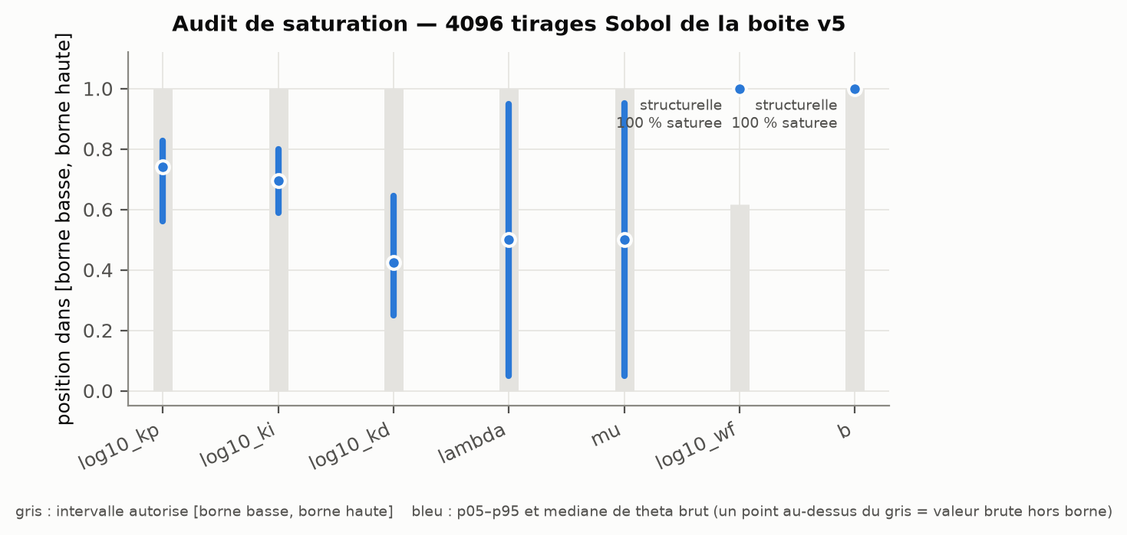
Saturation audit of the anchoring bounds (figure labels in French). No varying component saturates; the two observed saturations affect constants of the synthesis.

Exploratory probe: the feasible region exists
Before the campaign, an exploratory probe (seeds 1 to 6, distinct from the campaign seeds) searched jointly over the whole of $θ$, with 1500 calls per method. The nominally feasible region exists: with $b$ free, the best margin is $0.191$ after replay at $0.2 μ$s (3 methods out of 6 reach it); with $b=1$ imposed, it is still $0.016$ (2 out of 6), figure 2. The parameter $b$ is therefore a margin lever, not a feasibility barrier, contrary to the hypothesis we first put forward. However, the feasible point found with $b=1$ requires $\log_{10}k_{p}≈−1.66$, outside the image of the v5 box under the synthesis; the one found with $b$ free requires $b=0$, which v5 cannot set.
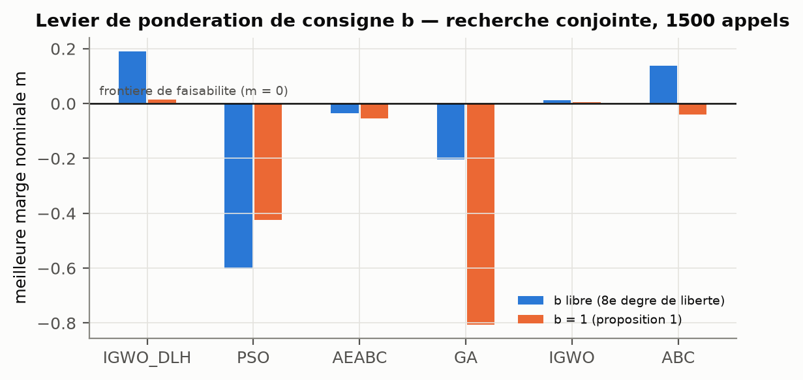
Exploratory probe: best nominal margin per method, $b$ free versus $b=1$. Joint search over the whole of $θ$, 1500 calls per run.

Confirmatory campaign
Table 1 summarises the three arms. None of the 540 cells is robustly feasible on the design set, and the Wilson interval per method and per arm is $[0;$11.4 %$]$.
Confirmatory campaign, 30 seeds $×$ 6 methods per arm.
 | v5 (brief) | v5b ($b$ free) | v5kp ($k_{p}$ free)
cells | 180 | 180 | 180
sterile seeds (stage 1) | 180 | 77 | 175
cells with a nominally feasible point | 0 | 159 | 65
best nominal margin (stage 1) | $−0.037$ | $0.221$ | $0.059$
robustly feasible cells | 0 | 0 | 0
best robust margin (stage 2) | $−0.439$ | $−0.067$ | $−0.312$
Friedman, $p$ | $2.0×{10}^{−18}$ | $2.5×{10}^{−14}$ | $1.1×{10}^{−16}$
significant pairs (Holm, of 15) | 11 | 9 | 8
method with best median margin | PSO | pIGWO | pIGWO
The v5 arm, as specified by the brief, finds no nominally feasible point in 700 calls, for any of the 180 cells. Freeing $b$ (v5b) makes nominal feasibility reachable in 159 cells out of 180, and freeing $k_{p}$ (v5kp) in 65; in both cases, no cell holds on the design set.
Friedman tests are significant in every arm. These differences, however, concern proximity to feasibility (all margins are negative), not feasibility achieved. The ranking of methods changes from one arm to another (PSO leads on v5, pIGWO on v5b): no universal superiority is established (figure 3).
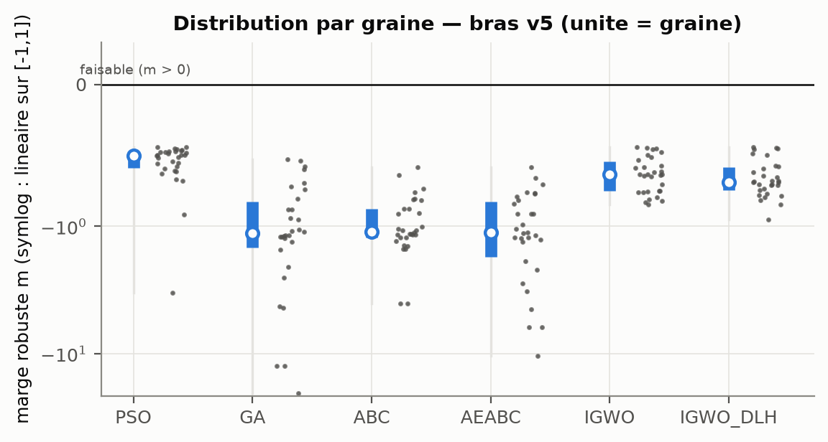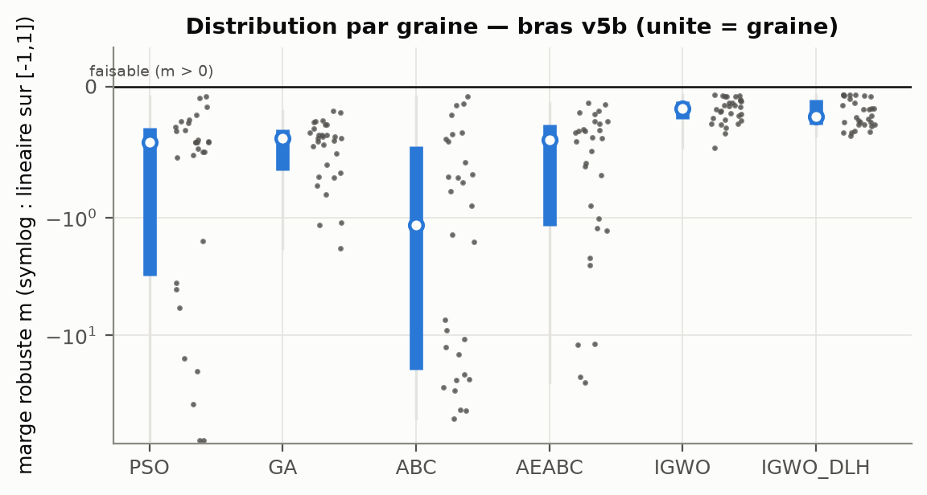
Robust margin per seed (the statistical unit), arms v5 and v5b. Symlog scale: linear over $\left[−1;1\right]$. Figure labels in French.

Stage 3 and sealed test.
Since no candidate is feasible on the design set, stage 3 has nothing to replay and the sealed test was not played. It remains untouched, seed 2026092402 included, and keeps its full probative value for a later study.

Two post hoc diagnostics
The following two diagnostics were added after observation. They are reported, but were used for no selection.

Voltage floor at minimum duty ratio.
The $g_{6}$ margins recur identically, to the fourth decimal, across controllers and arms. At $d=d_{min}=0.02$ in open loop, the converter in discontinuous conduction settles at $0.755$ V in the nominal case, and below $0.8$ V in 13 of the 17 cases (down to $0.586$ V). Any controller that stays saturated at the floor during the $24→1$ V descent is trapped there and violates $g_{6}$; to satisfy $g_{6}$, it must leave saturation before the voltage falls below $0.8$ V.

Limit cycles invisible to the constraints.
The best controller of the probe, feasible with respect to the six constraints, sustains at the 24 V plateau a limit cycle at about $7.7$ kHz, of 624 mV peak-to-peak on $v_{o}$ averaged over a PWM period (figure 4). The controller obtained with $b=1$ also oscillates, more weakly (158 mV). Plateau errors are window means, which cancel the oscillation, and the $\left|Δd\right|$ term of $J$ is too weak to penalise it. With $b=0$, the output also drops from about 24 to 14 V at start-up, a transient that no constraint detects.
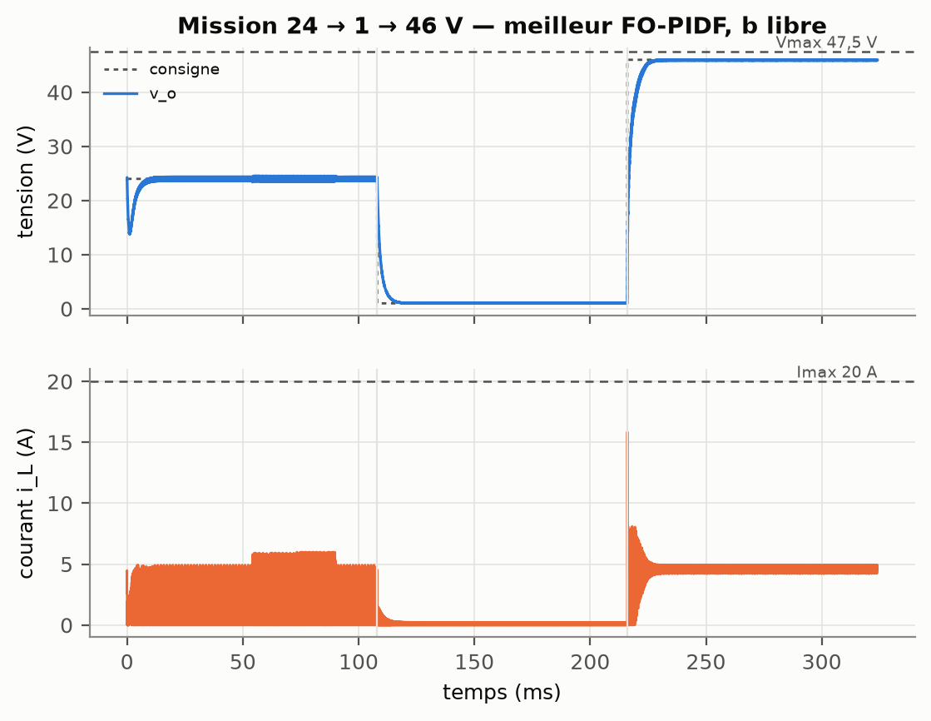
Trajectory of the best controller of the probe ($b$ free). Feasible with respect to the six constraints, it shows a start-up dip and a limit cycle at the 24 V plateau. Figure labels in French.

Discussion

What the audit changes in the diagnosis.
The earlier failure was attributed to a bound. The audit shows that, for a verified projection, the bound is never reached. The actual obstruction lies in the image of the parameterisation: the FO-LQI synthesis produces neither the low values of $k_{p}$ nor the values $b<1$ required by the feasible points found by direct search. A bound is therefore meaningful only relative to what the synthesis chain can produce; a saturation rate says nothing without the distinction between structural and pathological saturation.

What the campaign establishes.
Over 540 preregistered cells, no controller is robustly feasible. This negative result is measured, not assumed: sterile seeds are reported, Wilson intervals bound the success rate, and the sealed test remained untouched for lack of a candidate to test. Freeing $b$ or $k_{p}$ makes nominal feasibility reachable, but not robustness: tuning freedom is not enough.

A physical obstruction.
The voltage floor at minimum duty ratio is a property of the converter, not of the controller. The threshold $V_{min}≥0.8$ V lies above this floor in most uncertainty cases, so a control action saturated during the $24→1$ V descent cannot satisfy it. The specification thus implicitly requires the controller to leave saturation in time, a requirement that depends on anti-windup as much as on gains. Any future comparison should check whether this threshold is compatible with $d_{min}=0.02$ and the load before searching for gains.

A blind spot of the specification.
Controllers that are feasible with respect to the six constraints can oscillate permanently. For an implementation-oriented journal, this is the finding with the heaviest consequences: a mean-value constraint does not guarantee the absence of a limit cycle. We do not modify the constraints after observation; we recommend adding, in a future preregistered study, a constraint on the oscillation amplitude over steady-state windows.

Fractional character.
The best points found have $λ$ and $μ$ equal or very close to 1. The resulting controller is, in practice, of integer order. Nothing in our results attributes a benefit to fractional order; the study lacks the direct-tuning, equal-budget comparator that would allow such a judgement.

Limitations and what has not been demonstrated
- Model. All results concern a switched simulator written in Python, not the reference Simulink model. Snubbers are absent, the diode follows a static affine law, and no cross-validation against Simulink has been carried out.
- Projection. The FO-LQI $→$ FO-PIDF identity is exact only in integer order, with the exact pole, on the unsaturated nominal plant; the pole projection alone introduces up to $63 \%$ error at the top of the band.
- Infeasibility not proven. No cell is robustly feasible, but this does not prove that no robust controller exists: budgets are finite, and the uncertainty set is a declared choice.
- Uncertainty set. The uncertain parameters and their ranges were chosen by us, as the brief does not specify them.
- Sealed test. It was not played: no robustness claim is therefore made, not even as a proportion.
- Comparators. The state-of-the-art references and the direct-tuning, equal-budget comparator are not implemented; no superiority can be attributed to fractional order.
- Post hoc diagnostics. The voltage floor and the limit cycles were identified after observation; they motivate a future preregistered study but must not be read as confirmatory results.
- Metaheuristics. Significant differences measure proximity to feasibility, not feasibility achieved, and their ranking depends on the arm.

Reproducibility
The code, the frozen protocol (protocol/protocol_v6_1.json, hash bf8859a2465011bf), the per-cell log, the seeds and the log of deviations from the brief (docs/ECARTS.md) are published with the article. Protocol v6.1 is chained to version v6 and was amended before the first campaign seed. Every number in this article is generated by scripts/make_numbers.py from the JSON results.

