Structural LQI–PIDF equivalence and constrained weight tuning for a wide-range Buck converter
Anonymous author(s) — affiliation withheld for review

Abstract
Metaheuristic tuning of PID-type controllers for power converters usually searches gain spaces that carry no stability guarantee, and its results are rarely checked against switching effects. This paper shows that, for a non-ideal Buck converter, the linear–quadratic–integral (LQI) law has an exact realization as a two-degree-of-freedom PIDF that measures only the output voltage. When its derivative pole is placed on the capacitor ESR zero, the filter state reconstructs the capacitor voltage along every trajectory. The PIDF and the full-state LQI therefore coincide under saturation, anti-windup and discontinuous conduction. They differ only through an explicit output-current term, output-network mismatch and sampling, and a first-order-hold discretization reduces the sampling gap by a factor of about 40. The controller is tuned by searching the LQI weights, not the gains, so every candidate is LQ-optimal and carries guaranteed margins and a certified pole region. A constrained, multi-fidelity search includes short switched-model simulations to reject coexisting switching limit cycles that averaged models miss. On a 48 V converter commanded from 1 to 46 V, six metaheuristics converge to the same optimum. An unconstrained gain search reaches the same controller, but 42 % of its feasible solutions are not LQ-optimal. On a switched replica of the reference Simulink model, the tuned controller eliminates overshoot and respects the device current rating, whereas standard PI, PID, PIDF, LQR, LQG and LQI designs exceed the specification by factors of 6 to 30.
Keywords: Buck converter; LQI control; 2-DOF PIDF; structural equivalence; metaheuristic optimization; multi-fidelity constraints; switching limit cycles

1 Introduction
Digitally controlled DC–DC converters are routinely tuned by metaheuristics: particle swarms, genetic algorithms, bee colonies and grey-wolf variants search the gains of a PI, PID or filtered PID (PIDF) against a tracking index (Izci et al., 2022; Nanyan et al., 2024; Rodríguez-Molina et al., 2020). Two weaknesses recur in that literature, and both are visible to an industrial reader. First, the searched object is a vector of gains with no structural meaning, so a good gain vector carries no stability or robustness certificate and the search space is sized by guesswork. Second, the evidence is usually produced on the same averaged model that drives the search, so switching ripple, duty saturation and discontinuous conduction, which decide whether a tuning is admissible on the real power stage, never enter the comparison (Erickson and Maksimović, 2020; Middlebrook and Ćuk, 1976).
This paper addresses both points on one concrete, audited plant: a non-ideal asynchronous Buck converter supplied from a fixed 48 V source and commanded over the whole attainable range 1 V–46 V. The design is formula first. The searched object is not a gain vector but the set of Bryson excursions that define a linear–quadratic–integral (LQI) cost; every candidate is solved from the algebraic Riccati equation and then realized exactly as a two-degree-of-freedom PIDF (2-DOF PIDF) that reads the output voltage only. Every evaluated point is therefore a genuine LQI law, with the classical LQR return-difference guarantees, and at the same time a controller that a practitioner can implement in a standard PID block with setpoint weights.
The central theoretical observation is stronger than a transfer-function identity. We show that the derivative filter of the realizing PIDF, when its pole is placed at the equivalent-series-resistance (ESR) zero $N_{C}=1/(r_{C}C)$ and its state is initialized consistently, reconstructs the capacitor voltage exactly, whatever happens in the inductor branch. Consequently the output-feedback PIDF and the full-state LQI generate identical trajectories under duty saturation, anti-windup activity, discontinuous conduction and any mismatch of $L$, $r_{L}$, $R_{on}$, $r_{d}$ or $V_{f}$; only an unmeasured load current, a mismatch of the output network $(R,r_{C},C)$, or sampling break the equivalence. This turns a nominal, small-signal equivalence into a structural statement that can be checked on a simulator to machine precision, and it tells the practitioner exactly which sensors the PIDF saves and at what price.
The optimization layer compares six equal-budget global operators—PSO, GA, ABC and three project variants pAEABC, pIGWO and pIGWO–DLH—each followed by a common Gaussian-process refinement stage (refineBO), over 30 matched seeds. The seven algorithms are not the contribution by themselves; the question they answer is whether the LQI-weight parameterization helps them. We therefore run the identical protocol on five other controller families that share the evaluator, the budget and the specifications: the full-state twin of the design (same weights, measured $i_{L}$), the same 2-DOF PIDF searched directly in gain space, a PIDF with free filter pole and setpoint weights, a PID and a PI. Six fixed-rule comparators—PI, PID, PIDF (Type-III rule), LQR, LQG and LQI—complete the picture, and every frozen controller is replayed on a switched replica of the reference Simulink/Simscape model on the complete 24$→$1$→$46 V mission, with a closed energy balance.
A previous version of this protocol accepted candidates on an averaged model guarded by an analytical switching-ripple bound, and four of six branch winners failed on the switched model. We reproduce that failure mode, show that it is caused by coexisting switching limit cycles whose selection depends on the preceding transient, and replace the analytical bound by three measured inequalities obtained from a 34 ms switched transition sequence inside each evaluation, a multi-fidelity constraint that roughly doubles the cost of a candidate. Feasibility is also stated in absolute engineering units (overshoot, load deviation, device current, steady error) instead of ratios to a reference controller, so that every family is judged against the same specification.
The contributions are:
- a formula-first chain from the non-ideal converter equations to the exact output-feedback realization of any LQI law as a 2-DOF PIDF, with all analytical quantities (equilibria, transfer functions, Riccati gain, LQR margins, a common-$P$ D-region certificate over the operating polytope) instantiated and independently recomputed;
- a structural equivalence theorem (Proposition 2) showing that the PIDF filter state equals the capacitor voltage along every trajectory, with its exact domain of validity, a closed-form expression of the gap to the full-state law, and the discretization that preserves it under sampling;
- a constrained co-design problem in the space of LQI weights with 33 inequalities in engineering units, three of which are measured on the switched model during the search, and the evidence (two reported pilots) of why an analytical ripple bound or a steady switched screen is not enough;
- a matched, equal-budget comparison of seven algorithms across six controller families, showing that the LQI coordinates do not speed up the search but confine it, at no cost in optimality, to the LQ-optimal manifold on which the gain-space optimum also lies;
- a switched-model validation on the reference mission against PI, PID, PIDF, LQR, LQG and LQI, reported specification by specification.
Section 3 derives the model and describes the switched replica. Section 4 states the LQI synthesis and the equivalence results. Section 5 defines the co-design problem and the algorithms. Section 6 reports the results and Section 7 concludes. All code, including a MATLAB S-function that runs the same control layer in the reference Simulink model, is released with the paper.

2 Related work and positioning
Model-based converter control. State-space averaging supplies the standard low-cost converter model (Erickson and Maksimović, 2020; Middlebrook and Ćuk, 1976); non-ideal averaged plants with inductor and capacitor ESR, switch resistance and diode drop have been used to tune implementable low-order controllers with hardware validation (Siddhartha et al., 2018), and robust nonlinear or observer-based laws extend disturbance rejection (Abdelmalek et al., 2020; Bouchama et al., 2020; Sitbon et al., 2020). Convex methods—MPC solved as a quadratic program (Liu et al., 2018), LMI regional pole placement (Chilali and Gahinet, 1996)—give certificates relative to their model class but do not make fixed-structure PIDF tuning convex once saturation, discontinuous conduction and event-wise requirements are included.
LQ design and PID structure. The LQR return-difference inequality guarantees an infinite upward gain margin, a gain reduction margin of one half and 60 ° of phase margin for the full-state loop (Anderson and Moore, 1990; Kalman, 1964; Safonov and Athans, 1977); the guarantee is not inherited by observer-based implementations (Doyle, 1978), and loop-transfer recovery trades it against observer bandwidth (Doyle and Stein, 1979). Bryson’s rule converts admissible excursions into diagonal weights (Bryson and Ho, 1975). Setpoint weighting and back-calculation anti-windup are the standard means of shaping the command response of a PID and of handling actuator saturation (Åström and Hägglund, 2006; Åström and Rundqwist, 1989; Bianchi et al., 2008). The connection exploited here—that the full-state LQI law of a second-order plant with an output-network zero is a filtered PID of the measured output—is known in nominal transfer-function form; what is new is its trajectory-level validity and the use of the Riccati weights, not the gains, as the search space.
Metaheuristic tuning. PSO (Kennedy and Eberhart, 1995), genetic algorithms, ABC (Karaboga and Basturk, 2008) and GWO (Mirjalili et al., 2014) with improved variants (Alsamia et al., 2024; Hou et al., 2022; Nadimi-Shahraki et al., 2021) are widely used to tune converter controllers (Izci et al., 2022; Nanyan et al., 2024; Valencia-Rivera et al., 2024); surrogate-based Bayesian optimization is attractive when evaluations are expensive (Coutinho et al., 2023; Snoek et al., 2012). Constraint handling by Deb’s feasibility rules avoids penalty weights (Deb, 2000), and matched-seed non-parametric statistics are the accepted way to compare stochastic solvers (Demšar, 2006). A weighted scalar index does not produce a Pareto front (Rodríguez-Molina et al., 2020); we therefore report a constrained scalar problem and do not claim a multi-objective characterization.
Switching effects in digital control. In digitally controlled PWM converters, the sampled switching ripple and the duty resolution can sustain limit cycles that an averaged model does not predict (Peterchev and Sanders, 2003). This is the mechanism behind the rejection of averaged-feasible candidates reported in Section 6.5, and the reason why three inequalities of the present problem are measured on the switched model.
Table 1 positions the study. The gap is not a new metaheuristic but the conjunction of (i) a structurally meaningful search space whose every point carries an LQ certificate and an exact output-feedback realization, (ii) a feasibility set stated in engineering units and partly measured on the switched plant, (iii) matched equal-budget comparisons that separate the parameterization from the optimizer, and (iv) a closed-energy-balance switched validation on the full commanded range.
Table 1: Positioning with respect to representative Buck control and tuning studies. “Not reported” refers to the stated scope of each work only.
Study | Plant evidence | Controller / search | Relative to the present question
Siddhartha et al. (2018) | non-ideal Buck, dSPACE | IMC-PID, direct | no repeated solver comparison, no switched energy audit
Izci et al. (2022) | averaged Buck | PID, AEO + Nelder–Mead | gain-space search, no structural certificate, no switched admissibility
Nanyan et al. (2024) | averaged Buck | PID, improved SCA | gain-space search, single fidelity
Siano and Citro (2014) | Buck prototype | fuzzy, MO-PSO | no equal-budget solver comparison
Abdelmalek et al. (2020) | Buck, experimental | observer-based nonlinear, PSO | tracking/robustness focus, not a matched co-design
Coutinho et al. (2023) | multiloop process | PID, Bayesian optimization | not a power converter
Present work | audited non-ideal Buck, 1–46 V, switched replica with energy balance | LQI weights $→$ exact 2-DOF PIDF; 6 global operators + refineBO; 6 families | structural equivalence theorem; 33 inequalities (3 measured on the switched model); switched validation vs. PI, PID, PIDF, LQR, LQG, LQI

3 Non-ideal Buck converter: from the circuit to the switched replica

3.1 Circuit and conventions
Fig. 1 shows the asynchronous converter. The state is $x=[i_{L} v_{C}]^{T}$; $i_{L}$ flows from the switching node to the output, $i_{C}$ flows downward in the capacitor branch and the load disturbance $i_{p}$ is positive when it draws additional current. The source is fixed, $V_{in}=48 V$. The high-side switch is an IRF540N represented by its static on-resistance $R_{on}$; the freewheel diode follows the affine conduction law of the STPST10H100SF data sheet, $v_{D}=V_{f}+r_{d}i_{D}$ (Infineon Technologies AG, 2026; STMicroelectronics, 2023). Table 2 lists the values, all decoded from the workspace of the reference Simulink model.
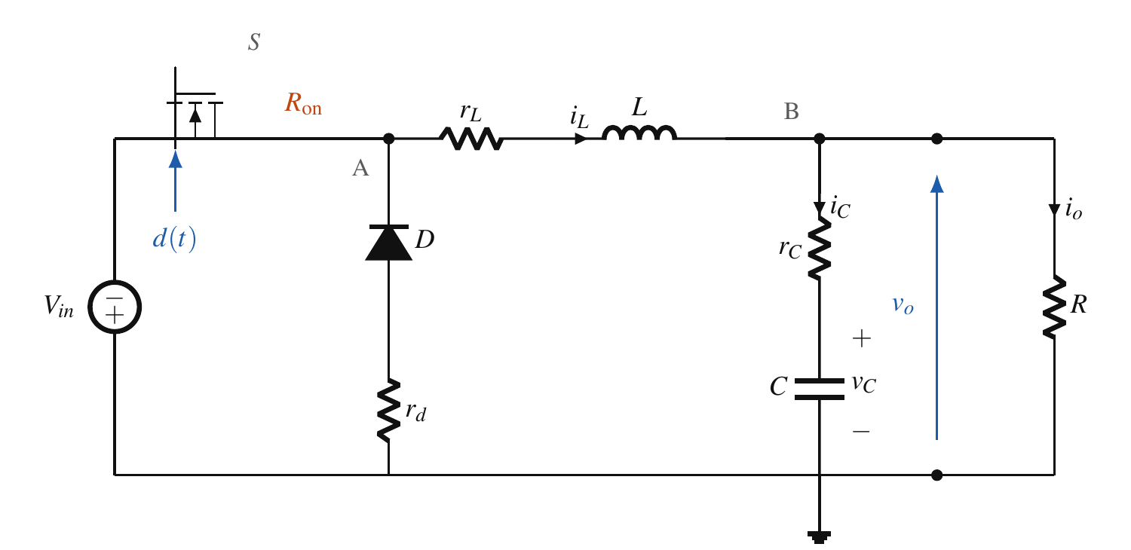
Figure 1: Non-ideal asynchronous Buck converter and adopted conventions.
Table 2: Electrical and numerical parameters (reference model workspace).
Quantity | Value | Role
$V_{in}$ | 48 V, constant | source
$L$, $r_{L}$ | 100 μH, 0.10 Ω | inductor branch
$C$, $r_{C}$ | 100 μF, 0.05 Ω | capacitor branch
$R$ | 10 Ω | nominal load
$R_{on}$ | 0.05 Ω | IRF540N static surrogate
$V_{f}$, $r_{d}$ | 0.42 V, 0.020 Ω | STPST10H100SF affine law
$R_{s}$ ($C_{s}=∞$) | 100 k Ω | resistive snubber across the switch
$R_{d,body}$ | 0.01 Ω | MOSFET body diode
$f_{s}$ | 50 kHz | PWM carrier
$T_{s}$ | 10 μs | controller sampling ($=1/(2f_{s})$)
$[d_{min},d_{max}]$ | $[0.02, 0.98]$ | total duty saturation

3.2 Averaged model and loss-aware equilibrium
The output node and the ESR give
 | $$i_{L}=i_{C}+\frac{v_{o}}{R}+i_{p}, v_{o}=v_{C}+r_{C}i_{C},$$ | (1)
hence
 | $$i_{C}=\frac{R(i_{L}−i_{p})−v_{C}}{R+r_{C}}, v_{o}=\frac{R}{R+r_{C}}v_{C}+\frac{Rr_{C}}{R+r_{C}}(i_{L}−i_{p}).$$ | (2)
With the switch on, $L{\dot{i}}_{L}=V_{in}−(r_{L}+R_{on})i_{L}−v_{o}$; with the diode conducting, $L{\dot{i}}_{L}=−V_{f}−(r_{L}+r_{d})i_{L}−v_{o}$; in both cases $C{\dot{v}}_{C}=i_{C}$. Duty averaging yields
 | $$L{\dot{i}}_{L}=dV_{in}−\left[r_{L}+dR_{on}+(1−d)r_{d}\right]i_{L}−(1−d)V_{f}−v_{o}.$$ | (3)
At equilibrium $I_{L}=V_{o}/R+I_{p}$ and the loss-aware duty is
 | $$d_{ff}=\frac{V_{o}+(r_{L}+r_{d})I_{L}+V_{f}}{V_{in}−(R_{on}−r_{d})I_{L}+V_{f}}.$$ | (4)
Every controller of this paper uses (4) with nominal parameters and $I_{p}=0$ as feedforward; the feedforward never sees the simulated plant.

3.3 Small-signal model and transfer functions
Let $γ=R/(R+r_{C})$, $ρ_{0}=r_{L}+r_{d}+d_{0}(R_{on}−r_{d})$ and $E_{d}=V_{in}+V_{f}−(R_{on}−r_{d})I_{L,0}$. Linearizing (2)–(3) gives $δ\dot{x}=Aδx+B_{d}δd+B_{p}δi_{p}$, $δv_{o}=C_{y}δx+D_{p}δi_{p}$ with
 | $$A=\left[\begin{matrix}−(ρ_{0}+γr_{C})/L & −γ/L \\ γ/C & −γ/(RC)\end{matrix}\right], B_{d}=\left[\begin{matrix}E_{d}/L \\ 0\end{matrix}\right], C_{y}=\left[\begin{matrix}γr_{C} & γ\end{matrix}\right],$$ | (5)
$B_{p}=[γr_{C}/L −γ/C]^{T}$ and $D_{p}=−γr_{C}$. The control-to-output transfer function is
 | $$\begin{aligned}G_{vd}(s)&=\frac{E_{d}R(1+r_{C}Cs)}{Δ(s)}, \\ Δ(s)&=LC(R+r_{C})s^{2}+\left[L+C\left((R+r_{C})ρ_{0}+Rr_{C}\right)\right]s+R+ρ_{0},\end{aligned}$$ | (6)
with the ESR zero $ω_{z}=N_{C}=1/(r_{C}C)=2×{10}^{5} rad/s$. Table 3 instantiates (4)–(6) at the three commanded levels; the closed form and a state-space conversion agree to machine precision. At the 24 V synthesis point, $(A,B_{d})$ and $(A,C_{y})$ have rank two and the integral-augmented pair has rank three.

Table 3: Equilibria, monic $Δ(s)$, $G_{vd}$ numerator and stationary conduction screen at the three commanded levels (nominal load, $i_{p}=0$). $ω_{z}=1/(r_{C}C)=2×{10}^{5} rad/s$ at every level.
$V_{o}$ (V) | $I_{L,0}$ (A) | $d_{0}$ | $ρ_{0}$ ($Ω$) | $E_{d}$ (V) | $Δ(s)/(LC(R+r_{C}))$ | $G_{vd}$ numerator | $ΔI_{L,pp}$ (A) | $I_{crit}$ (A) | ${\overset{‾}{I}}_{L}−I_{crit}$ (A) | $R_{crit}/R$
1 | 0.1 | 0.029576 | 0.120887 | 48.417 | $s^{2}+2701.41s+1.00705×{10}^{8}$ | $2.40881×{10}^{4}s+4.81761×{10}^{9}$ | 0.1941 | 0.0970 | 0.0030 | 1.030
24 | 2.4 | 0.511045 | 0.135331 | 48.348 | $s^{2}+2845.85s+1.00849×{10}^{8}$ | $2.40537×{10}^{4}s+4.81075×{10}^{9}$ | 2.3470 | 1.1735 | 1.2265 | 2.045
46 | 4.6 | 0.972868 | 0.149186 | 48.282 | $s^{2}+2984.40s+1.00987×{10}^{8}$ | $2.40209×{10}^{4}s+4.80418×{10}^{9}$ | 0.2496 | 0.1248 | 4.4752 | 36.856

3.4 Conduction mode across the range
For a duty $d_{ff}$ the inductor ripple, the boundary current and the boundary load are
 | $$ΔI_{L,pp}=\frac{V_{o}(1−d_{ff})}{Lf_{s}}, I_{crit}=\frac{ΔI_{L,pp}}{2}, R_{crit}=\frac{2Lf_{s}}{1−d_{ff}}.$$ | (7)
The stationary screen (Table 3) is positive at every level but not uniform: at 1 V the current margin is 2.96 mA (3.05 % of $I_{crit}$) and $R_{crit}$ is only 1.030 times the nominal load. The switched model is more pessimistic than this screen: over the steady 1 V window it spends 15.00 % of the time in discontinuous conduction at 60.57 % efficiency, because the diode drop is 42 % of the commanded output. Discontinuous conduction is thus a nominal regime of the mission, and every controller is validated in it.

3.5 Switched replica of the reference model
The acceptance model (Fig. 2) is the Simulink/Simscape Electrical model buck_fo_lqi_fixed_reference_v6_1_46V_R2022a.slx. For the campaign we use a replica written from its block parameters (cmo/sim.py): a resistive switch with snubber $R_{s}$ and a body diode $R_{d,body}$; the affine freewheel diode, which blocks reverse current so that discontinuous conduction arises by itself (the 1 ns snubber-leakage branch is solved quasi-statically); a continuous sawtooth carrier whose edges are located exactly inside the integration step; a controller sampled at $T_{s}$ with a one-sample output delay, exactly as the S-function of the reference model. The step is 0.2 μs (100 steps per switching period) with fourth-order Runge–Kutta integration.
The energy boundary is the one declared in the model workspace:
 | $$\begin{aligned}P_{in}&=V_{in}i_{in}, P_{u}=\frac{v_{o}^{2}}{R}+v_{o}i_{p}, \\ P_{loss}&=r_{L}i_{L}^{2}+r_{C}i_{C}^{2}+v_{SW}i_{SW}+v_{D}i_{D},\end{aligned}$$ | (8)
the snubber dissipation being contained in $v_{SW}i_{SW}$. The three energies are integrated with the same Runge–Kutta stages as the states, so the residual $E_{in}−E_{u}−E_{loss}−ΔE_{stored}$ measures integration consistency only. It stays below $4.5×{10}^{−6} \%$ of the input energy for every replay reported here.
The replica reproduces the controller-independent figures of the reference model: 15.00 % of discontinuous conduction and 60.57 % efficiency in the 1 V window (15.27 % and 60.51 % in the Simulink audit of the previous version of this study). Its discrete LQI comparator gain, synthesized by the rule of Section 5.5, equals the gain stored in the model workspace to all printed digits, and the fixed PI and LQI comparators reproduce the Simulink overshoot and peak current to within 2 % (Section 6.5). A MATLAB S-function (matlab/cmo_sfun.m) implements the same control layer line by line, and matlab/run_cmo_validation.m replays every frozen controller on the reference .slx without modifying it.
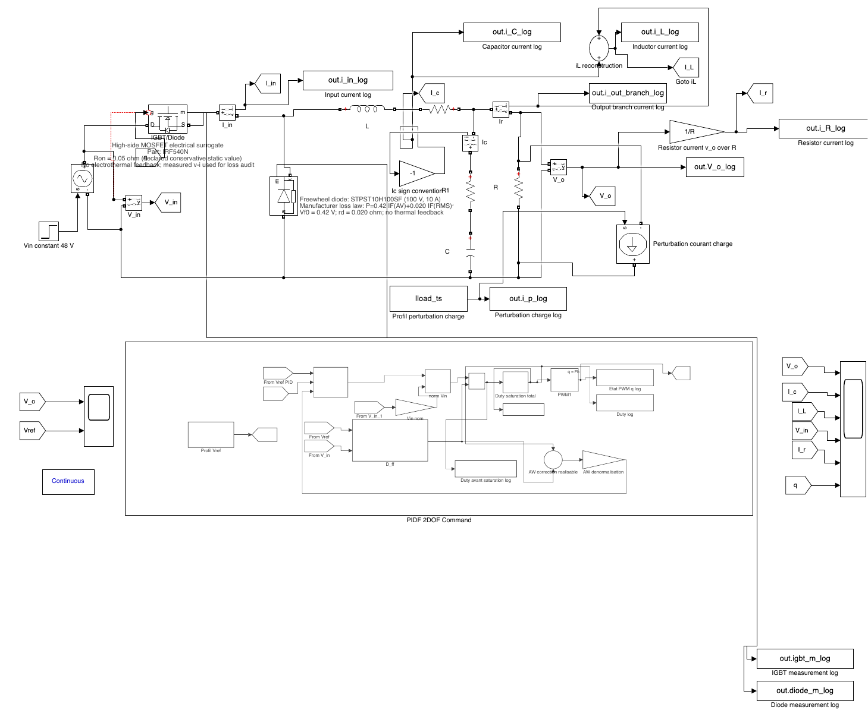
Figure 2: Reference Simulink/Simscape Electrical switching model (fixed 48 V source, IRF540N surrogate, STPST10H100SF diode, resistive snubber, continuous PWM at 50 kHz, sampled controller subsystem and energy loggers). Only the controller S-function is replaced when a candidate is replayed.

4 LQI synthesis in weight space and its exact 2-DOF PIDF realization

4.1 Integral augmentation and Bryson weights
Let $z(t)=\int_{0}^{t}{(}r−v_{o}) dτ$. Around the synthesis equilibrium ($V_{o}=24 V$) the augmented plant is
 | $${\dot{x}}_{a}=A_{a}x_{a}+B_{a}δd, A_{a}=\left[\begin{matrix}A & 0 \\ −C_{y} & 0\end{matrix}\right], B_{a}=\left[\begin{matrix}B_{d} \\ 0\end{matrix}\right], x_{a}=\left[\begin{matrix}δx \\ z\end{matrix}\right],$$ | (9)
and the LQI law $δd=−Kx_{a}$, $K=[K_{ix} K_{vx} K_{z}]$, minimizes $\int_{0}^{∞}{(}x_{a}^{T}Qx_{a}+R_{d}δd^{2}) dt$ with
 | $$A_{a}^{T}P+PA_{a}−PB_{a}R_{d}^{−1}B_{a}^{T}P+Q=0, K=R_{d}^{−1}B_{a}^{T}P.$$ | (10)
Bryson’s rule assigns $Q=diag(Δ_{i}^{−2},Δ_{v}^{−2},(Δ_{v}/ω_{B})^{−2})$ and $R_{d}=Δ_{d}^{−2}$: $Δ_{i}$ and $Δ_{v}$ are admissible current and voltage excursions and the integral state, in V s, is scaled by a target bandwidth $ω_{B}$. The duty excursion is fixed at its physical value $Δ_{d}=(d_{max}−d_{min})/2=0.48$, which removes the scale redundancy $(Q,R_{d})→(αQ,αR_{d})$ of (10). The decision vector of the co-design is
 | $$ξ=[\log_{10}Δ_{i}, \log_{10}Δ_{v}, \log_{10}ω_{B}, \log_{10}K_{b}]^{T},$$ | (11)
where $K_{b}$ is the back-calculation rate of the anti-windup, which lies outside the linear theory and is searched alongside the weights. The normalization record $ξ_{0}$ uses $Δ_{i}=15 A$, $Δ_{v}=46 V$ (the largest commanded output) and $ω_{B}=K_{b}=2π⋅1500 rad/s$.

4.2 Frequency-domain realization
For $i_{p}=0$ the output network gives, in the Laplace domain, $v_{C}=v_{o}/(1+r_{C}Cs)$ and $i_{L}=v_{o}/R+Csv_{o}/(1+r_{C}Cs)$. Substituting into the state part of the LQI law,
 | $$\frac{K_{ix}i_{L}+K_{vx}v_{C}}{v_{o}}=\frac{K_{ix}}{R}+\frac{K_{ix}Cs+K_{vx}}{1+r_{C}Cs}=K_{p}+K_{d}\frac{N_{C}s}{s+N_{C}},$$ | (12)
which exposes one constant and one filtered derivative term.
Proposition 1 (Nominal realization). The output-error compensator generated by the full-state LQI law is the 2-DOF PIDF
 | $$d=d_{ff}(r)+K_{p}(br−v_{o})+\frac{K_{i}}{s}(r−v_{o})+K_{d}\frac{N_{C}s}{s+N_{C}}(cr−v_{o}),$$ | (13)
with
 | $$\begin{aligned}K_{p}&=K_{vx}+\frac{K_{ix}}{R}, K_{i}=−K_{z}, K_{d}=C(K_{ix}−r_{C}K_{vx}), \\ N&=N_{C}=\frac{1}{r_{C}C}, b=1, c=0.\end{aligned}$$ | (14)
Proof. Split the right-hand side of (12) into its zero-frequency value $K_{vx}+K_{ix}/R$ and the remainder $C(K_{ix}−r_{C}K_{vx})N_{C}s/(s+N_{C})$. The equilibrium map $x_{eq}(r)=[r/R r]^{T}$ contributes $+(K_{ix}/R+K_{vx})r=K_{p}r$, hence $b=1$; the state-feedback law has no derivative of the reference, hence $c=0$; the integral state contributes $−K_{z}z$, hence $K_{i}=−K_{z}$. ◻
Because $N_{C}=2×{10}^{5} rad/s<π/T_{s}=3.14×{10}^{5} rad/s$, the exact filter pole is implementable at the adopted sampling period, and no projected surrogate is needed: every candidate of the search is realized with its own exact pole.

4.3 Structural (trajectory-level) equivalence
Proposition 1 is a statement about transfer functions, i.e. about the linear nominal plant with consistent initialization. The next result shows that the realization is in fact exact along every trajectory of the nonlinear converter, because it only uses the output network, never the inductor branch. Write the PIDF of (13) in state form,
 | $$\begin{aligned}\tilde{d}&=d_{ff}(r)+K_{p}(br−v_{o})+x_{I}+K_{d}N(cr−v_{o}−x_{F}), d=sat(\tilde{d}), \\ {\dot{x}}_{I}&=K_{i}(r−v_{o})+K_{b}(d−\tilde{d}), {\dot{x}}_{F}=N(cr−v_{o}−x_{F}),\end{aligned}$$ | (15)
and the LQI with the same feedforward and anti-windup as
 | $$\begin{aligned}\tilde{d}&=d_{ff}(r)−K_{ix}\left(i_{L}−r/R\right)−K_{vx}(v_{C}−r)−K_{z}z, \\ \dot{z}&=(r−v_{o})+{K_{b}}/{|K_{z}|}(d−\tilde{d}).\end{aligned}$$ | (16)
Proposition 2 (Structural equivalence). Let $r$ be piecewise constant, let the PIDF use (14) with $c=0$, $N=N_{C}$ computed from the true $(r_{C},C)$, and let $x_{F}(0)=−v_{C}(0)$ and $x_{I}(0)=−K_{z}z(0)$. Then, along every trajectory of the converter—averaged or switched, in continuous or discontinuous conduction, with or without active saturation and anti-windup, and for any values of $L$, $r_{L}$, $R_{on}$, $r_{d}$, $V_{f}$ and $V_{in}$:
- $x_{F}(t)=−v_{C}(t)$ for all $t≥0$;
- the two unsaturated commands satisfy
 | - $${\tilde{d}}_{LQI}(t)−{\tilde{d}}_{PIDF}(t)=−K_{ix}\left(i_{o}(t)−\frac{v_{o}(t)}{R}\right),$$ | (17)
- where $i_{o}=i_{L}−i_{C}$ is the actual output-branch current and $R$ the nominal load;
- if $i_{o}≡v_{o}/R$ (no load disturbance, nominal load), the two closed loops generate identical trajectories.
Proof. (i) The capacitor branch gives $v_{o}=v_{C}+r_{C}C{\dot{v}}_{C}$ exactly, whatever flows into the output node, so ${\dot{v}}_{C}=N_{C}(v_{o}−v_{C})$. Let $ε=x_{F}+v_{C}$. Between reference steps, with $c=0$, $\dot{ε}=N_{C}(−v_{o}−x_{F})+N_{C}(v_{o}−v_{C})=−N_{C}ε$, and $ε$ is continuous across steps because $c=0$. Hence $ε(0)=0$ implies $ε≡0$. (ii) With (i), the derivative term of (15) is $K_{d}N_{C}(v_{C}−v_{o})=−K_{d}N_{C}r_{C}i_{C}=−(K_{ix}−r_{C}K_{vx})i_{C}$. In (16) substitute $i_{L}=i_{o}+i_{C}$ and $v_{C}=v_{o}−r_{C}i_{C}$: $−K_{ix}(i_{L}−r/R)−K_{vx}(v_{C}−r)=K_{p}(r−v_{o})−(K_{ix}−r_{C}K_{vx})i_{C}−K_{ix}(i_{o}−v_{o}/R)$. With $b=1$ and $x_{I}=−K_{z}z$ the difference of the two commands is (17). (iii) If the right-hand side of (17) vanishes, both laws issue the same $\tilde{d}$ and $d$ at every instant. Then $\frac{d}{dt}(x_{I}+K_{z}z)=K_{i}(r−v_{o})+K_{b}(d−\tilde{d})−|K_{z}|(r−v_{o})−K_{b}(d−\tilde{d})=0$ because $K_{z}<0$, so $x_{I}=−K_{z}z$ is preserved, and the two closed-loop systems coincide; uniqueness of solutions gives identical trajectories. ◻
Three practical consequences follow. First, the PIDF does not approximate the LQI on the nonlinear converter; it is the LQI whenever the load current is the nominal one, and the saturation, anti-windup and conduction-mode effects that invalidate small-signal arguments do not break it. Second, the price of removing the current sensor is stated exactly by (17): the full-state law contains an instantaneous proportional feedback $−K_{ix}(i_{o}−v_{o}/R)$ on the unmodelled output current, which the PIDF must recover through its integral action. Third, the equivalence is lost by exactly three mechanisms: a load disturbance or load mismatch (through (17)), a mismatch of $(r_{C},C)$ (through $N≠N_{C}$ in (i)), and sampling, because the discrete filter reconstructs $v_{C}$ only between samples while the sampled LQI reads $i_{L}$ with its switching ripple. Section 6.2 verifies each case.

4.4 Guarantees and their scope
LQR margins. For the full-state augmented loop $L_{K}(s)=K(sI−A_{a})^{−1}B_{a}$ the return-difference identity gives $|1+L_{K}(jω)|≥1$, hence the gain margin $(1/2,∞)$ and a phase margin of at least 60 ° (Anderson and Moore, 1990; Safonov and Athans, 1977). By Proposition 2(iii) these margins are those of the PIDF loop at the input of the nominal linear plant; they do not survive sampling or an observer (Doyle, 1978).
Operating-polytope certificate. The augmented closed-loop matrix is affine in $(ρ_{0}(d_{0}),E_{d}(I_{L,0}))$. Over $v_{o}∈[1,46]$ V and $i_{p}∈[0,0.5]$ A the rectangle $d_{0}∈[0.0295764,0.9744132]$, $I_{L,0}∈[0.1,5.1]$ A has four vertices $A_{cl,k}$. A common $P≻0$ with
 | $$A_{cl,k}P+PA_{cl,k}^{T}+2αP≺0, \left[\begin{matrix}sinθ(M_{k}+M_{k}^{T}) & cosθ(M_{k}−M_{k}^{T}) \\ cosθ(M_{k}^{T}−M_{k}) & sinθ(M_{k}+M_{k}^{T})\end{matrix}\right]≺0,$$ | (18)
$M_{k}=A_{cl,k}P$, $ζ=cosθ$, places every closed-loop matrix of the convex hull in $\{ℜs<−α\}∩\{ζ(s)>ζ\}$ (Chilali and Gahinet, 1996). Bisection gives the boundary values; a 1 % safety factor is applied and the recovered $P$ is re-checked for strictness.
Discrete implementation. All controllers run at $T_{s}$ with a one-sample computational delay, total duty saturation and forward-Euler integral and back-calculation updates. Proposition 2(i) says that the derivative-filter state is an observer of the capacitor voltage, $x_{F}=cr−v_{C}$, and it should be discretized as one. The usual zero-order-hold discretization, $x_{F}[k+1]=ϕx_{F}[k]+(1−ϕ)w[k]$ with $w=cr−v_{o}$ and $ϕ=e^{−NT_{s}}$, uses at sample $k$ an estimate built from $v_{o}[k−1]$ only; during a 45 V slew $v_{o}$ moves by about 2.7 V per sample and $K_{d}N≈0.7$ turns this lag into a duty error of order one. We therefore use the triangle-hold (first-order hold) update, exact when $v_{o}$ is piecewise linear between samples,
 | $$x_{F}[k]=ϕ x_{F}[k−1]+(1−ϕ) w[k−1]+γ\left(w[k]−w[k−1]\right), γ=1−\frac{1−ϕ}{NT_{s}},$$ | (19)
evaluated with the current sample before the command $\tilde{d}[k]=d_{ff}+K_{p}(br[k]−v_{o}[k])+x_{I}[k]+K_{d}N(w[k]−x_{F}[k])$ is formed, and initialized with $x_{F}[0]=cr[0]−v_{C}(0)$. Section 6.2 shows that this single choice decides whether the sampled PIDF remains equivalent to the sampled LQI.

4.5 Numerical instantiation
At the 24 V point, (5) evaluates to
 | $$\begin{matrix}A=\left[\begin{matrix}−1850.8259 & −9950.2488 \\ 9950.2488 & −995.0249\end{matrix}\right]s^{−1}, \\ B_{d}=\left[\begin{matrix}483480 \\ 0\end{matrix}\right], C_{y}=\left[\begin{matrix}0.0497512 & 0.9950249\end{matrix}\right].\end{matrix}$$ | (20)
For $ξ_{0}$, $Q=diag(0.00444444,0.00047259,41978.4686)$, $R_{d}=4.34027778$ and (10) gives $K=[0.03564341 0.01212576 −98.34550916]$ with a relative Riccati residual of $2.18×{10}^{−14}$ and closed-loop poles $−4243.01$ and $−7917.86±j6986.57$ rad/s. The realization (14) gives
 | $$\begin{aligned}θ_{0}&=[K_{p},K_{i},K_{d},N,b,c,K_{b}] \\ &=[0.0156901028, 98.3455092, 3.5037119×{10}^{−6}, 2×{10}^{5}, 1, 0, 9424.778],\end{aligned}$$ | (21)
with a zero coefficient residual and a maximum relative frequency-domain error of $8.67×{10}^{−16}$ over $[{10}^{−1},{10}^{8}]$ rad/s. The minimum return difference is 1.000000 and the phase margin of the full-state loop is 87.04 °. The operating-polytope certificate at $ξ_{0}$ is $α_{cert}=4157.9286 rad/s$ and $ζ_{cert}=0.7330911$ ($λ_{min}(P)>0$ and strictly negative LMI eigenvalues were re-verified on the recovered matrices).

5 Constrained co-design problem and algorithms

5.1 Workflow
Fig. 3 summarizes the protocol. Offline, a candidate $ξ$ is mapped by (10) and (14) to a 2-DOF PIDF; the averaged evaluator runs six scenarios and the switched screen runs one 34 ms transition sequence; Deb ordering ranks the record. After 240 global and 60 local calls the best record of each run is frozen, and only then replayed on the full switched mission, which is never visible to the search.
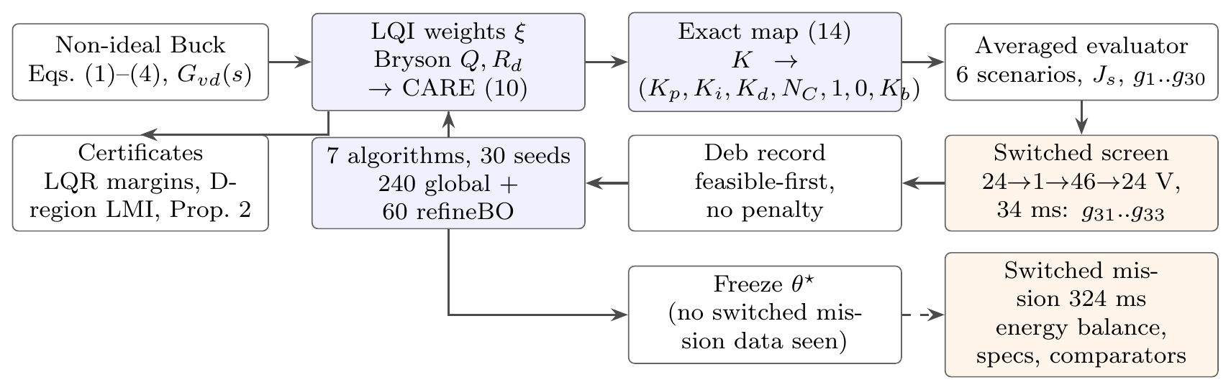
Figure 3: Formula-first CMO–LQI–PIDF workflow. Solid arrows: evaluation inside the search; dashed arrow: acceptance replay after the freeze. The switched screen is the only switched information used during the search.

5.2 Scenarios and objective
The averaged evaluator integrates (3) with the hybrid guard $i_{L}≥0$ (RK4, 2 μs) under the sampled control layer of Section 4. Six scenarios are declared (Table 4); each starts from the analytical equilibrium preceding its first event. For scenario $s$ the seven criteria are the loss intensity $E_{loss}/E_{u}$, IAE, ISE, global ITAE, event-reset ITAE, RMSE and MAE, each divided by its value for the normalization record $ξ_{0}$. The scalar objective is the mean of the $6×7$ ratios,
 | $$J_{s}(ξ)=\frac{1}{42}\sum_{s=1}^{6}{1^{T}}r_{s}(ξ), J_{s}(ξ_{0})=1.$$ | (22)
MAE is IAE divided by the horizon and RMSE is the square root of ISE divided by it, so two of the seven entries are redundant; the induced weights (2/7 on the IAE family, 2/7 on the ISE family, 1/7 on each other criterion) are declared rather than left implicit. The objective ranks feasible candidates only.
Table 4: Averaged scenarios (the source is 48 V in all of them).
ID | $T$ (ms) | reference | load pulse (+0.5 A)
S0 | 90 | 24$→$1$→$46 V at 30, 60 ms | 15–25 ms
S1a | 40 | 24$→$1 V at 10 ms | –
S1b | 40 | 1$→$46 V at 10 ms | –
S1c | 40 | 46$→$24 V at 10 ms | –
S2a | 40 | 24 V | 10–20 ms
S2b | 40 | 46 V | 10–20 ms

5.3 Thirty-three inequalities in engineering units
For each scenario five inequalities $g_{s,j}≤0$ are evaluated separately:
 | $$\begin{aligned}g_{s,1}&=\frac{\max_{t} σ_{k}\left(v_{o}−r_{k}\right)}{1.5 V}−1&&\text{overshoot beyond each new level}, \\ g_{s,2}&=\frac{\max_{t∈T_{p}}|r−v_{o}|}{0.5 V}−1&&\text{load-pulse deviation}, \\ g_{s,3}&=\frac{\max_{t}i_{L}+ΔI_{L,pp}^{max}/2}{23 A}−1&&\text{device current}, \\ g_{s,4}&=\frac{\max_{k}|{\overset{‾}{e}}_{k}|}{25 mV}−1&&\text{steady error}, \\ g_{s,5}&=\frac{ρ_{ℓ,s}−1}{0.005}−1, ρ_{ℓ,s}=\frac{E_{loss}/E_{u}}{(E_{loss}/E_{u})_{ξ_{0}}}&&\text{loss intensity},\end{aligned}$$ | (23)
where $σ_{k}$ is the sign of the $k$-th reference step, $T_{p}$ runs from the onset of the load pulse to the next event, ${\overset{‾}{e}}_{k}$ is the mean error over the last 2 ms of each constant segment and 23 A is the IRF540N continuous drain rating at 100 °C. The averaged peak current is augmented by the worst half ripple $ΔI_{L,pp}^{max}/2=1.17 A$ (Table 3). A family that does not apply to a scenario (no step, no load pulse) is set to $−1$. The loss-intensity gate keeps the design loss-aware: no scenario may convert energy less efficiently, per useful joule, than the Bryson record $ξ_{0}$ by more than 0.5 %. These 30 inequalities are completed by three measured ones,
 | $$g_{31}=\frac{\max_{k} pp(d)}{0.20}−1, g_{32}=\frac{\max_{k}|{\overset{‾}{e}}_{sw,k}|}{25 mV}−1, g_{33}=\frac{\max_{t}i_{L,sw}}{23 A}−1,$$ | (24)
obtained from one run of the switched replica over the transition sequence 24$→$1$→$46$→$24 V (steps at 2, 14 and 24 ms, 34 ms in total, 1 μs RK4 with exact PWM edges). The duty peak-to-peak and the mean error are measured over the last 4 ms of each level. A candidate is feasible when j​max(gj,0)≤10−4; the screen costs about 12 ms per candidate against 14 ms for the six averaged scenarios.
Why the screen contains large transitions. The protocol was frozen after two pilot campaigns that are reported, not hidden. Pilot 1 used the analytical ripple bound of the earlier version of this study, $ρ_{rip}=\max_{V}|C_{fb}(z=−1)|ΔV_{o,pp}(V)/2≤0.20$, where $C_{fb}$ is the discrete feedback path evaluated at the controller Nyquist frequency, which coincides with the carrier frequency because $T_{s}=1/(2f_{s})$. Every branch winner it produced satisfied the bound ($ρ_{rip}≈0.07$–$0.19$) and yet, on the switched model, several sustained a limit cycle with duty swings of 0.7–0.9 at 24 V and offsets of 0.3–1.8 V. Pilot 2 replaced the bound by steady 10 ms switched windows started from equilibrium at 1, 24 and 46 V. Its best design (178 of 180 runs feasible) passed that screen, but on the reference mission it entered, after the large 24$→$1 V transition, a different limit cycle in which one sample in four clips at $d_{min}$, leaving a −42 mV offset at 1 V. The loop thus holds coexisting switching limit cycles, and the one reached depends on the transient that precedes it; this is why the final screen is a transition sequence. $ρ_{rip}$ is kept as a reported diagnostic only. Both pilots used the zero-order-hold filter; the triangle-hold update (19), adopted after the equivalence audit of Section 6.2, removes most of the limit-cycling designs by itself.
Useful-energy band. The earlier protocol also required $|E_{u}/E_{u,ξ_{0}}−1|≤0.5 \%$ in every scenario. We report this quantity but no longer constrain it. Anchored to $ξ_{0}$, it penalizes the removal of the 9.8 V undershoot of $ξ_{0}$ on the 46$→$24 V step, because a controller that holds 24 V delivers more energy than one that undershoots; anchored to the ideally regulated task, it penalizes every controller by 1–5 % on step-down scenarios, where the asynchronous converter can only discharge through its load. With absolute overshoot, load-deviation and steady-error gates the delivered task is already pinned, and the loss intensity is normalized per useful joule, so under-delivery cannot improve it.
Feasibility is stated in absolute units, not as non-inferiority against $ξ_{0}$. With ratio gates, 24 of 36 constraints are active at $ξ_{0}$ and a gentler normalization record leaves no candidate that dominates it; with absolute gates every controller family of Section 5.5 is judged against the same specification, and $ξ_{0}$ itself is infeasible because it overshoots by 6.2 V on the 1$→$46 V step.

5.4 Algorithms and budgets
Constraint handling uses Deb’s rules (Deb, 2000): feasible beats infeasible, feasible records are ranked by $J_{s}$, infeasible ones by aggregate violation; no penalty weight is tuned. All methods work in the normalized box $u∈[0,1]^{n}$, receive the matched seed $2026091200+k$, $k=1,…,30$, and the same initial population of 12: $ξ_{0}$ first, six further individuals within a normalized radius 0.05 of it, five uniform. One counted call is one complete evaluation (six averaged scenarios, the switched screen, 33 inequalities). Table 5 lists the operators.
Table 5: Algorithms 1–7. Population 12, 240 global calls, then 60 refineBO calls initialized from the same run’s history (300 calls per run).
Alg. | Exploration / update | Exploitation / survival | Fixed parameters
1 PSO (Kennedy and Eberhart, 1995) | velocity with independent cognitive and social draws | personal and global Deb incumbents | $w=0.9−0.5τ$, $c_{1}=c_{2}=1.7$, $|v|≤0.2$
2 GA | binary Deb tournaments, SBX crossover | polynomial mutation, elitist $(μ+λ)$ | $η_{c}=15$, $η_{m}=20$, $p_{m}=1/n$
3 ABC (Karaboga and Basturk, 2008) | one-coordinate differential move (employed, onlooker) | greedy Deb replacement, scout | limit $max(5,round(0.5 n_{p}n))$
4 pAEABC | ABC move scaled by diversity $s_{k}=clip(0.5+0.15/D_{k},0.5,2)$, extra coordinate kick w.p. $0.25(1−τ)$ | as ABC | inspired by Alsamia et al. (2024)
5 pIGWO | three-leader GWO with $a=2(1−τ^{2})$, Gaussian kick w.p. $0.15(1−τ)+0.02$ | elitist pooling | inspired by Hou et al. (2022)
6 pIGWO–DLH | linear $a=2−2k/K$ GWO trial and an independently evaluated radial local-hunt trial | better trial replaces the wolf (non-elitist) | $R_{i}=∥x_{i}−x_{α}∥/2$; inspired by Nadimi-Shahraki et al. (2021)
7 refineBO | shared-kernel Matérn-5/2 GPs on $J_{s}$ and $g_{1},…,g_{33}$; pool of 1000 around the 10 Deb-best records, radius $0.04→0.003$ | $α=P_{f}(EI+0.02σ_{J})+{10}^{−4}P_{f}$, Pf=j​Φ(−μj/σj); restoration mode if no feasible incumbent | 60 calls
The prefix “p” marks project variants that are inspired by, but not claimed to be operator-identical with, the cited algorithms. $τ$ is the fraction of the budget consumed. The product $P_{f}$ of marginal feasibility probabilities is an independence approximation used for ordering only; every accepted point is checked by the exact evaluator. Wall time is logged but never interpreted as an energy or performance quantity.

5.5 Controller families and fixed-rule comparators
To separate the value of the parameterization from that of the optimizer, the identical protocol (evaluator, 33 inequalities, 7 algorithms, 30 seeds, 300 calls) is run on six families:
- CMO–LQI–PIDF: $ξ$ of (11) $→$ (10) $→$ (14); 4 variables, reads $v_{o}$ only;
- CMO–LQI–SF: the same $ξ$ and the same continuous gain, applied as full-state LQI with measured $i_{L}$ and $i_{C}$ (the twin of Proposition 2);
- PIDF-direct: the same 2-DOF structure ($b=1$, $c=0$, $N=N_{C}$) with $(logK_{p},logK_{i},logK_{d},logK_{b})$ searched directly over the gain ranges spanned by the LQI box;
- PIDF7-direct: $K_{p},K_{i},K_{d},N,b,c,K_{b}$ all free (7 variables);
- PID-direct: backward-difference derivative on $−v_{o}$, $b=1$, $(K_{p},K_{i},K_{d},K_{b})$ free;
- PI-direct: $(K_{p},K_{i},K_{b})$ free.
Fixed-rule comparators. Six classical designs share the control layer and are synthesized at 24 V, $T_{s}=10 μs$, with the delay $1.5T_{s}$ (computation plus ZOH) in every frequency-domain rule. PI: crossover $0.03f_{s}$, phase margin 60 °, $K_{b}=K_{i}/K_{p}$. PID: zeros cancelling the $LC$ pair of $Δ(s)$, crossover set for 60 ° of phase margin including the ESR zero, backward-difference derivative on $−v_{o}$, $b=1$, $c=0$, $K_{b}=1/\sqrt{T_{i}T_{d}}$. PIDF: the Type-III rule, i.e. the PID zeros plus a filter pole on the ESR zero $N=N_{C}$, 60 ° of phase margin. LQR: discrete Riccati solution on the ZOH model with the Bryson limits of $ξ_{0}$, measured $i_{L}$ and $v_{C}=v_{o}−r_{C}i_{C}$, no integral action. LQG: the LQR gain with a steady-state Kalman predictor on $v_{o}$ only (process noise 0.01 in duty, measurement noise 0.05 V). LQI: discrete Riccati solution of the integral-augmented ZOH model with the same weights, measured state, $K_{b}=ω_{B}$. None of them is tuned by the proposed search; they represent what the standard rules deliver on this plant.

5.6 Statistics and validation
Methods are compared as matched blocks over the 30 seeds with the Friedman test and Holm-adjusted paired Wilcoxon signed-rank tests (Demšar, 2006); a run’s score is $J_{s}$ if feasible and ${10}^{3}$ plus its violation otherwise, which is consistent with Deb ordering. Families are compared pairwise on the same (method, seed) cells. The retained controller of each family is the best feasible record over its 180 runs; it is frozen and replayed on the 324 ms reference mission of the Simulink model (24$→$1$→$46 V at 108 and 216 ms, +0.5 A load pulse at 54–90 ms, initial state at the 24 V equilibrium), with the energy balance of (8).

6 Results and discussion

6.1 Formula-first verification
Every analytical quantity of Sections 3–4 was recomputed twice: from the closed forms and from independent numerical routes (state-space to transfer-function conversion, a general CARE solver, a frequency sweep of (12) against (13), and an SDP solver for (18)). The results of Section 4.5 agree with the values archived by the earlier version of this study, obtained with a different code base: the gain, the poles and $θ_{0}$ to all printed digits, and the LMI bounds $α_{cert}$, $ζ_{cert}$ to within $2×{10}^{−7}$ relative, the bisection tolerance. The companion MATLAB script cmo_formula_first.m repeats the chain with icare and freqresp.

6.2 The equivalence, tested where it should hold and where it should fail
Table 6 and Fig. 4 test Proposition 2 on the 324 ms reference mission with continuous-time controllers on the nonlinear averaged plant (RK4, 0.05 μs). With nominal output network and no load pulse the LQI and its 2-DOF PIDF produce identical trajectories to $1.6×{10}^{−13}$ V, although 1.1 % of the mission is spent in duty saturation, the averaged DCM guard $i_{L}≥0$ is active and the anti-windup path is exercised. Changing $L$ by $−20 \%$ and doubling $r_{L}$ and $R_{on}$ leaves the identity intact ($2.8×{10}^{−14}$ V, with 34.1 % of saturation), exactly as the proof predicts, because these parameters never enter the output network. The three predicted failure modes appear with the predicted signs: a 0.5 A load pulse (0.411 V), a 20 % load mismatch (0.609 V) and a 20 % capacitance mismatch that detunes $N$ from $N_{C}$ (2.823 V).
Sampling is the practical case. With the zero-order-hold filter the sampled PIDF departs from the sampled full-state LQI by 14.54 V on the 1$→$46 V step; with the triangle-hold update (19) the departure falls to 0.35 V, while both sampled laws sit 2.54 V from the continuous trajectory because of the common one-sample delay. The realization is therefore exact in continuous time and remains a close realization under sampling provided the filter is discretized as the capacitor-voltage observer it is.
Table 6: Structural-equivalence audit (Proposition 2): largest $|v_{o}^{LQI}−v_{o}^{PIDF}|$ over the 324 ms mission.
Case | predicted | measured
nominal, $i_{p}=0$ | identical | $1.6×{10}^{−13}$ V
$L−20 \%$, $r_{L}×2$, $R_{on}×2$ | identical | $2.8×{10}^{−14}$ V
0.5 A load pulse | $≠$, Eq. (17) | 0.411 V
$R+20 \%$ | $≠$, Eq. (17) | 0.609 V
$C+20 \%$ | $≠$, $N≠N_{C}$ | 2.823 V
sampled, ZOH filter, 1$→$46 V | close | 14.54 V
sampled, FOH filter (19), 1$→$46 V | close | 0.35 V
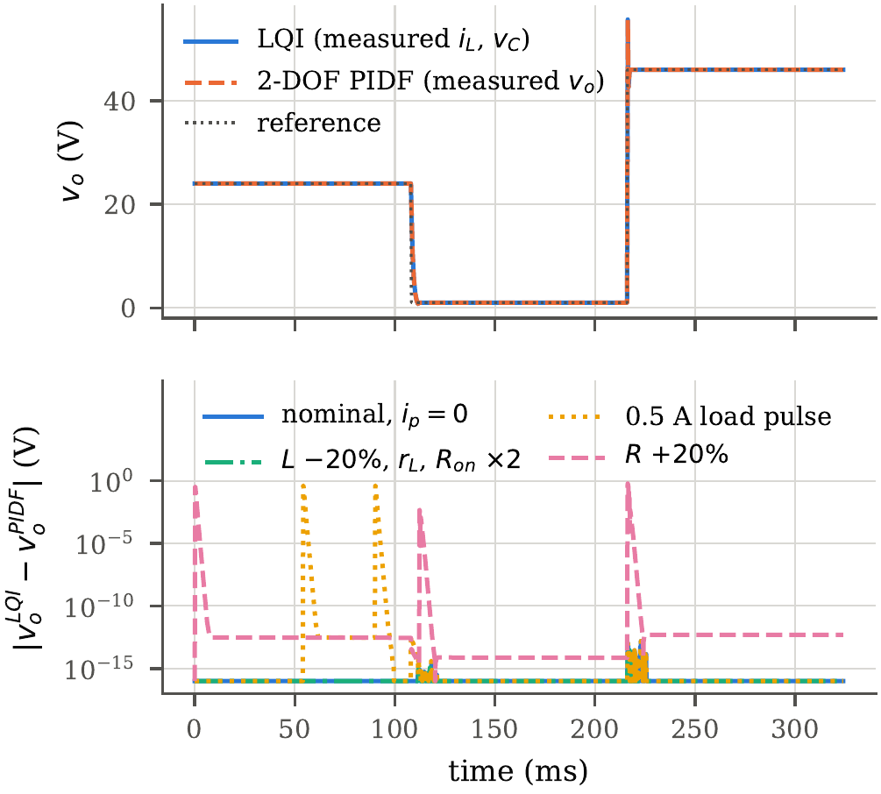
Figure 4: Top: LQI with measured $(i_{L},v_{C})$ and its 2-DOF PIDF with measured $v_{o}$ on the reference mission (continuous time, averaged nonlinear plant, saturation active). Bottom: absolute output difference; the nominal and inductor-branch-mismatch curves lie at the floating-point floor, the load-pulse and load-mismatch curves show the predicted departures.

6.3 Seven algorithms on the LQI-weight space
Table 7 and Fig. 5(a) summarize the 180 runs of the CMO–LQI–PIDF family. 124 runs end feasible. All six branches converge to the same optimum: their best records lie between 0.8151 and 0.8153, a spread of $2×{10}^{−4}$, and decode to practically the same controller. The LQI-weight space therefore has a single, well-defined optimum under the 33 inequalities, and the retained design is not an artefact of one operator or one seed. The retained record improves the normalized objective by 18.5 % with respect to the Bryson record $ξ_{0}$, while $ξ_{0}$ itself violates the overshoot specification.
What separates the operators is reliability, not the optimum. The Friedman test over matched seeds rejects equality ($Q=11.96$, $p=0.035$); after Holm correction 1 pairwise difference remains (GA–pIGWO). pIGWO reaches a feasible design in 28 of 30 seeds and pAEABC in 25, against 13 for GA. The refinement stage matters most where the global stage is weakest: it raises the number of feasible runs from 8 to 17 for ABC and from 18 to 25 for pAEABC (Table 7), whereas it adds one run for pIGWO and none for PSO and GA. A practitioner who can afford only one run should therefore prefer the grey-wolf or adaptive-bee variant followed by refineBO; one who can afford a few seeds can use any of the six.
Table 7: CMO–LQI–PIDF family: 30 matched seeds per algorithm (Algorithms 1–6, each followed by refineBO). $J_{s}$ statistics over feasible runs; “global counts runs already feasible after the 240 global calls.
Algorithm | feasible | global | best $J_{s}$ | median | IQR | mean rank
PSO | 18/30 | 18/30 | 0.8152 | 0.8283 | 0.0208 | 3.77
GA | 13/30 | 13/30 | 0.8151 | 0.8330 | 0.0190 | 4.23
ABC | 17/30 | 8/30 | 0.8152 | 0.8163 | 0.0162 | 3.77
pAEABC | 25/30 | 18/30 | 0.8151 | 0.8161 | 0.0177 | 2.77
pIGWO | 28/30 | 27/30 | 0.8153 | 0.8308 | 0.0205 | 3.10
pIGWO-DLH | 23/30 | 18/30 | 0.8152 | 0.8291 | 0.0256 | 3.37
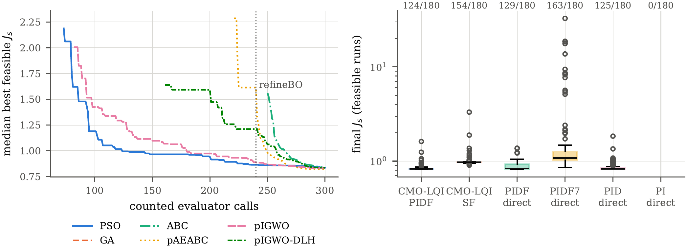
Figure 5: (a) Median best-feasible objective against counted calls for the CMO–LQI–PIDF family (dotted line: end of the global stage); a curve starts once at least half of the 30 seeds hold a feasible record, which GA never achieves (13/30). (b) Final objective of the feasible runs of every family under the identical protocol, with the number of feasible runs out of 180 above each box.
Retained controller. The retained weights are $Δ_{i}=10.842 A$, $Δ_{v}=3.301 V$, $ω_{B}=6505 rad/s$, giving $K=[0.090893, 0.165271, −945.806]$ and closed-loop poles $−6493$ and $−20149±j17169$ rad/s. Its exact realization is
 | $$θ^{⋆}=[K_{p},K_{i},K_{d},N,b,c,K_{b}]=[0.17436, 945.81, 8.2629×{10}^{−6}, 2×{10}^{5}, 1, 0, 92951].$$ | (25)
Being an LQI law, it inherits the full-state LQR margins (minimum return difference 1, phase margin 70.25 °), and the common-$P$ certificate over the operating polytope gives $α_{cert}=6414.8 rad/s$ and $ζ_{cert}=0.7496$, i.e. 1.54 times the guaranteed decay rate of $ξ_{0}$ at slightly better guaranteed damping. None of these certificates is available for a gain vector found by direct search.

6.4 Does the LQI parameterization help? Six families, one protocol
Table 8 and Fig. 5(b) compare six families run under the identical protocol, so that the only difference between two rows is the space in which the seven algorithms search.
Same structure, different coordinates. PIDF-direct searches the same 2-DOF PIDF ($b=1$, $c=0$, $N=N_{C}$) directly in $(logK_{p},logK_{i},logK_{d},logK_{b})$ over the gain ranges spanned by the LQI box. It reaches the same optimum (best $J_{s}=0.8154$ against 0.8151) with a similar number of feasible runs (129 against 124 of 180), and the paired comparison on the same (algorithm, seed) cells is not significant ($p=0.74$). The LQI coordinates therefore do not make the search easier on this problem. What they change is what every candidate is. Inverting the map (14) and applying Kalman’s return-difference condition shows that the best direct-search design is itself LQ-optimal, $K=[0.0906, 0.1650, −943.2]$ with $\min_{ω}|1+L_{K}(jω)|=1$, i.e. the gain search converges onto the LQ manifold; yet only 75 of its 129 feasible designs satisfy the condition, so 42 % of the controllers an equally lucky gain search may return carry no LQ optimality, no guaranteed margins and no reason to be certifiable. The LQI parameterization confines the search to that manifold from the first evaluation, at no cost in optimality.
Richer and poorer structures. PID-direct (backward-difference derivative) reaches best $J_{s}=0.8249$ in 125 feasible runs and is not significantly different from CMO–LQI–PIDF ($p=0.41$). PIDF7-direct, with free filter pole and setpoint weights, finds more feasible runs (163) but a worse optimum (0.8513), with $N=141939$ rad/s, $b=1.00$ and $c=0.31$; on the switched mission this design holds the 1 V level with 0.0 mV of error and IAE 0.0348 V s, i.e. the extra freedom buys switched robustness at the price of the averaged objective. PI-direct never becomes feasible (minimum violation 1.04): a PI cannot meet the overshoot, load-deviation and current specifications of the six scenarios at once, and the paired comparison is decisive ($p=2.7×{10}^{−31}$).
The full-state twin. CMO–LQI–SF uses the same four variables but applies the gain as a measured-state LQI. It is feasible more often (154 runs) but at a worse averaged optimum (0.9054) than its output-feedback realization ($p=0.035$ in favour of the PIDF on the averaged objective). On the switched mission the ordering reverses (Section 6.5): the twin is the more robust controller at the 1 V level, which is the switched counterpart of the output-current term of (17).
What the protocol, rather than the parameterization, buys. Every family tuned under the constrained multi-fidelity protocol ends close to full compliance on the reference mission (Table 9: $u$ between 0.74 and 1.02; the lowest value belongs to a slow PI whose IAE, 0.0943 V s, is 2.6 times that of the others), whereas the six fixed-rule designs lie between 6.28 and 30.17. The decisive ingredients are the engineering-unit specification and the switched transition screen; the choice of search coordinates decides the guarantees that come with the result.
Table 8: Controller families under the identical protocol (7 algorithms, 30 seeds, 300 calls, 33 inequalities). Paired comparison with CMO–LQI–PIDF on the same (algorithm, seed) cells: Deb-consistent score, two-sided Wilcoxon signed-rank test.
Family | variables | feasible runs | best $J_{s}$ | median $J_{s}$ (feasible) | CMO better / tie / worse | $p$ | min. violation
CMO-LQI-PIDF | 4 (LQI weights, $K_{b}$) | 124/180 | 0.8151 | 0.8287 | – | – | 0.000
CMO-LQI-SF | 4 (same, full state) | 154/180 | 0.9054 | 0.9749 | 132 / 0 / 48 | $3.5×{10}^{−2}$ | 0.000
PIDF-direct | 4 ($K_{p},K_{i},K_{d},K_{b}$) | 129/180 | 0.8154 | 0.8273 | 99 / 0 / 81 | $7.4×{10}^{−1}$ | 0.000
PIDF7-direct | 7 (+$N,b,c$) | 163/180 | 0.8513 | 1.1018 | 121 / 0 / 59 | $7.7×{10}^{−1}$ | 0.000
PID-direct | 4 | 125/180 | 0.8249 | 0.8278 | 99 / 0 / 81 | $4.1×{10}^{−1}$ | 0.000
PI-direct | 3 | 0/180 | – | – | 180 / 0 / 0 | $2.7×{10}^{−31}$ | 1.041

6.5 Switched validation on the reference mission
Table 9 and Fig. 6 report the frozen controllers on the 324 ms mission of the reference model. The energy balance closes to better than $4.5×{10}^{−6} \%$ of the input energy for every row, so all efficiency and loss figures are resolved by the integrator. As a fidelity check against the Simulink audit of the earlier version of this study, the replica gives for the fixed PI 26.63 V of overshoot, 40.78 A and IAE 0.0480 V s (Simulink: 26.75 V, 40.76 A, 0.0464 V s) and for the fixed LQI 9.41 V, 32.61 A and 0.0348 V s (Simulink: 9.56 V, 31.27 A, 0.0346 V s).

Table 9: Switched replay on the 324 ms reference mission (24$→$1$→$46 V, 0.5 A load pulse). Specification ratios: overshoot/1.5 V, load deviation/0.5 V, peak $i_{L}$/23 A, worst steady error/25 mV, steady duty peak-to-peak/0.20; a ratio $≤1$ meets the specification. $u$ is the largest ratio. Energy residual below $4.5×{10}^{−6} \%$ for every row.
Controller | IAE (V s) | overshoot (V) | $i_{L,pk}$ (A) | $|\overset{‾}{e}|_{max}$ (mV) | load dev. (V) | $η$ (%) | $E_{loss}/E_{u}$ | sat. frac. | $u$ | specs met | sensors
CMO–LQI–PIDF (retained, $v_{o}$ only) | 0.0364 | 0.02 | 22.44 | 25.6 | 0.137 | 97.978 | 0.01801 | 0.089 | 1.02 | 4/5 | $v_{o}$
CMO–LQI–SF (twin, measured $i_{L}$) | 0.0347 | 0.02 | 22.87 | 0.0 | 0.214 | 97.978 | 0.01800 | 0.008 | 0.99 | 5/5 | $v_{o},i_{L},i_{C}$
PIDF, direct gain search | 0.0363 | 0.02 | 22.42 | 25.0 | 0.137 | 97.978 | 0.01801 | 0.089 | 1.00 | 5/5 | $v_{o}$
PIDF7, direct search | 0.0348 | 0.02 | 22.11 | 0.0 | 0.164 | 97.978 | 0.01800 | 0.011 | 0.96 | 5/5 | $v_{o}$
PID, direct search | 0.0368 | 0.02 | 21.83 | 23.7 | 0.138 | 97.980 | 0.01798 | 0.087 | 0.95 | 5/5 | $v_{o}$
PI, direct search | 0.0943 | 0.23 | 6.04 | 6.8 | 0.369 | 97.987 | 0.01786 | 0.009 | 0.74 | 5/5 | $v_{o}$
Bryson LQI–PIDF $ξ_{0}$ | 0.0340 | 8.05 | 32.50 | 0.0 | 0.193 | 97.936 | 0.01845 | 0.012 | 5.37 | 3/5 | $v_{o}$
PI (loop shaping) | 0.0480 | 26.63 | 40.78 | 0.1 | 0.474 | 97.813 | 0.01972 | 0.012 | 17.76 | 3/5 | $v_{o}$
PID (pole–zero) | 0.0467 | 28.64 | 40.77 | 11.3 | 0.128 | 97.802 | 0.01984 | 0.093 | 19.09 | 3/5 | $v_{o}$
PIDF (Type III) | 0.0453 | 28.65 | 40.78 | 0.0 | 0.157 | 97.801 | 0.01986 | 0.013 | 19.10 | 3/5 | $v_{o}$
LQR | 0.1339 | 0.97 | 24.36 | 754.3 | 0.805 | 97.969 | 0.01811 | 0.001 | 30.17 | 2/5 | $v_{o},i_{L},i_{C}$
LQG | 0.0716 | 0.28 | 24.39 | 289.5 | 0.466 | 97.960 | 0.01818 | 0.000 | 11.58 | 3/5 | $v_{o}$
LQI (discrete, full state) | 0.0348 | 9.41 | 32.61 | 0.0 | 0.552 | 97.931 | 0.01849 | 0.013 | 6.28 | 2/5 | $v_{o},i_{L},i_{C}$

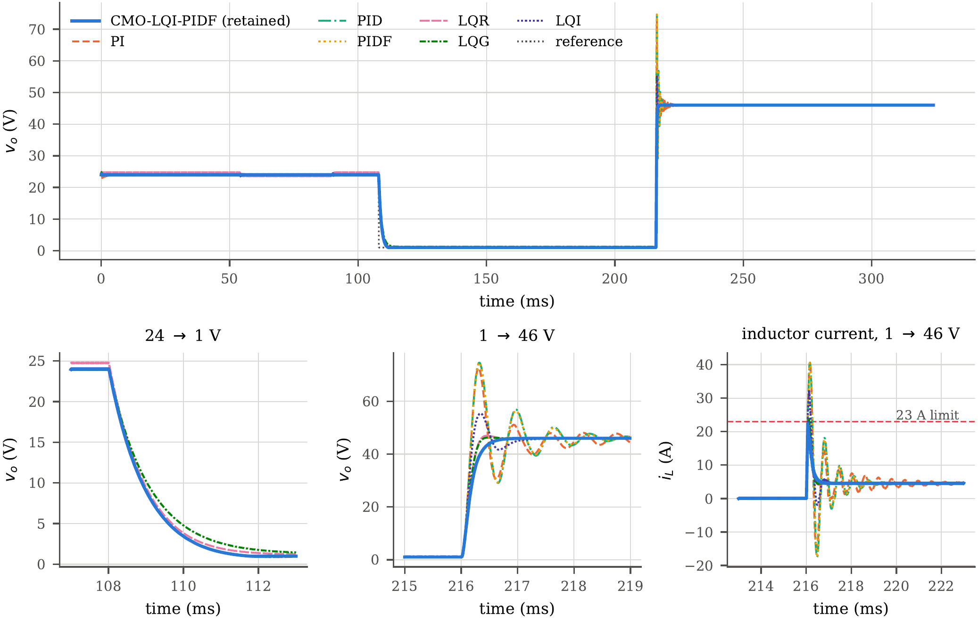
Figure 6: Switched replay on the reference mission: retained CMO–LQI–PIDF and the six fixed-rule comparators. Bottom: 24$→$1 V and 1$→$46 V transitions and the inductor current on the 1$→$46 V step against the 23 A device limit.
Answer to the comparison question. Against the six classical designs the result is unambiguous on the specification, and nuanced on individual indices.
- PI, PID and PIDF designed by standard frequency-domain rules hold every level but overshoot the 1$→$46 V step by 26.63–28.65 V and draw about 40.78 A, i.e. 1.8 times the 23 A device rating; their specification ratios are 17.76–19.10.
- LQR and LQG, having no integral action, leave offsets of 754.3 and 289.5 mV at the worst level.
- LQI, synthesized from the same Bryson limits and reading the full state, tracks well (IAE 0.0348 V s) but overshoots by 9.41 V and peaks at 32.61 A.
- The retained CMO–LQI–PIDF, reading $v_{o}$ only, removes the overshoot, stays at 22.44 A, keeps the load deviation at 0.137 V and converts at 97.978 %, against 97.80–97.97 % for the six fixed-rule designs. Its IAE, 0.0364 V s, is within 5 % of the LQI and 7 % of $ξ_{0}$, whose lower IAE is bought with 8–9 V of overshoot. It misses one of the five mission specifications by 0.6 mV: 25.6 mV of steady error at 1 V for a 25 mV limit ($u=1.02$).
- Its full-state twin CMO–LQI–SF, with the same weights and a measured inductor current, meets all five specifications ($u=0.99$) with IAE 0.0347 V s.
The procedure is therefore superior to the six classical design rules in the sense that matters to an industrial user: every controller it returns, in any of the tuned families of Table 8, removes the overshoot, stays within the device rating and holds the levels, with specification ratios between 0.74 and 1.02 against 6.28–30.17 for PI, PID, PIDF, LQR, LQG and LQI. It does not dominate every index: the LQI and $ξ_{0}$ track slightly better in IAE, at the cost of 8–9 V of overshoot and 32–33 A of peak current. The retained CMO–LQI–PIDF and its direct-search counterpart are practically the same controller (IAE 0.0364 and 0.0363 V s), and their 1 V steady error sits on the 25 mV line (25.6 and 25.0 mV); this level is the binding one, which the switched screen resolves only to within a millivolt because it is a shorter transient than the mission.
The value of the current sensor. Among the LQI-structured controllers, the full-state twin meets every specification and the output-feedback realization misses one by 0.6 mV. By Proposition 2 the two differ only by the term $−K_{ix}(i_{o}−v_{o}/R)$ of (17), an instantaneous feedback on the unmodelled output current. At 1 V in discontinuous conduction the output-current estimate $v_{o}/R$ is least accurate relative to the signal, and the PIDF must remove the resulting bias through its integrator in the presence of a switching limit cycle; the twin removes it directly. The gap between the two rows of Table 9 is thus the measured dividend of one current sensor, predicted in sign and location by the theory. The efficiencies of all tuned designs agree within 0.01 percentage point (97.978–97.987 %), so the conversion loss does not discriminate between them; it does separate them from the fixed-rule designs, whose overshoots and current peaks cost 0.01–0.18 percentage point.

6.6 Limitations
The evidence is simulated. The switched replica reproduces the controller-independent figures of the reference Simulink model and its fixed comparators, but the final numbers of Table 9 should be regenerated on the .slx with the provided S-function before being quoted as Simulink results. Losses are the modelled conduction and snubber losses of the declared boundary; dynamic switching loss, reverse recovery, magnetic and thermal effects are outside it, and the efficiency differences between rows (a few hundredths of a percentage point) are far below the accuracy of a laboratory power analyser. Component tolerances were not supplied and are not claimed: the common-$P$ certificate covers the nominal operating polytope only. The mission and the specification are those of a fixed 48 V source; line regulation is outside the study. Finally, the specification set and the filter discretization were revised during pilot campaigns that are reported in Section 5 and Appendix B; the final campaign was run once, with the protocol frozen, and its switched validation was not used for selection.

7 Conclusions
A formula-first co-design was carried out for a non-ideal asynchronous Buck converter supplied at 48 V and commanded over 1 V–46 V. Its search space is the set of Bryson excursions of an LQI cost, so every evaluated point is a Riccati-optimal law with LQR margins and an operating-polytope certificate, and every point is implemented exactly as a 2-DOF PIDF that measures the output voltage only.
Three results carry the paper.
Theory. The realization is structural, not only nominal: the derivative filter of the PIDF, with its pole at the ESR zero, reconstructs the capacitor voltage along every trajectory of the converter, so the PIDF and the full-state LQI coincide under saturation, anti-windup and discontinuous conduction and for any inductor-branch or semiconductor parameters. They differ only by an explicit feedback on the unmodelled output current, by a mismatch of the output network, and by sampling. Under sampling the equivalence survives when the filter is discretized as the observer it is: a triangle-hold update keeps the sampled PIDF within 0.35 V of the sampled LQI on a 45 V step, where the usual zero-order-hold update departs by 14.54 V.
Optimization. Seven algorithms applied to the four LQI weights converge to one optimum; they differ in reliability, pIGWO and pAEABC reaching feasibility in 28 and 25 of 30 seeds against 13 for GA, and the Gaussian-process refinement matters most where the global stage is weakest. Searching the same 2-DOF PIDF directly in gain space reaches the same optimum, which turns out to be LQ-optimal; the LQI parameterization does not accelerate the search on this problem, but it confines it to the manifold on which the optimum lies and gives every candidate its margins and certificate, whereas 42 % of the feasible direct-search designs are not LQ-optimal for any weight.
Validation. Switched admissibility is not inherited from an averaged model: an analytical ripple bound and a steady switched screen both admitted designs that limit-cycle on the reference mission, because the loop holds coexisting switching limit cycles selected by the preceding transient. A 34 ms switched transition screen inside the search removes them. On the reference mission, the retained CMO–LQI–PIDF removes the overshoot of the classical designs and stays within the 23 A device rating; its only miss is a steady error of 25.6 mV at 1 V against a 25 mV limit, which its full-state twin meets. PI, PID, PIDF, LQR, LQG and LQI designed by their standard rules exceed at least two specifications by factors of 6 to 30.
The contribution is therefore a design procedure an industrial engineer can apply with standard tools: choose admissible excursions, solve one Riccati equation, realize the gain as a PIDF with setpoint weight one and a derivative pole on the ESR zero, discretize the filter as a capacitor-voltage observer, and let a small, constrained, multi-fidelity search tune four physically meaningful numbers. Hardware validation, component-tolerance robustness and line regulation are the next evidence levels.

Appendix A. Reproducibility record
Reference model. buck_fo_lqi_fixed_reference_v6_1_46V_R2022a.slx, SHA-256 948fbae2679b57ed726a92eeebcae398aaf0ca6b9b3a74216759ca80b390c7fe. All plant, mission and logging parameters of Table 2 were decoded from its model workspace; the snubber is resistive ($R_{s}=100 kΩ$, $C_{s}=∞$) on the MOSFET only, the diode snubber is disabled, and the MOSFET body diode has $R_{d}=0.01 Ω$, $V_{fd}=0$. The saved model initializes $L$ at 1.2 A and $C$ at 12 V; all replays of this paper start at the 24 V equilibrium (2.4 A, 24 V).
Commands. From the repository root:
python scripts/cmo_formula_first.py # Sections 3-4, Prop. 2 tests
python scripts/cmo_campaign.py # 6 families x 6 methods x 30 seeds
python scripts/cmo_analyze.py # statistics, freeze, switched replay
python scripts/cmo_figures.py; python scripts/cmo_numbers.py
In MATLAB (R2022a or later, Simscape Electrical, Control System Toolbox):
cmo_formula_first
T = run_cmo_validation(slx, 'results/cmo/controllers.csv');
The second call replaces only the controller S-function (cmo_sfun, a line-by-line port of cmo/ctrl.py) and never saves the model.
Seeds and budgets. Seeds $2026091201,…,2026091230$; population 12; 240 global and 60 refineBO calls per run; 30 runs per method and family. Each checkpoint stores the method, seed, best decision vector, objective, the 33 inequalities, the global-stage record and the best-so-far curve.

Appendix B. Protocol changes with respect to the earlier version
Table B.1: Declared changes and their reasons.
Change | Reason
Feasibility in engineering units instead of ratios to $ξ_{0}$ | with ratio gates 24 of 36 constraints are active at $ξ_{0}$, and a gentle record leaves no dominating candidate; absolute gates make all families comparable
Analytical ripple bound $→$ switched transition screen ($g_{31}$–$g_{33}$) | pilots 1 and 2: the bound and a steady screen both admitted limit-cycling designs (Section 5)
Device current limit 23 A (IRF540N at 100 °C) | the earlier retained design used 90 % of the 25 °C rating
refineBO budget stated once: 60 calls | the earlier text gave both 20 and 60
Structural equivalence (Prop. 2) | replaces the claim that saturation, DCM and PWM break the realization
Triangle-hold (FOH) discretization of the derivative filter, Eq. (19) | the ZOH filter makes the sampled PIDF deviate by up to 14.54 V from the sampled LQI on the 1$→$46 V step; FOH reduces it to 0.35 V (identified by the equivalence audit, before the final campaign)
Useful-energy band reported, not constrained | ill-posed on step-down transients of an asynchronous converter (Section 5); identified before the final campaign
Six added families and six fixed-rule comparators on one specification | separates parameterization from optimizer

Data availability
All code (Python replica, evaluator, algorithms, analysis, figures), the MATLAB S-function and replay script for the reference Simulink model, the per-run checkpoints and the generated tables are archived with the manuscript repository; a public DOI will be assigned at acceptance.

Declaration of competing interest
The authors declare that they have no known competing financial interests or personal relationships that could have appeared to influence the work reported in this paper.

References
Abdelmalek, S., Dali, A., Bakdi, A., Bettayeb, M., 2020. Design and experimental implementation of a new robust observer-based nonlinear controller for DC–DC buck converters. Energy 213, 118816. https://doi.org/10.1016/j.energy.2020.118816
Alsamia, S., Koch, E., Albedran, H., Ray, R., 2024. Adaptive exploration artificial bee colony for mathematical optimization. AI 5, 2218–2236. https://doi.org/10.3390/ai5040109
Anderson, B.D.O., Moore, J.B., 1990. Optimal control: Linear quadratic methods. Prentice Hall, Englewood Cliffs, NJ.
Åström, K.J., Hägglund, T., 2006. Advanced PID control. ISA – The Instrumentation, Systems, and Automation Society, Research Triangle Park, NC.
Åström, K.J., Rundqwist, L., 1989. Integrator windup and how to avoid it, in: 1989 American Control Conference. pp. 1693–1698. https://doi.org/10.23919/ACC.1989.4790464
Bianchi, F.D., Mantz, R.J., Christiansen, C.F., 2008. Multivariable PID control with set-point weighting via BMI optimisation. Automatica 44, 472–478. https://doi.org/10.1016/j.automatica.2007.05.021
Bouchama, Z., Khatir, A., Benaggoune, S., Harmas, M.N., 2020. Design and experimental validation of an intelligent controller for DC–DC buck converters. Journal of the Franklin Institute 357, 10353–10366. https://doi.org/10.1016/j.jfranklin.2020.08.011
Bryson, A.E., Ho, Y.-C., 1975. Applied optimal control: Optimization, estimation, and control. Hemisphere, Washington, DC.
Chilali, M., Gahinet, P., 1996. $H_{∞}$ design with pole placement constraints: An LMI approach. IEEE Transactions on Automatic Control 41, 358–367. https://doi.org/10.1109/9.486637
Coutinho, J.P.L., Santos, L.O., Reis, M.S., 2023. Bayesian optimization for automatic tuning of digital multi-loop PID controllers. Computers & Chemical Engineering 173, 108211. https://doi.org/10.1016/j.compchemeng.2023.108211
Deb, K., 2000. An efficient constraint handling method for genetic algorithms. Computer Methods in Applied Mechanics and Engineering 186, 311–338. https://doi.org/10.1016/S0045-7825(99)00389-8
Demšar, J., 2006. Statistical comparisons of classifiers over multiple data sets. Journal of Machine Learning Research 7, 1–30.
Doyle, J.C., 1978. Guaranteed margins for LQG regulators. IEEE Transactions on Automatic Control 23, 756–757. https://doi.org/10.1109/TAC.1978.1101812
Doyle, J.C., Stein, G., 1979. Robustness with observers. IEEE Transactions on Automatic Control 24, 607–611. https://doi.org/10.1109/TAC.1979.1102095
Erickson, R.W., Maksimović, D., 2020. Fundamentals of power electronics, 3rd ed. Springer. https://doi.org/10.1007/978-3-030-43881-4
Hou, Y., Gao, H., Wang, Z., Du, C., 2022. Improved grey wolf optimization algorithm and application. Sensors 22, 3810. https://doi.org/10.3390/s22103810
Infineon Technologies AG, 2026. IRF540NPbF data sheet.
Izci, D., Ekinci, S., Hekimoğlu, B., 2022. A new artificial ecosystem-based optimization integrated with Nelder–Mead method for PID controller design of buck converter. Alexandria Engineering Journal 61, 2030–2044. https://doi.org/10.1016/j.aej.2021.07.037
Kalman, R.E., 1964. When is a linear control system optimal? Journal of Basic Engineering 86, 51–60. https://doi.org/10.1115/1.3653115
Karaboga, D., Basturk, B., 2008. On the performance of artificial bee colony (ABC) algorithm. Applied Soft Computing 8, 687–697. https://doi.org/10.1016/j.asoc.2007.05.007
Kennedy, J., Eberhart, R., 1995. Particle swarm optimization, in: Proceedings of ICNN’95 – International Conference on Neural Networks. pp. 1942–1948. https://doi.org/10.1109/ICNN.1995.488968
Liu, Z., Xie, L., Bemporad, A., Lu, S., 2018. Fast linear parameter varying model predictive control of buck DC–DC converters based on FPGA. IEEE Access 6, 52434–52446. https://doi.org/10.1109/ACCESS.2018.2869043
Middlebrook, R.D., Ćuk, S., 1976. A general unified approach to modelling switching-converter power stages, in: 1976 IEEE Power Electronics Specialists Conference. pp. 18–34. https://doi.org/10.1109/PESC.1976.7072895
Mirjalili, S., Mirjalili, S.M., Lewis, A., 2014. Grey wolf optimizer. Advances in Engineering Software 69, 46–61. https://doi.org/10.1016/j.advengsoft.2013.12.007
Nadimi-Shahraki, M.H., Taghian, S., Mirjalili, S., 2021. An improved grey wolf optimizer for solving engineering problems. Expert Systems with Applications 166, 113917. https://doi.org/10.1016/j.eswa.2020.113917
Nanyan, N.F., Ahmad, M.A., Hekimoğlu, B., 2024. Optimal PID controller for the DC–DC buck converter using the improved sine cosine algorithm. Results in Control and Optimization 14, 100352. https://doi.org/10.1016/j.rico.2023.100352
Peterchev, A.V., Sanders, S.R., 2003. Quantization resolution and limit cycling in digitally controlled PWM converters. IEEE Transactions on Power Electronics 18, 301–308. https://doi.org/10.1109/TPEL.2002.807092
Rodríguez-Molina, A., Mezura-Montes, E., Villarreal-Cervantes, M.G., Aldape-Pérez, M., 2020. Multi-objective meta-heuristic optimization in intelligent control: A survey on the controller tuning problem. Applied Soft Computing 93, 106342. https://doi.org/10.1016/j.asoc.2020.106342
Safonov, M.G., Athans, M., 1977. Gain and phase margin for multiloop LQG regulators. IEEE Transactions on Automatic Control 22, 173–179. https://doi.org/10.1109/TAC.1977.1101470
Siano, P., Citro, C., 2014. Designing fuzzy logic controllers for DC–DC converters using multi-objective particle swarm optimization. Electric Power Systems Research 112, 74–83. https://doi.org/10.1016/j.epsr.2014.03.010
Siddhartha, V., Hote, Y.V., Saxena, S., 2018. Non-ideal modelling and IMC based PID controller design of PWM DC–DC buck converter. IFAC-PapersOnLine 51, 639–644. https://doi.org/10.1016/j.ifacol.2018.06.168
Sitbon, M., Aharon, I., Averbukh, M., Baimel, D., Sassonker, M., 2020. Disturbance observer based robust voltage control of photovoltaic generator interfaced by current mode buck converter. Energy Conversion and Management 209, 112622. https://doi.org/10.1016/j.enconman.2020.112622
Snoek, J., Larochelle, H., Adams, R.P., 2012. Practical Bayesian optimization of machine learning algorithms, in: Advances in Neural Information Processing Systems.
STMicroelectronics, 2023. STPST10H100: 100 V–10 A power Schottky trench diode, data sheet.
Valencia-Rivera, G.H., Benavides-Robles, M.T., Vela Morales, A., Amaya, I., Cruz-Duarte, J.M., Ortiz-Bayliss, J.C., Aviña-Cervantes, J.G., 2024. A systematic review of metaheuristic algorithms in electric power systems optimization. Applied Soft Computing 150, 111047. https://doi.org/10.1016/j.asoc.2023.111047

