detection using iot



Air Quality

IOT_Phase1

project objectives

The project involves setting up IoT devices to measure air quality parameters and make the data publicly available. The project’s main objective is to measure the air quality information in real-time. The real time data sharing can be made publicly available so that it can create awareness among the people.

air quality index

An air quality index (AQI) is an indicator developed to communicate to the public how polluted the air currently is or how polluted it is forecast to become. As air pollution levels rise, so does the AQI, along with the associated public health risk. Children, the elderly, and individuals with respiratory or cardiovascular problems are typically the first groups affected by poor air quality.

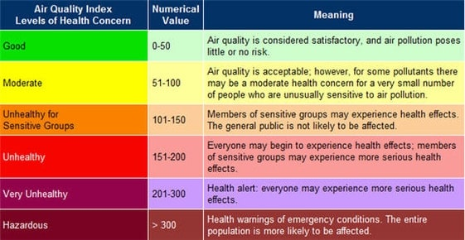

iot devices designs

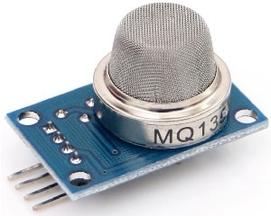The primary sensor that will be used for air quality detection will be the MQ-135 sensor. The MQ-135 gas sensor senses the gases like ammonia, nitrogen, oxygen, alcohols, aromatic compounds, sulfide and smoke. In the atmosphere, clean air has very low conductivity, but the conductivity of the gas increases as the concentration of polluting gas increases. This is used by the sensor to detect pollution levels. It is low cost and particularly suitable for air quality monitoring application.

It has two outputs: analog output and TTL output. The TTL output is low signal light which can be accessed through the IO ports on the Microcontroller. The analog output gives voltage which is directly proportional to concentration of the pollutants. This sensor has a long life and reliable stability as well.

This sensor can be connected with a ESP32 module that can provide Wi-Fi and Bluetooth functionality through its interfaces. Using this, we can obtain the AQI parameters and share it or make it publicly available in a website or such.

Additionally, a 0.96" I2C OLED Display can be added to display the Air Quality Index on the device.

data sharing platform

A basic webpage that could display the real-time values can be created using HTML, CSS and JS and the captured data can be displayed there. This webpage can be publicly hosted to display Air Quality data to the people.

Integration approach

We can use an open-source IoT application or API to store and retrieve data from the internet to store the data obtained.

One such API is thingspeak. ThingSpeak is an open-source Internet of Things application and API to store and retrieve data from things using the HTTP and MQTT protocol over the Internet or via a Local Area Network. Thingspeak enables you to collect, store, analyze, visualize, and act on data from sensors.