Air Quality Monitoring System

# INTRODUCTION :

[An IoT-powered air quality monitoring system is a data-driven approach to monitor air quality](https://www.bing.com/ck/a?!&&p=515adc69bf5bf8ecJmltdHM9MTY5ODc5NjgwMCZpZ3VpZD0wYzU1Y2MxNC1lNTFlLTY4MGMtMmZlNS1kZjkxZTQ4ZTY5YjkmaW5zaWQ9NTc3OA&ptn=3&hsh=3&fclid=0c55cc14-e51e-680c-2fe5-df91e48e69b9&psq=what+is+air+quality+monitoring+using+iot&u=a1aHR0cHM6Ly93d3cuYml6NGludGVsbGlhLmNvbS9ibG9nL2JlbmVmaXRzLW9mLWlvdC1iYXNlZC1hbWJpZW50LWFpci1xdWFsaXR5LW1vbml0b3Jpbmctc3lzdGVtLw&ntb=1).

1. [It consists of sensor devices and gateway connectivity to ensure fresher surroundings free from air pollutants and other toxic components spread in the air](https://www.bing.com/ck/a?!&&p=f57e3fe715ad58bdJmltdHM9MTY5ODc5NjgwMCZpZ3VpZD0wYzU1Y2MxNC1lNTFlLTY4MGMtMmZlNS1kZjkxZTQ4ZTY5YjkmaW5zaWQ9NTc4MA&ptn=3&hsh=3&fclid=0c55cc14-e51e-680c-2fe5-df91e48e69b9&psq=what+is+air+quality+monitoring+using+iot&u=a1aHR0cHM6Ly93d3cuYml6NGludGVsbGlhLmNvbS9ibG9nL2JlbmVmaXRzLW9mLWlvdC1iYXNlZC1hbWJpZW50LWFpci1xdWFsaXR5LW1vbml0b3Jpbmctc3lzdGVtLw&ntb=1" \t "_blank).
2. [These sensors track temperature, humidity, altitude, atmospheric pressure, carbon dioxide levels, as well as pollutants like methane, carbon monoxide, and ammonium](https://www.bing.com/ck/a?!&&p=35390f6ef80f3d27JmltdHM9MTY5ODc5NjgwMCZpZ3VpZD0wYzU1Y2MxNC1lNTFlLTY4MGMtMmZlNS1kZjkxZTQ4ZTY5YjkmaW5zaWQ9NTc4Mg&ptn=3&hsh=3&fclid=0c55cc14-e51e-680c-2fe5-df91e48e69b9&psq=what+is+air+quality+monitoring+using+iot&u=a1aHR0cHM6Ly93d3cuaW90LW5vdy5jb20vMjAyMS8wOC8wNC8xMTE4NzctaW1wcm92aW5nLWFpci1wb2xsdXRpb24tbW9uaXRvcmluZy13aXRoLWlvdC1zZW5zb3JzLw&ntb=1" \t "_blank).
3. [The system consists of electrochemical sensors that monitor the constituents which result in pollution like aerosol, VOC, CO, CO2, and temperature-humidity and will trigger an alarm when the air quality goes down beyond a certain level](https://www.bing.com/ck/a?!&&p=fc4b72d19a31538eJmltdHM9MTY5ODc5NjgwMCZpZ3VpZD0wYzU1Y2MxNC1lNTFlLTY4MGMtMmZlNS1kZjkxZTQ4ZTY5YjkmaW5zaWQ9NTc4NA&ptn=3&hsh=3&fclid=0c55cc14-e51e-680c-2fe5-df91e48e69b9&psq=what+is+air+quality+monitoring+using+iot&u=a1aHR0cHM6Ly9wc2lib3JnLmluL2Fpci1xdWFsaXR5LW1vbml0b3JpbmctdXNpbmctaW90Lw&ntb=1" \t "_blank)**.**

# PROJECT OBJECTIVES:

The main objective of this project is to develop and design a flood detection system that will detect flood automatically and send data to the Local Government Unit and to residents using an Arduino. Specific Objectives

* To design a circuit and create a programming code using the microcontroller.
* To apply the Serial Communication in transmitting the data from one place to another place.
* To detect the current level of the flood where the system sensor will be divided into four levels
* [An air quality monitoring system using IoT is a system that **measures the concentration of various pollutants in the air using sensors and sends the data to a cloud platform for analysis and visualization**](https://www.bing.com/ck/a?!&&p=db54df690bfa85deJmltdHM9MTY5ODc5NjgwMCZpZ3VpZD0wYzU1Y2MxNC1lNTFlLTY4MGMtMmZlNS1kZjkxZTQ4ZTY5YjkmaW5zaWQ9NTY2NQ&ptn=3&hsh=3&fclid=0c55cc14-e51e-680c-2fe5-df91e48e69b9&psq=objectives+of+the+air+quality+monitoring+using+iot+devices&u=a1aHR0cHM6Ly9jaXJjdWl0ZGlnZXN0LmNvbS9taWNyb2NvbnRyb2xsZXItcHJvZWpjdHMvaW90LWJhc2VkLWFpci1xdWFsaXR5LWluZGV4LW1vbml0b3Jpbmctc3lzdGVtLW1lYXN1cmUtcG0yNS1wbTEwLWNvLXVzaW5nLWVzcDMy&ntb=1).
* The system can use sensors such as Nova PM Sensor SDS011 for measuring PM2.5 and PM10, MQ-7 Sensor for measuring CO, and other gas sensors for measuring O2, NO2, SO2, etc.
* [The system can also be mobile and use GPS for location tracking](https://www.bing.com/ck/a?!&&p=05d8a46e784b56a1JmltdHM9MTY5ODc5NjgwMCZpZ3VpZD0wYzU1Y2MxNC1lNTFlLTY4MGMtMmZlNS1kZjkxZTQ4ZTY5YjkmaW5zaWQ9NTY3MQ&ptn=3&hsh=3&fclid=0c55cc14-e51e-680c-2fe5-df91e48e69b9&psq=objectives+of+the+air+quality+monitoring+using+iot+devices&u=a1aHR0cHM6Ly9wc2lib3JnLmluL2Fpci1xdWFsaXR5LW1vbml0b3JpbmctdXNpbmctaW90Lw&ntb=1).
* [The system can help monitor the air quality index and alert the users about the pollution lev](https://www.bing.com/ck/a?!&&p=8736e21f435b8f43JmltdHM9MTY5ODc5NjgwMCZpZ3VpZD0wYzU1Y2MxNC1lNTFlLTY4MGMtMmZlNS1kZjkxZTQ4ZTY5YjkmaW5zaWQ9NTY3Mw&ptn=3&hsh=3&fclid=0c55cc14-e51e-680c-2fe5-df91e48e69b9&psq=objectives+of+the+air+quality+monitoring+using+iot+devices&u=a1aHR0cHM6Ly9jaXJjdWl0ZGlnZXN0LmNvbS9taWNyb2NvbnRyb2xsZXItcHJvZWpjdHMvaW90LWJhc2VkLWFpci1xdWFsaXR5LWluZGV4LW1vbml0b3Jpbmctc3lzdGVtLW1lYXN1cmUtcG0yNS1wbTEwLWNvLXVzaW5nLWVzcDMy&ntb=1)el.

# ESP32:

* ESP32 is a series of low-cost, low-power system on a chip (SoC) microcontrollers with wi-Fi and dual-mode Bluetooth.
* It is developed by Espressif Systems and launched in September 2016.
* It has a dual-core 32-bit Xtensa LX6 microprocessor and various features such as antenna switches, RF balun, power amplifier, filters, and power management modules.
* It is a successor to the ESP8266 SoC and a popular choice for IoT applications.

# COMPONENTS:

1. ESP 32.
2. DHT22.
3. PHOTORESISTOR.
4. RESISTOR.
5. POTENTIOMETER.
6. BUZZER.
7. LED.
8. JUMPER WIRES.

# DEVICE SETUP :

Setting up an IoT project using an ESP32 board, , DHT22 Sensor, photoresistor,potentiometer,resistor,led, buzzers and jumper wires involves several steps. I'll provide an overview of how you can set up this project, but please note that this is a complex project, and you may need to consult specific documentation and libraries for each component. Additionally, coding this project will require programming skills in platforms like Arduino IDE.

1. **Gather the Required Components**:

* ESP 32.
* Photoresistor.
* Potentiometer.
* DHT22.
* Resistor.
* Buzzer.
* Led.
* Jumper wires.
* Power supply .

1. **Connect the photoresistor:**

* sConnect the VCC pin of the photoresistor to the 3.3V output of voltage pin .
* Connect the GND pin of the photoresistor to the GND of microprocessor.
* Connect the DO pin of the photoresistor to an analog input pin(eg..D13).

**3.Connect the potentiometer:**

* Connect the VCC pin of the potentiometer to the 3.3V output of voltage pin .
* Connect the GND pin of the potentiometer to the GND of microprocessor.
* Connect the DO pin of the potentiometer to an analog input pin(eg..D13).

**4.CONNECT THE DHT22 SENSOR**

|  |  |
| --- | --- |
| * VCC | Positive voltage of DHT22 Connect to the 3v pin in esp32. |
| * SDA | Digital data pin (input/output) connect to the analog pin. |
| * NC | Not connected. |
| * GND | Ground in ground state . |

**5.CONNECT THE LED ,RESISTOR AND BUZZER**

* Connect the LED digital input analog pin.
* Connect the Buzzer digital input analog pin.

**HARD WARE CONECTION DIAGRAM**

The diagram of the overall system is shown in the figure below. The sensors placed at the different places reads the data which are manipulated through the microcontroller and the values of the sensors are displayed. The values obtained repeatedly are send to database and through the web API, warning message is sent into the phone.

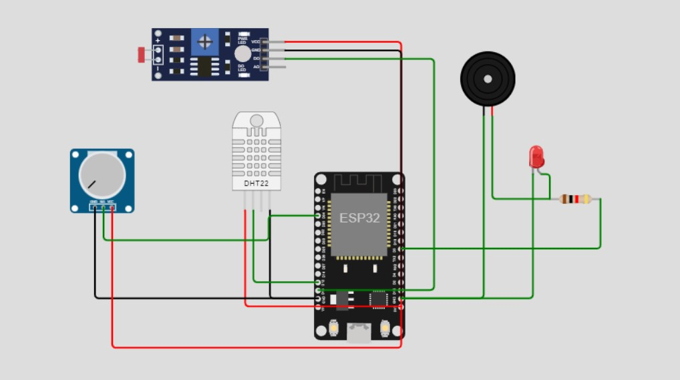

**SOURCE CODE:**

#include <WiFi.h>

#include <ThingSpeak.h>

#include "DHTesp.h"

#define ledPin 5

#define DO\_PIN 13

char ssid[] = "Wokwi-GUEST";

char pass[] = "";

WiFiClient client;

unsigned long myChannelNumber =  2311245;

const char \* myWriteAPIKey = "EUME5SWFX3BNSUWD";

DHTesp dhtSensor;

TempAndHumidity data;

const int DHT\_PIN = 12;

int statusCode;

void setup() {

**Serial**.begin(9600);

pinMode(32, INPUT);

pinMode(34, INPUT);

pinMode(ledPin, OUTPUT);

WiFi.mode(WIFI\_STA);

ThingSpeak.begin(client);

dhtSensor.setup(DHT\_PIN, DHTesp::DHT22);

}

void loop() {

  pinMode(DO\_PIN, INPUT);

connectToCloud();

aqi();

computeData();

writeData();

}

void connectToCloud(){

if(WiFi.status() != WL\_CONNECTED) {

**Serial**.print("Attempting to connect");

while(WiFi.status() != WL\_CONNECTED) {

WiFi.begin(ssid, pass);

for(int i=0;i<5;i++) {

**Serial**.print(".");

delay(5000);

}

}

**Serial**.println("\nConnected.");

}

}

void aqi(){

  int aqi=analogRead(34);

**Serial**.println("AQI INDEX=" + String(aqi));

  if (aqi<100){

**Serial**.println("Air Quality : Good");

  }

  else{

**Serial**.println("Air Quality : UnHealthy");

  }

  if(aqi<100){

    digitalWrite(ledPin, LOW);

    delay(1000);

    }

  else{

    digitalWrite(ledPin, HIGH);

    delay(5000);

  }

}

void computeData(){

data = dhtSensor.getTempAndHumidity();

**Serial**.println("Humi: " + String(data.humidity));

**Serial**.println("Temp: " + String(data.temperature));

int lightState = digitalRead(DO\_PIN);

  if (lightState == HIGH)

**Serial**.println("It is dark");

  else

**Serial**.println("It is light");

**Serial**.println("\-----------");

}

void writeData(){

int lightState = digitalRead(DO\_PIN);

int aqi=analogRead(34);

ThingSpeak.setField(3, data.humidity);

ThingSpeak.setField(2, data.temperature);

ThingSpeak.setField(4, lightState);

ThingSpeak.setField(5, aqi);

statusCode = ThingSpeak.writeFields(myChannelNumber,myWriteAPIKey);

if(statusCode == 200) //successful writing code

**Serial**.println("Channel update successful.");

else

**Serial**.println("Problem Writing data. HTTP error code :" +

String(statusCode));

delay(5000); // data to be uploaded every 15secs

}

**CONNECTING TO THE CLOUD**

In Wokwi platform simulation happen then it sends data into the ThingSpeak . It is an IoT analytics platform service that allows you to aggregate, visualize, and analyze live data streams in the cloud. You can send data to ThingSpeak from your devices, create instant visualization of live data, and sendalerts.

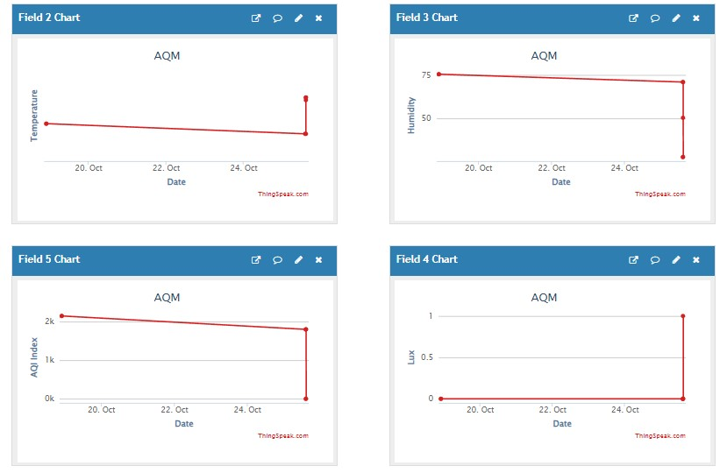

**DEVELOP APK USING MIT APP INVENTOR**

For every simulation in the wokwi platform the data can be update into personal channel created in the Thingspeak. We can use the data to know the difference level daily update and also live stream the data into the API interface using MIT APP INVENTOR

>Using MIT app inventor we have to create app that can be named as AQM(Air Quality Monitoring)

>AQM can be used to monitor and regular update from the cloud system

>AQM contains two screen

It is the open Desktop for the AQM

DATA ANALYST

It is used to collect the data from the cloud and provide alert message to the device

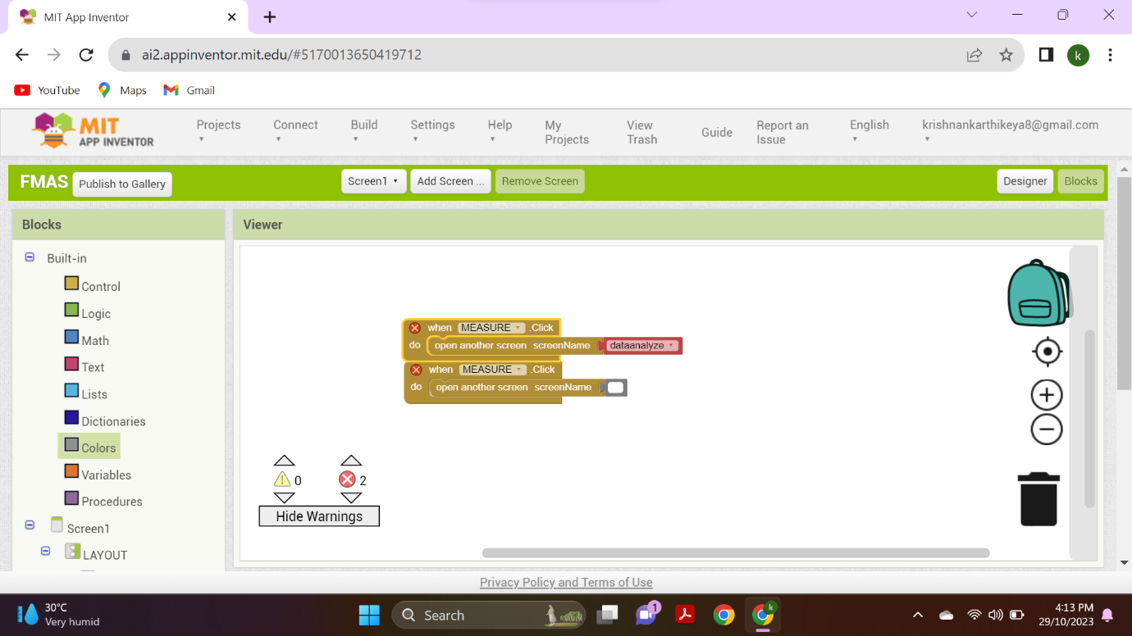

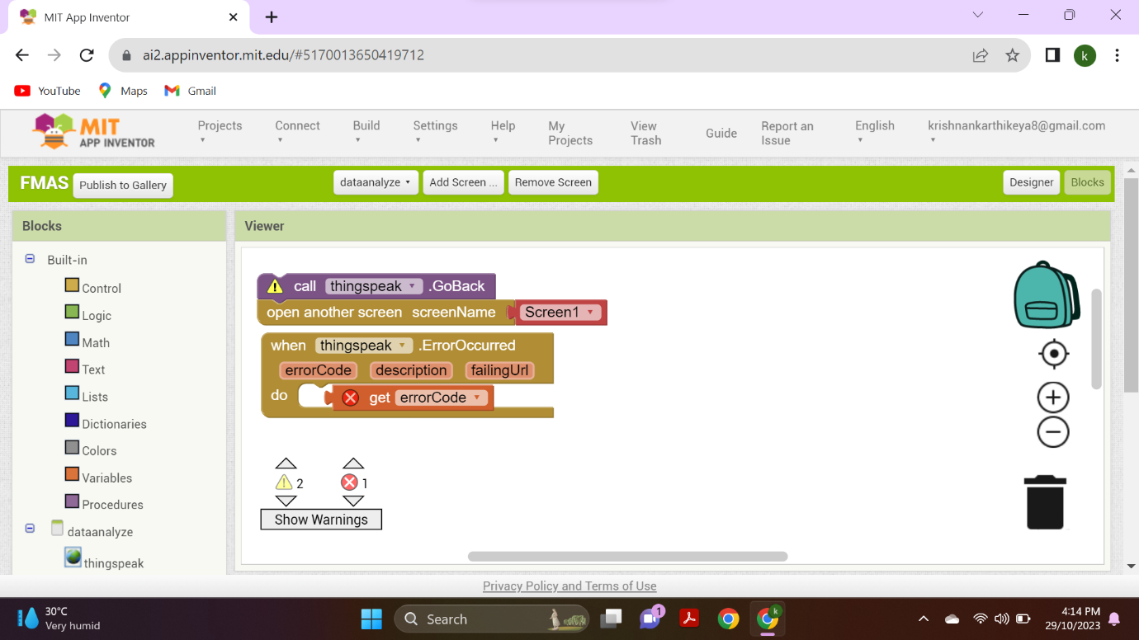

**INSTALL THE APK MODE INTO THE MOBILE**

**1. USER INTERFACE**

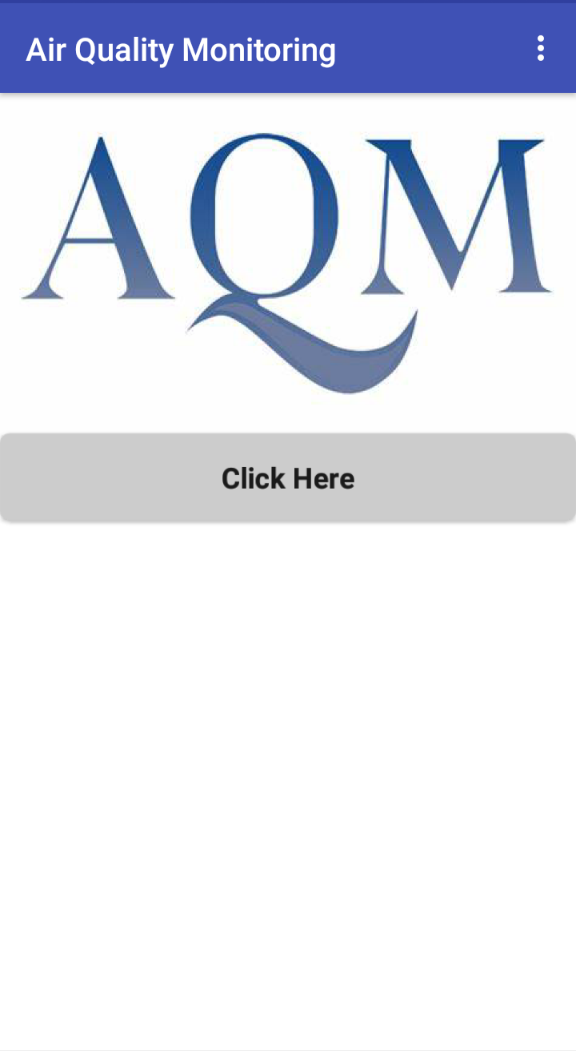

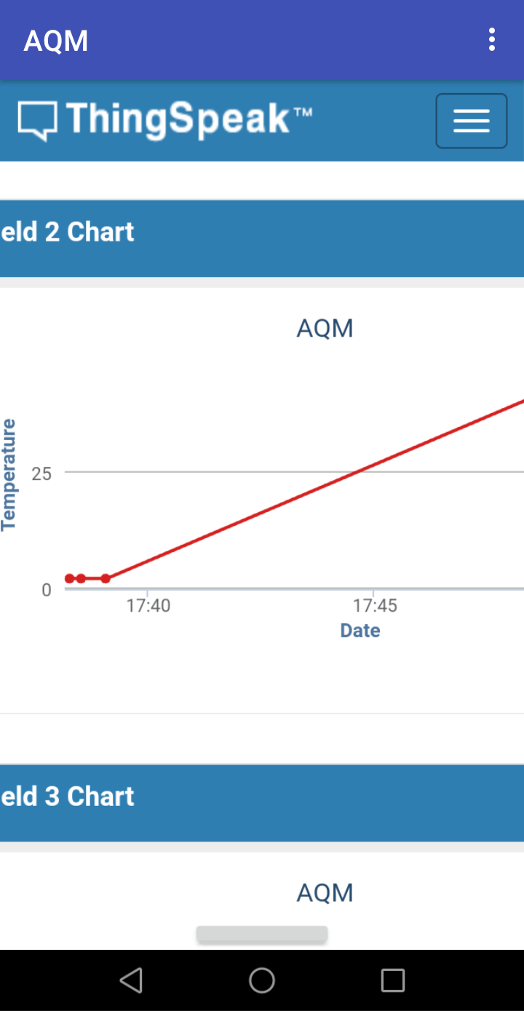

**DATA ARRIVED FROM THINGSPEAK CONNECTED THROUGH THE MIT APP INVENTOR .**

**BENEFITS OF AIR QUALITY MONITORING:**

* [Improved Public Health](https://oizom.com/benefits-of-air-quality-monitoring/#elementor-toc__heading-anchor-2)
* [Reduction in Airborne Viruses and Bacteria](https://oizom.com/benefits-of-air-quality-monitoring/#elementor-toc__heading-anchor-3)
* [Cleaner and Healthier Indoor Environments](https://oizom.com/benefits-of-air-quality-monitoring/#elementor-toc__heading-anchor-4)
* [Protection from Harmful Emissions](https://oizom.com/benefits-of-air-quality-monitoring/#elementor-toc__heading-anchor-5)
* [Environmental Conservation](https://oizom.com/benefits-of-air-quality-monitoring/#elementor-toc__heading-anchor-6)
* Cleaner and healthier indoor environments.

**CHALLENGES OF AQM**

* Lack of Real-time Monitoring Traditional HVAC systems often lack real-time monitoring capabilities.
* Complexity of HVAC Systems HVAC systems are often complex, with various components working together to deliver optimal performance.
* Limited Data Analytics Obtaining data is not enough; analyzing it is equally important.
* Cost and Installation Challenges.

**CONCLUSION**

The results of this study indicate that there are many applications to monitor air quality in major cities in the world. **Air quality monitoring** systems can produce information on which cities have the best, sufficient, and worst air quality. Also, the applications show air quality information in real- time.