**Day-4 Assignments & class notes, Wipro C# TUTOR-Narashima**

* **If_Departments.cs**

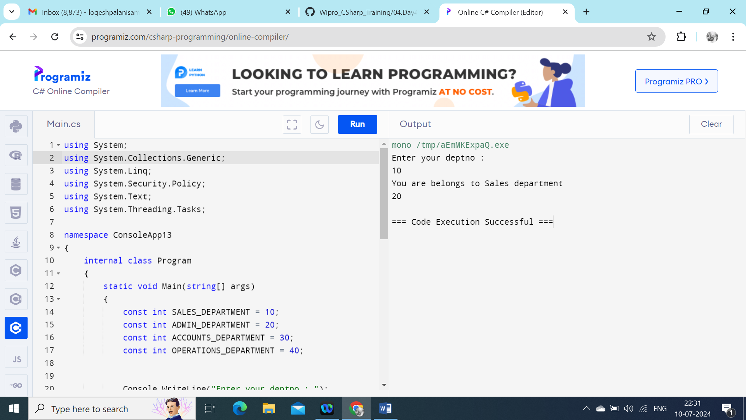

**Multiple_IfElse_blocks.cs**

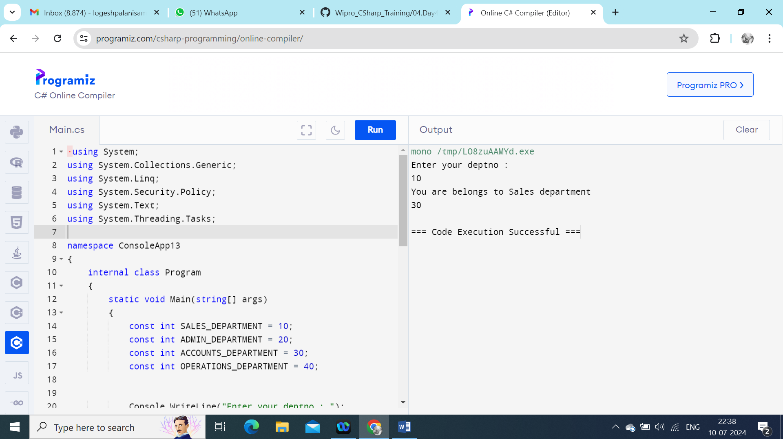

**If_Else_UserLogin.**

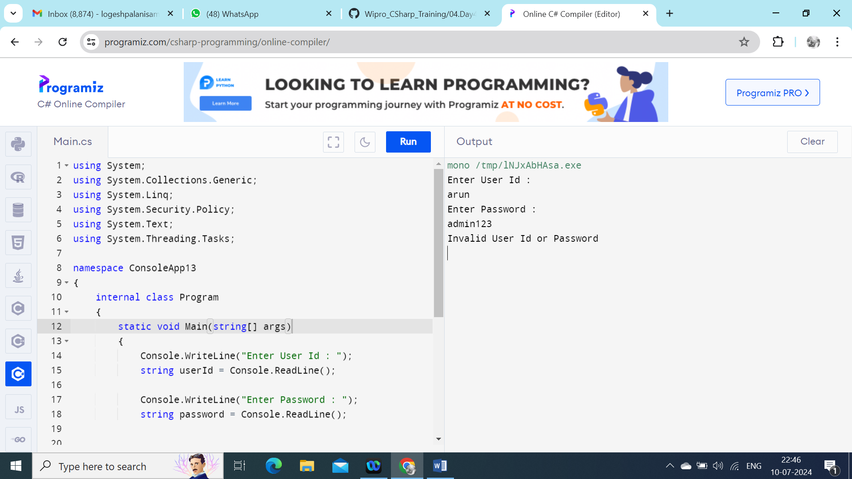

# Loops_Usage.cs

# Loops are used to execute one or more statements multiple times until a specified condition is fulfilled. There are many loops in C# such as for loop, while loop, do while loop

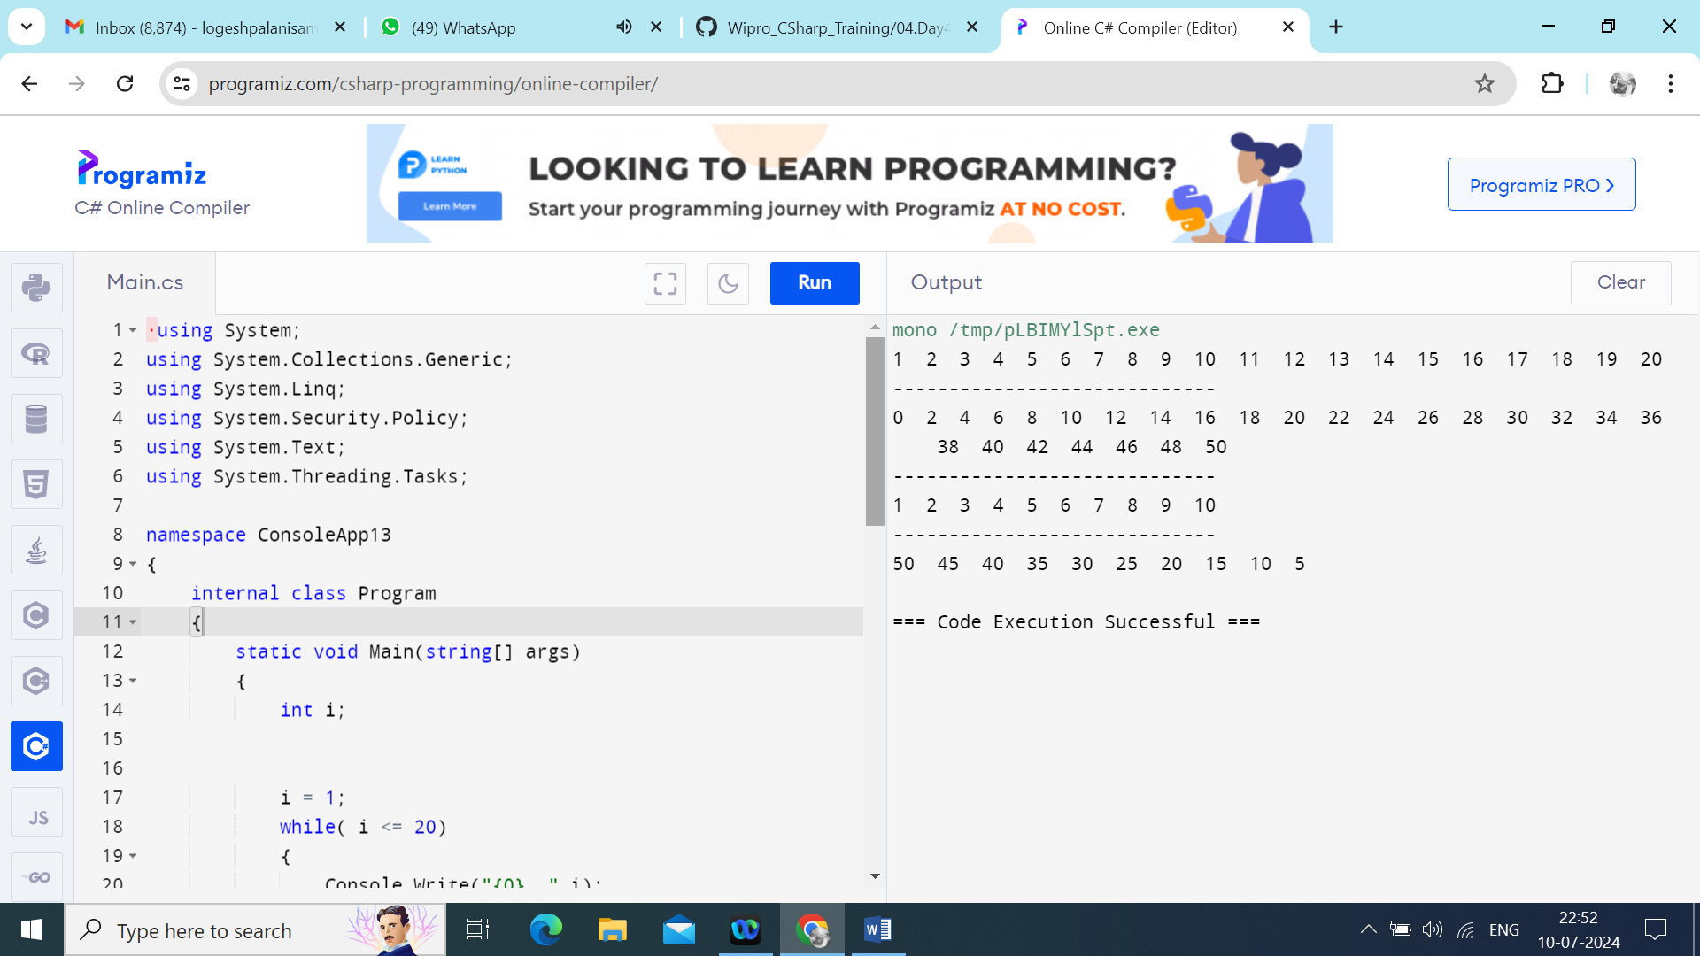

**Nested_ForLoops**

Nested loops are those loops that are present inside another loop. In C#, nesting of for, while, and do-while loops are allowed and you can also put any nested loop inside any other type of loop like in a for loop you are allowed to put nested if loop.

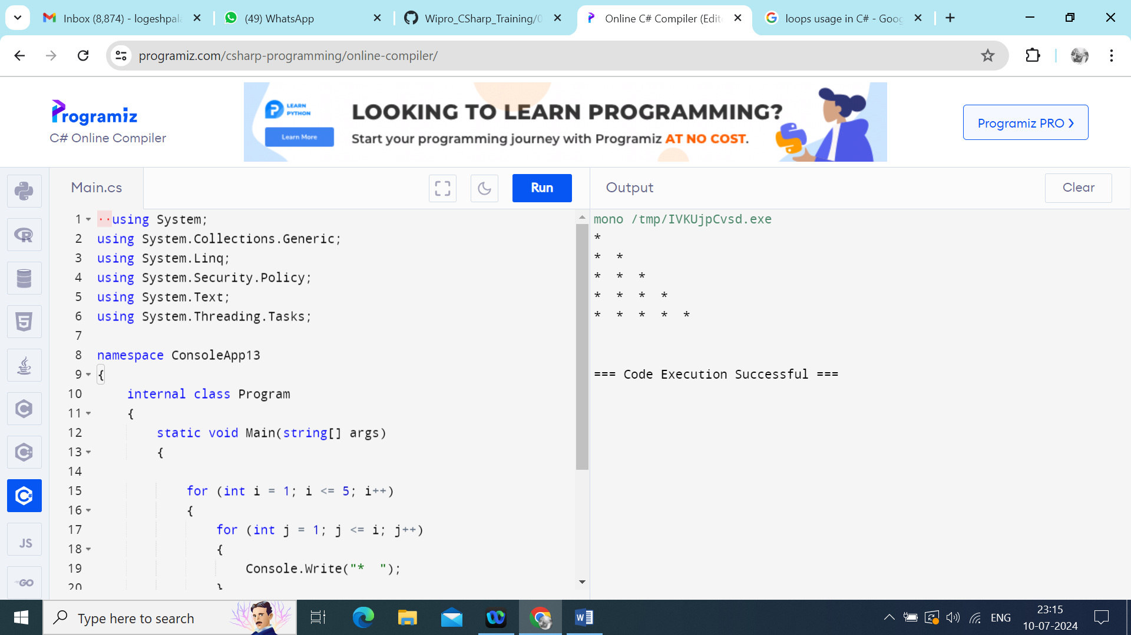

**Nested_ForLoops_Stars.**

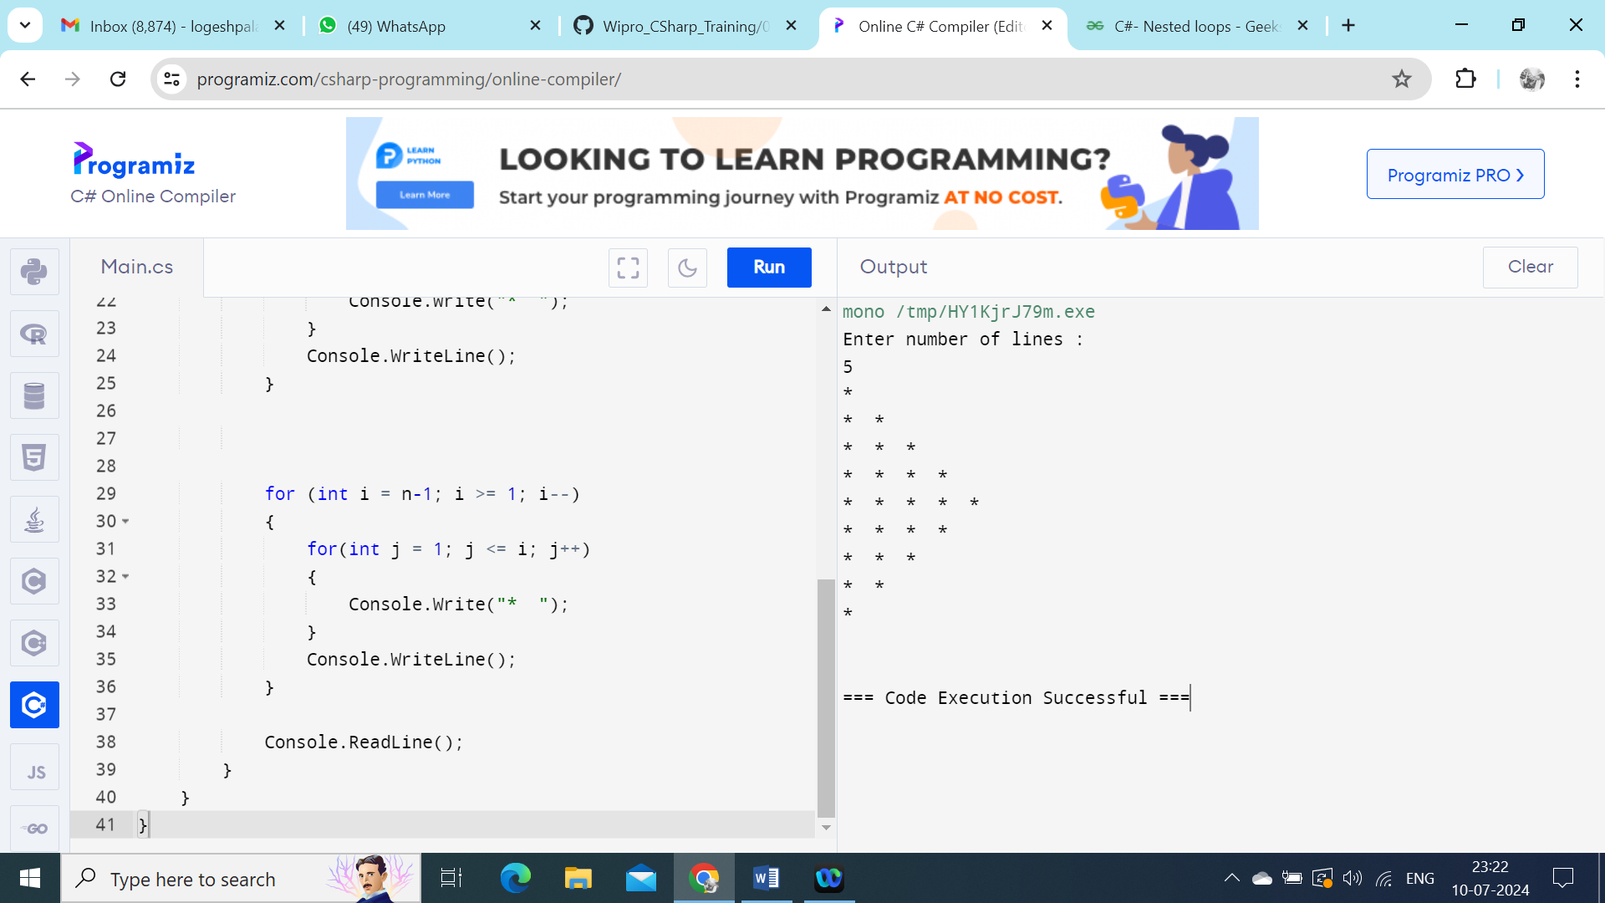

**Nested_ForLoops_Hearts**

