**MICROSERVICES:**

One of the popular architecture in Software World.

**Agenda:**

1. History of Microservices

2. Problems with Monolith & SOA[Service Oriented Architecture]

3. Microservices Architecture

4. Problems solved by Microservices

5. Designing Microservices Architecture

6. Deploying Microservices [deep dive in CONTAINERS & Kubernetes concepts]

7. Testing Microservices

8. Service Mesh [Make Communication between services]

9. Logging & Monitoring

10. When we should not use Microservices

11. Microservices & the organization

12. Anti-Patterns & Common Mistakes

13. Breaking Monolith to Microservices

14. Case Study

15. Conclusions

**History:**

Microservices are introduced to overcome the problems faced in 2 different architectures...

i. Monolith

ii. SOA (Service Oriented Architecture)

*MONOLITH Architecture:*

Original Architecture

All the software components are executes as Single Process.

-> Thread

-> Memory Resource

-> Compute Power

Strong Coupling

Implemented as SILO (Standalone Apps). It will not export anything. Nothing can Go Out.

**Pros:**

Easier to design [Because, there is no *Networking, Message transfer, Cross Debugging*]

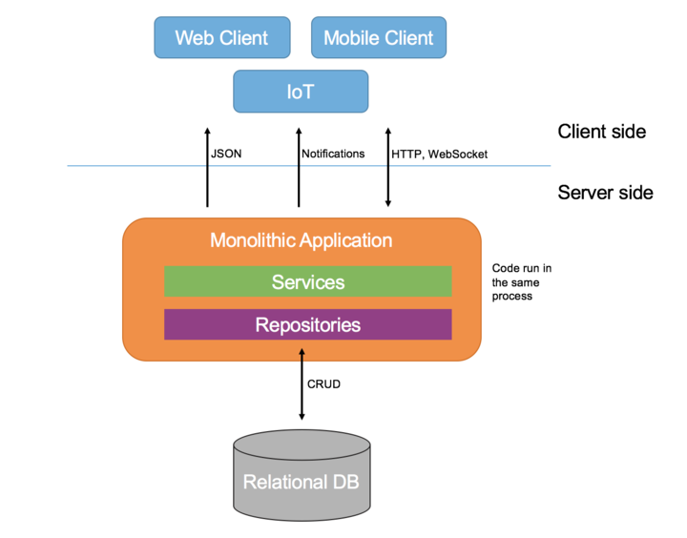

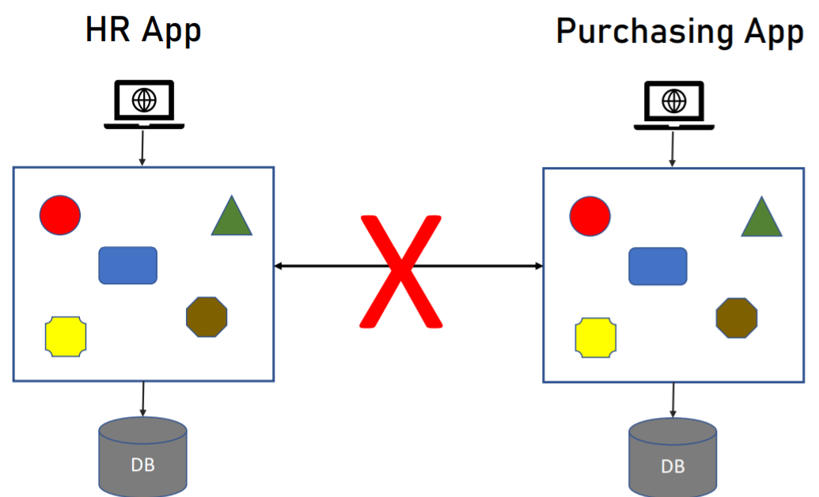

*SOA: [Service Oriented Architecture]*

Coined in 1998

Apps are exposing the functionality to outside world

Usually implemented using **SOAP, WSDL**. SOAP & WSDL are in XML formats that contains all the things that are exposed by the Apps.

**ESB (Enterprise Service Bus)** is used to make communication between 2 services or else between 1 service & 1 client.

-> It is the very important component in SOA.

-> It takes of routing, aggregation, validation, authentication etc.,

-> ESB engines are basically developed by ORACLE or IBM.

Things which was overcome from Monolith by SOA:

We allowing the set of information of the application into outside world. If I want to access the azure application by referring & implementing its WSDL we can access it.

Problems that found in Monolith and SOA:

**Problem in MONOLITH:**

*1.Single Technology*

Finally, *Monolith* is going to execute as a SINGLE Process. So, all the components are needs to be developed using the same development platform.

Upgrading is also a problem. We can’t able to upgrade single component.

*2.Inflexible Deployment*

We should deploy all the components every time. If we have single line change we should deploy all the components.

*3.Inefficient Compute Resources: [CPU & RAM]*

If one specific component needs more *CPU or RAM* resources. We can’t able to allocate it. Because, whole *CPU or RAM* was allocated to entire Monolith Process.

*4.Large & Complex:*

Codebase is LARGE and Complex. Which contains lot of dependencies. So, small changes will affect the other components.

Testing the application also difficult.

**Problems in SOA [Service Oriented Architecture]:**

*1.Complicated & Expensive ESB (Enterprise Service BUS):*

ESB engines are basically provided by companies like ORACLE or IBM. So, it also seems to be expensive.

Because of all the important tasks are handled by ESBs most of the companies which are using this ESBs are focusing more on ESBs rather than the actual services in the SOA.

*2.Lack of Tooling:*

SOA should achieve the Short Development Cycle. When achieving this *SHORT DEVELOPMENT CYCLE,* **testing and deployment** takes place manually by the developers there is *no tool* to provide the testing and deployment functionality.

**Characteristics of Microservices: [1,2,5,6,7 are the Most Important Attributes]**

*1.Componentization via Services*

Creating a modular Software is the Best Practice.

-> Using Libraries

-> Using Services (Web APIs, RPC)

In Microservices we are using the Services

*2.Organized Around Business Capabilities*

UI 🡪 API 🡪 Logic 🡪 DB (All these things are handled by a SINGLE Team)

Motivation:

-> Quicker Development

-> Well defined Boundaries

*3.Products not projects*

Traditionally, developers don’t have a interaction with customers when developing the PROJECTS. But, Customer interaction will present in developing the PRODUCTS.

Motivation:

-> Increase the customer satisfaction

-> Changes he developer’s mindset.

*4.Smart End-Points and Dump pipes*

In SOA, communication between 2 services are handled using ESBs(Enterprise Service Bus). This ESBs are more complex & expensive.

Microservices systems use ‘dump pipes’ – simple protocols[HTTP]

Services can communicate each other by using simple HTTP Request.

Motivation:

->Accelerate Development

->Make the app easier to maintain

*5.Decentralised Governance*

We can select any type of DBs and any type of languages based on the technology requirements. We no need to follow any centralised approach.

Motivation:

Enables making the optimal decisions for the specific service.

*6.Decentralised Data Management*

Each services no need to use the Single DB. Each services can have its own. But, it is not for all the cases it may change based on the requirements.

Motivation:

-> Having the right DB is important.

->Encourages Isolation.

*7.Infrastructure Automation*

To add the AUTOMATION in TESTING and DEPLOYMENT. Short Deployment Cycles is must in Microservices. Because, it is essential for the Microservices.

Most used Automation Tools:

1.Azure Devops

2.GitLab

3.Jenkins

Motivation:

->Short Deployment Cycle

*8.Design for failure*

In Microservices, there are *lot of processes* and *Network Traffic* will present.

We should handle all those things by implementing proper *Logging & Monitoring* Mechanisms.

Monitoring Tools:

1.Azure Monitor

2.Application Insights

3.Kubernetes

Motivation:

->Increase the System’s Reliability

*9.Evolutionary Design*

Moving from Monolith to Microservices should be GRADUAL. No need the break the whole part.