**MVC (Model View Controller) Approach:**

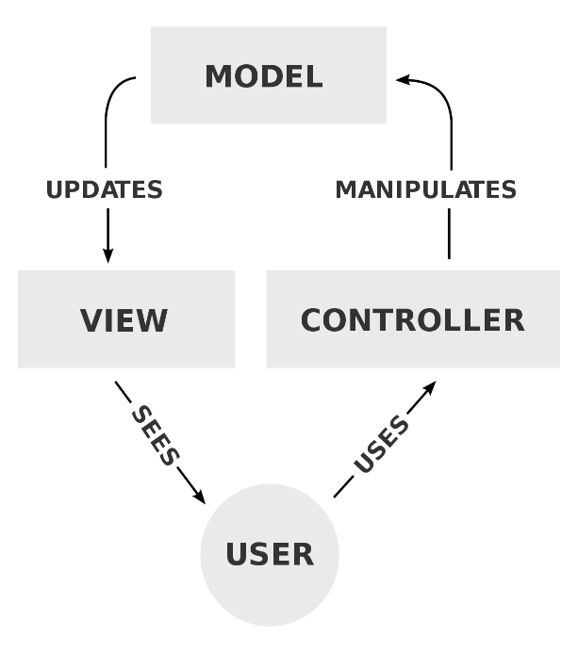

View Technologies – JSP or Velocity or Thyme leaf

Controller Technologies – Java Servlet

**Spring MVC:**

Advantages of using Spring MVC:

* Easy to learn
* Flexibility
* Separation of concern (important feature)
* Easily modifiable after implementation. (eg: If we want to change the view technology we can make change only in configuration (.xml) file of Front Controller)

Dispatcher Servlet Our Controllers

FRONT CONTROLLER (enabled by Spring MVC). We have separate configuration (.xml) file for this

LOGIN

Request Request

LOGOUT

Web.xml

CLIENT

ADD

**Our Controllers** gives the data of specific controller.

**Dispatcher Servlet:**

Front Controller receives the request from the Web.xml and it make response (which contains the specific VIEW(HTML) and DATA[is received from OUR CONTROLLERS]) based on the type of request i.e. request needs the which controller either LOGIN or LOGOUT or ADD controller.

*How the FRONT CONTROLLER knows which controller that needs to call?*

*Front Controller have a specific configuration file which maintains the annotations of our created controllers.*

**MAVEN Concepts:**

MAVEN provides all the .jar dependencies needed for our project. For eg: If we create Spring project we can call all the .jar dependencies required for the Spring project from Maven.

*How can we make our project global to be unique?*

***Project:*** *Sample*

***Group ID:*** *com.company.*

***Artifact ID:*** *demo*

***Package:*** *com.company.demo.web*

Adding dependencies into **pom.xml** [pom – project object model]:

**<dependency>**

**<groupId>junit</groupId>**

**<artifactId>junit</artifactId>**

**<version>3.8.1</version>**

**<scope>test</scope>**

**</dependency>**

**<dependency>**

**<groupId>org.springframework</groupId>**

**<artifactId>spring-context</artifactId>**

**<version>4.1.8.RELEASE</version>**

**</dependency>**

**<dependency>**

**<groupId>org.springframework</groupId>**

**<artifactId>spring-webmvc</artifactId>**

**<version>4.1.8.RELEASE</version>**

**</dependency>**

**<dependency>**

**<groupId>mysql</groupId>**

**<artifactId>mysql-connector-java</artifactId>**

**<version>5.1.36</version>**

**</dependency>**

**<dependency>**

**<groupId>javax.servlet</groupId>**

**<artifactId>jstl</artifactId>**

**<version>1.2</version>**

**</dependency>**

Creation of DispatcherServlet or Front Controller:

*Web.xml:*

**<servlet>**

**<servlet-name>logesh</servlet-name>**

**<servlet-class>**

**org.springframework.web.servlet.DispatcherServlet**

**</servlet-class>**

**</servlet>**

**<servlet-mapping>**

**<servlet-name>logesh</servlet-name>**

**<url-pattern>/</url-pattern>**

**</servlet-mapping>**

Creation of configuration file for DispatcherServlet or Front Controller:

**Format of Configuration file name should be:** {servlet-name}-servlet.xml

**Reason for creating this file:** we receive huge number of requests. To control the process of calling the specific controller for specific requests

*logesh-servlet.xml: (inside WEB-INF folder)*

**<beans xmlns="http://www.springframework.org/schema/beans"**

**xmlns:ctx="http://www.springframework.org/schema/context"**

**xmlns:xsi="http://www.w3.org/2001/XMLSchema-instance"**

**xmlns:mvc="http://www.springframework.org/schema/mvc"**

**xsi:schemaLocation="http://www.springframework.org/schema/beans**

**http://www.springframework.org/schema/beans/spring-beans-2.5.xsd**

**http://www.springframework.org/schema/mvc**

**http://www.springframework.org/schema/mvc/spring-mvc-3.0.xsd**

**http://www.springframework.org/schema/context**

**http://www.springframework.org/schema/context/spring-context-2.5.xsd ">**

**<ctx:annotation-config></ctx:annotation-config>**

**<ctx:component-scan base-package=“”></ctx:component-scan>**

**</beans>**

Creation of our own controller: (inside the ‘src/main’ folder)

We have to annotate this JAVA CLASSES i.e. We have to assign the name for the request what we have to made.

*AddController.java:* (Create a Java Class which contains a method)