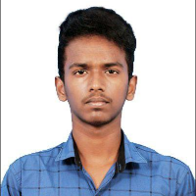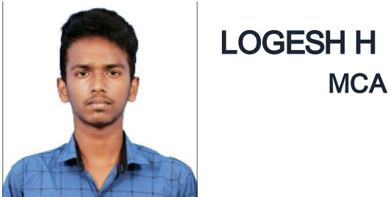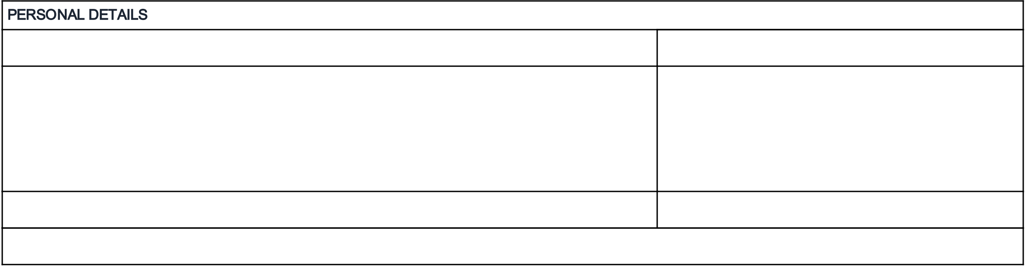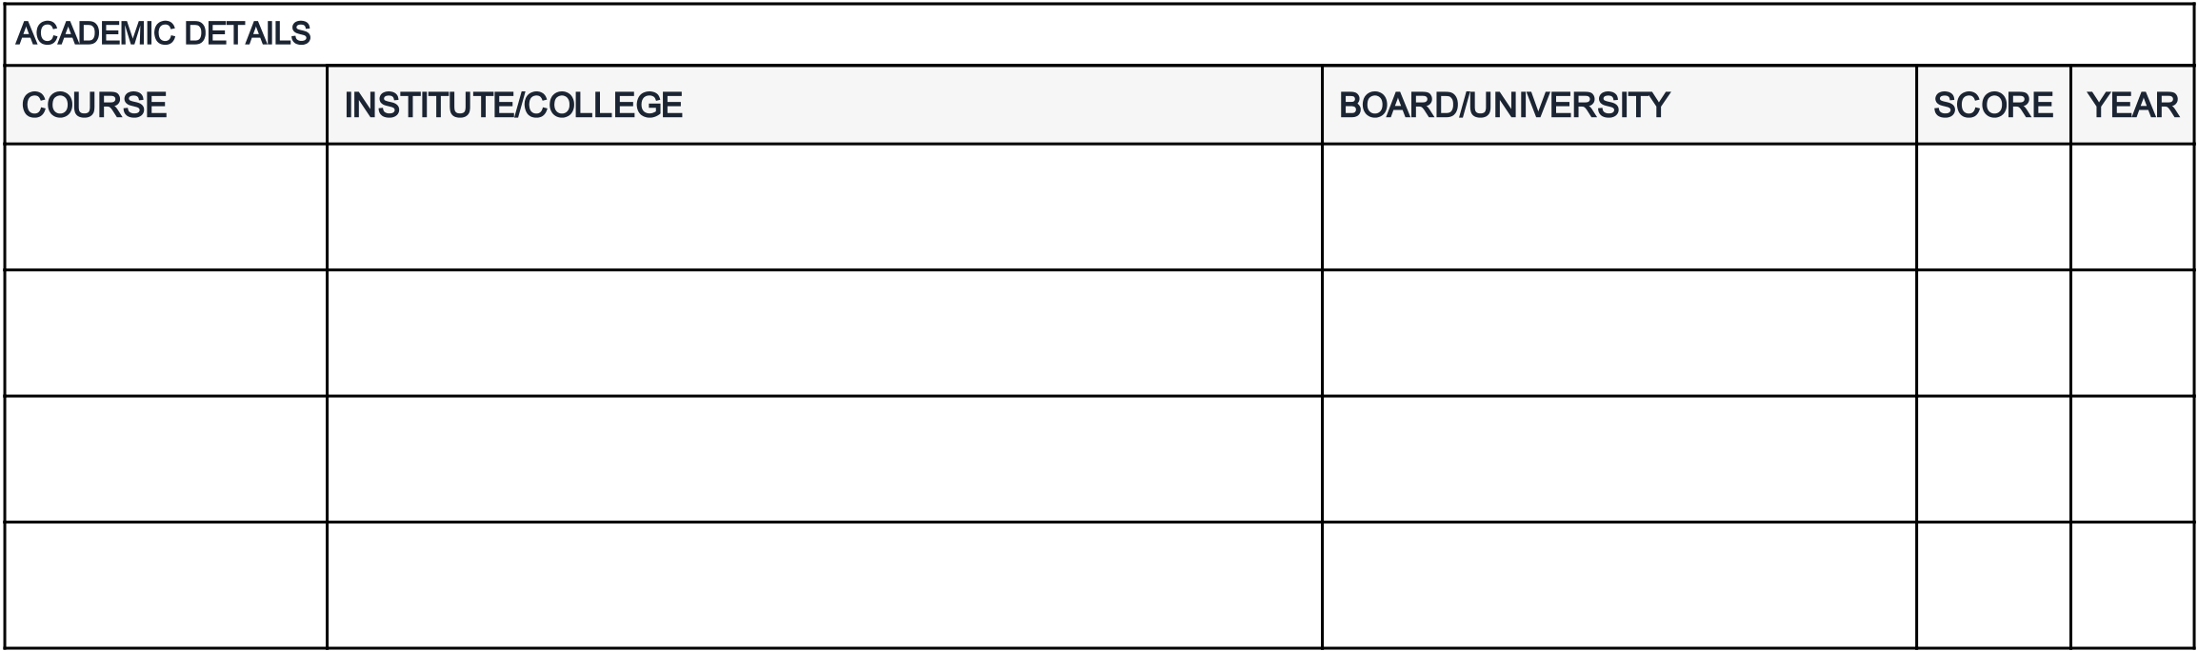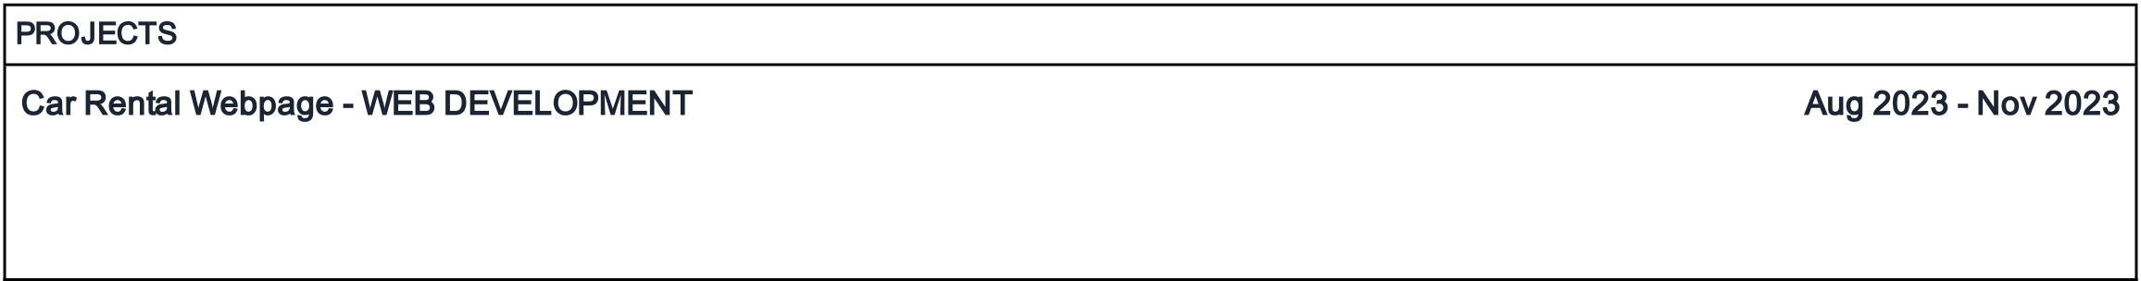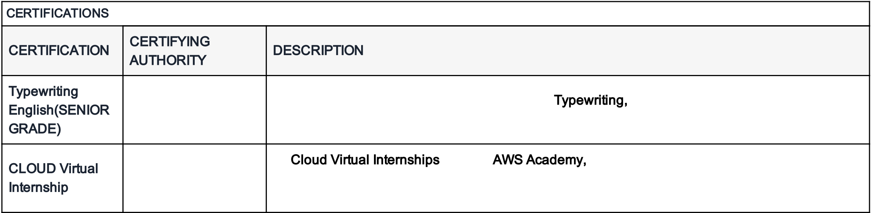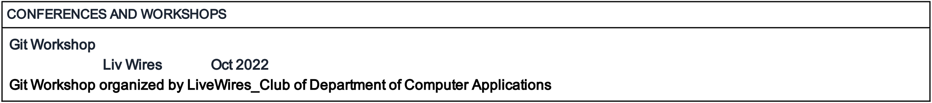

LOGESH H, RA2232241010107   
Course :MCA, Computer Application, 2024   
Email :lh1335@srmist.edu.in   
Mobile :7358729619

ACADEMIC DETAILS



|  |  |  |  |  |
| --- | --- | --- | --- | --- |
| COURSE | INSTITUTE/COLLEGE | BOARD/UNIVERSITY | SCORE | YEAR |
| CLASS X | ANNA GEM SCIENCE PARK MAT HR SEC SCHOOL GUINDY | Tamil Nadu Board of Secondary | 83 % | 2017 |
| CENTRAL CHENNAI | Education (DGE) |
| CLASS XII | JRK MATRIC HR SEC SCHOOL KATTANKULATHUR | Tamil Nadu Board of Secondary | 62 % | 2019 |
| Education (DGE) |
| B.Sc in Computer | SRM ARTS AND SCIENCE COLLEGE | UNIVERSITY OF MADRAS | 79 % | 2022 |
| Science |
| MCA | SRM Institute of Science and Technology - Kattankulathur | 7.94 | 2024 |
| Campus | CGPA |
| Subjects / Electives | Python, Sql, Java |
| Technical Proficiency | Java, CSS, HTML, MySQL, JavaScript, Python |

PROJECTS

Car Rental Webpage - WEB DEVELOPMENT Aug 2023 - Nov 2023 The Project is designed to aid the car rental webpage to enable renting of cars through on online system. It helps to search for available cars view profile and book the cars for the time period. This system saves time and labour availability. Moreover, this project has a fleet of cars ranging from luxury to budget cabs.

CERTIFICATIONS

|  |  |  |
| --- | --- | --- |
| CERTIFICATION | CERTIFYING | DESCRIPTION |
| AUTHORITY |
| Typewriting | DEPARTMENT OF | The senior grade demonstrates strong skills in Typewriting, consistently producing accurate and |
| English(SENIOR | TECHNICAL |
| well-formatted documents. |
| GRADE) | EDUCATION |
| CLOUD Virtual | AWS academy | In Cloud Virtual Internships through AWS Academy, demonstrating a solid grasp of cloud |
| computing concepts. And actively participated in practical scenarios, showcasing their skills in |
| Internship |
| AWS services. |

CONFERENCES AND WORKSHOPS

Git Workshop   
Organized by: Liv Wires | Date: Oct 2022   
Git Workshop organized by LiveWires_Club of Department of Computer Applications

PERSONAL DETAILS

Date of birth: 28 November 2001 Permanent address:

Father's name: Harinarayanan G

|  |  |
| --- | --- |
| No-9, kandaswamy street, pallipattu, taramani post, chennai, Chennai,  Chennai, Tamil Nadu, | Languages known:  Tamil, English |

PIN - 600113   
Permanent contact number: 7358729619 Nationality: indian Passport availability: No