**EXERCISE NO** :14

**DATE** : 22-11-2020

**AIM:**

Write a Python class to find validity of a string of parentheses, '(', ')', '{', '}', '[' and ']. These brackets must be close in the correct order, for

example "()" and "()[]{}" are valid but "[)", "({[)]" and "{{{" are invalid.

**PROGRAM:**

def areBracketsBalanced(expr):

stack=[]

open_expressions=['{','[','(']

for i in range(len(expr)):

if(expr[i] in open_expressions):

stack.append(expr[i])

else:

if not stack:

return False

curr=stack.pop()

if(curr == '{' and expr[i]!='}'):

return False

if(curr == '[' and expr[i]!=']'):

return False

if(curr == '(' and expr[i]!=')'):

return False

if stack:

return False

else:

return True

if __name__ == "__main__":

expr=input()

if(areBracketsBalanced(expr)):

print("valid")

else:

print("invalid")

**LINK:**

<http://103.53.53.18/mod/vpl/forms/edit.php?id=327&userid=1784#>

**OUTPUT:**

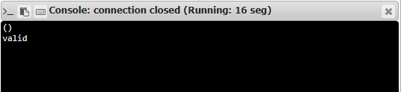

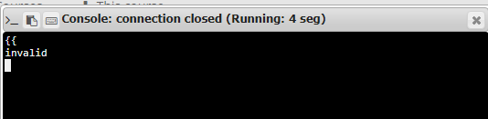

**RESULT:**

Hence, the program is executed successfully.