**EXERCISE NO** :1

**DATE** : 11-10-2020

**AIM:**

To write a Python program to print the calendar of a given month and year.

**PROGRAM:**

import calendar as cal

y=int(input())

m=int(input())

if(y>999 and y<10000):

if(m>0 and m<13):

print(cal.month(y,m))

else:

print("Invalid Input")

else:

print("Invalid Input")

**LINK:**

[http://103.53.53.18/mod/vpl/forms/edit.php?id=229&userid=1784#](http://103.53.53.18/mod/vpl/forms/edit.php?id=229&userid=1784)

**OUTPUT:**

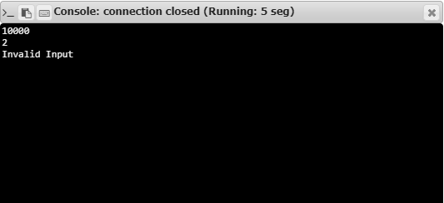

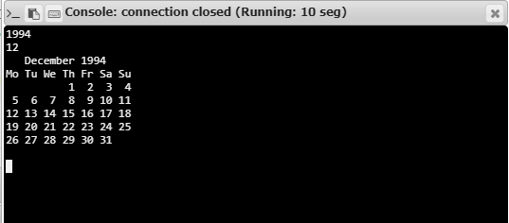

**RESULT:**

Hence, the program is executed successfully.