**EXERCISE NO** :2

**DATE** : 11-10-2020

**AIM:**

To given a list in Python and a number x, count number of occurrences of x in the given list.

**PROGRAM:**

def countX(lst1,x1):

count=0

for i in range(0,len(lst1)):

if(x1==lst1[i]):

count=count+1

return count

lst=[]

n=int(input("No of elements"))

for i in range(0,n):

inp=int(input())

lst.append(inp)

print(lst)

x=int(input("The element to be searched"))

y=countX(lst,x)

print(y)

**LINK:**

<http://103.53.53.18/mod/vpl/forms/edit.php?id=230&userid=1784>

**OUTPUT:**

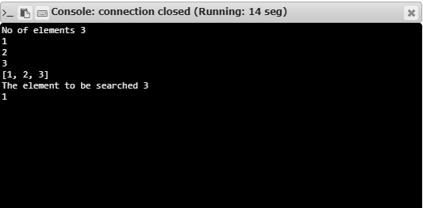

**RESULT:**

Hence, the program is executed successfully.