**EXERCISE NO** :3

**DATE** : 11-10-2020

**AIM:**

To write a Python program to remove and print every second number from a list of numbers until the list becomes empty.

**PROGRAM:**

def removeThirdNumber(lst):

lst1=[]

position=1

a=0

for i in range(0,len(lst)):

a=(position+a)%len(lst)

e1ement=lst.pop(a)

lst1.append(e1ement)

return lst1

n=int(input())

int_list=[]

for i in range(0,n):

b=int(input())

int_list.append(b)

c=removeThirdNumber(int_list)

print(c)

**LINK:**

<http://103.53.53.18/mod/vpl/forms/edit.php?id=231&userid=1784>

**OUTPUT:**

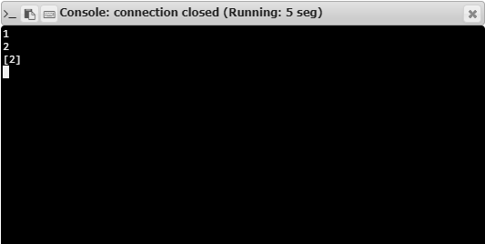

**RESULT:**

Hence, the program is executed successfully.