**EXERCISE NO** :4

**DATE** : 11-10-2020

**AIM:**

To Write a Python program (function) to print a single string from two set of strings received from user and swap the first two characters of each string.

**PROGRAM:**

def swap(x,y):

if(len(x)>2 and len(y)>1):

a=y[:2]+x[2:]

b=x[:2]+y[2:]

print(a+' '+b)

else:

print("Invalid")

x=input().strip()

y=input().strip()

swap(x,y)

**LINK:**

<http://103.53.53.18/mod/vpl/forms/submissionview.php?id=234&userid=1784>

**OUTPUT:**

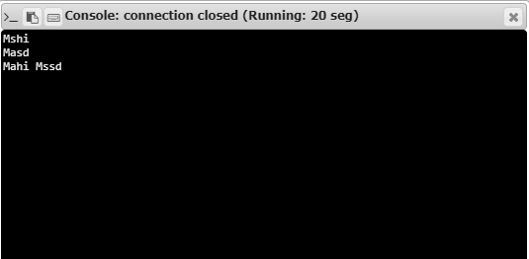

**RESULT:**

Hence, the program is executed successfully.