**EXERCISE NO** :5

**DATE** : 11-10-2020

**AIM:**

To Write a Python function to print missing characters to make string pangram.

**PROGRAM:**

a=input()

a=set(a.strip())

a.remove(chr(32))

b="abcdefghijklmnopqrstuvwxyz"

b=set(b)

b=b.difference(a)

b=list(b)

b.sort()

print("".join(b))

**LINK:**

<http://103.53.53.18/mod/vpl/forms/submissionview.php?id=235&userid=1784>

**OUTPUT:**

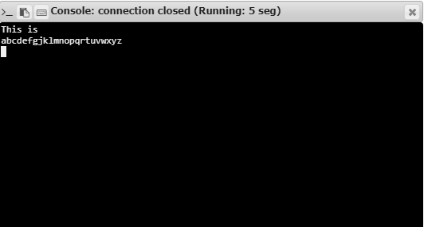

**RESULT:**

Hence, the program is executed successfully.