SIMATS ENGINEERING
ASSESSMENT TOOL 2 : Scenario-Based

COURSE NAME: | Cloud Computing and Big Data Analytics | COURSE CODE: | CSA1506

COURSE OUTCOME COVERED
CO2: Analyze virtualization architectures to identify performance and security issues in cloud computing environments. (BL3)
Assessment Tool Weightage: 20%

Dave's Taxonomy: Manipulation (Level 2)  Question Count: 5 | Total Marks: 25

Code of Conduct
I Logeshwaran R- 192511175 (Name / Reg No) certify that this submission is my original work and that I have adhered to the guidelines specified for this assessment.
I understand that any violation of academic integrity rules will result in disciplinary action.
Signature of the student: 

Assessment Tasks
Scenario-Based Questions And Answers

- A media company wants to migrate its video streaming platform to the cloud.
The system must handle millions of concurrent users with minimal buffering.
Design a cloud architecture using scalability and caching techniques.
Explain how load balancing and auto-scaling can ensure smooth streaming.
Discuss cost optimization strategies for such high-demand workloads.
Answer:
A media company is migrating its video streaming platform to the cloud and must support millions of concurrent viewers with minimal buffering, while controlling cost.
1. Architecture Design - Scalability and Caching
- Global DNS / Global Load Balancer: Routes each user request to the nearest healthy region using latency-based or geo-DNS routing, forming the entry point of the architecture.
- CDN edge caching (e.g., Cloud Front, Akamai): Popular video segments and thumbnails are cached at edge locations close to users, so most requests never reach the origin, drastically cutting latency and buffering.
- Adaptive bitrate streaming: Video is pre-transcoded into multiple resolutions (HLS/DASH) so the player can switch quality based on the viewer's bandwidth, avoiding buffering rather than reacting to it.
- Regional load balancers and auto-scaling groups: Distribute traffic across a fleet of transcoding and streaming servers that scale in/out automatically.
- In-memory cache (Redis/Memcached): Stores hot metadata (session state, recommendation results, view counts) to reduce database load.
- Object storage origin: Master video files are stored in durable, versioned object storage (e.g., S3) as the single source of truth behind the CDN.
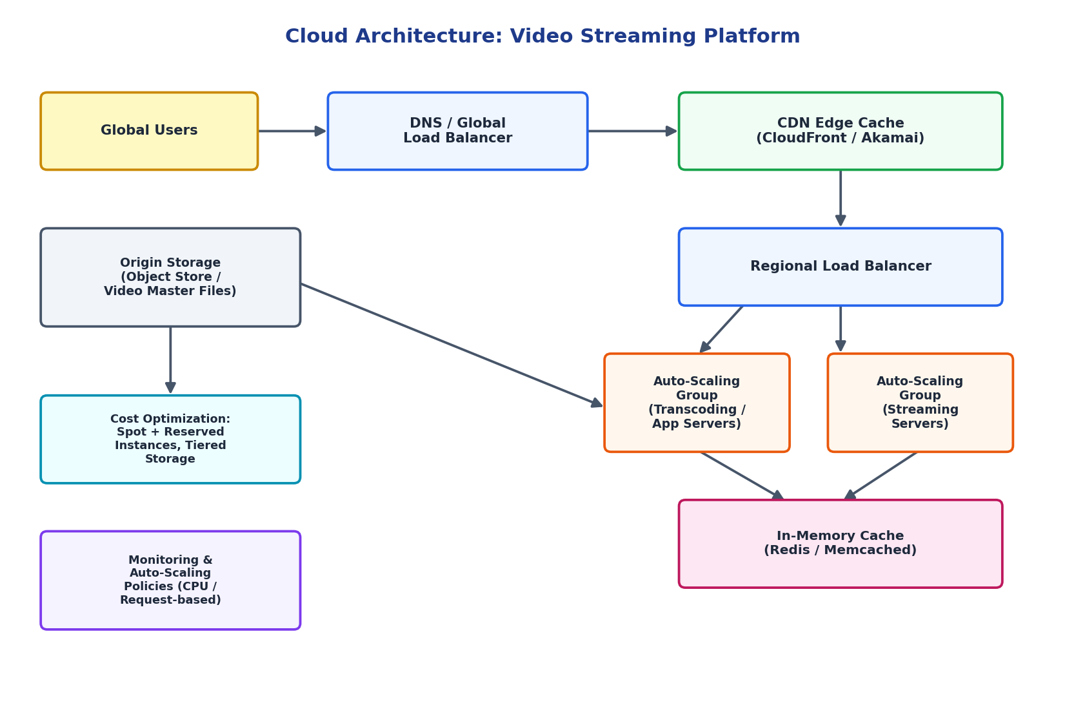
2. Load Balancing and Auto-Scaling for Smooth Streaming
- Load balancers perform continuous health checks and remove unhealthy instances from rotation, preventing failed requests from reaching users.
- Layer-7 (application) load balancing routes requests based on content type, e.g., separating lightweight API calls from heavy video-segment requests.
- Auto-scaling policies trigger on CPU utilization, network throughput, or concurrent-connection count, adding streaming server instances ahead of demand spikes (e.g., a new episode release).
- Predictive/scheduled scaling can pre-warm capacity before known peak events (prime-time hours, live sports), avoiding cold-start delays.
- Combined with CDN offload, load balancing ensures that only a fraction of total traffic ever reaches the origin infrastructure, keeping response times low even at millions of concurrent users.
3. Cost Optimization Strategies
- Use a mix of Reserved/Committed instances for predictable baseline load and Spot instances for burst transcoding jobs.
- Apply storage tiering: frequently accessed videos on hot storage, older/rarely watched content moved automatically to cold/archive storage.
- Maximize CDN cache-hit ratio to reduce expensive origin egress bandwidth costs.
- Use serverless/on-demand transcoding for infrequent formats instead of always-on servers.
- Continuously monitor cost via cloud cost-management dashboards and set budget alerts tied to auto-scaling thresholds.

- A fintech startup is deploying applications using containers across multiple cloud providers.
They face challenges in maintaining consistency and managing deployments.
Propose a solution using container orchestration and multi-cloud strategies.
Explain how service discovery and scaling can be handled efficiently.
Highlight the benefits and risks of a multi-cloud deployment model.
Answers:
A fintech startup deploys containerized applications across multiple cloud providers and struggles with consistency and deployment management.
1. Proposed Solution - Container Orchestration and Multi-Cloud Strategy
- Kubernetes as the common orchestration layer: Deploy Kubernetes clusters (EKS on AWS, AKS on Azure, GKE on GCP) so the same container images, manifests, and Helm charts run identically on every cloud, removing provider-specific inconsistency.
- GitOps-based CI/CD pipeline: A single pipeline builds container images once and pushes declarative manifests to all clusters, guaranteeing configuration consistency across providers.
- Cluster/fleet management layer: Tools like Rancher, Anthos, or Kubernetes Federation give one control plane view across all clusters for centralized policy, RBAC, and monitoring.
- Centralized secrets and configuration store: A provider-agnostic vault (e.g., HashiCorp Vault) keeps credentials and config consistent instead of duplicating them per cloud.
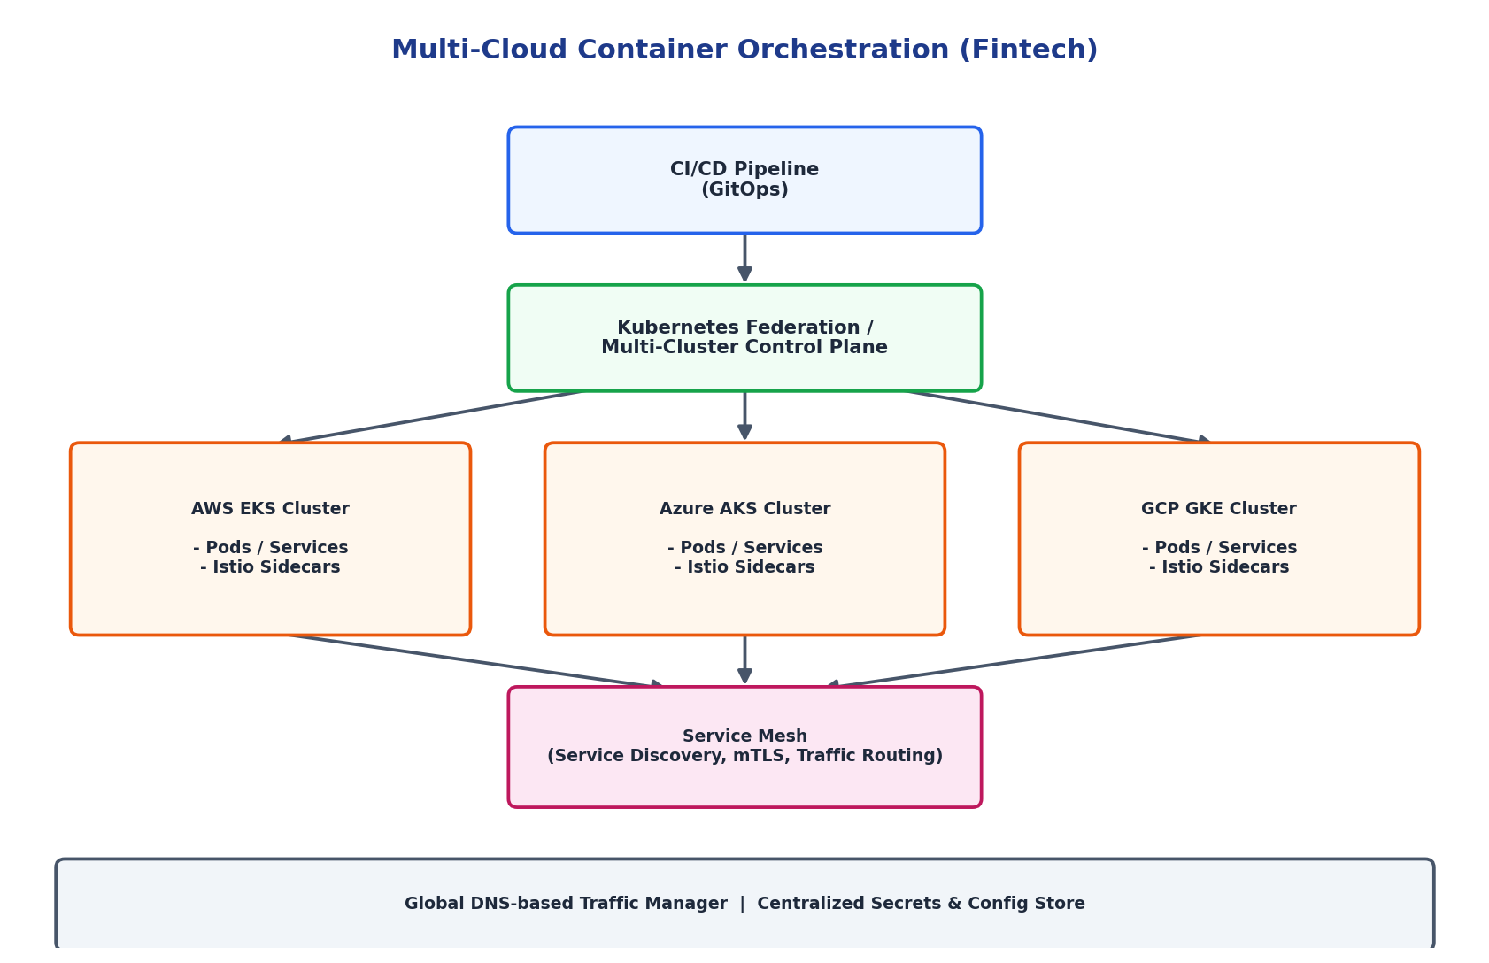
2. Service Discovery and Scaling
- A service mesh (Istio/Linkerd) is deployed as sidecars in every pod, providing uniform service discovery, mutual TLS, and traffic routing regardless of which cloud a service runs in.
- Each Kubernetes cluster runs its own Horizontal Pod Autoscaler (HPA) based on CPU/memory/custom metrics, so services scale independently per region/cloud.
- A global DNS-based traffic manager distributes user requests across clouds based on latency, health, or cost, enabling cross-cloud load balancing.
- Cluster Autoscaler adds/removes worker nodes automatically as pod scheduling demand changes on each cloud.
3. Benefits and Risks of Multi-Cloud Deployment
- Benefits: avoids vendor lock-in, improves resilience (one provider's outage does not take down the whole platform), allows choosing the best/cheapest service per workload, and helps meet regulatory data-residency requirements.
- Risks: higher operational complexity, inconsistent native services between providers, increased networking/egress costs for cross-cloud traffic, a larger security surface to secure and audit, and the need for specialized multi-cloud skills within the team.

- An e-learning platform experiences data loss due to accidental deletion in the cloud.
The organization needs a robust backup and disaster recovery strategy.
Design a solution using cloud-native backup, replication, and versioning.
Explain how recovery time objective (RTO) and recovery point objective (RPO) are achieved.
Provide steps to ensure business continuity during failures.
Answers:
An e-learning platform suffered data loss from accidental deletion and needs a robust backup and disaster recovery (DR) strategy.
1. Solution Design - Backup, Replication and Versioning
- Continuous replication: The primary database is replicated (synchronously within a region, asynchronously to a secondary region) so a near-real-time standby copy always exists.
- Scheduled automated snapshots: Hourly/daily snapshots of databases and file storage are taken automatically without manual intervention, reducing human error risk.
- Versioned, immutable object storage: Course content and files are stored with versioning enabled, so an accidental delete or overwrite can simply be rolled back to a prior version rather than being permanently lost.
- Cross-region backup vault: Backups are copied to a separate region/account, protecting against a full regional failure or malicious deletion of the primary backup set.
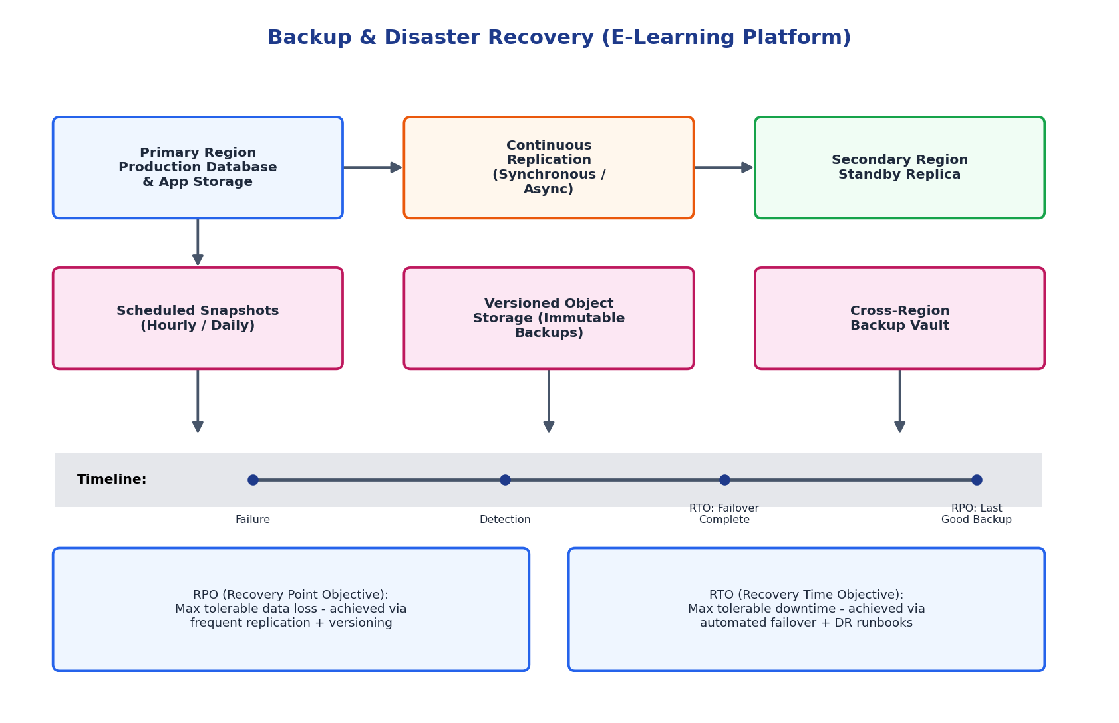
2. Achieving RTO and RPO
- Recovery Point Objective (RPO): the maximum acceptable data loss, measured in time. It is minimized by increasing replication frequency (near-continuous log shipping or synchronous replication) and enabling object versioning, so the last recoverable state is only seconds to minutes old.
- Recovery Time Objective (RTO): the maximum acceptable downtime before service is restored. It is minimized through automated failover scripts/runbooks, pre-provisioned standby infrastructure, and regular DR drills that rehearse the failover procedure so it can be executed quickly under real incident pressure.
Together, tighter RPO/RTO targets require more redundant infrastructure, so the organization should set targets based on the criticality of each system component (e.g., stricter for grading/transcript data than for discussion forums).
3. Steps to Ensure Business Continuity
- Classify data/services by criticality and assign RTO/RPO targets accordingly.
- Automate backups and replication; never rely on manual processes.
- Enable versioning and soft-delete/retention locks so deletions are recoverable for a defined window.
- Maintain a documented, tested DR runbook and run periodic failover drills.
- Set up monitoring and alerting on backup job failures and replication lag.
- Apply least-privilege access controls and multi-factor approval for destructive operations (bulk delete).

- A government agency is adopting a hybrid cloud model for sensitive and non-sensitive data.
Some applications must remain on-premises due to compliance requirements.
Design a hybrid architecture that ensures secure communication between environments.
Explain how identity management and encryption should be implemented.
Discuss challenges in managing hybrid cloud environments.
Answers:
A government agency is adopting a hybrid cloud model, keeping compliance-sensitive applications on-premises while moving other workloads to the cloud.
1. Hybrid Architecture Design
- On-premises environment: Hosts regulated/sensitive data and legacy compliance systems that cannot legally or practically move to a public cloud, along with the agency's identity provider (Active Directory).
- Public cloud environment: Hosts non-sensitive, scalable workloads such as public-facing web applications, analytics, and backup storage, taking advantage of cloud elasticity.
- Secure connectivity layer: A dedicated private interconnect (AWS Direct Connect / Azure ExpressRoute) or a site-to-site IPsec VPN links the two environments, avoiding exposure over the public internet.
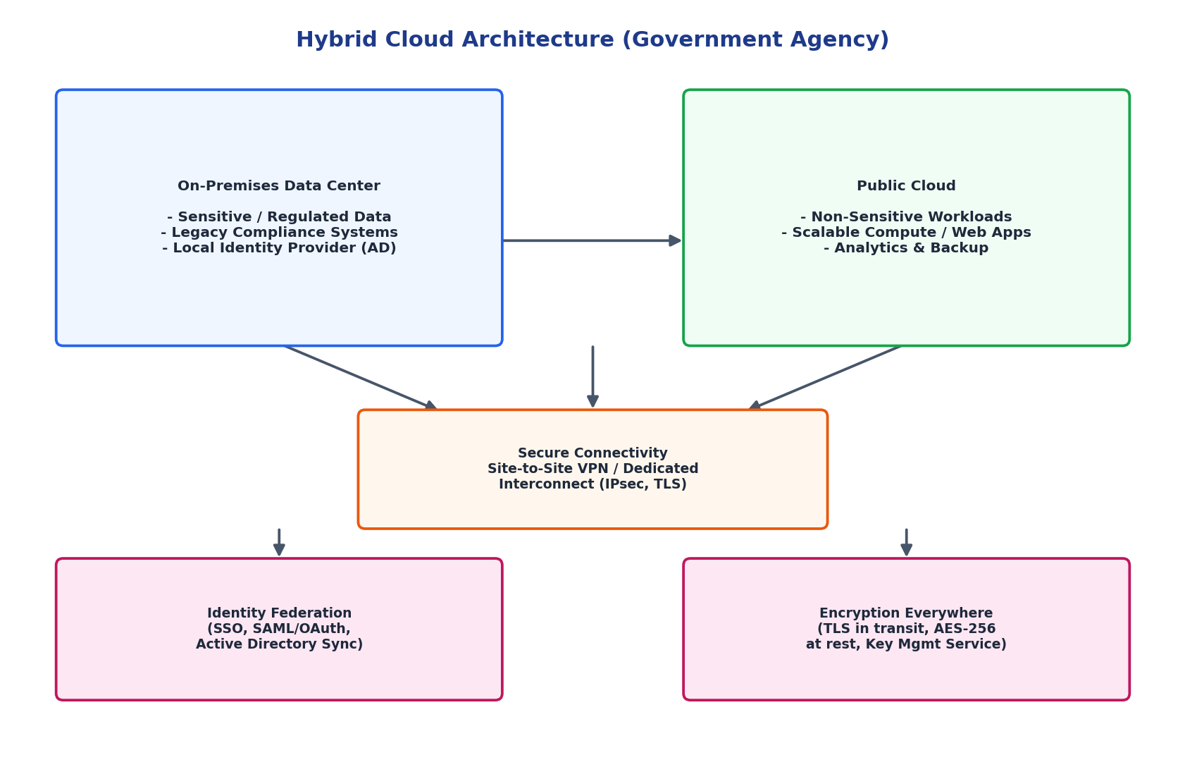
2. Identity Management and Encryption
- Identity management: Federated identity (SAML/OAuth2 SSO) synchronizes the on-premises Active Directory with the cloud identity service, so users authenticate once and access is governed by a single source of truth, with role-based access control (RBAC) enforced consistently on both sides.
- Encryption: All data in transit between on-premises and cloud is encrypted with TLS/IPsec, and data at rest is encrypted (e.g., AES-256) using a centrally managed Key Management Service (KMS), with keys for the most sensitive data optionally held under the agency's own control (bring-your-own-key).
3. Challenges in Managing Hybrid Cloud
- Maintaining consistent security policy and monitoring across two very different environments.
- Network latency and reliability of the interconnect between on-premises and cloud.
- Data residency and compliance mapping - knowing exactly which data is allowed to leave the on-premises boundary.
- Identity synchronization drift and access-control complexity across federated systems.
- Higher operational overhead: staff need skills in both traditional data-center operations and cloud-native tools.
- Cost visibility, since spend is split across capital (on-prem) and operational (cloud) expenditure models.

- A SaaS provider needs to ensure high availability and fault tolerance for its application.
The system must continue operating even if one region goes down.
Propose a multi-region deployment strategy in the cloud.
Explain how data replication and failover mechanisms should be configured.
Discuss monitoring and alerting strategies for proactive issue detection.
Answers:
A SaaS provider must remain available and fault-tolerant even if an entire cloud region fails.
1. Multi-Region Deployment Strategy
- Active-active regions: The application stack (load balancer, app tier, database) is fully deployed in two or more regions simultaneously, each capable of serving live traffic rather than sitting idle as cold standby.
- Global traffic manager: A DNS-based or anycast global load balancer performs continuous health checks and routes each user to the nearest healthy region.
- Regional isolation: Each region has its own load balancer and auto-scaling app tier, so a failure in one region's infrastructure does not cascade to the other.
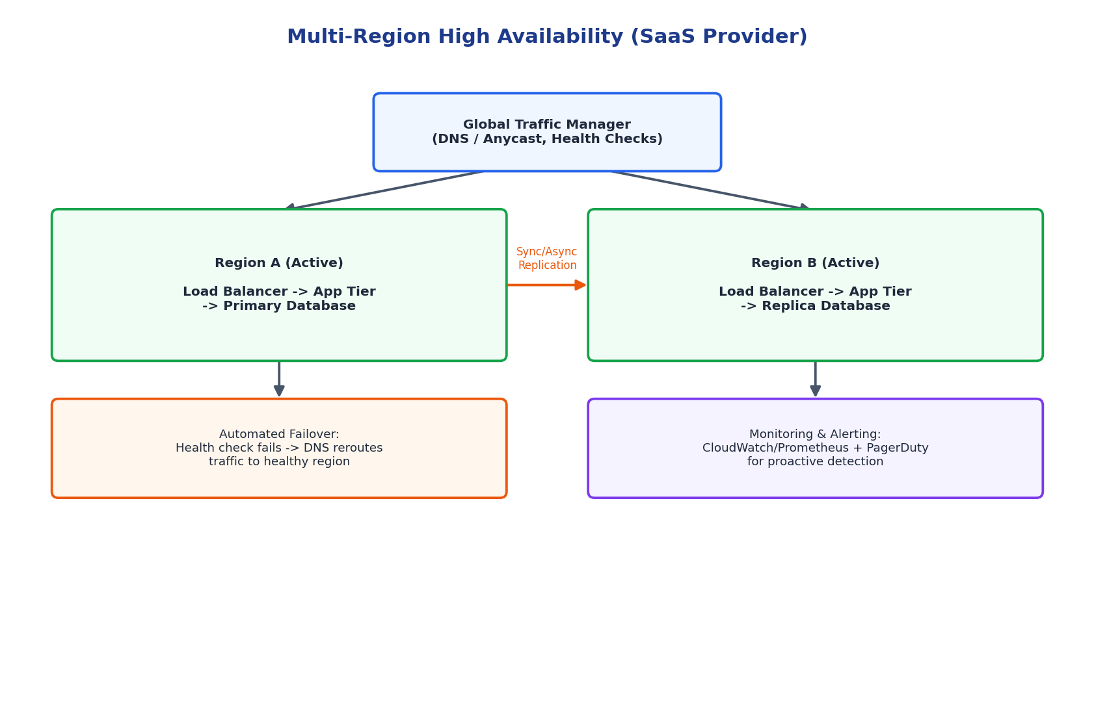
2. Data Replication and Failover Mechanisms
- Data replication: The primary database in Region A replicates continuously (synchronously for strong consistency or asynchronously for lower latency, depending on the application's consistency needs) to a replica in Region B, keeping both regions close to in-sync.
- Automated failover: When health checks detect Region A is unhealthy, the global traffic manager automatically reroutes all traffic to Region B, and the database replica is promoted to primary, all without manual intervention, minimizing downtime.
- Failback: Once the failed region recovers, it is resynchronized and can be reintroduced as active or kept as the new standby, following a controlled failback procedure.
3. Monitoring and Alerting for Proactive Detection
- Deploy synthetic health checks and real-user monitoring in every region to detect degradation before users report it.
- Use metrics platforms (CloudWatch, Prometheus/Grafana) to track latency, error rate, replication lag, and resource saturation.
- Configure automated alerting (PagerDuty/Opsgenie) with escalation policies so on-call engineers are notified within minutes of an anomaly.
- Set threshold-based and anomaly-detection alerts so gradual degradation is caught, not just hard outages.
- Run regular chaos-engineering/failover drills to validate that monitoring correctly triggers failover under real failure conditions.

Scenario-Based Rubric

Criteria | Weightage | Level 4 - Exemplary | Level 3 - Proficient | Level 2 - Developing | Level 1 - Beginning
Understanding of Scenario | 20% | Demonstrates complete understanding of the scenario context | Good understanding with minor gaps | Partial understanding | Fails to understand the scenario
Identification of Risks / Issues | 20% | Identifies all major issues correctly | Identifies most issues | Limited issue identification | Misses major issues
Application of Concepts | 25% | Applies virtualization concepts effectively | Applies concepts with minor mistakes | Partially correct application | Weak application
Decision Justification | 20% | Decisions are well justified and technically strong | Reasonable justification | Weak justification | No useful justification
Clarity | 15% | Clear and well-organized response | Generally clear | Somewhat unclear | Poorly presented

