# LS1/LS1X MANUAL

Multi-card Long-Term Underwater Acoustic Recorder

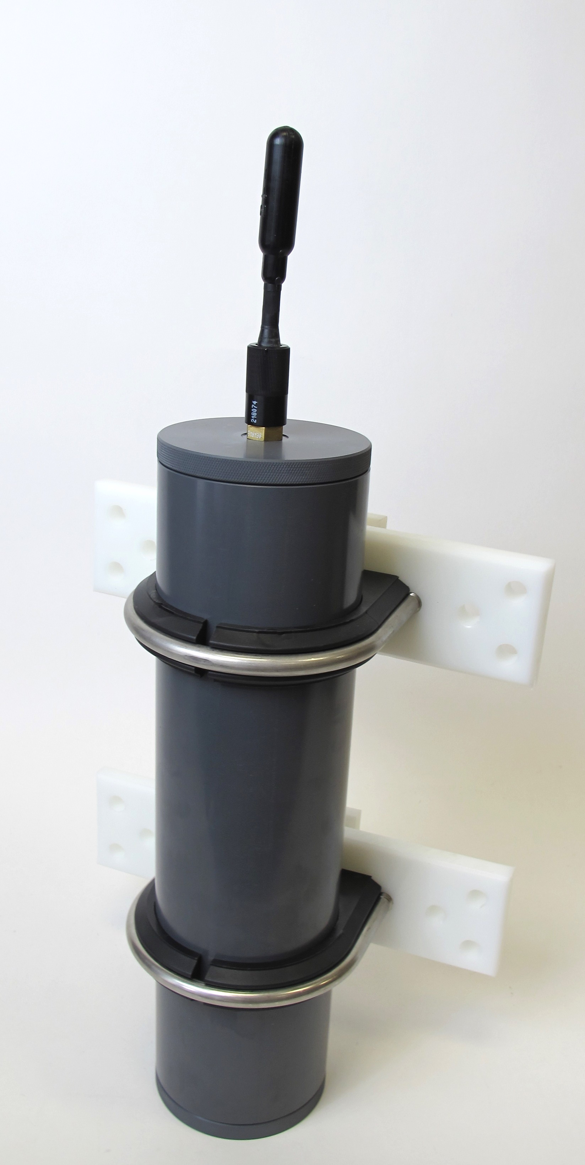

Manual v1.0

Updated 26 February 2018

www.loggerhead.com

# Overview

**Hardware**

LS1/LS1X is a multi-card datalogger designed for collecting large amounts of underwater acoustic recordings. Setup is designed to run through a simple button interface with a display. No PC is needed to setup and deploy the LS1/LS1X.

* HTI-96-min hydrophone
* Fixed 44.1 kHz sample rate
* Up to 4 microSD cards formatted as FAT32

**Software**

LS1/LS1X store data directly as audio wav files.

Any audio analysis software (Adobe Audition, Cornell Raven, MATLAB, R, Python) will work with these files.

**Setting up LS1/LS1X for Deployment**

**See the online video for a tutorial on setting up the LS1/LS1X**

**Step 1.** **Prepare microSD card.** Create setup.txt file if changing default gain setting. This is usually not necessary. Be sure to safely eject the card before removing from computer.

microSD cards larger than 32 GB need to be formatted as FAT32. Appendix 1 describes software that can be used to do this on Windows PCs.

**Step 2**. **O-rings**. Clean and grease o-rings with silicone grease and insert into the groove on the ring. The fatter radial o-ring is 5 mm wide x 90 mm inner diameter (McMaster Part number [9262K395](https://www.mcmaster.com/#9262k395/=1bqo6oc)). The o-ring that seals with the top of the tube is -155 (McMaster Part number [9452K176](https://www.mcmaster.com/#9452k176/=1bqo7nd)).

**Step 3. Turn on power switch.**

The microSD cards will be scanned for free memory. There MUST be a card in slot 1.

Use buttons to change settings

**En**ter: Used to move through menu settings and accept changes.

**UP/DN**: Used to change values.

|  |  |
| --- | --- |
| **Display Setting** | **Description** |
| UP+DN->Rec | Hold down UP + DN to start  Press Enter to change settings |
| Rec: | Record duration in seconds |
| Slp: | Sleep duration in seconds. This is the time from the END of one recording to the START of the next recording. |
| Batt: | Number of battery *packs* you will fill. There are 3 D-cells per battery pack.  This setting was made available in Feb 2018. Previous versions of firmware used 4 battery packs for this setting. |
| Year: | Year |
| Month: | Month |
| Day: | Day of month |
| Hour: | Hour (24 hour time) |
| Minute: | Minute |
| Second: | Second |
| Mode: | Switch between Norm(al) and Diel recording. In Diel recording mode the Start HH:MM and End HH:MM are specified to limit recording to certain parts of the day (e.g. record only in the morning). In Normal recording mode, recordings are made throughout the day. |

**Step 5. Start Recording.** Hold down the UP and DN buttons at the same time to start recording. If this is not done, the recorder will automatically start after 15 minutes.

**Step 6. Close lid.** Lids should be closed securely using a coin. It should be more than hand-tight.

**setup.txt Commands**

All commands are optional. Default column lists values if no setting in setup.txt file. Record duration and record interval can be set through the button interface.

|  |  |  |  |  |
| --- | --- | --- | --- | --- |
| **Command** | **Function** | **Default** | **Example** | **Setup.txt example** |
| RD | Record duration (s) | Last used | Record 600 second files | RD 600 |
| RI | Record interval (s) | Last used | Sleep 240 seconds between files | RI 240 |
| SG | Hydrophone system gain. See table for dB gains associated with different settings. | 4 | Set gain to setting ‘10’, which corresponds to 11.1 dB gain | SG 10 |
| ND | Remove DC from audio. Turning on increases electrical noise | Off | Turn on feature to remove DC from audio | ND |

**Power**

The LS1 has battery holders for 4 sets of D-cell batteries (12 batteries total).

The LS1X has battery holders for 8 sets of D-cell batteries (24 batteries total).

Always use new batteries with the LS1, and tape them into place.

The display will provide estimated run time based on the number of battery packs that are filled (LS1: 1-4 battery packs: LS1X: 1-8 battery packs) and the memory available in all of the microSD cards.

# HTI Hydrophone and Recording Gain

The LS1/LS1X uses a hydrophone manufactured by High-Tech Inc. The sensitivity of the hydrophone will be on a specification sheet included with the shipment (typically -170 dBV/uPa or -180 dBV/uPa).

The hydrophone has a red LED in the end to indicate when it is getting power. This will only be turned on during startup and recording. The hydrophone red LED will be off when sleeping.

The A/D converter gain can be changed through the setup.txt file. The default is setting 4. The setting can be changed with SG command in setup.txt. The actual setting that was used is stored to the log.txt file.

|  |  |  |  |
| --- | --- | --- | --- |
| **Setting** | **Clip Level (peak-peak)** | **Clip Level (peak)** | **Gain (dB)** |
| 0 | 3.12 | 1.56 | -3.9 |
| 1 | 2.63 | 1.315 | -2.4 |
| 2 | 2.22 | 1.11 | -0.9 |
| 3 | 1.87 | 0.935 | 0.6 |
| **4** | **1.58** | **0.79** | **2.0** |
| 5 | 1.33 | 0.665 | 3.5 |
| 6 | 1.11 | 0.555 | 5.1 |
| 7 | 0.94 | 0.47 | 6.6 |
| 8 | 0.79 | 0.395 | 8.1 |
| 9 | 0.67 | 0.335 | 9.5 |
| 10 | 0.56 | 0.28 | 11.1 |
| 11 | 0.48 | 0.24 | 12.4 |
| 12 | 0.4 | 0.2 | 14.0 |
| 13 | 0.34 | 0.17 | 15.4 |
| 14 | 0.29 | 0.145 | 16.8 |
| 15 | 0.24 | 0.12 | 18.4 |

**Vent Plug**

**This plug is only to be used if there is a leak in the housing.**

A leak in the housing can be dangerous because the housing will pressurize internally to the same pressure as the depth of deployment.

If there is a leak, it is critical to relieve the pressure before removing the lid, otherwise the lid could fly off.

The vent plug can be used to relieve the pressure, by turning it slowly until you start hearing air come out. Once air starts coming out, stop unscrewing and wait until air stops coming out. The vent plug is designed to stay in the endcap and safely vent air through holes machined in the plug.

Once the internal pressure has equalized, you may remove the top lid with the hydrophone. There is no need to fully remove the vent plug. Then gently retighten the vent plug. On PVC housings be very careful not to overtighten the plug, otherwise the threads in the bottom endcap may strip.

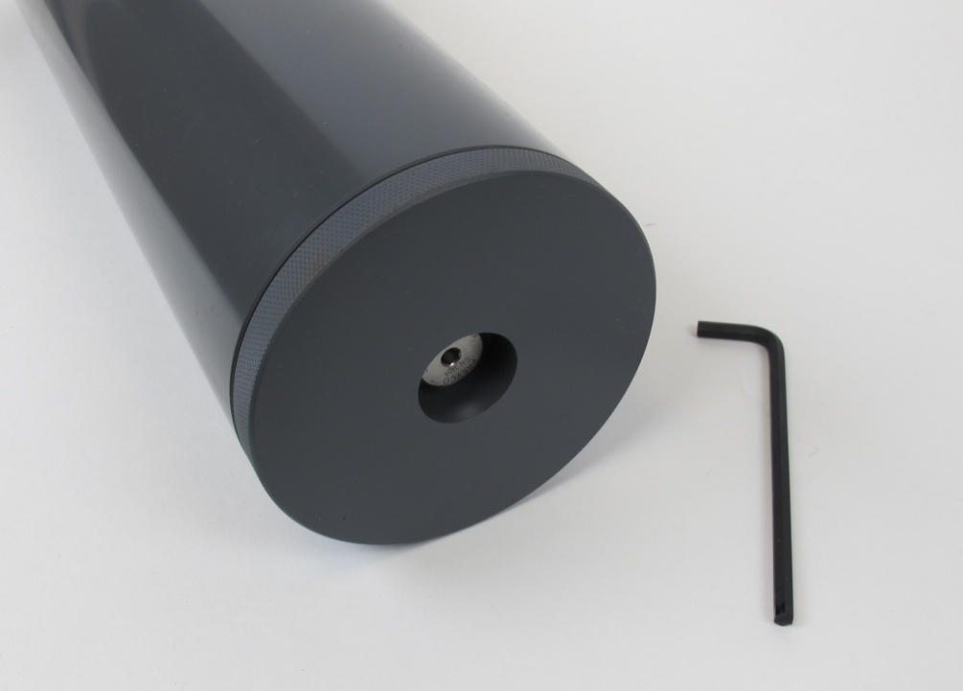

# Appendix I

**Formatting SD card with EaseUS Partition Master for Cards Larger than 32 GB**

**32 GB cards can be formatted as FAT32 in Windows with standard re-formatting. New 32 GB cards will come formatted as FAT32 (you don’t need to do anything).**

Cards larger than 32 GB can not be formatted with the FAT32 file system with the regular windows formatting tools. Cards shipped from Loggerhead have been formatted as FAT32. The exFAT file system will not work with the DSG boards. These larger cards can be formatted with EaseUS Partition Master, which has a free personal edition available.

http://www.partition-tool.com/personal.htm

Run EaseUS Partition Master

1. Select drive with SD card.

2. Click on Format Partition on left.

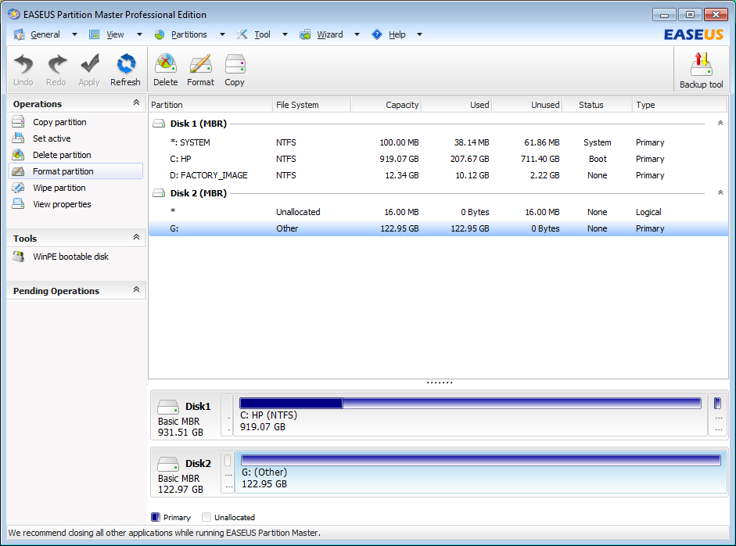

3. Make sure File System is FAT32. Click OK.

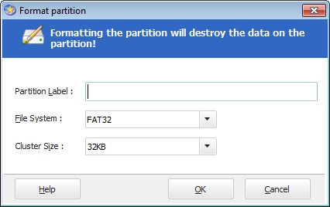

4. Click Apply on the toolbar. Then click Yes.

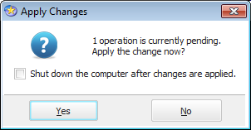

You should see this screen. When it is done you can close EaseUS.

