**Axes of tag used in ot_AHRS.m**

The raw data file records the axes as per the MPU9250 IMU specification sheet. The ot3_AHRS.m code alters the axes of the IMU so that they follow the NED orientation.

The 'NED' orientation is with X facing North at 0 degrees, Y facing east at 90 degrees, and Z pointing down. Positive rotations follow the right-hand rule, where you point your thumb along the positive axis, and your fingers curl in the direction of positive rotation.

X

Y

Z (down)

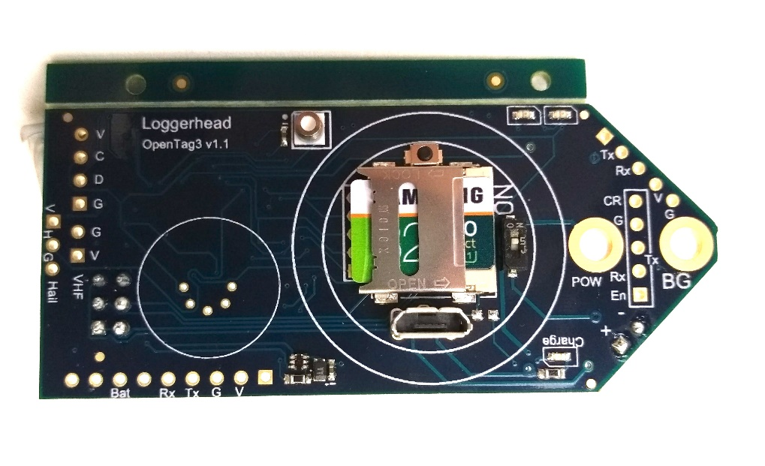

For example, a rotation about the z-axis to + 90 degrees, would yield the following:

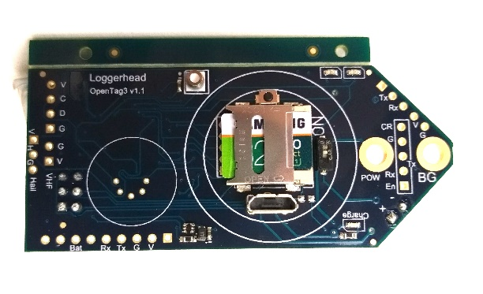

X

Y

Z (down)

In the Euler plots, the rotations about each axes are described by Phi (rotation about x-axis: roll), Theta (rotation about y-axis; pitch), and Psi (rotation about z-axis; yaw).

**Using ot3_AHRS.m**

**ot3_AHRS.m is an example m-file for loading OpenTag .csv files, plotting them, and calculating Euler angles using the Madgwick algorithm, which uses quaternions to determine rotation. See the file help for details about the algorithm.**

**The CSV files must contain only the first 9 columns. The date and other sensor columns need to be deleted to load properly in MATLAB.**

Unzip folder and add all folders to your MATLAB path.

From MATLAB:

>ot3_AHRS

You will be prompted to select a .csv file.

The data will be loaded into the INER structure, which will have accel, mag, and gyro members.

These data will be plotted with the axes changed to the NED orientation.

If a magnetometer correction (magoffset) and gyrooffset are present, they will be subtracted from the data. See below on recording and using calibration files.

The quaternion calculations will be performed, and the Euler angles will be computed and plotted from those.

**Using ot3_gyrocal.m**

ot3_gyrocal.m is used to calculate a static offset in the gyroscope axes, which measure rotational velocity. To make a calibration file, run the OpenTag and leave it sitting motionless on a flat surface.

1. Remove all but the first 9 columns from the csv data file.
2. Run ot3_gyrocal.m and select this file.

No plots will be generated, but the offsets will be stored in a variable in the workspace called gyrocal.

**Using ot3_magcal.m**

Ot3_magcal.m is used to calculate offsets in the magnetometer readings, which can lead to errors in heading. The offset is affected by the local magnetic field, so if you are going to be attaching the tag to something with metal in it, this calibration should be done in that situation.

1. Make a recording from OpenTag while rotating the tag around all axes.
2. Remove all but the first 9 columns from the csv data file.
3. Run ot3_magcal.m and select this file.

The data will be plotted in uncorrected and corrected forms.

You should see circles in the plots of X vs Y, and X vs Z. The software corrects for the offset by calculating the minimum and maximum of each axes and centering it. It does not correct for offsets that distort the field (you would see ellipses in the plots).

The offsets are stored in the variable 'magoffset', which is then used by ot3_AHRS.m.

Note that this can be saved in a .mat file, and then reloaded prior to running ot3_AHRS.m.



Example: Sequential rotation about X, Y, and Z axes (90 degrees positive, then 90 degrees negative) while pointing North. Euler angles calculated with ot_AHRS.m using Madgwick algorithm in MATLAB.

Without Magnetometer Correction

Without Magnetometer Correction: Note error in Psi (Yaw) at about -60 degrees, when should be 0.



With Magnetometer Offset Calibration:



