AMX MANUAL

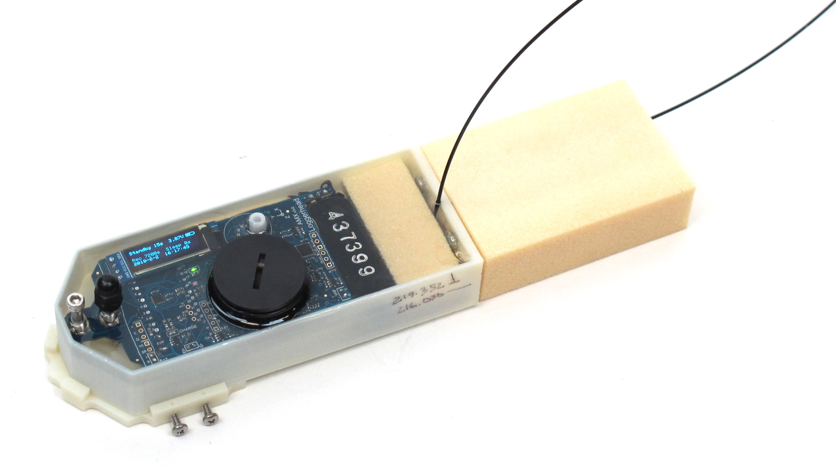
Audio-Motion Datalogging Tag

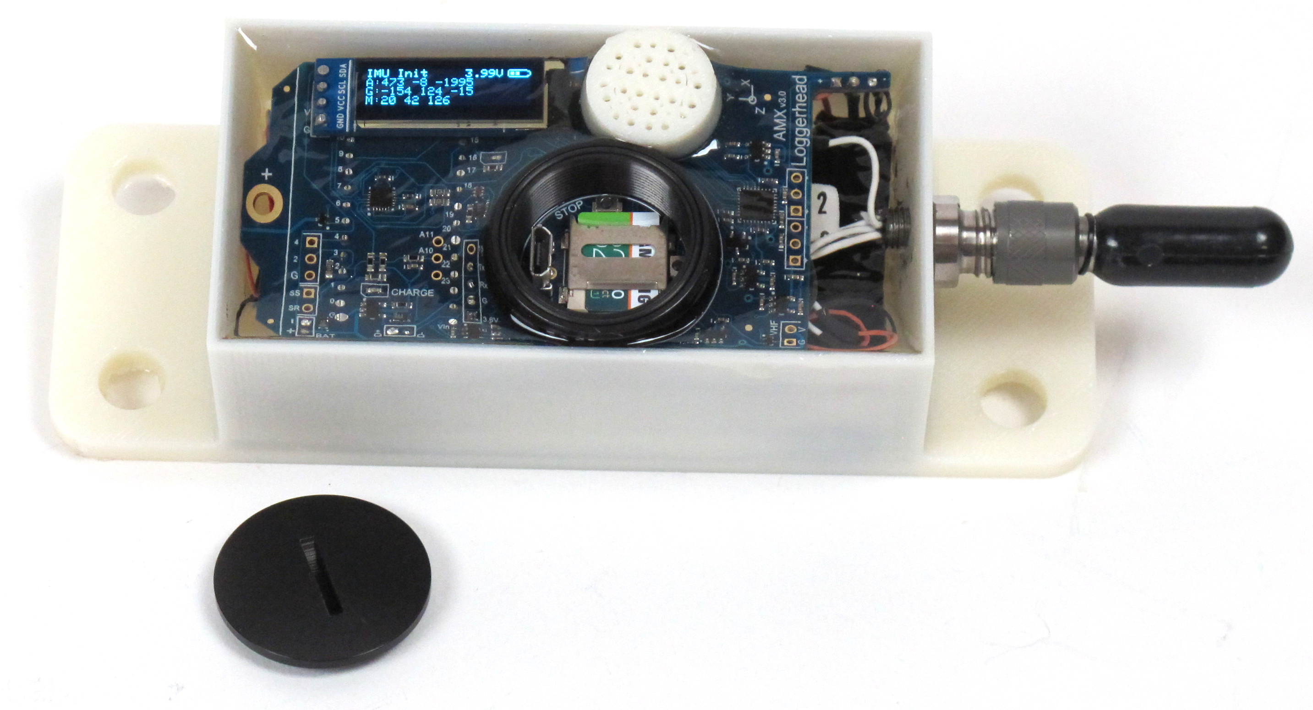

Manual v1.0
Updated 8 February 2018

www.loggerhead.com

Overview

Hardware

AMX is a multi-sensor datalogger designed for collecting acoustic and motion data from tagged animals and underwater platforms.

Sensors:
- HTI hydrophone: 44.1 kHz
- Accelerometer, Gyroscope, Magnetometer (MPU9250): 100 Hz
- Pressure/Temperature (MS5837 or Keller PA7LD): 1 Hz
- RGB light level (ISL29125): 1 Hz
- Burn wire release: controls a FET switch to ground which can be used to corrode a stainless steel wire in seawater
- Optional camera
- Optional sound playback
- Optional VHF board to aid in recovery

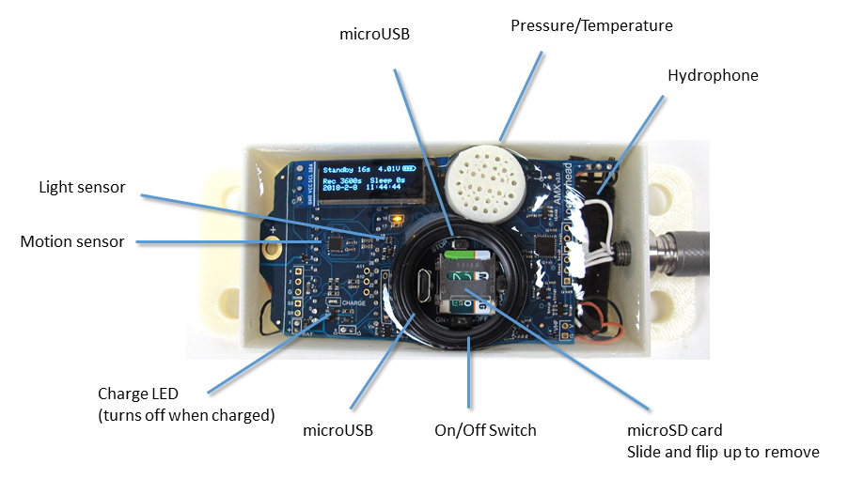

Software
AMX stores data as .amx binary files. These files can be converted to multi-channel wav files with one for each sensor using AMX2WAV (Windows 10).

https://github.com/loggerhead-instruments/amx/blob/master/AMXsetup.zip

MATLAB code for importing files is available at: https://github.com/loggerhead-instruments/amx/tree/master/MATLAB

All firmware is open source and is available at GitHub: https://github.com/loggerhead-instruments/amx

Setting up AMX for Deployment

Step 1. Prepare microSD card. Create setup.txt file if setting the time, using the burn wires, or changing default settings. Be sure to safely eject the card before removing from computer.

Step 2. O-rings. Clean and grease o-rings with silicone grease, and insert into the groove on the ring. The o-ring is a 1 x 25 mm 70 Shore A Buna N o-ring. They are McMaster-Carr part number 9262K624.

The o-rings need to be removed and cleaned for each use. If there are nicks in an o-ring DO NOT use it.

Step 3. Turn camera switch on if using camera.

Step 4. Turn on tag power switch and monitor display (see below) during startup.

Step 5. Close lid. Lids should be closed securely using a coin. It should be more than hand-tight.

Startup Sequence
After powering on AMX the following operations will be performed.

Tag power up sequence | Display | LED pattern
- Tag turned on |  | On for 4 seconds
- IMU initialization | IMU Init  Raw:  A(ccelerometer)  G(yroscope)  M(agnetometer)  Calculated:  P(itch)  R(oll)  Y(aw) | Off
- Light sensor initialization | Light Init  R(ed)  G(reen)  B(lue) | Off
- Pressure/Temp Sensor Initialization | Pressure (mBar)  Depth (m)  Temperature (C) | Off
- Standby to start | Count down  Burn date and time *B (if set)  Record file duration  Sleep duration  Current date and time | Solid On
- Start recording | Turns Off | Blink for 1 hour.  After 1 hour the LED will be turned off. The tag will still be recording.

setup.txt Commands
All commands are optional. Default column lists values if no setting in setup.txt file. The sample rates of the pressure and light sensors are fixed.

Command | Function | Default | Example | Setup.txt example
TM | Sets time  Time is given as:  YY-MM-DD HH:MM:SS  If a value is less than 10, it should be written with a leading 0. E.g. 5 should be 05  There must be a space between the DD and HH. | Current time, unless battery exhausted. | Set time to 2017-July-02 04:00:00 when tag powered on | TM 17-07-02 04:00:00
RD | Record duration (s) | 3600 | Record 600 second files | RD 600
RI | Record interval (s) | 0 | Sleep 240 seconds between files | RI 240
SG | Hydrophone system gain. See table for dB gains associated with different settings. | 4 | Set gain to setting ‘10’, which corresponds to 11.1 dB gain | SG 10
ND | Remove DC from audio. Turning on increases electrical noise | Off | Turn on feature to remove DC from audio | ND
AG | Accelerometer full scale (2, 4, 8, or 16 g) | 16 | Set accelerometer to +/- 8 g full scale | AG 8
IM | IMU sample rate | 100 | Set IMU sample rate to 50 Hz | IM 50

Burn Wire Settings: *Only one burn wire command will be active (the last one in the script).

BW | Burn at YY-MM-DD HH:MM:SS | No burn | Burn at 2017-July-03 20:00:00 | BW 17-07-03 20:00:00
BM | Burn in Minutes from start | No burn | Burn 60 minutes after start | BM 60
Hydrophone Calibration
HC | Hydrophone sensitivity stored to file | -180 | Change hydrophone sensitivity to -170 dBV/uPa | HC -170
Playback Commands
PF | Number of playback files | 0 | 5 wav files | PF 5
PI | Minimum playback interval (seconds) | 120 | Playbacks separated by at least 500 s | PI 500
PD | Longest file for playback (seconds). Used to power down playback board. | 30 | Longest playback is 15 seconds | PD 15
PT | Playback depth threshold (m). Tag must go deeper than this depth to trigger threshold | 10.0 | Tag must go deeper than 100.0 m before an ascent trigger can trigger playback | PT 100.0
PA | Ascent depth trigger. After exceed depth threshold, must ascend this amount to trigger playback | 5.0 | Trigger playback when ascend through 20.0 m | PA 20.0
PR | Reset depth (m). Tag needs to come back above this depth before next playback can happen. | 2.0 | Tag must ascend through 5.0 m before another playback can be queued | PR 5.0
PM | Max number of playbacks | 20 | Maximum of 10 playbacks | PM 10
SD | Simulate depth profile to test playback. | Off | Turn on simulation of depth (NEVER USE THIS FOR AN ACTUAL DEPLOYMENT) | SD
Debugging
DI
 | Print debug information to serial port | Off | Turn on debug information | DI

Charging
The AMX incorporates rechargeable lithium polymer batteries. Connect the microUSB cable to the AMX and plug into a computer to charge. The red LED will come on to indicate the batteries are charging. The red LED will go out when the batteries are fully charged. It will take approximately 10 hours to fully charge the double-battery version of AMX.

Power
Tags can be supplied with either 1 or 2 lithium polymer rechargeable batteries (2500 mAh).

Run time for tags without cameras
Run time with 1 battery is approximately 1.5 days.
Run time with 2 batteries is approximately 3.0 days.

Tags with cameras are custom designed to have the needed battery power to achieve user-specified recording durations.

If the battery voltage drops below 3.7 V the camera will be powered down to save power. If the voltage drops below 3.0 V, audio files will stop being recorded.

Setting Time
The time is set through the setup.txt file. When creating the setup.txt file to set the time, pick a time in the near future. Eject the card, put it in the tag, and then wait until the time you had put in the setup.txt file occurs, and then turn the tag on. The clock will reset to the time in the setup.txt file.

Note that the TM line in setup.txt will be commented out after the time is set, to avoid the time being reset incorrectly if the tag is turned off and on.

Burn Wire

A burn wire is a corrodible stainless steel wire that can be used to release the AMX from a platform or release suction from suction cups. The recommended wire is from McMaster-Carr (302/304 stainless steel wire 0.01” diameter). https://www.mcmaster.com/ - 6517k61/=17yvpwx

If using suction cups, after attaching the burn wire, coat the base of burn wire where it attaches to the post with nail polish so that it corrodes preferentially at the point of attachment to the suction cups.

The timing of the start of the burn is controlled by a setting in the setup.txt file located on the microSD card in the AMX. Note that the microSD card in the camera is separate, and is only used to store camera data (i.e. don’t put the setup.txt file on the camera card)

There are two ways to set when the burn wire will start, either by specifying a date and time (BW command) or by specifying the number of minutes after the start of recording to start burning (BM command). The format for the two commands is below. Only one of these commands should be used. Pay attention to the exact format of the command. EACH DATE AND TIME VALUE MUST BE TWO CHARACTERS.

BW YY-MM-DD HH:MM:SS
BM minutes

The BM command is the safest, because it will still work even if the time on the real-time clock is wrong.

After the burn wire is triggered the VHF beacon will be turned on. When the power gets low, the AMX will go into sleep mode. The green LED will flash 10x once every 2 minutes in sleep mode.

VHF
If your AMX has the optional VHF, it will turn on based on the depth or the status of the burn wire. If the depth is deeper than 1.0 m, the VHF will turn off. The VHF will be turned on and stay on after the burn wire is triggered. The VHF signal is very strong, and is picked up as electromagnetic interference on the hydrophone. This is normal, if not annoying.

Depth Sensors and Maximum Depth
The AMX is equipped with one of two types of pressure sensors, each of which has a maximum depth that it can sustain. If the tag could go deeper than 300 m, the air void where the microSD card is located should be filled with mineral oil. Mineral oil is non-conductive, and will keep the cap from imploding if the tag goes deeper than 300 m.
TE Connectivity (Measurement Specialities)
2 Bar (20 m max depth)
30 Bar (300 m max depth)

Keller
200 Bar (2000 m max depth)
Or other sensor as specified.

HTI Hydrophone Specifications

The AMX uses a hydrophone manufactured by High-Tech Inc. The sensitivity of the hydrophone will be on a specification sheet included with the shipment.

The A/D converter gain can be changed through the setup.txt file. The default is setting 4. The setting can be changed with SG command in setup.txt. The actual setting that was used is stored to the log.txt file.

Setting | Clip Level (peak-peak) | Clip Level (peak) | Gain (dB)
0 | 3.12 | 1.56 | -3.9
1 | 2.63 | 1.315 | -2.4
2 | 2.22 | 1.11 | -0.9
3 | 1.87 | 0.935 | 0.6
4 | 1.58 | 0.79 | 2.0
5 | 1.33 | 0.665 | 3.5
6 | 1.11 | 0.555 | 5.1
7 | 0.94 | 0.47 | 6.6
8 | 0.79 | 0.395 | 8.1
9 | 0.67 | 0.335 | 9.5
10 | 0.56 | 0.28 | 11.1
11 | 0.48 | 0.24 | 12.4
12 | 0.4 | 0.2 | 14.0
13 | 0.34 | 0.17 | 15.4
14 | 0.29 | 0.145 | 16.8
15 | 0.24 | 0.12 | 18.4

AMX File Conversion Software
The AMX files are binary encoded. AMX2WAV is a Windows 10 software program that will convert the AMX files to a wav file. Each converted wav file stores the data from one of the sensors (e.g. hydrophone audio, 3D IMU, RGB light sensor).

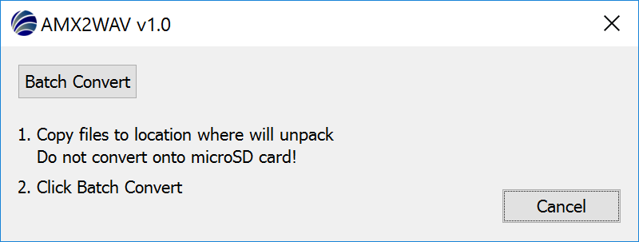
- Copy the files from the microSD card to a new location.
- Click Batch Convert and select a file from the folder where you copied the data to convert.
- A new folder labeled wav will be created with the converted files.

Playback Operation

The AMX uses the Adafruit Audio FX board with serial interface: https://learn.adafruit.com/adafruit-audio-fx-sound-board/overview

File Configuration
- Files are uploaded to the playback board through a USB connection, and then the drive ejected to make sure they all copied. The copy rate IS VERY SLOW. BE PATIENT!
- Files should be named: T00.wav, T01.wav, T02.wav, T03.wav
- Maximum of 16 MB total for all files
- Files will be triggered in sequence, first 0, then 1, then 2, ….

Setup.txt File
The setup.txt file is placed on the microSD card of the AMX board to control playback operation.
Each command should go on its own line with a space before the value, if the command takes a value.
A double slash // can be used to put in a short comment.
Principles of playback triggering
- A depth threshold (PT) must be exceeded to prime a playback.
- Once the depth threshold is exceeded, a playback will occur when the depth goes shallower than the ascent depth trigger (PA).
- For another playback to occur, the following must be satisfied:
  - the tag went shallower than the reset depth (PR). This is to prevent multiple playbacks if the animal goes up and down around the ascent depth trigger.
  - at least x seconds (PI) must have elapsed since the last playback

Testing Settings
The SD command in setup.txt may be used to have the tag cycle through simulated depths.

The simulated profile is hard coded here as one depth value per minute. The value used will correspond to the real-time clock minute.
float depthProfile[] = {0.0, 12.0, 1.0, 12.0, 4.0, 3.0, 10.0, 20.0, 50.0, 10.0, 0.0, 1.0, 40.0, 11.0, 5.0, 2.0, 0.0, 50.0, 2.0, 4.0,0.0, 12.0, 1.0, 20.0, 4.0, 3.0, 10.0, 20.0, 50.0, 10.0, 0.0, 1.0, 12.0, 11.0, 5.0, 2.0, 0.0, 60.0, 2.0, 4.0, 0.0, 12.0, 1.0, 20.0, 4.0, 3.0, 10.0, 20.0, 50.0, 10.0, 0.0, 1.0, 12.0, 11.0, 5.0, 2.0, 0.0, 70.0, 2.0, 4.0};

A custom depth profile can be loaded in a depth.txt file. The depth.txt file should list one depth per line. A maximum of 60 depths can be listed in the depth.txt file.

The simulated depth is NOT stored in the recorded files. It is only used to trigger playbacks.
Example of playbacks on a depth profile
Blue line: Water surface
Green line: Reset depth
Red line: Ascent trigger (when going shallower than this line a playback may be triggered)
Orange line: Depth threshold (must go deeper than this depth to prime ascent trigger)
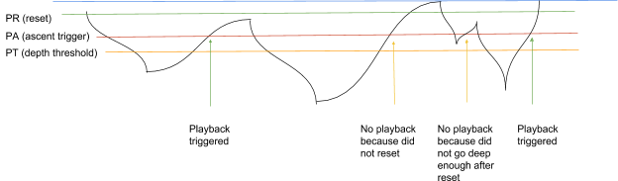
Example setup.txt file for testing simulated depths

// Simulate playback
// Number files
PF 4
// Minimum time between files
PI 600
// Longest file
PD 15
// Depth threshold
PT 40
// Ascent threshold
PA 30
// Reset depth
PR 5
// Simulate depth profile
SD
// Debug info
DI

Appendix I
Formatting SD card with EaseUS Partition Master for Cards Larger than 32 GB

32 GB cards can be formatted as FAT32 in Windows with standard re-formatting. New 32 GB cards will come formatted as FAT32 (you don’t need to do anything).

Cards larger than 32 GB can not be formatted with the FAT32 file system with the regular windows formatting tools. Cards shipped from Loggerhead have been formatted as FAT32. The exFAT file system will not work with the DSG boards. These larger cards can be formatted with EaseUS Partition Master, which has a free personal edition available.
http://www.partition-tool.com/personal.htm

Run EaseUS Partition Master

1. Select drive with SD card.
2. Click on Format Partition on left.

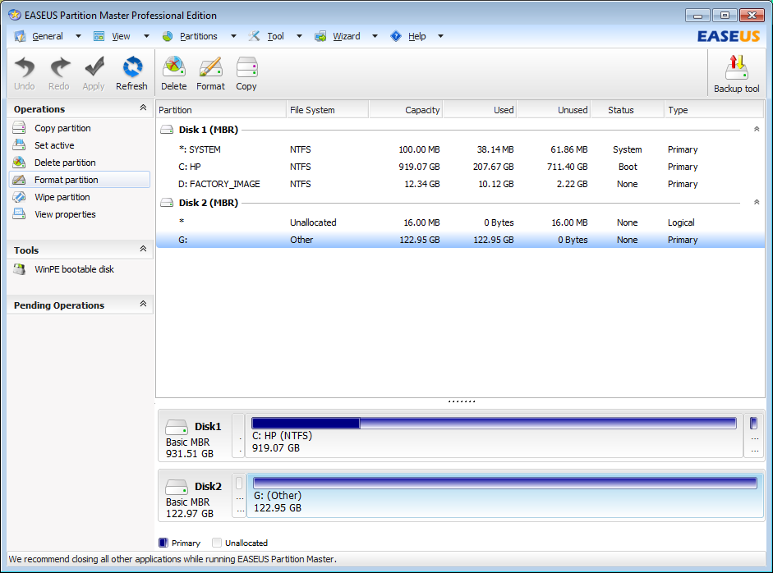
3. Make sure File System is FAT32. Click OK.

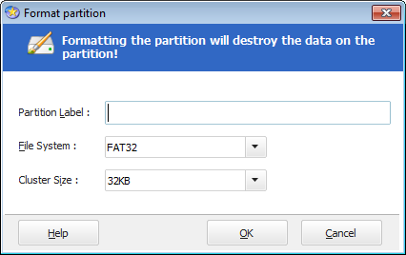

4. Click Apply on the toolbar. Then click Yes.

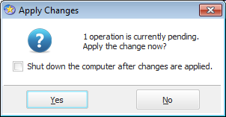

You should see this screen. When it is done you can close EaseUS.

