NASA Technology Maturation Plan for In-space Manufacturing of Metals
Christopher E. Roberts, Frank Ledbetter, Jennifer M. Jones, Zach Courtright,
Alexander Blanchard

NASA Marshall Space Flight Center, Huntsville AL 35812

Abstract

As the International Space Station’s (ISS) life approaches its end, NASA intends to travel back to the Moon and establish a sustainable presence, paving a pathway towards Mars. A fundamental shift in the current logistics strategy is required to support extended missions. On-demand manufacturing enables reduced operational cost and increased long term sustainability providing a pathway towards reducing NASA’s logistics burden. The In-Space Manufacturing (ISM) portfolio at Marshall Space Flight Center is developing additive polymers, metals, and electronics manufacturing technologies to enable a sustainable presence on the Moon and enable long-duration transit missions. Manufacturing systems for in-space applications must meet a unique set of constraints requiring a maturation path independent from processes targeted for terrestrial use. In May 2023, the On Demand Manufacturing of Metals (ODMM) project, part of the ISM portfolio funded through the Game Changing Development (GCD) program office, was canceled; however, prior to cancelation, the engineering team developed a technology maturation plan for in-space manufacturing of metallic components. The status of ODMM at closeout and an overview of the technology maturation plan for ODMM are discussed.

Introduction & Current State of In-Space Manufacturing Payloads

Current logistics models for supplying the ISS rely on a relatively steady supply of replacement components and prepositioned spares for on-orbit maintenance. A 2016 study by Andrew Owens and Oliver De Weck illustrated the challenges of supporting logistics for the ISS noting that approximately 13,000 kg of spares were prepositioned with an additional 18,000 kg premanufactured on the ground [9]. Additionally for most payloads, if the system experiences a failure, the full assembly, referred to as an Orbital Replacement Unit (ORU), is down-massed to determine the cause of the fault, and inform design changes or repair. On orbit repair is limited to operations which require very limited crew time or critical systems that cannot be down-massed, such as the structure or power sub-systems. While this approach is suitable for low-Earth orbit where launch costs are decreasing due to the introduction of commercial partners, a logistics architecture based on prepositioned spares and minimal repair capability is unsustainable for a permanent presence on the surface of or in orbit around the moon or Mars. Current up-mass costs for passive cargo to low-Earth Orbit is $20,000 per kilogram while down-mass costs exceed $40,000 per kilogram [2]. Prices to bring cargo to lunar orbit and the lunar surface are exponentially more expensive. Astrobotic’s Peregrine lander’s, which was selected as a lander for the Commercial Lunar Payload Services (CLPS) missions, publicly listed service costs are $300,000 per kilogram to lunar orbit and $1.2 M per kilogram to the lunar surface [1]. In space manufacturing and assembly approaches can reduce the logistics burden for future missions and enable long duration mission architectures not viable using the current approach. Initial technologies would require feedstock to be up-massed along with the manufacturing unit; however, as the manufacturing system and auxiliary technologies, such as recycling and metal extraction from regolith, mature, the feedstock for in-space manufacturing systems is anticipated to first shift towards recycling of discarded products brought from Earth and ultimately to feedstocks derived from in situ resources further reducing up-mass and associated costs.

In-space manufacturing may also provide a path towards increasing the overall reliability of critical mission systems. While critical systems are extensively tested prior to use and designed to include multiple redundancies, target mission locations exhibit exceedingly hostile environments that cannot be perfectly reproduced in testing. The inability to test within the intended use environment for extended periods of time prior to the onset of missions introduces risk including common cause failures which may affect not only the primary system, but any spares that are brought along. Such common cause failures have been repeatedly identified as a risk to NASA missions [3,12]. Harry W. Jones notes that to protect against common cause failures “Extensive failure mode analysis, redesign for higher intrinsic reliability, and use of technical diversity” must be utilized [4]. The ability to manufacture parts at the point of use provides the ability to redesign parts and increase the technical diversity of systems when a failure is experienced. However, extensive testing and analysis of the manufacturing system and hardware itself is needed to extract any potential reliability gains. Thus, early testing and development within a relevant environment is needed to mature systems to an adequate readiness level for mission infusion.

In 2017, NASA issued a broad agency announcement (BAA) to solicit proposals for the development of a multi-materials fabrication laboratory (FabLab) focused on additively manufacturing detailed metal parts [6]. Of the three partners initially selected through this FabLab solicitation, Techshot, which merged with Redwire Inc., was selected to continue into detailed design. The Techshot FabLab consists of three components – a printer module, a furnace module, and a process gas drawer. The FabLab printer module includes a bound metal deposition (BMD) system capable of producing Ti64 components with a maximum build volume of 4.5”x4.5”x6”. The unit can print a variety of feedstocks including polymer filaments, metal bound filaments and pastes, and electronic inks. Additional capabilities include defect detection and remediation during the printing process, dry finish milling, and an environmental control system to extract milling debris before the manufacturing volume is opened to the habitable volume.

The primary challenge associated with bound metal manufacturing systems for use in space is the relatively high-power consumption of the furnace during the sintering stage. At the time of cancelation, the FabLab furnace module was measured to have a power draw of approximately 2250 W, slightly above the target requirement of 2000 W; however, several potential mitigation strategies were identified including additional insulation of the furnace hot zone and decreasing the sintering temperature. In April of 2023, the FabLab payload successfully completed a preliminary design review showing a feasible path forward to flight followed by completion of a phase I payload safety review in May. Due to funding challenges and changing agency priorities, the development of the furnace module and the process gas drawer was canceled in May of 2023. Development of the printer module, specifically for electronics printing, is continuing and may provide some insights relevant to the printing portion of the bound metal deposition process.

Technology Maturation Plan Overview & Structure

Prior to cancelation, the Marshall Space Flight Center (MSFC) engineering team developed a Technology Maturation Plan (TMP) for on demand manufacturing of metal parts in space. The purpose of the TMP was to document the major technical accomplishments necessary to develop manufacturing systems from the current phase through infusion into mission architecture for surface or transit applications and show the interactions between technology development efforts. Due to the breadth of manufacturing, the development plan was limited to additive manufacturing methods intended for use in a pressurized, temperature-controlled, reduced gravity environment. Additionally, as the project previously down-selected from a variety of manufacturing methods including ultrasonic deposition and wire fed additive manufacturing to bound metal deposition, much of the development plan focused on the maturation and testing of the FabLab payload. However, while the maturation plan was developed to target one process, many of the tasks generalize to any manufacturing process targeted for NASA applications in space.

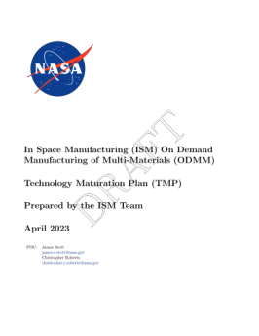
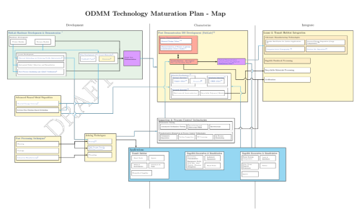
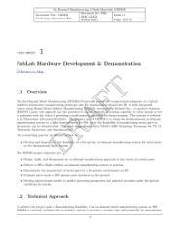
The overarching structure of the plan was based on the technical maturation plans for both the Nuclear Thermal Propulsion Project (NTP) and the Moon to Mars Planetary Autonomous Construction Technology (MMPACT) project and includes two primary sections. The first is the TMP map which illustrates the interaction between development blocks. The second section includes the task sheets which give detail to the development blocks shown in the map. Each task sheet provides an overview, technical approach, and deliverables for each development block. When applicable, assumptions, risks, and dependencies on other efforts are also noted.
Figure 1: Technology Maturation Plan Structure: Scope and Purpose Frontmatter (Top) TMP Map (Middle) Task Sheets (Bottom)
The ODMM TMP is divided into three major phases as denoted by the vertical columns within the TMP map: demonstrate, characterize, and infuse. Each phase has specific entrance and exit criteria with a milestone allowing advancement through phasing. If multiple manufacturing systems are being developed concurrently, each may be in a different phase; however, certain core tasks such as developing standards for in-space manufacturing systems may leverage the previously acquired knowledge for similar systems.
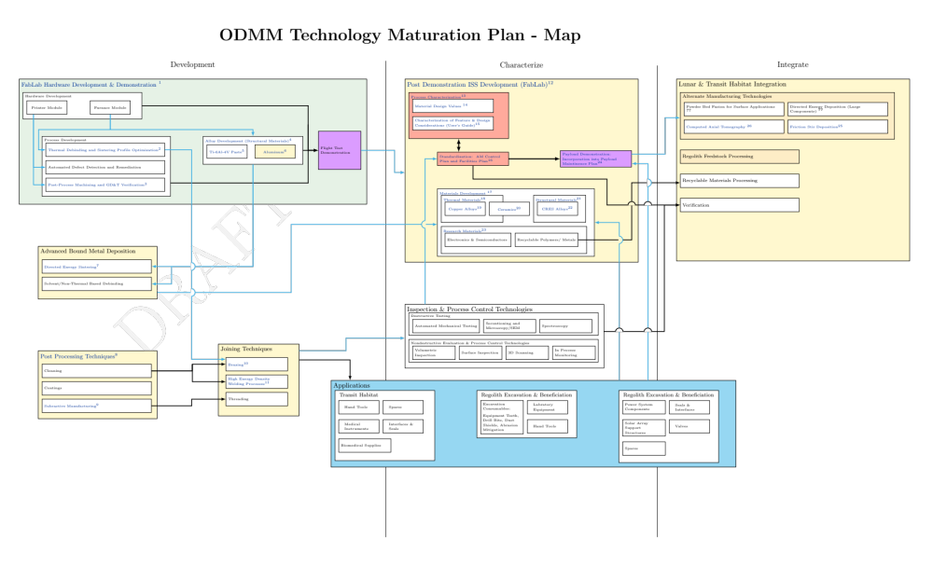
Figure 2: Technology Maturation Plan Map showing relationships between project blocks.

Development Phase

The first phase is the demonstration phase. The main goal of this phase is to develop technologies which illustrate the feasibility of manufacturing components in space, act as pathfinders for future in-space manufacturing processes and serve as a testbed for materials and tooling. The demonstration phase culminates in the on-orbit testing of the FabLab (or similar) payload.

A major focus of the development phase is the initial hardware development for the payload and the associated technologies. During development, power consumption has remained a significant challenge; thus, many of the advanced bound metal deposition processes, such as laser debinding and sintering, are targeted at decreasing peak power usage. Laser sintering allows for the power draw to be extended over a longer time scale which reduces peak power loads. Unlike powder bed fusion (PBF) technologies, there is limited research on the laser debinding process for BMD; however, direct PBF processes are not well suited for space applications due to safety concerns and the complexities associated with maintaining an even powder bed without the aid of gravity. Additional blocks noted for the development stage include technologies to expand the available materials space. One notable example is solvent debinding which is useful for low temperature materials such as aluminum which can be extracted from regolith. While solvent debinding is the standard method for terrestrial BMD processes, the space environment introduces several challenges. Fluid flow in microgravity is significantly altered from a terrestrial environment, and solvent regeneration processes are necessary to minimize consumables [5]. While these additional technologies are not necessary for initial demonstrations, their maturation provides a path towards more efficient systems for lunar surface applications.
Figure 3: Development Phase of the TMP

Additional technology development blocks identified for further research in the demonstration phase are post processing and joining techniques. Joining techniques have also been identified by NASA as a required ISM technology area “to fully deploy and expand human exploration, enable colonization, and to make possible the exploitation of in-situ resources” [11]. The usefulness of manufacturing systems is greatly enhanced when piece parts can be assembled into more complex structures which can be used in harsh environments. These technology blocks are specifically aimed at enhancing the interoperability of parts manufactured with ODMM technologies with existing components.

Characterization Phase

The second phase begins following the initial demonstration mission and is denoted as the Characterization Phase. During this phase, the manufacturing payload will be used as a pathfinder to develop an approach for how in-space manufacturing technologies can be utilized at the point of use. A particular emphasis is placed on developing an approach to either meet NASA standards or inform revision of those standards for use in the space environment. An additional focus during this phase is part verification and inspection. The second phase culminates in baselining in-space manufactured components in the maintenance or assembly plan for an external payload.

Three primary blocks comprise the characterization phase. The first is using the systems developed during the demonstration phase to inform methodologies for control of additive manufacturing processes in space. One of the primary barriers preventing the widespread adoption of in-space manufacturing techniques is the lack of “design to” standards for engineers. Current standards for additive manufacturing, such as NASA-STD-6030 and NASA-STD-6033, are targeted at applications where parts are produced on earth where there is a plethora of relatively cost-effective materials characterization services and non-destructive (NDE) evaluation methods [7, 8]. No mechanical testing capabilities or volumetric testing capabilities currently exist for in-space applications. Furthermore, many applications require minimization of volume and mass which prohibits the up-massing of multiple support payloads. The benefit of in-space manufacturing techniques is greatly reduced if payloads are not designed for manufacturing and assembly in space which is fundamentally reliant upon providing designers clear and concise requirements and standards.
Figure 4: Characterization Phase of the TMP

The second primary block in the characterization phase is the development of NDE techniques and in situ monitoring. The primary goal of this block is to respond to and support the development of standards specific to in space manufacturing. The standardization activity will develop a risk based minimum required testing approach which is likely to include a form of NDE. While not a primary focus of the ODMM project, this block documents the effect of NDE development on ODMM technologies.

The third major block within the characterization phase is materials development. One of the primary functions of the pathfinder manufacturing systems is to be used as a testbed for materials development and microgravity research. Materials science on the ISS is often limited in size; however, there is great interest in both the fundamental science and application of microgravity effects for materials research [5, 10].

Integration Phase

The third phase, integration, focuses on the transition of technology demonstrators and approaches developed during phase I and II into mission architectures and lunar surface applications. In addition to the development of second-generation hardware, this transition phase will heavily focus on application specific technologies and advanced feedstocks.

As noted previously, a key aspect of the infusion phase is the transition away from up-massed feedstock to recycling discarded materials and deriving feedstocks from in situ resources. Thus, the technology focus of this phase primarily targets these auxiliary technologies and understanding stakeholder needs. As needs are identified, the knowledge gained through the demonstration and characterization phases will be used to optimize manufacturing systems to high priority needs.
Figure 5: Integration Phase of the TMP

Conclusion

Prior to project cancelation, ODMM developed a TMP to guide the advancement of technologies for in space manufacturing of metallic components through infusion into NASA’s mission architecture. The TMP outlines three phases necessary for the development and adoption of in space manufacturing into NASA’s logistics model. While the TMP concludes before widespread infusion into critical systems, key elements are outlined providing a pathway for enabling long duration missions and reducing operations costs. When efforts regarding the in-space manufacturing of metals resume, the TMP should be updated to reflect the state of the art and realigned with priorities identified by stakeholders.

References
[1] Astrobotic Technology Inc. “Lunar Landers: Astrobotic Technology.” Astrobotic, July 6, 2023. https://www.astrobotic.com/lunar-delivery/landers/.
[2] Hark, Frank, Rob Ring, Steven Novack, and Paul Britton. “Common Cause Failure Modeling in Space Launch Vehicles.” International Association for the Advancement of Space Safety (IAASS) Conference. Melbourne, FL. Accessed August 21, 2023. https://ntrs.nasa.gov/citations/20160007073.
[3] Johnson, Michael, ed. “Commercial and Marketing Pricing Policy.” NASA, May 31, 2019. https://www.nasa.gov/leo-economy/commercial-use/pricing-policy.
[4] Jones, Harry. “Common Cause Failures and Ultra Reliability.” 42nd International Conference on Environmental Systems, 2012. https://doi.org/10.2514/6.2012-3602.
[5] Littles, Louise, ed. “Fluid Physics,” n.d. Accessed August 21, 2023.
[6] NASA. “NEXTSTEP-2 Omnibus Broad Agency Announcement NNH16ZCQ001K-ISM FabLab: In-Space Manufacturing (ISM) Multi-Material Fabrication Laboratory (FabLab).” NASA, February 12, 2018. https://www.nasa.gov/content/nextstep-2-omnibus-baa.
[7] NASA. “Additive Manufacturing Requirements for Equipment and Facility Control". NASA-STD-6033.
[8] NASA. “Additive Manufacturing Requirements for Spaceflight Systems". NASA-STD-6030.
[9] Owens, Andrew, and Olivier De Weck. “Systems Analysis of In-Space Manufacturing Applications for the International Space Station and the Evolvable Mars Campaign.” AIAA SPACE 2016, 2016. https://doi.org/10.2514/6.2016-5394.
[10] Smith, Amelia Williamson. “Looking at Liquid Motion in Microgravity.” ISS National Laboratory, March 13, 2019. https://www.issnationallab.org/looking-at-liquid-motion-in-microgravity/.
[11] Sowards, Jeffery, et al. “Topical. Permanent Low-Earth Orbit Testbed for Welding and Joining: A Path Forward for the Commercialization of Space.” NASA, NASA Technical Reports Server, 4 Mar. 2022, ntrs.nasa.gov/citations/20210023463.

[12] Wetherholt, Jon, Timothy Heimann, and Brenda Anderson. “Common Cause Failure Modes.” 29th International System Safety Conference (ISSC). Las Vegas, NV. Accessed August 21, 2023. https://ntrs.nasa.gov/citations/20110015733.

