TeamsAPI – simple Django Rest

Loghman Barari

loghmanb@gmail.com

1. Challenge definition
Build a simple Django project that has a RESTful API. We should be able to run your codebase locally
to verify the work.
- Install Django and your Python environment (bonus points for a docker infrastructure)
- Set up your new Django project
- Create API Django app and register with your Django project
- Migrate database (please use the default SQLite database)
- Create a football team model that stores:
  - Team name
  - Stadium name
  - Stadium capacity
  - Country
  - League
  - Year founded
- 6. Populate the model with at least 10 teams
- 7. Set up the Django REST framework
- 8. Create uri endpoints to view the data
- 9. Update the GET call to be able to use “id”, “name” and “country” as parameters
- 10. Ensure the PUT/PATCH and POST calls are functional

2. How to run and test the code
There are three ways to run the code:
- Build the docker image and run:
  - Download the code and Extract tp TeamsAPI folder
  - cd TeamsAPI
  - docker-compose build
  - docker-compose up

- Pulling via Docker Hub and run:
  - docker pull loghmanb/teamsapi:0.0.1
  - docker-compose up

- Running via virtual environment:
For preparing the local environment:
- Extract zip file to TeamsAPI in home
- cd TeamsAPI && python -m venv .venv
- pip install -r python-requires.txt

For running the application:
- cd football-team
- python manage.py runserver 0:8000

Admin panel: ‘http://127.0.0.1:8000/admin’
Testing API: ‘http://127.0.0.1:8000/api/teams/’
for filter by country name: GET http://127.0.0.1:8000:/api/teams/?country=england
for filter by name: GET http://127.0.0.1:8000/api/teams/?name=man
Username: admin
Password: admin

Note:
For security reason, only GET method for team listing is available without authentication. On the rest of the other method (POST, PUT, PATCH, DELETE) which used for apply the changes you need to authentication first.

3. User manual

- Admin Panel
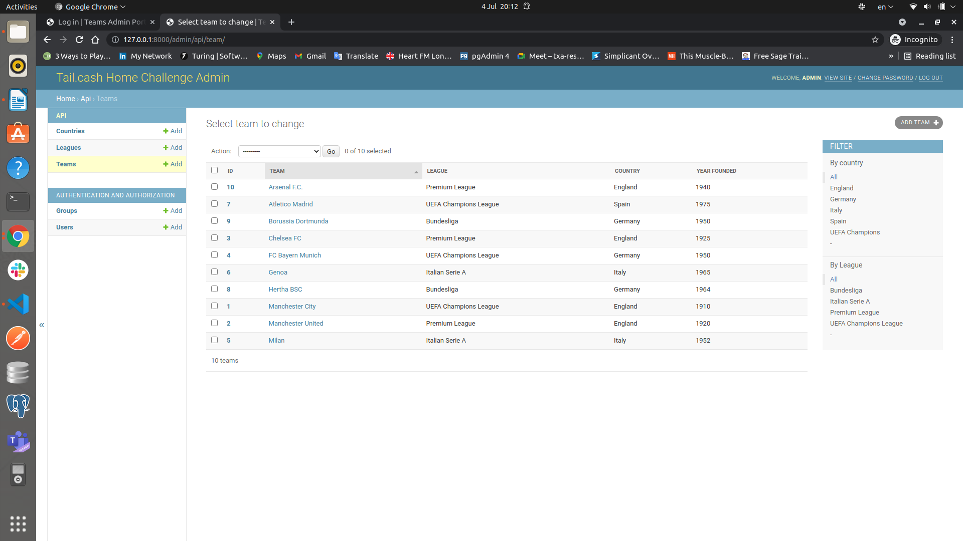

- Browse API without authentication

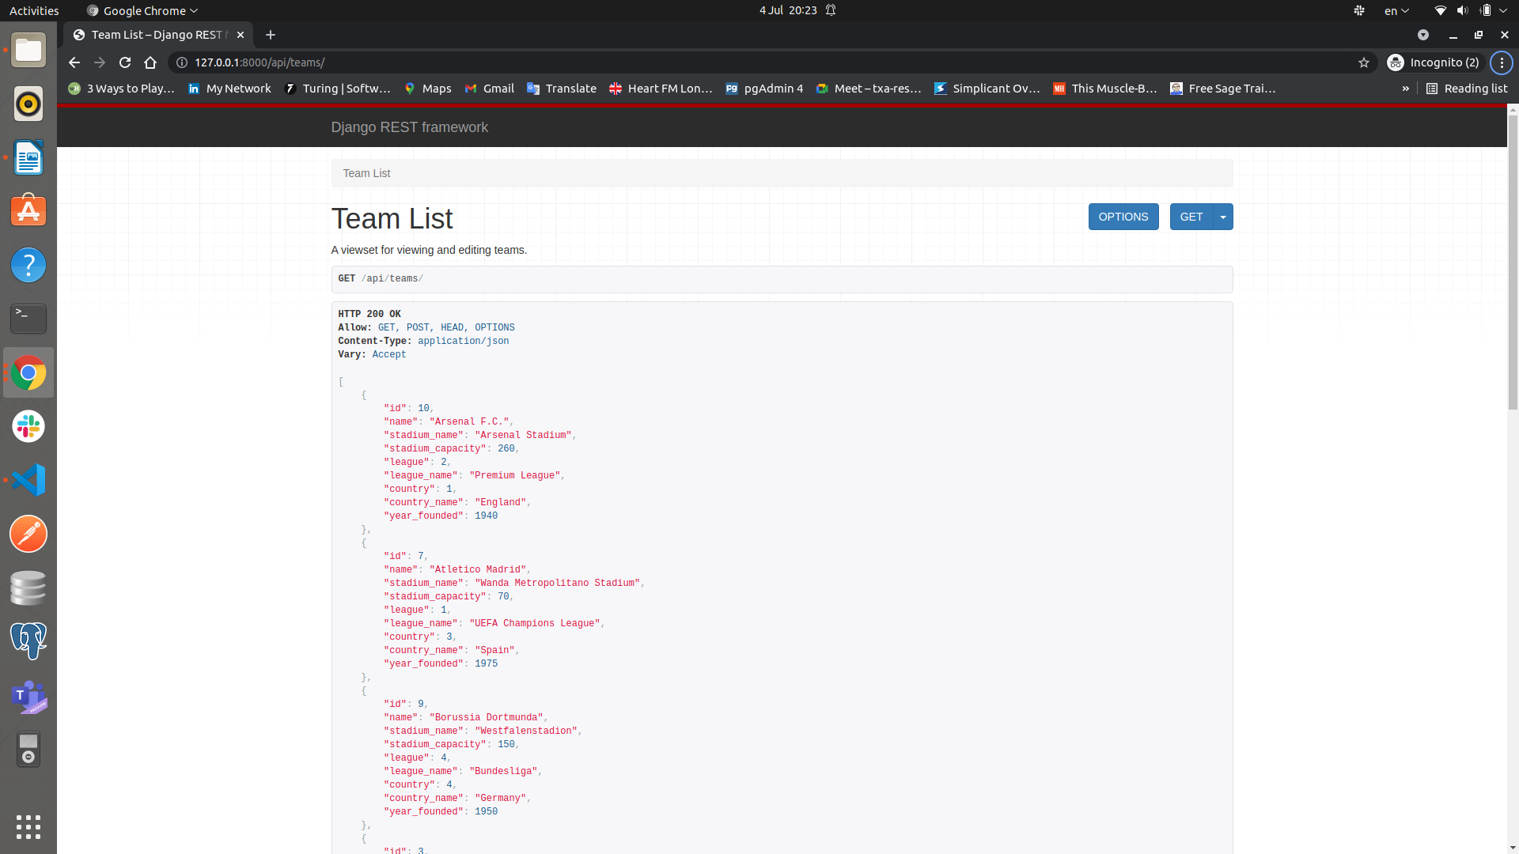
- Browse API with authentication
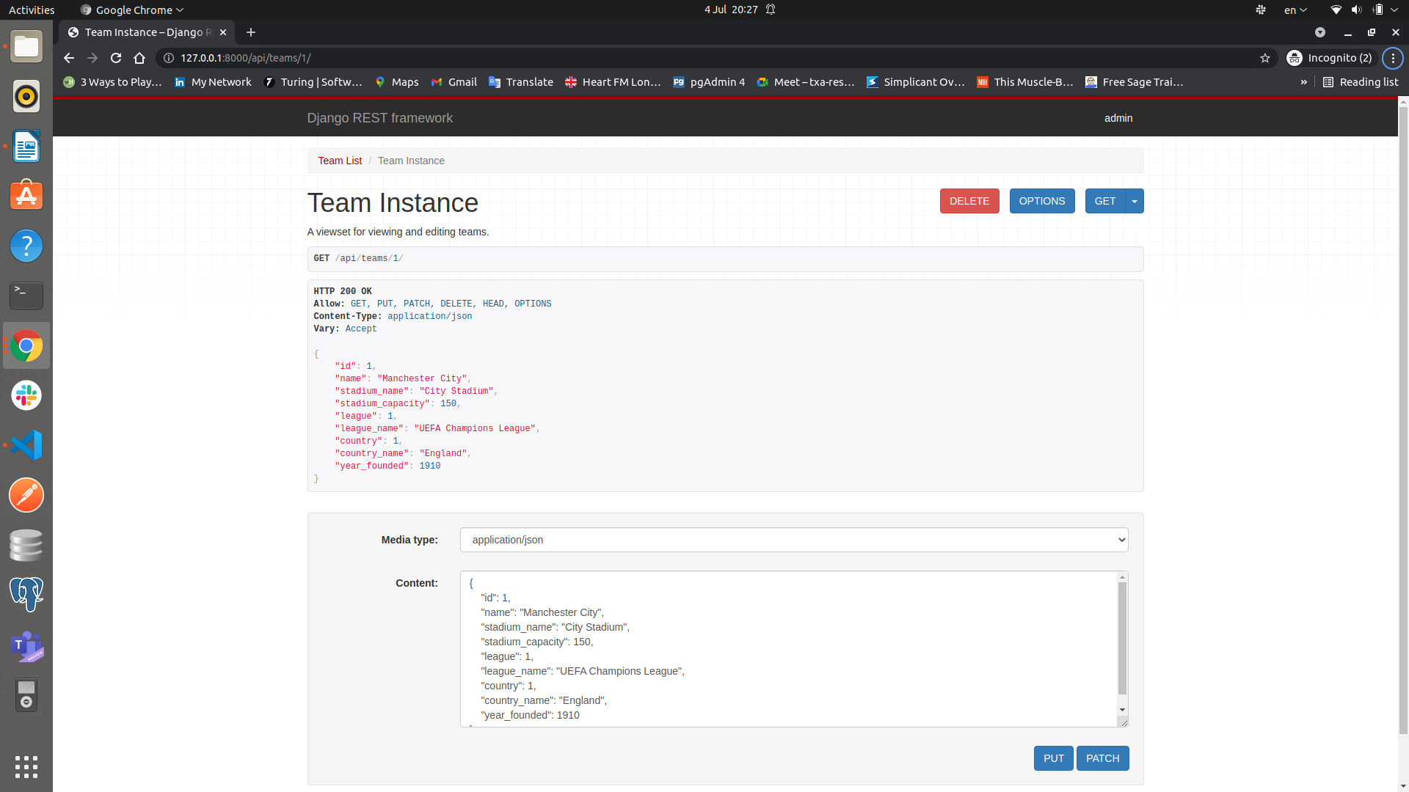

4. Database diagram

