**[如果把编程语言比作武器](http://www.cnblogs.com/Wayou/p/if-programming-languages-were-weapons.html)**

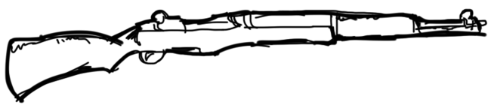

C 是经久不衰的M1半自动来复，虽然有些时日了但稳定压倒一切。

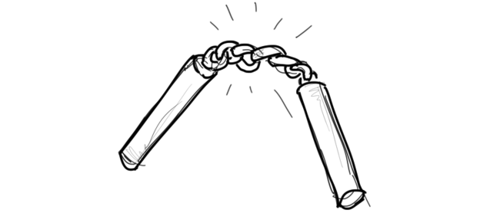

c++ 是威力强大的双截棍，看看李小龙使它的时候那鼓威风劲你就领悟了。但问题是掌握它需要很长段时间，而在这段时间内经常是把自己打得鼻青脸肿而不是敌人。

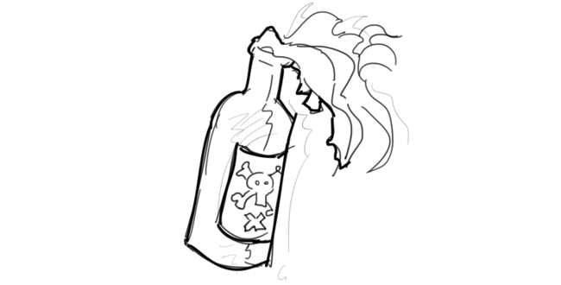

Perl是莫洛托夫鸡尾酒，偶尔会很有用，但现今用的人已少。

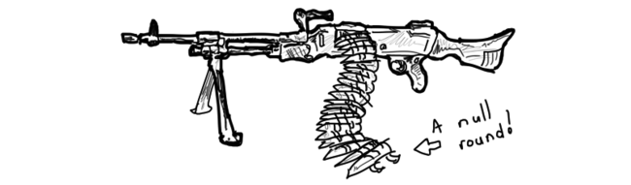

Java是架240发全自动冲锋枪，扫起来爽翻天，前提是弹夹没空。一旦弹夹空了会发生NullPointerException异常，表明这枪就报废了然后你就挂了。

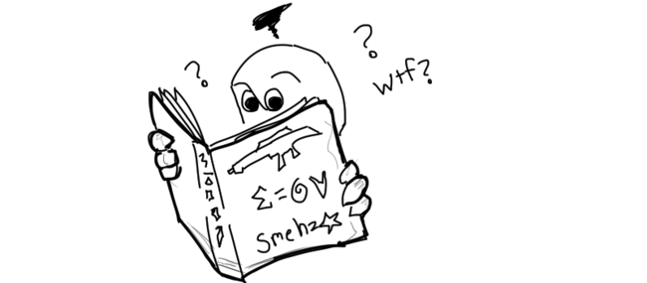

Scala跟Java的冲锋枪没差，唯一的不同是他的使用说明是用你看不懂的方言写成的天书，而且里面大部分都还是在瞎B。

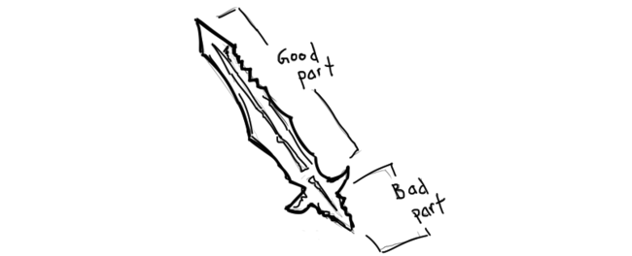

JavaScript是把没有手柄的双刃剑，不多说。

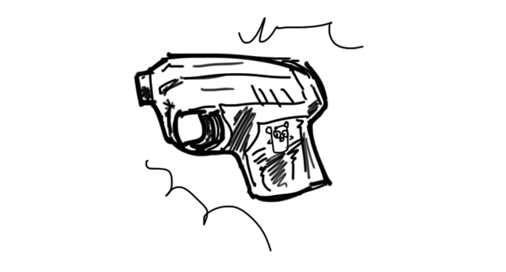

Go 就自制的拥有if err != nil 检查特性的短枪，每次射完你都要执行一次以确定是不是射成功了，并且它只射Tab不射空格。

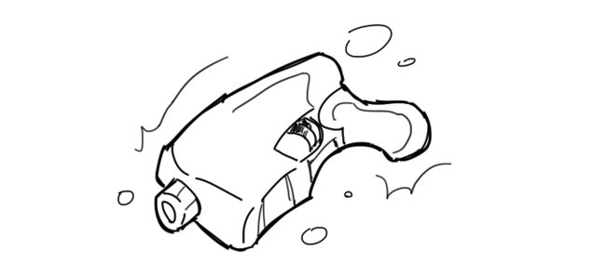

Rust 纯属3D打印的产物，兴许哪天能派上用场。



bash是被下了诅咒的锤子，挥起来的时候全世界都是钉子，包括你自己的手指。

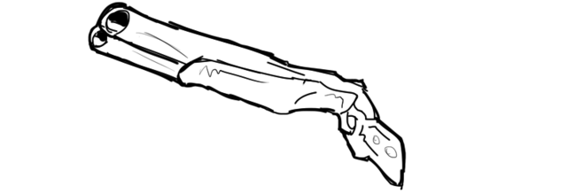

Python是牛逼哄哄的双管枪，但一次只射一管，另一管不知何时射。或许曾经我用过工具来把它启用。

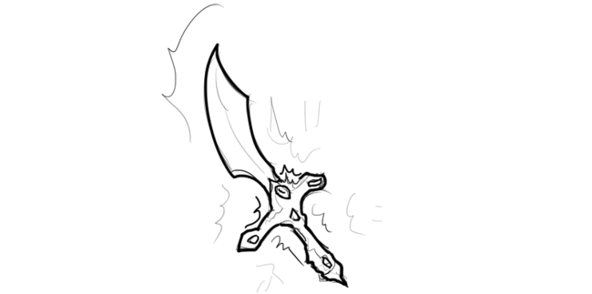

Ruby「红宝石」是把镶嵌了红宝石的宝剑，你使用它的原因正是那闪闪的宝石可以亮瞎众人。

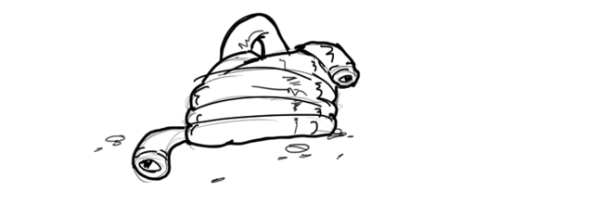

PHP像一根管子，你把一头插入汽车的排气管，然后另一头通过车窗插到车内，再接着你坐进了车里发动了引擎。

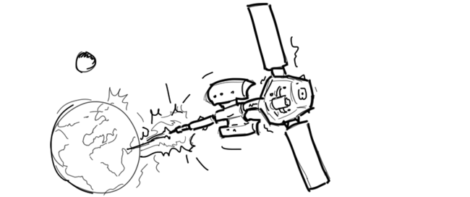

Mathematica 是一个可以发射低轨地球卫星的发射器，非常的华丽与强劲，前提是你也土豪到用得起它。

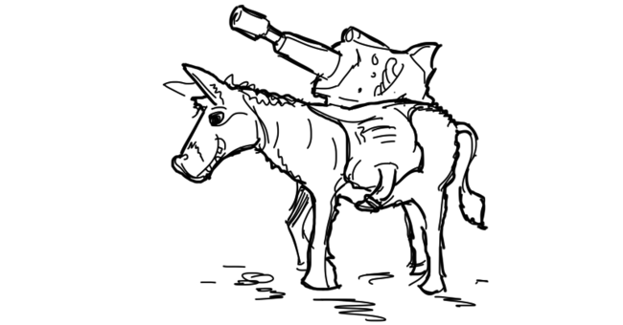

C#是搭配在一头驴上的激光步枪，效果可想而知。但将它从这头驴上拿下来后，似乎也不能工作。

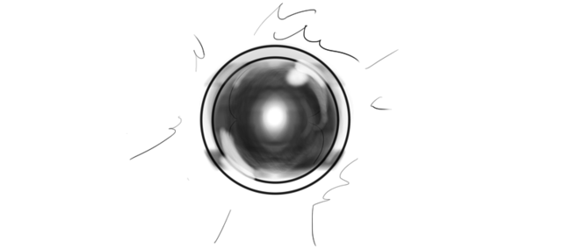

Prolog 是高级的AI智能武器，你告诉他怎么做做哪些，但最后他还会多生成一些终结者把制造他的人干掉。

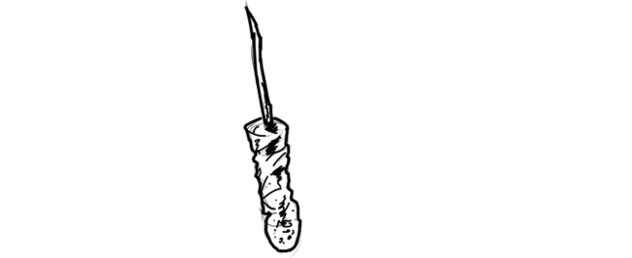

Lisp 精巧如剃刀，使用者往往非常疯狂且危险。

# [If programming languages were weapons](http://bjorn.tipling.com/if-programming-languages-were-weapons)

[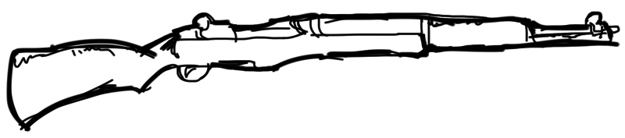](http://img.svbtle.com/1zrekyewqiaxq.png)

C is an M1 Garand standard issue rifle, old but reliable.

[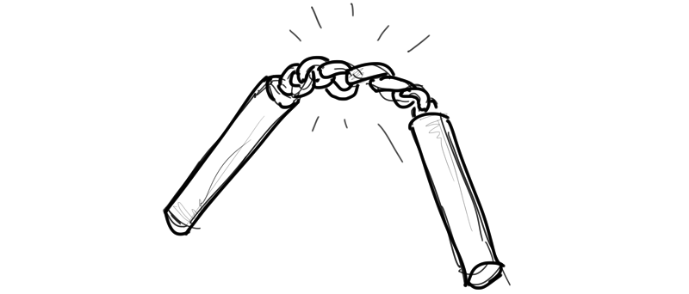](http://img.svbtle.com/nbipbvfwmqb7va.png)

C++ is a set of nunchuks, powerful and impressive when wielded but takes many years of pain to master and often you probably wish you were using something else.

[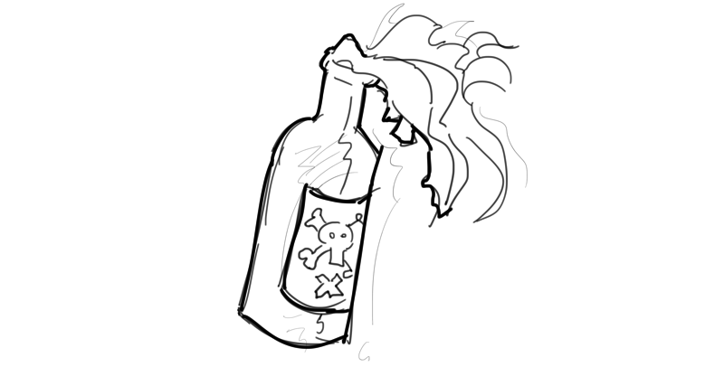](http://img.svbtle.com/4bukyhephoe7g.png)

Perl is a molotov cocktail, it was probably useful once, but few people use it now.

[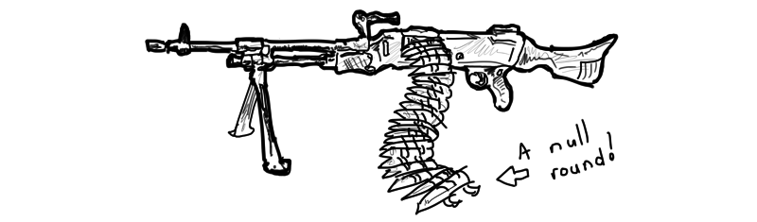](http://img.svbtle.com/qmhanlakiyccw.png)

Java is a belt fed 240G automatic weapon where sometimes the belt has rounds, sometimes it doesn’t, and when it doesn’t during firing you get an NullPointerException, the gun explodes and you die.

[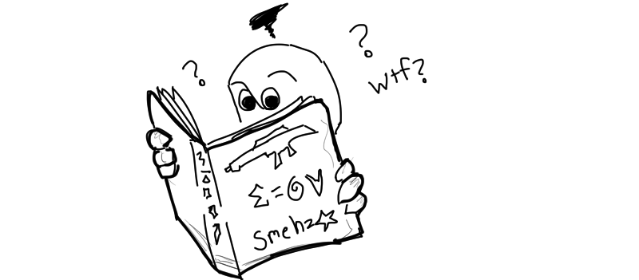](http://img.svbtle.com/odb1et34erhiq.png)

Scala is a variant of the 240G Java, except the training manual is written in an incomprehensible dialect which many suspect is just gibberish.

[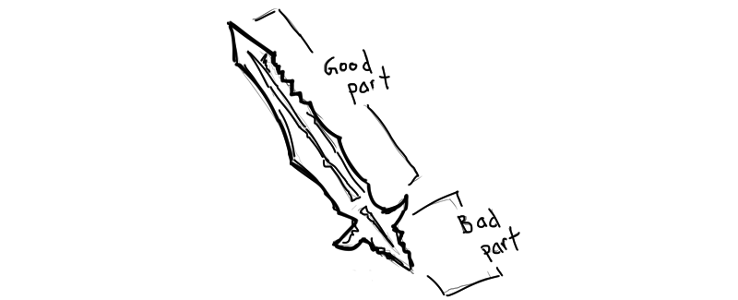](http://img.svbtle.com/tdsjt1pa55fafg.png)

JavaScript is a sword without a hilt.

[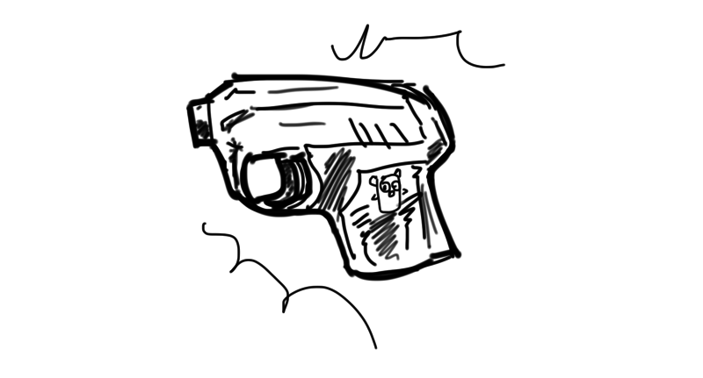](http://img.svbtle.com/2apco7plivhetq.png)

Go is the custom made “if err != nil” starter pistol and after each shot you must check to make sure it actually shot. Also it shoots tabs instead of blanks.

[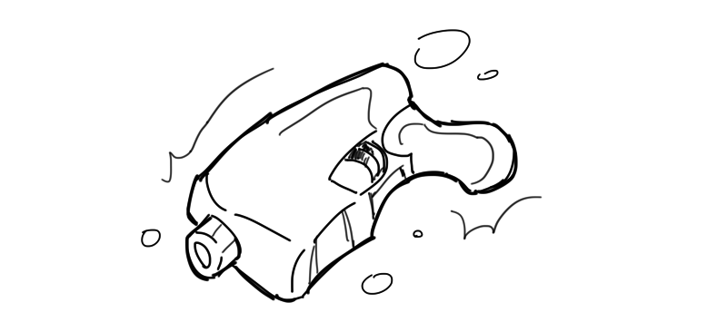](http://img.svbtle.com/ngydoijonok5sg.png)

Rust is a 3d printed gun. It may work some day.

[](http://img.svbtle.com/zjgvgtmrhgmpw.png)

bash is a cursed hammer, when wielded everything looks like a nail, especially your thumb.

[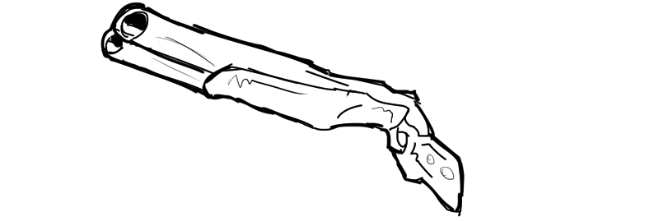](http://img.svbtle.com/dvtsddj7yqfna.png)

Python is the “v2/v3” double barrel shotgun, only one barrel will shoot at a time, and you never end up shooting the recommended one. Also I probably should have used a line tool to draw that.

[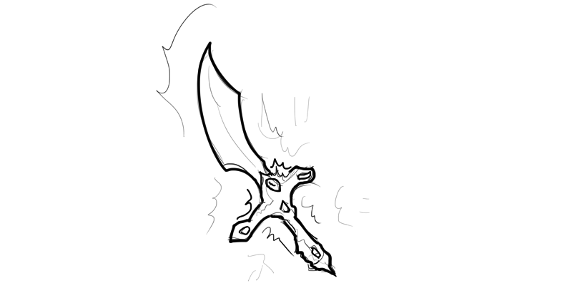](http://img.svbtle.com/ysu6nkp3etd8yw.png)

Ruby is a ruby encrusted sword, it is usually only used because of how shiny it is.

[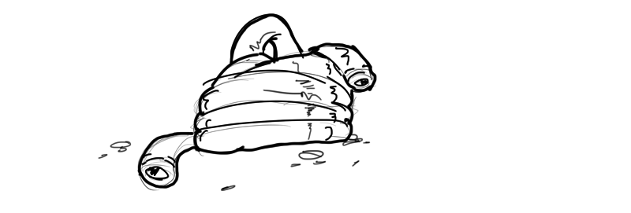](http://img.svbtle.com/hxqywt4ymqxqza.png)

PHP is a hose, you usually plug one end into a car exhaust, and the other you stick in through a window and then you sit in the car and turn the engine on.

[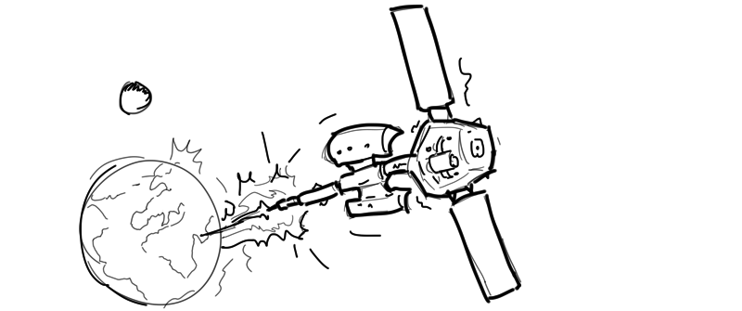](http://img.svbtle.com/f38gi2tpijc7q.png)

Mathematica is a low earth orbit projectile cannon, it could probably do amazing things if only anyone could actually afford one.

[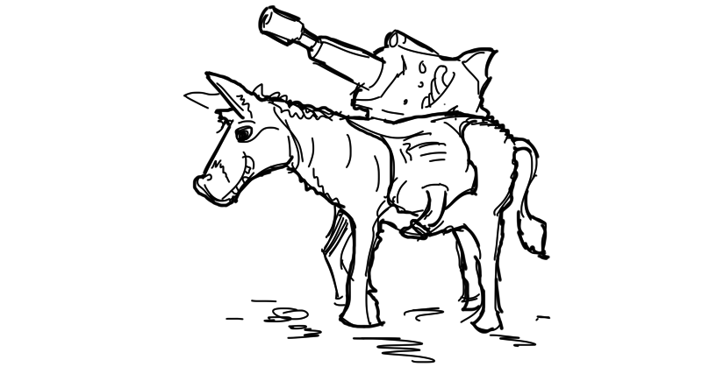](http://img.svbtle.com/ddmvewfmbobm0g.png)

C# is a powerful laser rifle strapped to a donkey, when taken off the donkey the laser doesn’t seem to work as well.

[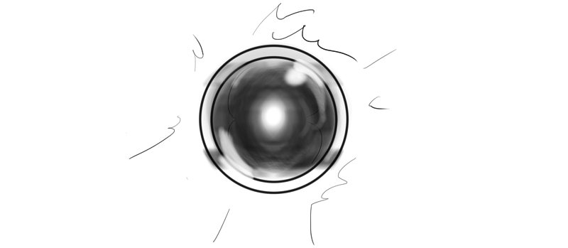](http://img.svbtle.com/i7vzcuof4i61a.png)

Prolog is an AI weapon, you tell it what to do, which it does but then it also builds some terminators to go back in time and kill your mom.

[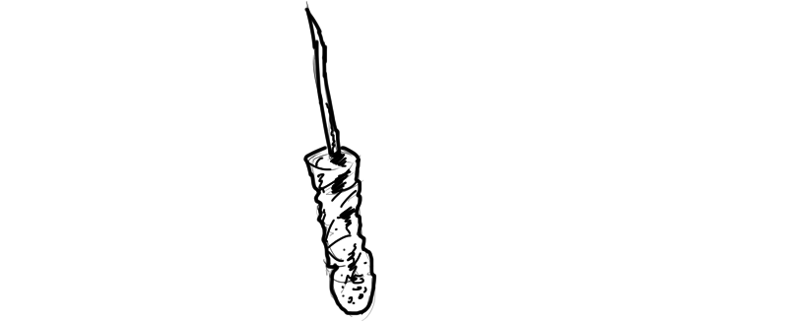](http://img.svbtle.com/w15natoim2lezq.png)

Lisp is a shiv which comes in many forms. Anyone who uses this is probably crazy and dangerous.