WEEK-1
STUDENT
CODE:-
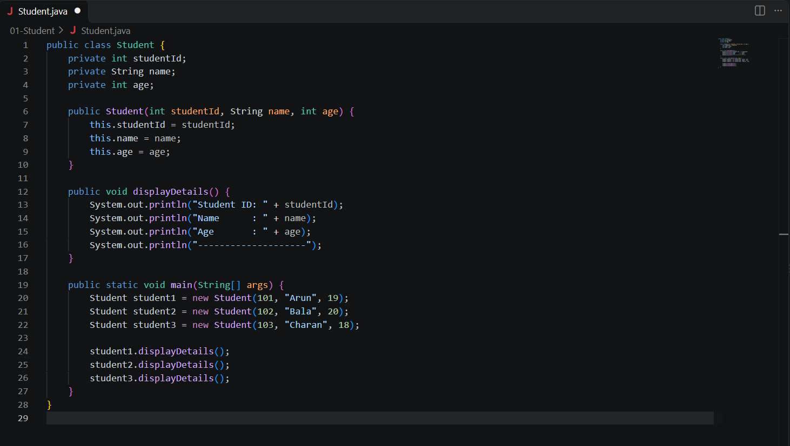
OUTPUT:-
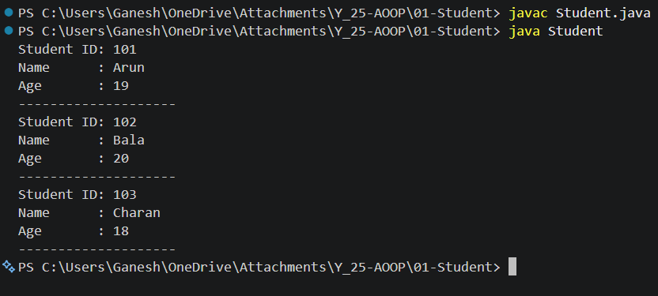
EMPLOYEE
CODE:-
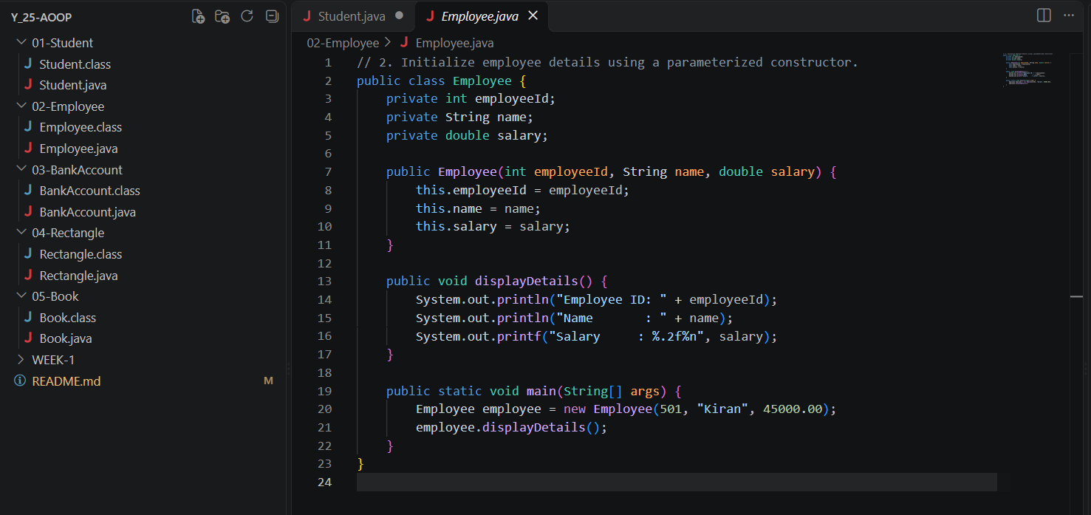
OUTPUT:-
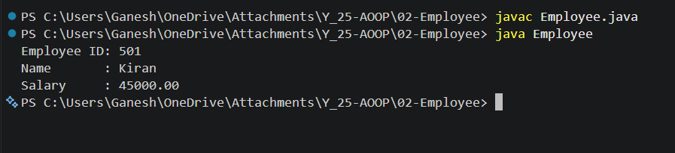
BANKACCOUNT
CODE:-
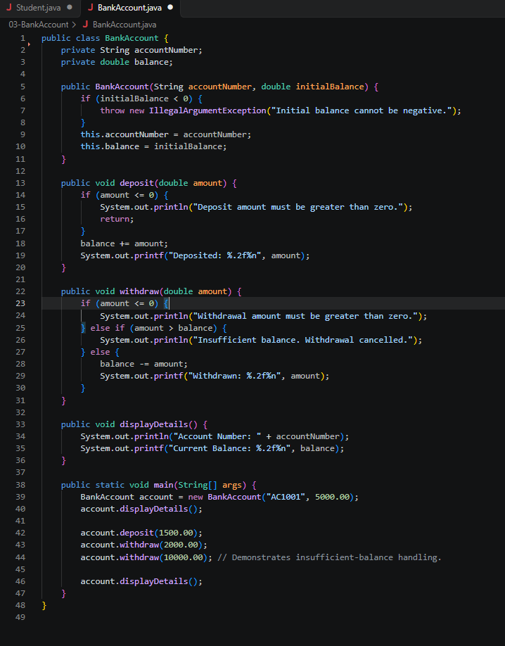
OUTPUT:-
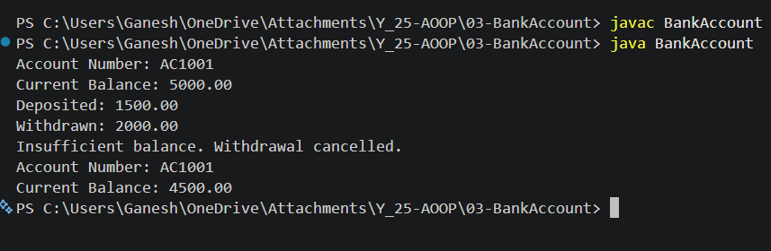
RECTANGLE
CODE:-
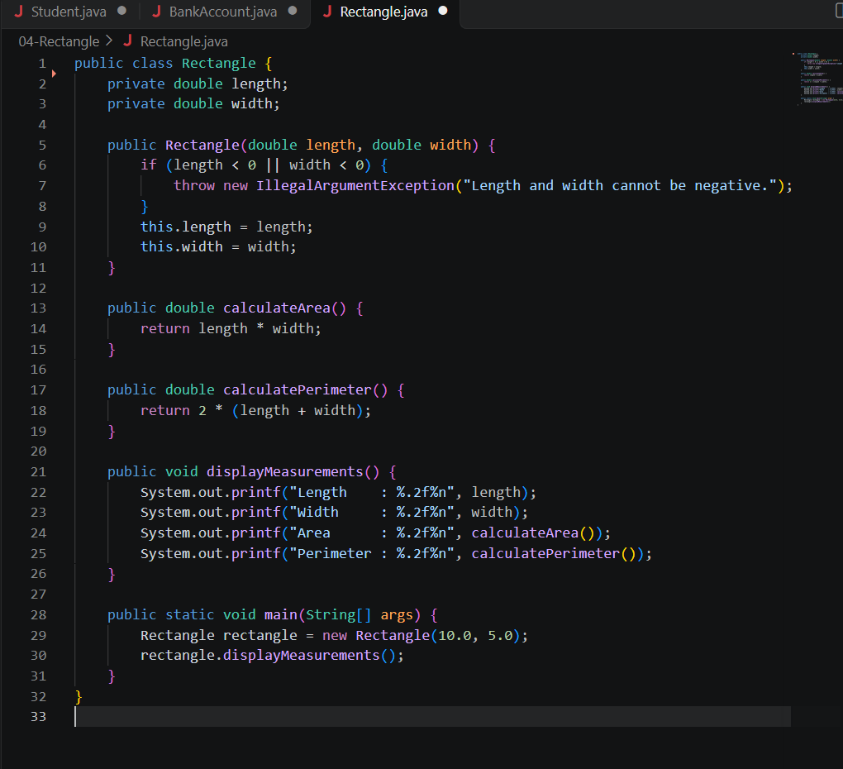
OUTPUT:-
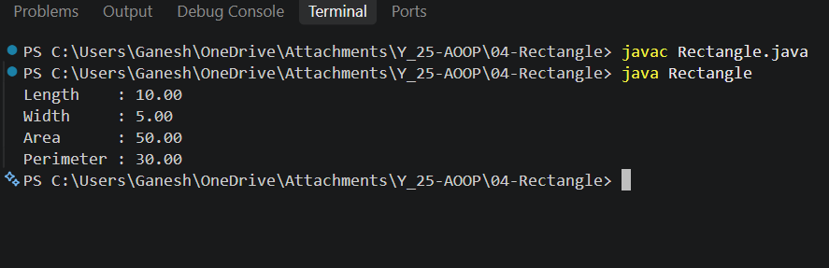
BOOK
CODE:-
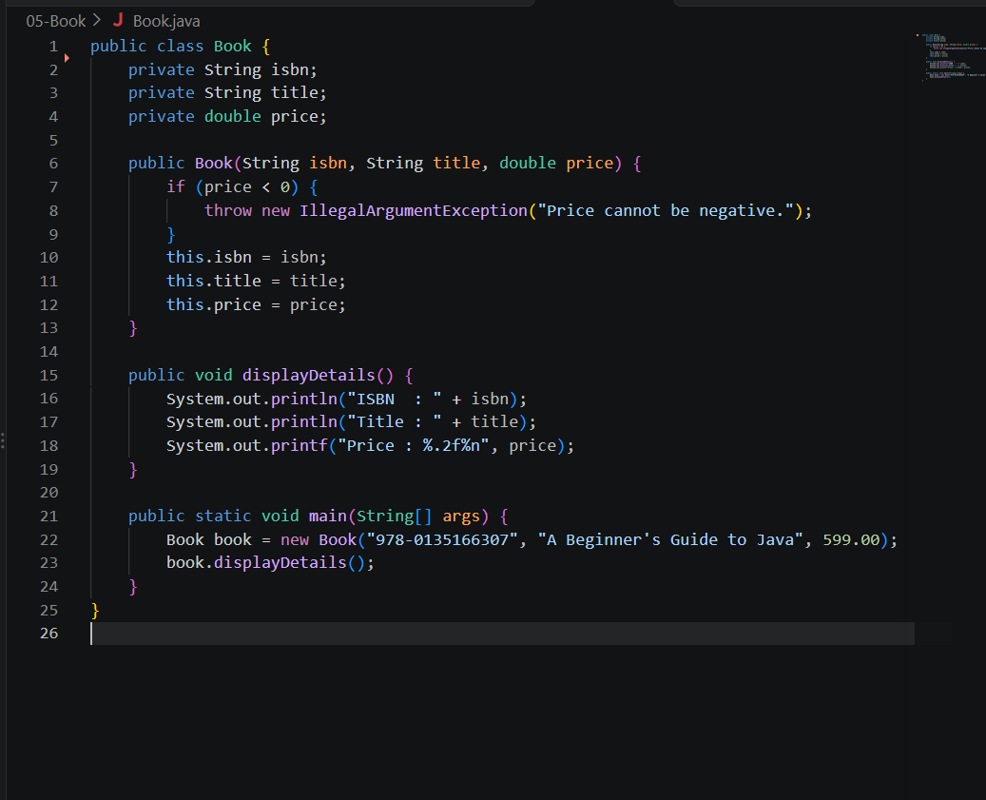
OUTPUT:-


