Disseminating Context-Specific Access to Online Knowledge Resources within
Electronic Health Record Systems
Guilherme Del Fiolª, Clayton Curtis^{b}, James J. Cimino^{c}, Andrew Iskanderª, Aditya S.D. Kalluriª,
Xia Jing^{c}, Nathan C. Hulse^{a,d}, Jie Long^{d}, Casey L. Overby^{e}, Connie Schardt^{f}, David M. Douglas^{b}
ª Department of Biomedical Informatics, University of Utah, Salt Lake City, UT, USA
^{b} Veterans Health Administration, USA
^{c} Laboratory for Informatics Development, National Institutes of Health (NIH) Clinicial Center, Bethesda, MD, USA
^{d} Homer Warner Center for Informatics Research, Intermountain Healthcare, Salt Lake City, UT, USA
^{e} Department of Biomedical Informatics, Columbia University, New York, NY, USA
^{f} Duke Medical Library, Duke University, Durham, NC, USA

Abstract
Clinicians’ patient care information needs are frequent and largely unmet. Online knowledge resources are available that can help clinicians meet these information needs. Yet, significant barriers limit the use of these resources within the clinical workflow. Infobuttons are clinical decision support tools that use the clinical context (e.g., institution, user, patient) within electronic health record (EHR) systems to anticipate clinicians’ questions and provide automated links to relevant information in knowledge resources. This paper describes OpenInfobutton (www.openinfobutton.org): a standards-based, open source Web service that was designed to disseminate infobutton capabilities in multiple EHR systems and healthcare organizations. OpenInfobutton has been successfully integrated with 38 knowledge resources at 5 large healthcare organizations in the United States. We describe the OpenInfobutton architecture, knowledge resource integration, and experiences at five large healthcare organizations.

Keywords:

information needs, information storage and retrieval, clinical decision support systems, electronic health records

Introduction
Clinicians raise multiple information needs in the course of patient care [1,2]. Estimates range from 0.2 to 1.5 questions per patient seen, with over half of these questions not being answered [3]. When not met, these gaps in medical knowledge may lead to errors and suboptimal care [4]. With the advent of the World Wide Web, a wide range of online health knowledge resources have become available. Studies have shown that these resources are able to answer up to 95% of the questions clinicians raise [3]. Yet, the use of these resources at the point of care remains relatively low. Significant barriers limit the use of these resources, notably time and cognitive effort that are incompatible with busy clinical workflows.
In the last two decades, researchers have investigated solutions to enable seamless access to online resources within the context of electronic health record (EHR) systems. “Infobuttons” are among these solutions [5]. Based on contextual attributes that describe the EHR user, the patient, and the care setting, infobuttons anticipate clinicians’ information needs and provide automated links to a set of relevant knowledge resources that may help clinicians meet these needs.
Despite studies showing positive impact of infobuttons on decision-making, the adoption of infobutton capabilities has been limited to a small set of healthcare organizations with home- grown systems and a strong informatics culture [6-8]. Among potential reasons for slow dissemination include the lack of standards and tools that facilitate implementing infobuttons. The goal of this paper is to describe OpenInfobutton (www.openinfobutton.org): a standards-based, open source Web service that was designed to enable infobutton capabilities in multiple EHR systems and healthcare organizations. Specifically, we describe 1) the system architecture and logic; 2) resources that have been integrated with OpenInfobutton; and 3) experiences with OpenInfobutton at five large healthcare organizations in the United States.

Background
A number of measures are needed to create an ecosystem that enables infobutton capabilities in healthcare settings, including: 1) incentives that promote overall EHR adoption; 2) studies demonstrating the impact of infobuttons on patient care; 3) widely adopted standards; and 4) freely available tools and resources. Examples of these measures are described in the sections below.

Incentives and Regulations for EHR Adoption
In the United States, significant incentives and regulations under the EHR Meaningful Use program are being implemented to promote the adoption and meaningful use of EHR systems [9]. This program includes a set of criteria that EHR vendors must comply with to obtain certification. Among these criteria is the requirement to implement HL7-compliant infobutton capabilities for both provider reference information and patient education. With these requirements, major EHR vendors are enabling infobutton capabilities within their products.

Impact of Infobuttons
Studies that assessed large scale infobutton implementations have shown the potential benefits of this kind of clinical decision support (CDS) tool [6-8]. In one of these studies, clinicians were able to answer their questions in 90% of the infobutton sessions within an average of 35 seconds, leading to decision enhancement or learning in 62% of these sessions [6].

Health Level Seven (HL7) Infobutton Standard
The HL7 Context-Aware Knowledge Retrieval Standard, also known as the Infobutton Standard, aims at simplifying the integration between EHR systems and knowledge resources [10]. The Infobutton Standard consists of a context information model and standard terminologies that can be implemented as RESTful Web services. In a standard-compliant implementation, EHR vendors send knowledge requests with context parameters to knowledge resources, which respond in an XML format. The HL7 Infobutton Standard has been widely adopted by major knowledge resources. While adoption among EHR systems has been slow, recent EHR Meaningful Use incentives are quickly changing the adoption pace [10].

Freely Available Tools
Early infobutton implementations have followed a software architecture that includes a broker known as an “infobutton manager” [11]. This approach allows complex infobutton logic to be implemented externally to, and independently from, any particular EHR. Implementers consider widely available infobutton managers to be a critical requirement to achieving scalable and high quality infobutton capabilities [10]. However, infobutton managers developed by early adopters were not compliant with the Infobutton Standard and could not be easily integrated into different EHR systems. OpenInfobutton was designed to fill this gap.

Materials and Methods
OpenInfobutton was initially funded by a grant from the United States Veterans Health Administration (VHA) and developed by researchers at the VHA, Duke University, and the University of Utah. The source code is freely available through the Open Source Electronic Health Record Agent (OSEHRA; http://code.osehra.org/journal/browse/publication/33) under Apache 2.0 license. OSEHRA is an open source framework that was created by the VHA to accelerate progress and innovation in EHR technology.

Overall System Architecture
The OpenInfobutton architecture consists of the following components (Figure 1): 1) A knowledge base of knowledge resource profiles; 2) context processing logic; 3) integration with terminology services; 4) an XML transformation service; 5) a Web service wrapper; and 6) integration with the Librarian Infobutton Tailoring Environment (LITE).
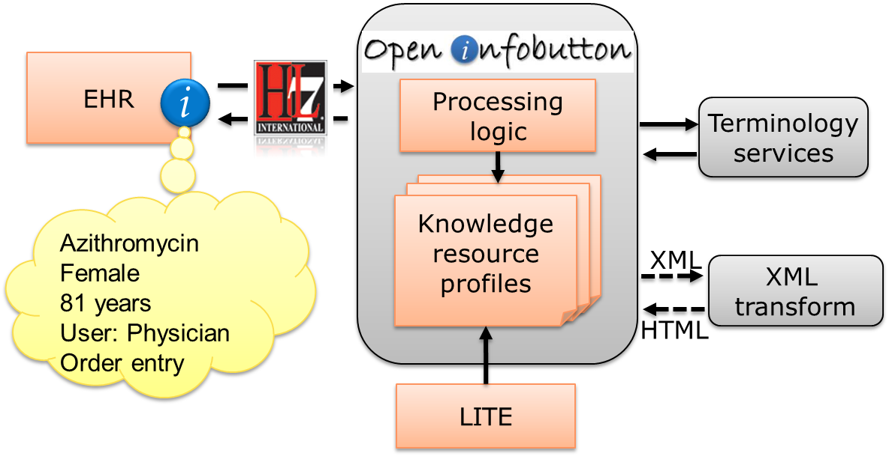
Figure 1 – OpenInfobutton architecture and information flow.

Knowledge Base
Knowledge resources that are accessed by OpenInfobutton are configured as resource profiles. These profiles provide information on the contexts in which a particular resource is relevant and the topics (e.g., therapy, diagnosis, drug dosing, contraindications) that are covered by the resource. For resources that are not HL7 compliant, the profile also includes information on the URL format of the resource’s application program interface (API). Resource profiles are represented in XML documents, which are stored in a relational database.

Context Processing Logic
When a knowledge request is sent to OpenInfobutton, an algorithm is executed in two steps: context matching and URL generation. First, the logic selects the set of resource profiles that are configured for the sender. Next, the logic attempts to match the incoming context to one of the contexts defined in each of the selected resources. For the matched resources, the logic creates a set of URLs in the format of the target resource API. Each of these URLs corresponds to one relevant content topic that is covered by a resource. The final output contains the set of matched resources with URLs that retrieve content on a particular topic. These URLs consist of a set of context parameters for a resource search engine to process or a static URL that points to a particular document.

Integration with Terminology Services
Both the context matching and URL generation steps rely on terminology inferences depending on the code systems used in an incoming request and the code systems supported by a particular resource. For example, if a request includes a SNOMED-CT code for diabetes mellitus type 2, but a target resource only supports ICD-10, terminology services are invoked to map the SNOMED-CT code to an equivalent code in ICD-10. Similarly, when an incoming request only includes a free text term, terminology services are used to map this term to a concept in a standard terminology.
OpenInfobutton delegates terminology inferences to external terminology services through a system-agnostic interface. This approach allows healthcare organizations to integrate OpenInfobutton with a terminology service of their choice. To date, OpenInfobutton has been integrated with three terminology services: Apelon Distributed Terminology System® (DTS), RxNorm API, and the Unified Medical Language System Terminology Services (UTS). Integration with the 3M™ Health Data Dictionary (HDD) is underway.

Web Service Wrapper
OpenInfobutton capabilities are accessed through a RESTful Web service layer compliant with the HL7 Infobutton Standard. The Web service takes knowledge requests represented in URL format and responds with an output in XML format. The output contains a list of resources that matched the incoming request context, one or more links for each of these resources, and metadata describing the resources and links.

XML Transformation Service
OpenInfobutton client applications have the option to render the XML output themselves or use an XML transformation service that is included in the OpenInfobutton architecture. The XML transformation service uses institution-specific stylesheets written in extensible stylesheet language (XSL) to render the content into a human-readable format.

Integration with LITE
Table 2 – OpenInfobutton implementation sites.
Site | EHR | Status
VHA | VistA | Live at one medical center
University of Utah | Epic® | Ready to go live at University clinics
Intermountain Healthcare | HELP2 | Live within problem list module; roll out to other EHR modules underway
Duke University | Medical Library site | Live for searching library resources
University of Washington | Cerner® | Prototype

LITE (lite.bmi.utah.edu) is an open-access tool that allows users of OpenInfobutton to create knowledge resource profiles by specifying the clinical contexts in which they would like OpenInfobutton to provide links to those resources [12]. Specifically, users can indicate information such as the base URL for a resource, the domains of knowledge it covers (e.g., specific diseases, demographic groups), and the parameters it uses for retrieving information (e.g., query terms, age, gender, language). Defining clinical contexts requires the LITE user to identify information about the EHR user who evokes OpenInfobutton (e.g., clinical role, specialty, language), what they were doing at the time (e.g., reviewing laboratory data, writing medication orders) and the patient in question (e.g., age, gender, and language). All information entered is specified as being relevant to a particular institution.
Users interact with LITE through a set of “wizards” that take them step-by-step through the knowledge capture process, first defining resources to create a library of choices, and then selecting a resource to define a context for its selection. Once one or more contexts have been defined, the user “publishes” the resource profile to OpenInfobutton’s knowledge base. Although LITE users do not need to be professional medical librarians (as implied by the system name), we refer to them as librarians because they fill the role of being the expert on clinician information needs and appropriate resources for addressing those needs.

Results

Resources
Since its first release in August 2010, collaborators have successfully created profiles for 38 knowledge resources. Table 1 summarizes the types of resources that have been integrated with OpenInfobutton. The list includes a wide variety of resources, including resources that offer information for health providers (e.g., PubMed) and/or patient education (e.g., Medline Plus); resources that are compliant with the HL7 Infobutton Standard and others that are not; resources that cover a broad range of health domains (e.g., UpToDate, Dynamed) versus those that specialize in a particular subdomain (e.g., genetic conditions, pharmacogenomics); and both freely available and subscription-based resources. Resource profiles were created by collaborators at several healthcare organizations using either an XML editor or LITE.

Implementations
Healthcare organizations have opted to deploy OpenInfobutton through one of two mechanisms: local hosting or remote access to an instance available at the University of Utah. Collaborators are also contributing to source code development. Table 2 summarizes the implementation sites.

Veterans Health Administration
The VHA is the United States’ largest health care system consisting of 152 medical centers and nearly 1,400 community clinics, which provide care to over 8 million Veterans annually. The VHA hospitals and clinics use a comprehensive EHR system called the Veterans Health Information Systems and Technology Architecture (VistA). VistA has a graphical user interface for clinicians known as the Computerized Patient Record System (CPRS). This system served as the first prototype for integrating OpenInfobutton with an EHR system (Figure 2). In a subsequent phase, OpenInfobutton was integrated with the VHA’s next generation EHR, known as the Health Management Platform (HMP). In July 2011, a first pilot implementation of HMP with infobuttons was launched at the VHA Medical Center in San Diego, with a plan to replace CPRS throughout the VHA system.

University of Utah Health System
The University of Utah Health System consists of 4 University hospitals, 10 community clinics, and several specialty centers. These sites use a commercial EHR system (Epic®) that provides HL7-compliant infobutton capabilities in several modules, such as problem list, order entry, and chief complaint. Although multiple resources can be configured within the EHR system itself, management of these resources and infobutton logic were delegated to OpenInfobutton. To implement this approach, OpenInfobutton was configured as an HL7-compliant resource within Epic®. As a result, all knowledge requests initiated by users in the EHR are sent to OpenInfobutton, instead of knowledge resources directly. The EHR configuration task took under one hour to complete.

Intermountain Healthcare
Intermountain Healthcare is a not-for-profit care delivery system of 22 hospitals, over 185 physician clinics, and an affiliated health insurance company. At Intermountain, Infobuttons have been enabled within a home-grown EHR known as HELP2 for over 12 years. Infobuttons have been well-received; approximately 1,800 users regularly use them to find answers, accounting for more than 11,000 monthly infobutton sessions.
Table 1 – Types of resources configured in OpenInfobutton.
Resource type | N | %
HL7 compliant | 10 | 26%
Provider reference | 31 | 82%
Patient education | 11 | 29%
Domain-specific information | 14 | 37%
Freely available | 15 | 39%

OpenInfobutton has been recently implemented at Intermountain to service a newly-developed problem list module. In this initial phase, OpenInfobutton supports 16 internal and external knowledge resources. A roll out plan is being developed to replace the legacy infobutton manager in the medications and laboratory test results modules. To integrate OpenInfobutton with the EHR architecture, locally-developed services were added, including terminology services integration and usage monitoring. Unlike the previous infobutton architecture at Intermountain, this new implementation follows the HL7 Infobutton Web services architecture, which enables the infobutton user interface to be rendered within specific EHR modules. OpenInfobutton's compliance with the HL7 standard has greatly improved software development efficiency and expanded the range of knowledge resources available for use.

Duke Medical Center Library
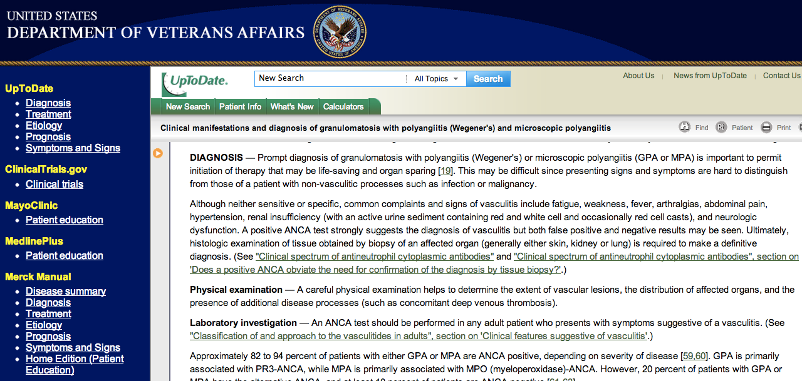
Figure 2 –Infobutton screen at the VHA showing a set of resources (left panel) with content on Wegener’s Granulomatosis.

The Medical Center Library at Duke University initiated an OpenInfobutton project with 2 objectives: 1) to create a federated search engine for key clinical resources that can be accessed from the Library’s Clinical Tools page (guides.mclibrary.duke.edu/clinicaltools); and 2) to provide a platform for integrating library-based knowledge resources into the Medical Center’s new EHR system (Epic®) . This 2-tiered approach was mandated by the change in EHR vendor during the early development of the project. Initiating OpenInfobutton as a federated search engine allowed the Library time to carefully test the search capabilities and to actively promote the search function to clinicians, students and members of the IT team. Phase 2 involves refining the list of specific resources and configuring the context specific links from the problem list and order entry within the EHR. Discussions are underway to implement OpenInfobutton as the HL7-compliant manager of these knowledge resources.

The University of Washington
At the University of Washington (UW), OpenInfobutton was explored as a method to deliver pharmacogenomics (PGx) knowledge to support drug therapy individualization [13]. PGx is the study of how variations in the human genome affect an individual's response to medications, and therefore provides the evidence-base for individualizing drug therapy. To support prescribing decisions, use of OpenInfobutton was investigated in the context of medication order entry within the UW implementation of the Cerner Millennium® EHR. The main limitation was missing support for the HL7 Infobutton Standard in Cerner products at the time. Although infobuttons could not be directly configured within Cerner, it was possible to configure OpenInfobutton to generate links to eight PGx knowledge resources. The majority of these resources provide domain-specific information and all but one are freely available. Links could be accessed from triggered alert messages via an "EVIDENCE" button.

Discussion
While several measures are currently in place to stimulate the dissemination of infobuttons, freely available tools are needed to facilitate the implementation and maintenance of infobuttons at various organizations. A tool like OpenInfobutton offers advantages over proprietary approaches in which resource integration is managed within each EHR system. The present report demonstrates these advantages.
First, The resource profiles configured in OpenInfobutton can be shared by multiple healthcare organizations. This allows organizations with little information technology support to enable infobuttons by leveraging resource profiles that are collaboratively created and maintained in LITE. Rather than relying on EHR analysts, resource profiles can be configured by information specialists such as medical librarians. To date, collaborators have been able to configure a wide range of resources with no need to change OpenInfobutton’s source code.
Second, EHR vendors can delegate infobutton processing to an external component, saving software development resources. OpenInfobutton has been successfully integrated with five EHR systems with very little programming effort. While all current implementation sites are in the United States, OpenInfobutton is freely available for use by healthcare organizations worldwide.
Last, an infobutton manager enables access to resources dedicated to specific areas, such as pharmacogenomics, pediatrics, and dermatology. These resources are offered to users only when the resource coverage matches the clinical context. We have been able to integrate OpenInfobutton with 14 of these highly-specialized resources.
Access to a wide range of knowledge resources is available through OpenInfobutton. While only 26% of these resources are HL7 compliant, most of the popular resources have implemented the HL7 Infobutton Standard. Yet, a gap exists in HL7 compliant resources that offer content for health providers and that are freely available.

Limitations
The main limitations of OpenInfobutton are related to limitations in the Infobutton Standard and the current infobutton approach itself. First, the clinical context is limited to a particular concept of interest, such as a medication or a problem. Additional information about the patient, such as co-morbidities, are not represented in the context information model. An enhanced context would enable resources to retrieve content that is more specific to the patient at hand. For example, drug dose recommendations may need to be adjusted if a patient has impaired renal function. To address this limitation, a new release of the Infobutton Standard with an enhanced context model will be published in January 2013.
Second, most infobutton implementations consist of hyperlinks adjacent to clinical concepts on the EHR screen. If a user has a question related to a concept of interest that is not on the EHR screen, a relevant infobutton will not be available. For example, this may happen when a clinician would like to know the laboratory tests that can be used to diagnose a condition that is not yet in the patient’s problem list or when the clinician would like to review the contraindications for a medication that she plans to prescribe. A potential solution for this limitation is voice activated infobuttons that allow the clinician to verbalize a concept of interest within the context of EHR use.
Third, the use of infobuttons imply that the clinician recognizes an information need. However, unrecognized information needs may be as important as those that the clinicians recognizes. This limitation could be addressed by triggering an infobutton request in the background based on certain EHR events, as opposed to the user clicking on a hyperlink. For example, as a clinician types a chief complaint, an infobutton request with the patient’s location can be automatically submitted to a registry of disease outbreaks. The registry would respond with potential outbreaks that are active within the patient’s geographical area and that may be causing the patient’s chief complaint. A similar approach can be adopted for other kinds of information needs that are typically not recognized, such as a patient being eligible for a clinical trial and relevant evidence updates.

Conclusion
Standards and regulations have been implemented to foster the dissemination of infobutton capabilities in healthcare organizations. However, freely available tools are also needed to assist EHR vendors and healthcare organizations to implement and manage this kind of functionality. In this paper we described the architecture and the experiences of large healthcare organizations with one of these tools. A similar model could be followed to enable the dissemination of other kinds of CDS capabilities at a large scale.

Acknowledgements
OpenInfobutton was supported by a Greenfield Innovations grant from the Veterans Health Administration and internal funds from the Department of Biomedical Informatics at the University of Utah. Del Fiol was supported by grant number K01HS018352 from the Agency for Healthcare Research and Quality. Jing and Cimino were supported by intramural research funds from the National Library of Medicine and the NIH Clinical Center.

References
- Covell DG, Uman GC, Manning PR. Information needs in office practice: are they being met? Annals of Internal Medicine. 1985;103(4):596-9.
- Ely JW, Osheroff JA, Chambliss ML, Ebell MH, Rosenbaum ME. Answering physicians' clinical questions: obstacles and potential solutions. J Am Med Inform Assoc. 2005;12(2):217-24.
- Del Fiol G, Workman TE, Gorman PN. Clinicians’ Patient Care Information Needs: Preliminary Results of a Systematic Review of the Literature. Proc AMIA Symp. 2012:1605.
- Leape LL, Bates DW, Cullen DJ, et al. Systems analysis of adverse drug events. ADE Prevention Study Group. JAMA. 1995;274(1):35-43.
- Cimino JJ, Elhanan G, Zeng Q. Supporting infobuttons with terminological knowledge. Proc AMIA Symp. 1997:528-32.
- Del Fiol G, Haug PJ, Cimino JJ, Narus SP, Norlin C, Mitchell JA. Effectiveness of topic specific infobuttons: A randomized controlled trial. J Am Med Inform Assoc. 2008;15(6):752-9.
- Maviglia SM, Yoon CS, Bates DW, Kuperman G. KnowledgeLink: impact of context-sensitive information retrieval on clinicians' information needs. J Am Med Inform Assoc.2006;13(1):67-73.
- Cimino JJ. Use, usability, usefulness, and impact of an infobutton manager. Proc AMIA Symp. 2006:151-5.
- Health Information Technology: Standards, Implementation Specifications, and Certification Criteria for Electronic Health Record Technology.2012. 2014 Edition, Final Rule, 171.
- Del Fiol G, Huser V, Strasberg H, Maviglia SM, Curtis C, Cimino JJ. Implementations of the HL7 Context-Aware Knowledge Retrieval (‘‘Infobutton’’) Standard: Challenges, strengths, limitations, and uptake. J Biomed Inform. 2012;45(4):726-35.
- Cimino JJ. Theoretical, empirical and practical approaches to resolving the unmet information needs of clinical information system users. Proc AMIA Symp. 2002:170-4.
- Cimino JJ, Xia J, Del Fiol G. Meeting the Electronic Health Record “Meaningful Use” Criterion for the HL7 Infobutton Standard Using OpenInfobutton and the Librarian Infobutton Tailoring Environment (LITE). Proc AMIA Symp. 2012:112-120.
- Overby C, Tarczy-Hornoch P, Kalet I, Thummel K, Smith J, Del Fiol G, Fenstermacher D, Devine E. Developing a prototype system for integrating pharmacogenomics findings into clinical practice. J Pers Med. 2012;2(4):241-256.

Address for correspondence
Guilherme Del Fiol, MD, PhD
26 South 2000 East Room 5775 HSEB
Salt Lake City, UT 84112-5775
guilherme.delfiol@utah.edu

