Clinical Decision Support (CDS) Content and Health Level 7 (HL7)-Compliant Knowledge Artifacts (KNARTs)
Women's Health: Breast Cancer Screening Clinical Content White Paper
Department of Veterans Affairs (VA)

Knowledge Based Systems (KBS)
Office of Informatics and Information Governance (OIIG)
Clinical Decision Support (CDS)
Clinical Decision Support (CDS) Content and Health Level 7 (HL7)-Compliant Knowledge Artifacts (KNARTs): Women's Health: Breast Cancer Screening Clinical Content White Paper
by Department of Veterans Affairs (VA), , , , and
Publication date December 2017
Contract: VA118-16-D-1008, Task Order (TO): VA-118-16-F-1008-0007
Table 1. Summary of Women's Health: Breast Cancer Screening KNARTs

Women's Health KNART | Associated CLIN
Breast Cancer Screening - ECA Rule | CLIN0007BA
Breast Cancer Screening - Documentation Template | CLIN0005AC
Breast Cancer Screening - Order Set | CLIN0004AA

Table of Contents
VA Subject Matter Expert (SME) Panel vi
Introduction vii
Conventions Used viii
1. Breast Cancer Screening 1
1.1. Clinical Context 1
1.2. Knowledge Artifacts 2
2. Event Condition Action (ECA) Rules: Breast Cancer Screening 3
2.1. Knowledge Narrative 3
2.2. Outpatient Visit, Age >=40 to <45 Years, Desires Early Breast Cancer Screening 3
2.3. Outpatient Visit, Age >=40 to <45 Years, No Desire for Early Breast Cancer Screening 4
2.4. Outpatient Visit, Age >=45 to <55 Years 4
2.5. Outpatient Visit, Age >=55 to <75 Years 5
2.6. Outpatient Visit, Age >=75 Years, Desires to Continue Screening 5
2.7. Outpatient Visit, Age >=75 Years, Desires to Stop Screening 6
2.8. Breast Cancer Screening Order Set ECA Rule 6
2.9. Periodic System Run 7
3. Breast Cancer Screening - Documentation Template 8
3.1. Knowledge Narrative 8
3.2. Breast Cancer Screening History 8
3.3. Breast Cancer Risk Assessment 9
3.4. Decline Breast Cancer Screening 10
3.5. Stop Breast Cancer Screening 11
4. Order Set: Breast Cancer Screening 12
4.1. Knowledge Narrative 12
4.2. Breast Cancer Screening 12
Bibliography/Evidence 13
A. Existing Sample VA Artifacts 14
B. American Cancer Society Guidelines 17
C. Logic Diagrams 18
D. Basic Laboratory Panel Definition 21
Acronyms 22

List of Figures
A.1. Mammogram Annual Screening 14
A.2. Mammogram Screening Clinical Reminder 15
A.3. Mammogram Screening 15
A.4. Stop Screening Dialogue 16
B.1. American Cancer Society Guidelines for Breast Cancer Screening, 2015 17
C.1. Breast Cancer Screening ECA Rules 18
C.2. Breast Cancer Screening ECA Rules 19
C.3. Breast Cancer Screening ECA Rules 20

List of Tables
1. Summary of Women's Health: Breast Cancer Screening KNARTs ii
1.1. Clinical Context Domains 1

VA Subject Matter Expert (SME) Panel

Name | Title | Project Role
C. Yvette Williams-Harris, MD, MPH | Physician, 1670 Clairmont Rd Atlanta, GA 30033 | SME, Primary
Megan Gerber, MD, MPH | Physician, VA Boston HealthCare System, 150 South Huntington Ave Boston, MA 02130 | SME, Secondary
Caitlin M. Cusack, MD, MPH | Contractor- Physician Informaticist, Office of Women's Health Services, 8455 Colesville Rd, 12th Floor Silver Spring, MD 20910 | SME

Introduction
The VA is committed to improving the ability of clinicians to provide care for patients while increasing quality, safety, and efficiency. Recognizing the importance of standardizing clinical knowledge in support of this goal, VA is implementing the Health Level 7 (HL7) Knowledge Artifact Specification for a wide range of VA clinical use cases. Knowledge Artifacts, referred to as (KNARTs), enable the structuring and encoding of clinical knowledge so the knowledge can be integrated with electronic health records to enable clinical decision support.
The purpose of this Clinical Content White Paper (CCWP) is to capture the clinical context and intent of KNART use cases in sufficient detail to provide the KNART authoring team with the clinical source material to construct the corresponding knowledge artifacts using the HL7 Knowledge Artifact Specification. This paper has been developed using material from a variety of sources: VA artifacts, clinical practice guidelines, evidence in the body of medical literature, and clinical expertise. After reviewing these sources, the material has been synthesized and harmonized under the guidance of VA subject matter experts to reflect clinical intent for this use case.
Unless otherwise noted, items within this white paper (e.g., documentation template fields, orderable items, etc.) are chosen to reflect the clinical intent at the time of creation. To provide an exhaustive list of all possible items and their variations is beyond the scope of this work.

Conventions Used
Conventions used within the knowledge artifact descriptions include:
<obtain>: Indicates a prompt to obtain the information listed
- If possible, the requested information should be obtained from the underlying system(s). Otherwise, prompting the user for information may be required
- The technical and clinical notes associated with a section should be consulted for specific constraints on the information (e.g., time-frame, patient interview, etc.)
- Default Values: Unless otherwise noted, <obtain> indicates to obtain the most recent observation. It is recognized that this default time-frame value may be altered by future implementations
[...]: Square brackets enclose explanatory text that indicates some action on the part of the clinical user, or general guidance to the clinical or technical teams. Examples include, but are not limited to:
[Begin ...], [End ...]: Indicates the start and end of specific areas to clearly delineate them for technical purposes.
[Activate ...]: Initiates another knowledge artifact or knowledge artifact section.
[Section Prompt: ...]: If this section is applicable, then the following prompt should be displayed to the user.
[Section Selection Behavior: ...]: Indicates technical constraints or considerations for the selection of items within the section.
[Attach: ...]: Indicates that the specified item should be attached to the documentation template if available.
[Link: ...]: Indicates that rather than attaching an item, a link should be included in the documentation template.
[Clinical Comment: ...]: Indicates clinical rationale or guidance.
[Technical Note: ...]: Indicates technical considerations or notes.
[If ...]: Indicates the beginning of a conditional section.
[Else, ...]: Indicates the beginning of the alternative branch of a conditional section.
[End if ...]: Indicates the end of a conditional section.
☐ [Check box]: Indicates items that should be selected based upon the section selection behavior.

Chapter 1. Breast Cancer Screening
1.1. Clinical Context
Several authoritative groups, including the United States Preventive Task Force (USPTF) (#ref USPTF), the American Cancer Society (ACS) (#ref Oeffinger, 2015), and the American College of Obstetrics and Gynecology (#ref Pearlman, 2017), have issued guidance that is partially overlapping and conflicting regarding screening mammography. To maximize clarity and reflect the most current evidence standard, the 2015 recommendations of the American Cancer Society (#ref ACS) will be regarded as the highest-tier evidence source (#ref ACSBCSG).
The American Cancer Society Guideline Development Group (ACSGDG) reviewed the evidence in an attempt to balance the benefit of early detection and treatment with the risk of false-positive findings, over detection, and over treatment. The ACSGDG also reviewed the evidence, evaluating the same issues, regarding the benefit of clinical breast exams. Based on that review, the ACS recommended starting annual screening mammography at the age of 45 years for all women at average risk of breast cancer, but to offer the opportunity of annual screening mammography starting at age 40 years. The ACS recommended transitioning to screening every other year starting at the age of 55 years, with the option of continuing annual screening. The ACS recommended continuing screening mammography as long as a woman’s overall health remains good and her life expectancy is at least 10 additional years. At the VA, women are offered biennial screening between the ages of 55-74 at which point providers are prompted to assess the patient’s life expectancy and if 10 years or greater, continue to offer screening.
The ACS did not recommend using the clinical breast exam as a screening method among average-risk women at any age. The ACS defined women at "average risk" as those who do not have a personal history of breast cancer, prior chest radiotherapy at a young age (age 30 or younger), or a suspected or known mutation of a gene, such as the breast cancer (BRCA) gene that increases the risk of breast cancer. The ACS also noted that mammography, alone, may not be as effective in women with a higher-than-average risk based on a significant family history, breast density on mammography, or a prior diagnosis of benign proliferative breast disease. Finally, the ACS noted that the risk of false-positives was increased for women receiving their first mammogram, those who had digital instead of film mammography, those who had longer intervals between mammograms, and those who did not have comparison images. The risk of false-positives was also increased in women using postmenopausal hormone therapy and those with mammographically dense breasts. It is important that providers evaluate a woman’s risk of breast cancer, discuss the risks and benefits of screening mammography with her, and determine her preferences for screening, particularly for women between the ages of 40 years and 44 years and those aged 55 years or older.
The Breast Cancer Screening documentation template, order set, ECA rule and composite KNART set is intended to prompt clinical providers to identify a woman's breast cancer risk category; counsel her about that risk; identify her screening preferences; screen based on age, risk, and patient preference; and document the entire process. Breast cancer is a common cause of morbidity and mortality among women. Early signs of breast cancer can be detected with mammography, but the question of when to start screening mammography remains somewhat controversial. The latest guidelines published by ACS and as chosen by the VA will be used for these knowledge artifacts. In addition, other constraints for these artifacts are that:
- They apply to female outpatients over the age of 18.
These context domains are summarized in the table below.
Table 1.1. Clinical Context Domains

Target User | Provider to include Primary Care, Obstetrics/Gynecology, Women's Health
Patient | Adult Female
Priority | Routine
Specialty | Primary Care, Obstetrics/Gynecology, Women's Health
Location | Outpatient
1.2. Knowledge Artifacts
This section describes the knowledge artifacts that are part of the Women's Health: Breast Cancer Screening group of clinical decision support artifacts, and include:
- Event Condition Action (ECA) Rule: Women's Health: Breast Cancer Screening
- Rule logic that describes the behavior of the consult
- Actions may include activating documentation templates or order sets
- Documentation Template: Women's Health: Breast Cancer Screening
- Documents the information provided by the referring provider
- Includes logic for appropriate display of documentation sections
- Order Set: Women's Health: Breast Cancer Screening
- Orderable items associated with the consult request
- Includes logic for appropriate display of the order set

Chapter 2. Event Condition Action (ECA) Rules: Breast Cancer Screening
[Begin ECA Rule.]
2.1. Knowledge Narrative
[Begin Knowledge Narrative.]
[See Clinical Context in Chapter 1.]
[Clinical Comment: The purpose of the ECA rule set for breast cancer screening is to assess the patient’s breast cancer screening status and, if warranted, to document breast cancer risk and screening desires as well as to order the recommended exam. The rule logic is based upon the ACS 2015 published recommendations as summarized in the clinical context. Essentially this entails, starting annual screening mammography at the age of 45 years for all women at average risk of breast cancer, with the opportunity for annual screening mammography to begin as early as age 40 years. Beginning at age 55, transitioning to mammography screening every other year, with the option of continuing annual screening as long as a woman’s overall health remains good and her life expectancy is at least 10 additional years. There are three main categories of events that function as triggers for breast cancer screening rules:
- Opening of the patient record during an encounter in either a primary care clinic, an obstetrics/gynecology (OB/GYN), or during a women's health outpatient visit.
- System run of preventive screening rules, run monthly.
- The breast cancer screening order set ECA rule is activated.]
[End Knowledge Narrative.]
2.2. Outpatient Visit, Age >=40 to <45 Years, Desires Early Breast Cancer Screening
[Begin Outpatient Visit, Age >=40 to <45 Years, Desires Early Breast Cancer Screening.]
Event
- Opening of the patient record during an encounter in either a primary care clinic, an OB/GYN or during a women's health outpatient visit.
Conditions
- Patient is female between the ages of >=40 years to <45 years.
- Patient does not decline early breast cancer screening.
- Patient does not have a documented mammography screening interval.
- Patient has not had mammography within 12 months.
- Patient does not have a personal history of breast cancer, prior chest radiotherapy at a young age, or a suspected or known mutation of a gene such as BRCA that increases the risk of breast cancer.
Actions
- Set screening interval to annual.
- Notify the provider that options for breast cancer screening should be discussed with patient and that the discussion should be documented.
- Activate the breast cancer screening history section of the documentation template.
- Activate the breast cancer risk assessment of the documentation template.
- Activate the breast cancer screening order set ECA rule.
[End Outpatient Visit, Age >=40 to <45 Years, Desires Early Breast Cancer Screening.]
2.3. Outpatient Visit, Age >=40 to <45 Years, No Desire for Early Breast Cancer Screening
[Begin Outpatient Visit, Age >=40 to <45 Years, No Desire for Early Breast Cancer Screening.]
Event
- Opening of the patient record during an encounter in either a primary care clinic, an OB/GYN, or during a women's health outpatient visit.
Conditions
- Patient is female between the ages of >=40 and <45 years.
- Patient declines early breast cancer screening.
- Patient does not have a documented mammography screening interval.
- Patient has not had mammography within 12 months.
- Patient does not have a personal history of breast cancer, prior chest radiotherapy at a young age (up to age 30), or a suspected or known mutation of a gene such as BRCA that increases the risk of breast cancer.
Actions
- Activate declines breast cancer screening section of the documentation template
- Set screening interval to declines early breast cancer screening.
[End Outpatient Visit, Age >=40 to <45 Years, No Desire for Early Breast Cancer Screening.]
2.4. Outpatient Visit, Age >=45 to <55 Years
[Begin Outpatient Visit, Age >=45 to <55 Years.]
Event
- Opening of the patient record during an encounter in either a primary care clinic, an OB/GYN, or during a women's health outpatient visit.
Conditions
- Patient is female between the ages of >=45 and <55 years.
- Patient has not had mammography within 12 months.
- Patient does not have a personal history of breast cancer, prior chest radiotherapy at a young age, or a suspected or known mutation of a gene such as BRCA that increases the risk of breast cancer.
Actions
- Set screening interval to annual.
- Notify the provider that options for breast cancer screening should be discussed with patient and that the discussion should be documented.
- Activate the breast cancer screening history section of the documentation template.
- Activate the breast cancer risk assessment of the documentation template.
- Activate the breast cancer screening order set ECA rule.
[End Outpatient Visit, Age >=45 to <55 Years.]
2.5. Outpatient Visit, Age >=55 to <75 Years
[Begin Outpatient Visit, Age >=55 to <75 Years.]
Event
Opening of the patient record during an encounter in either a primary care clinic, an OB/GYN, or during a women's health outpatient visit.
Conditions
- Patient is female between the ages of >=55 and <75 years.
- Patient has not had mammography within 12 months.
- Patient does not have a mammography screening interval set to "stop screening."
- Patient does not have a personal history of breast cancer, prior chest radiotherapy at a young age, or a suspected or known mutation of a gene such as BRCA (Breast Cancer gene) that increases the risk of breast cancer.
Actions
- Set screening interval to biennial.
- Notify the provider that options for breast cancer screening should be discussed with patient and that the discussion should be documented.
- Activate the breast cancer screening documentation template.
- Activate the breast cancer screening order set ECA rule.
[End Outpatient Visit, Age >=55 to <75 Years.]
2.6. Outpatient Visit, Age >=75 Years, Desires to Continue Screening
[Begin Outpatient Visit, Age >=75 Years, Desires to Continue Screening.]
Event
Opening of the patient record during an encounter in either a primary care clinic, an OB/GYN, or during a women's health outpatient visit.
Conditions
- Patient is female age >=75 years.
- Patient has a life expectancy greater than 10 years.
- Patient desires to continue breast cancer screening.
- Patient has not had mammography within 12 months.
- Patient does not have a mammography screening interval set to "stop screening."
- Patient does not have a personal history of breast cancer, prior chest radiotherapy at a young age, or a suspected or known mutation of a gene such as BRCA that increases the risk of breast cancer.
Actions
- Set screening interval to biennial.
- Notify the provider that options for breast cancer screening should be discussed with patient and that the discussion should be documented.
- Activate the breast cancer screening documentation template.
- Activate the breast cancer screening order set ECA rule.
[End Outpatient Visit, Age >=75 Years, Desires to Continue Screening.]
2.7. Outpatient Visit, Age >=75 Years, Desires to Stop Screening
[Begin Outpatient Visit, Age >=75 Years, Desires to Stop Screening.]
Event
Opening of the patient record during an encounter in either a primary care clinic, an OB/GYN, or during a women's health outpatient visit.
Conditions
- Patient is female age >=75 years.
- Patient has a life expectancy greater than 10 years.
- Patient desires to stop breast cancer screening.
- Patient has not had mammography within 12 months.
- Patient does not have a mammography screening interval set to "stop screening."
- Patient does not have a personal history of breast cancer, prior chest radiotherapy at a young age, or a suspected or known mutation of a gene such as BRCA that increases the risk of breast cancer.
Actions
- Set screening interval to stop screening.
[End Outpatient Visit, Age >=75 Years, Desires to Stop Screening.]
2.8. Breast Cancer Screening Order Set ECA Rule
[Begin Breast Cancer Screening Order Set ECA Rule.]
Event
Activation of the breast cancer screening order set ECA rule.
Conditions
- Breast Cancer Screening due date is prior to NOW or in the next 60 days
- The patient is not scheduled for Breast Cancer Screening
- The patient does not decline screening at this time
Actions
- Activate the breast cancer screening order set.
[End Breast Cancer Screening Order Set ECA Rule.]
2.9. Periodic System Run
[Begin Periodic System Run.]
Event
[Every month on day 1 of the month.]
Conditions
- Breast cancer screening due date is within the time period spanning 1 month ago to 2 months from now
- The patient is not scheduled for breast cancer screening
- The patient does not decline screening at this time
Actions
- For facilities that use auto-generated patient notifications: notify the patient of their Breast Cancer Screening due date
- For facilities that do not use auto-generated patient notifications: add the patient to the report of patients due for breast cancer screening with their Breast Cancer Screening due date
[End Periodic System Run.]
[ECA rule complete.]

Chapter 3. Breast Cancer Screening - Documentation Template
[Begin Documentation Template.]
3.1. Knowledge Narrative
[Begin Knowledge Narrative.]
[See Clinical Context in Chapter 1.]
[Technical comment: The Breast Cancer Screening Documentation Template provides a mechanism for documenting a patient’s risk for breast cancer. Although the template below is a series of questions and answers, any information that can be obtained from the system should be pre-filled in a manner that is apparent to the user. There are four sections contained within this documentation template, which may be activated independently:
- Breast Cancer Screening History
- Breast Cancer Risk Assessment
- Decline Breast Cancer Screening
- Stop Breast Cancer Screening]
[End Knowledge Narrative.]
3.2. Breast Cancer Screening History
[Begin Breast Cancer Screening History.]
[Section Prompt: Does the patient have breast implants?]
[Section Selection Behavior: Select one. Required.]
☐ Yes
☐ No
[Section Prompt: Does the patient have a history of breast cancer screening?]
[Section Selection Behavior: Select one. Required.]
☐ Yes
<obtain> Date
<obtain> Location
<obtain> Results
<link> Mammography Image
☐ No [If no, then End Breast Cancer Screening History section.]
[Section Prompt: Does the patient have a history of abnormal breast imaging and/or history of treatment for breast abnormality?]
[Section Selection Behavior: Select one. Required.]
☐ Yes
<obtain> Abnormal Results
<link> Abnormal Mammography Image
<obtain> Clinical Comments
<Select> Date, Location
☐ No
[Section Prompt: Does the patient have a history of mammographically dense breasts?
[Section Selection Behavior: Select one. Required.]
☐ Yes
☐ No
[Section Prompt: Does the patient have a history of a breast biopsy?
[Section Selection Behavior: Select one. Required.]
☐ Yes
<obtain> Results
☐ No
[End Breast Cancer Screening History Section.]
3.3. Breast Cancer Risk Assessment
[Begin Breast Cancer Risk Assessment.]
[Section Prompt: Conditions that may increase risk include but are not limited to:
- Personal history of any breast cancer, including ductal carcinoma in situ (DCIS).
- History of chest wall radiation up to the age equal to 30.
- Known or suspected genetic mutation that increases risk of breast cancer, such as BRCA.
- First degree relatives with ovarian cancer or early breast cancer.
- Women with a prior diagnosis of benign proliferative breast disease.
- Women with significant mammographic breast density.]
[Clinical Comment: Estimated lifetime risk of approximately 20% to 25% or greater, as defined by risk assessment models, such as the Breast Cancer Risk Assessment Tool https://www.cancer.gov/bcrisktool/.]
[Section Prompt: Does the patient have a personal history of any breast cancer including ductal carcinoma in situ (DCIS)?]
[Section Selection Behavior: Select one. Required.]
☐ Yes
☐ No
[Section Prompt: Does the patient have a history of chest wall radiation prior to the age of 31?]
[Section Selection Behavior: Select one. Required.]
☐ Yes
☐ No
[Section Prompt: Does the patient have a history of known or suspected genetic mutation that increases risk of breast cancer, such as BRCA?]
[Section Selection Behavior: Select one. Required.]
☐ Yes
<obtain> Details
☐ No
[Section Prompt: Does the patient have any first degree relatives with ovarian cancer or early breast cancer (breast cancer diagnosed prior to age 40)?]
[Section Selection Behavior: Select one. Required.]
☐ Yes
☐ No
[Section Prompt: Does the patient have a history of prior diagnosis of benign proliferative breast disease?]
[Section Selection Behavior: Select one. Required.]
☐ Yes
☐ No
[Section Prompt: Does the patient have an estimated lifetime risk of approximately 20% or greater, as defined by risk assessment models such as the Breast Cancer Risk Assessment Tool https://www.cancer.gov/bcrisktool/?]
[Section Selection Behavior: Select one. Required.]
☐ Yes
☐ No
[Technical Note: If any boxes are checked “yes”, then display the following notification and document the results.]
[Section Prompt: Evaluate the patient’s risk factors and determine the need for genetic evaluation and/or early, more frequent, or additional breast imaging.]
<obtain> Evaluation details
[End Breast Cancer Risk Assessment.]
3.4. Decline Breast Cancer Screening
[Begin Decline Breast Cancer Screening.]
[Section Prompt: After discussing the need for breast cancer screening, does the patient decline screening?]
[Section Selection Behavior: Select one. Required.]
☐ Yes
<obtain> Patient reason for declining screening.
☐ No
[If yes, then <obtain> Patient declines screening discussion.]
[End Decline Breast Cancer Screening Assessment.]
3.5. Stop Breast Cancer Screening
[Begin Stop Breast Cancer Screening.]
[Section Prompt: Does the patient have a history of bilateral mastectomy?]
[Section Selection Behavior: Select one. Required.]
☐ Yes
☐ No
[Section Prompt: Does the patient have a life expectancy less than 6 months?]
[Section Selection Behavior: Select one. Required.]
☐ Yes
☐ No
[Section Prompt: As the patient's provider, do you feel that there is no net benefit to screening due to life expectancy less than 10 years, or that due to comorbidities the patient will be unable to tolerate further workup or treatment if breast cancer screening were positive?]
[Section Selection Behavior: Select one. Required.]
☐ Yes
<obtain> Date
☐ No
[Section Prompt: Does the patient have any reason to stop screening in addition to or other than the ones listed above in this section?]
[Section Selection Behavior: Select one. Required.]
☐ Yes
<obtain> Additional reason to stop screening
☐ No
[End Stop Breast Cancer Screening.]
[End Documentation Template.]

Chapter 4. Order Set: Breast Cancer Screening
[Begin Order Set.]
4.1. Knowledge Narrative
[Begin Knowledge Narrative.]
[See Clinical Context in Chapter 1.]
[Clinical Comment: This order set applies to any patient that requires breast cancer screening. All orders are routine unless otherwise specified.]
[End Knowledge Narrative.]
4.2. Breast Cancer Screening
[Begin Breast Cancer Screening.]
[Section Prompt: Based upon the patient’s history, provide the appropriate detail for the screening mammography order.]
[Section Selection Behavior: Optional.]
☐ Perform screening mammography
<obtain> Brief clinical history
<obtain> Ordering Physician/Provider Name
<obtain> Ordering Physician/Provider Service/Section
<obtain> Ordering Physician/Provider Telephone Number
<obtain> Ordering Physician/Provider Pager
<obtain> Other Physician/Provider Name Who Should Also Receive Results
<obtain> Other Physician/Provider Service/Section
<obtain> Other Physician/Provider Telephone Number
<obtain> Other Physician/Provider Pager
Date desired: <obtain> Desired date
☐ Additional views: <obtain> Additional views
[End Breast Cancer Screening.]
[End Order Set.]

Bibliography/Evidence
United States Preventative Task Force Breast Cancer Screening Guidelines.. https://www.uspreventiveservicestaskforce.org/Page/Document/UpdateSummaryFinal/breast-cancer-screening.
[Oeffinger, 2015] KC Oeffinger, ETH Fontham, R Etzioni, and et al.. “Breast Cancer Screening for Women at Average Risk: 2015 Guideline Update From the American Cancer Society”. JAMA. 2015. 314. (15). 1599-1614.
[Pearlman, 2017] M Pearlman, M Jeudy, and D Chelmow. “Breast Cancer Risk Assessment and Screening in Average-Risk Women”. OBSTETRICS AND GYNECOLOGY. 2017 Jul 1. 130. (1). E1-6.
American Cancer Society Breast Cancer Screening Guidelines. https://www.cancer.org/health-care-professionals/american-cancer-society-prevention-early-detection-guidelines/breast-cancer-screening-guidelines.html.

Appendix A. Existing Sample VA Artifacts
Figure A.1. Mammogram Annual Screening
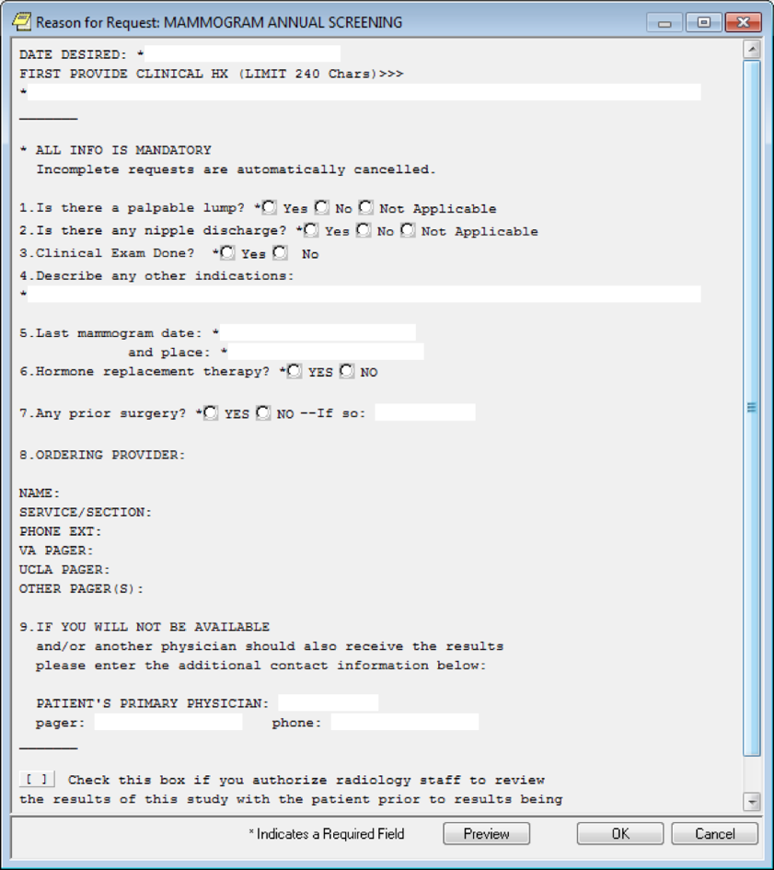
Figure A.2. Mammogram Screening Clinical Reminder
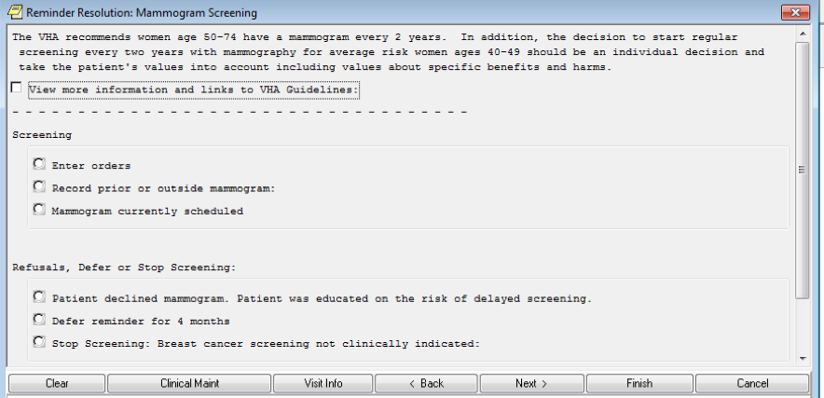
Figure A.3. Mammogram Screening
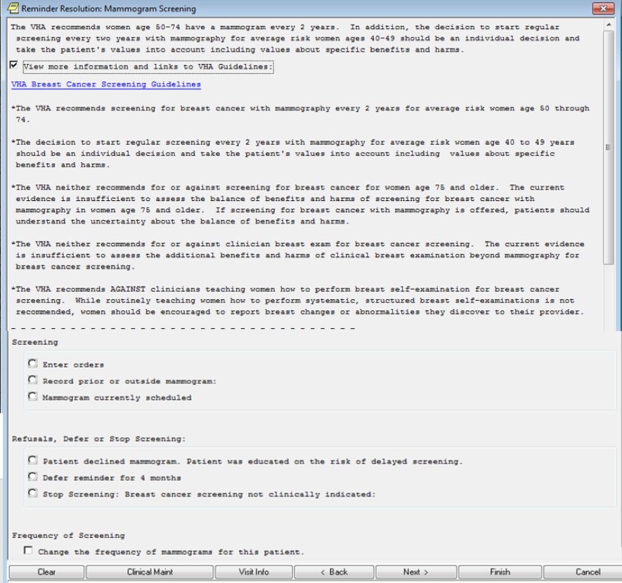
Figure A.4. Stop Screening Dialogue
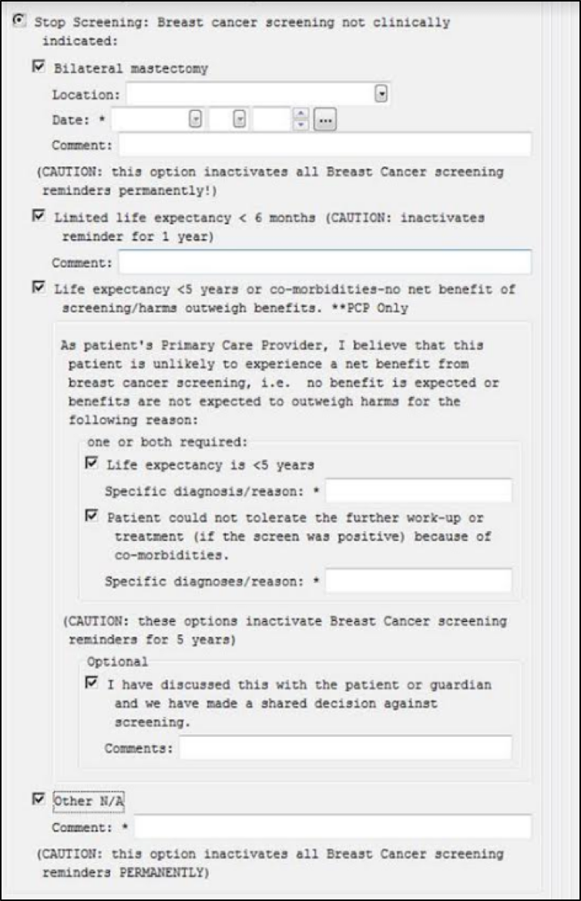

Appendix B. American Cancer Society Guidelines
American Cancer Society Guideline for Breast Cancer Screening, Summary of Recommendations.
See https://www.cancer.org/health-care-professionals/american-cancer-society-prevention-early-detection-guidelines/breast-cancer-screening-guidelines.html for complete guidelines.
Figure B.1. American Cancer Society Guidelines for Breast Cancer Screening, 2015
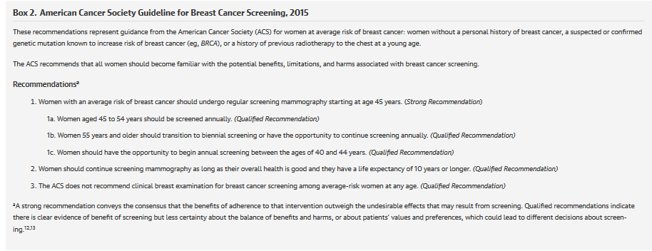

Appendix C. Logic Diagrams
Figure C.1. Breast Cancer Screening ECA Rules
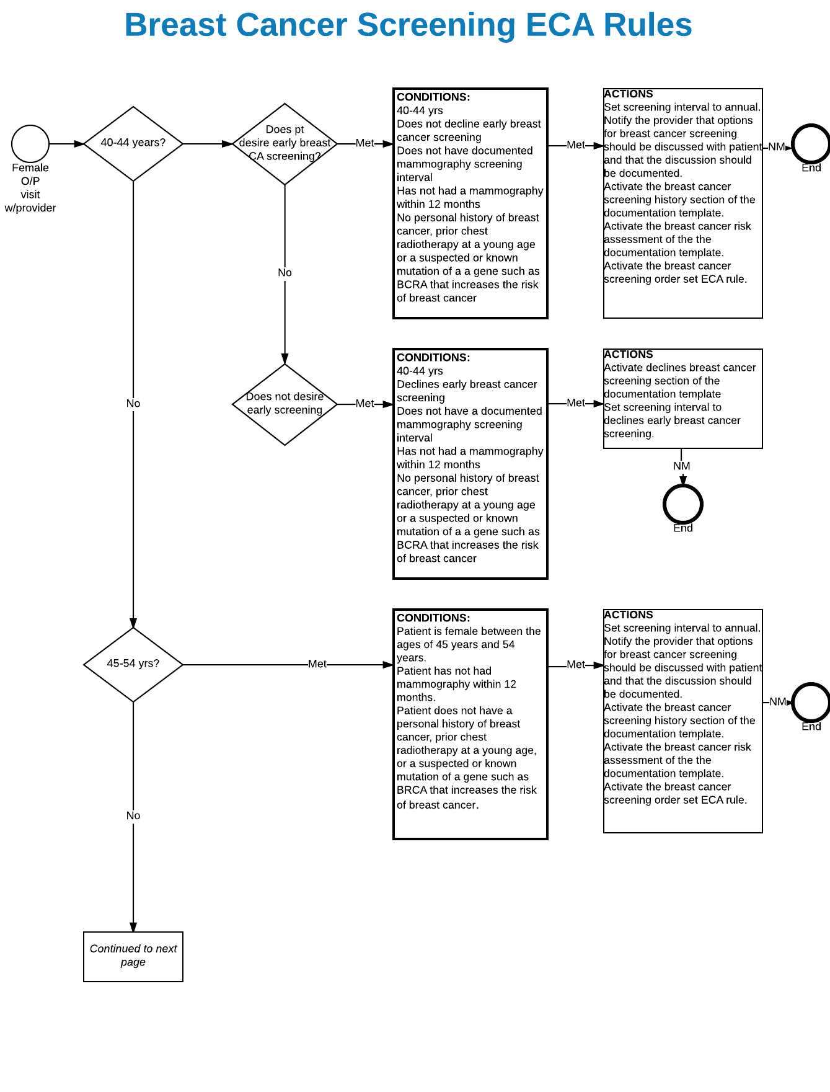
Figure C.2. Breast Cancer Screening ECA Rules
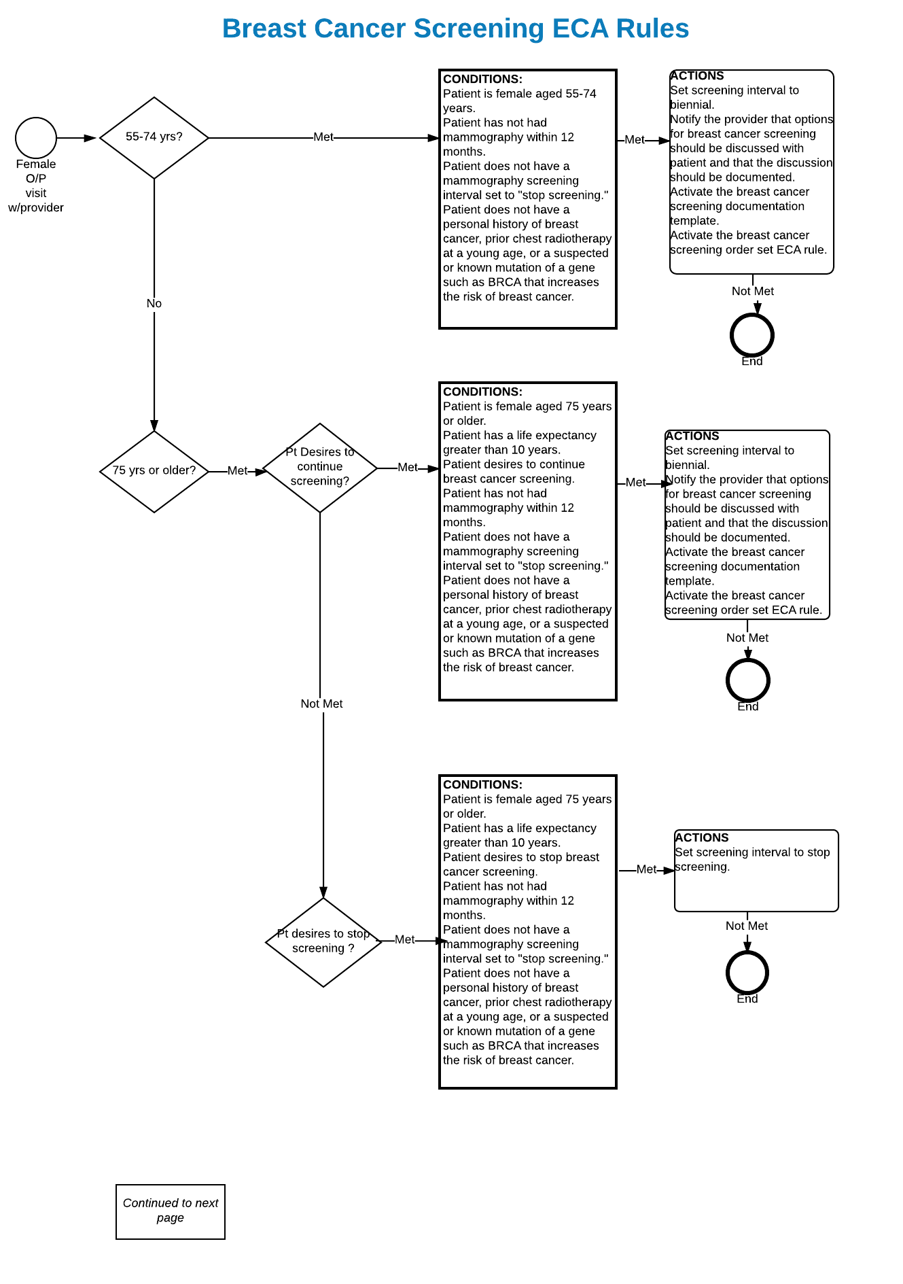
Figure C.3. Breast Cancer Screening ECA Rules
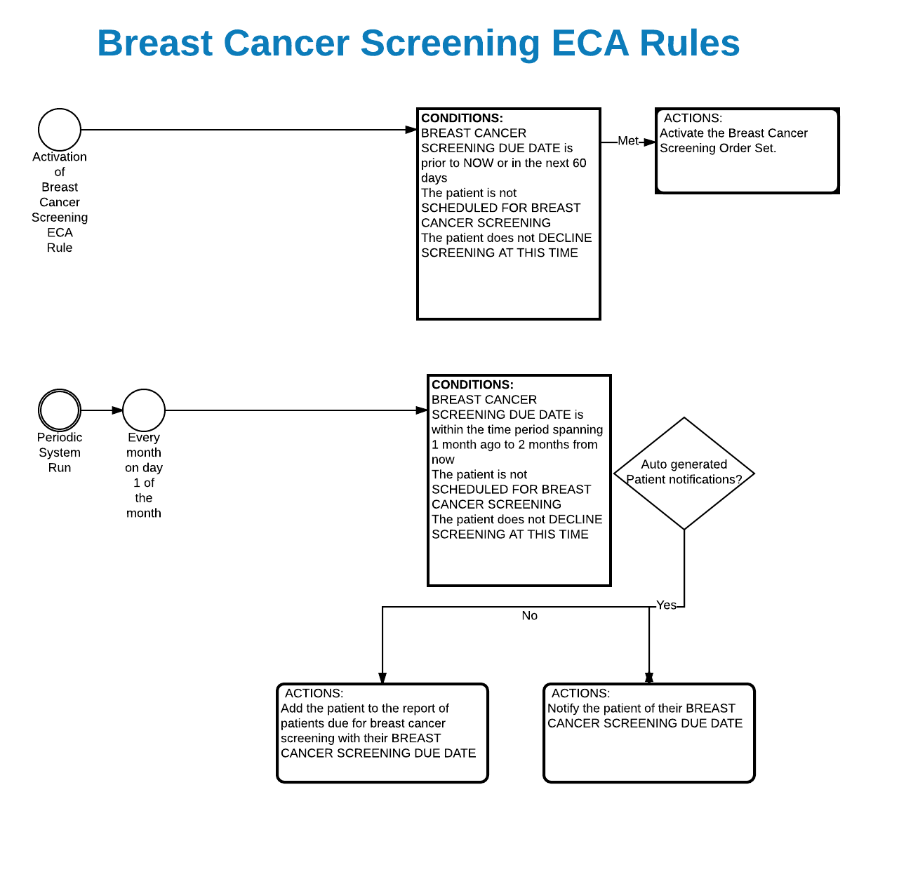

Appendix D. Basic Laboratory Panel Definition
- Blood Urea Nitrogen
- Calcium
- Chloride
- CO2 (Carbon Dioxide, Bicarbonate)
- Creatinine
- Glucose
- Potassium
- Sodium

Acronyms
USPTF United States Preventive Task Force
ACSGDG American Cancer Society Guideline Development Group
ACS Acute Coronary Syndrome
BRCA Breast Cancer
CCWP Clinical Content White Paper
DCIS Ductal carcinoma in situ
ECA Event Condition Action
HL7 Health Level 7
KNART Knowledge Artifact
KNARTs Knowledge Artifacts

