`0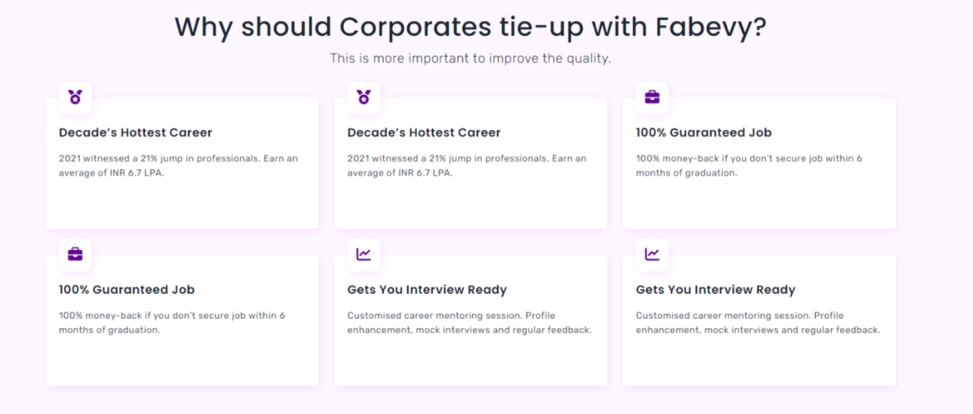

* **Industry-Ready Trainees**: We can provide corporates with highly skilled and industry-ready trainees in Web Development, including Front-end, Back-end, and Full Stack Development.
* **Customized Hiring and Training**: Our team can work with companies to understand their domain expertise and expectations, and then hire, train and enable talent acquisition as per corporate expectations.
* **Experienced Trainers**: Our trainers are experienced professionals who have worked in the industry and have hands-on experience with the latest tools and technologies. They can provide practical, real-world insights and training to corporates.
* **Customizable Training Programs**: We understand that each company has unique requirements, and therefore we offer customizable training programs that are tailored to the company's specific needs that align with their goals and objectives.
* **Cost-Effective**: Our training programs are cost-effective, and we offer flexible pricing options that fit within the company's budget. We believe that quality training should be accessible to all, and we work hard to ensure that our prices are competitive.
* **Continuous Support**: We provide continuous support to our trainees and corporates to ensure that they are successful in their roles. Our team is always available to answer any questions or concerns and provide additional support as needed.
* **Payroll Model**: We offer a unique opportunity for our clients to avail themselves of our trainees for a fixed period under our payroll model. This model is designed to provide clients with flexibility, cost-effectiveness, and reduced hiring risks.
* **Seamless integration**: Our trainees work seamlessly with the client's team and can be easily integrated into the organization's culture and processes. Our team ensures that trainees are prepared for their roles and provide support throughout the contract period.
* **Reduced hiring risks**: Clients can evaluate trainees before making long-term commitments, reducing the risk of hiring the wrong candidate.
* **payroll model** provides a cost-effective, low-risk, and flexible solution for clients to hire industry-ready trainees for a fixed period.
* **Train an Intern to be an Employee**: Fabevy offers employers to evaluate potential employees by providing trainees with practical experience in a real work environment. If trainees meet employer expectations, they can secure full-time employment, becoming industry-ready.
* **Internship First Approach:** Recruiters can hire our trainees as interns and evaluate their performance before onboarding as employees

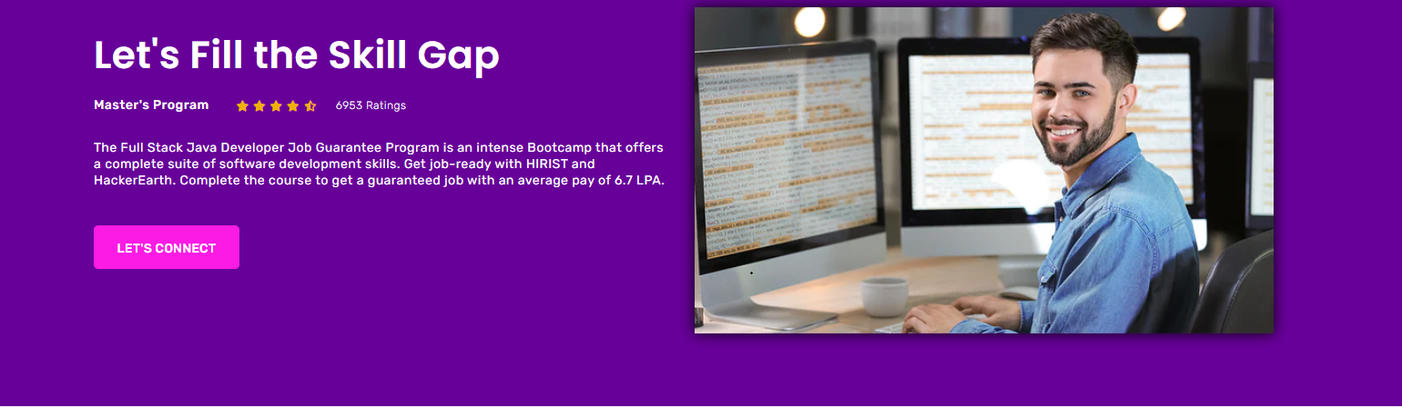

How Can We Assist Corporates in Bridging the Talent Gap?

At Fabevy, we understand that finding the right talent can be challenging for corporates. This is why we offer comprehensive training and upskilling programs that bridge the talent gap by equipping job seekers and freshers with the skills needed to excel in the technology industry. Our training modules are designed to meet the specific skill-based course curriculum of individual corporate clients, ensuring that our trainees are well-equipped to meet their requirements. Additionally, we monitor the quality of our trainees through periodic reviews and ensure that they perform as per corporate expectations through our team of quality assurance experts. We also provide personalized career counseling and placement services to help our trainees secure suitable employment opportunities. By bridging the talent gap in the industry, we aim to help corporates find the right talent and achieve their business goals.

What Makes Our Talent Acquisition Services Stand Out for Corporates?

Our talent acquisition services stand out for corporates because of our comprehensive approach to training, placement, and quality assurance. We work closely with corporate clients to understand their unique manpower requirements and design effective training modules that meet their specific needs. Our training programs not only fill the skill gap in the industry but also provide hands-on experience and soft skills training to help our trainees succeed in their careers. Additionally, we monitor the quality of our trainees through periodic reviews and ensure that they perform as per corporate expectations through our team of quality assurance experts. We also provide personalized career counseling and placement services to help our trainees secure suitable employment opportunities. By taking a holistic approach to talent acquisition, we aim to help corporates find the right talent and achieve their business objectives.

**What Makes Our Talent Acquisition Services Stand Out for Corporates?**

Comprehensive approach to training, placement, and quality assurance

Design customized effective training modules that meet unique corporate manpower requirements

Periodic reviews ensure trainees perform as per corporate expectations

Provide personalized career counseling and placement services to help secure suitable employment opportunities.

(Or)

**How Can We Assist Corporates in Bridging the Talent Gap?**

Train job seekers with skills needed to excel in tech industry

Modules that meet individual corporate skill-based course curriculum

Monitor trainees' quality through periodic reviews

Provide personalized career counseling and placement services to help secure suitable employment opportunities