

User's Manual
Version 5.1

© 2010 Logical Objects Srl, via Carlo Marx 131/2 – 41012 Carpi Italy.
All rights reserved.
http://www.logicalobjects.com

This document is subject to change without notice.

License
This work is licensed under a GNU Free Documentation License 1.2.
http://www.gnu.org/licenses/fdl-1.2.txt

Disclaimer
Documentation is provided 'AS IS' and all express or implied conditions, representations and warranties, including any implied warranty of merchantability, fitness for a particular purpose or on-infringement, are disclaimed, except to the extent that such disclaimers are held to be legally invalid.

Contents
1 General Information 6
1.1 What is LogicalDOC 6
1.2 Contacts 7
1.3 Manual layout 7
1.4 Acronyms and Abbreviations 7
1.5 Table icons 7
2 First access 10
2.1 Login 10
2.2 Home Page 11
2.3 Document management 11
2.4 Document search 14
2.4.1 Quick search 15
2.4.2 Advanced search 15
2.4.3 Parametric search 16
2.4.4 Tag search 17
2.5 Folder deletion 17
2.6 Program exit 17
3 Documents 18
3.1 Folders 18
3.1.1 Folder menu 19
3.1.2 Search Documents in a Folder 20
3.1.3 Folder History 20
3.1.4 RSS on Folder 20
3.1.5 Folder Creation 21
3.1.6 Folder Deletion 22
3.1.7 Rename a Folder 22
3.1.8 Move a Folder 22
3.1.9 Export a Folder in a Zip Archive 23
3.1.10 Rights setting 23
3.1.11 Subscription on Folder 24
3.1.12 Workflow on folder 25
3.2 Document creation 26
3.3 Operations on Document 27
3.3.1 Import Documents from Zip Archive 27
3.3.2 Start a Workflow 28
3.3.3 Insert a document into an export archive 29
3.3.4 Insert a document into an archive for Paper Dematerialization 29
3.3.5 Scanning of a document 30
3.3.6 Sign documents 31
3.3.7 Subscriptions on documents 31
3.3.8 Document Shortcut 32
3.3.9 Contextual menu 33
3.3.10 Checkout/Checkin 33
3.3.11 Lock/Unlock document 34
3.3.12 Document Editing 34
3.3.13 Paste as Link 34
3.3.14 Versions 35
3.3.15 Similar documents 36
3.3.16 Discussion Forum 37
3.3.17 Emailing Document 37
3.3.18 Sign a document 38
3.3.19 Convert a document into Pdf format 39
4 Personal Data 41
4.1 Changing Password 41
4.2 Editing Personal Data 41
4.3 Sending and Receiving Messages 41
4.3.1 Sending a message 41
4.3.2 Reading Messages 42
4.4 My Tasks 42
4.5 My Subscriptions 42
5 LogicalDOC as a Web Folder 43
5.1 Web Folder on Windows 43
5.2 Web Folder on Linux 46
5.2.1 Nautilus 46
5.2.2 Cadaver 46
5.2.3 Mount as local folder 46
5.2.4 Ubuntu 47
6 Administration 48
6.1 Database maintenance 48
6.2 Last Changes 50
6.3 SMTP 50
6.4 GUI 51
6.5 Parameters 51
6.6 User sessions 52
6.7 System restart 53
6.8 Web Service 53
6.9 WebDAV 53
6.10 Users 54
6.10.1 Creating a New User 54
6.10.2 Editing a User 56
6.11 Groups 56
6.11.1 Creation of a New Group 56
6.11.2 Editing an Existing Group 57
6.12 Security 58
6.13 LDAP 59
6.14 Active Directory 60
6.15 Template 61
6.16 Workflow 62
6.17 E-Mail accounts 63
6.17.1 Account Configuration 63
6.18 Scheduled Tasks 65
6.18.1 List of Scheduled Tasks 65
6.18.2 Scheduling 66
6.18.3 Progress Status and Log 67
6.19 Branding 67
6.20 Localization 68
6.21 Import folders 68
6.21.1 Configuring Remote folders 69
6.22 Custom ID 70

General Information
LogicalDOC is a system for archiving documents, it is easy to use and has been designed to be deployed into any corporate network. It is ideal for storing, sharing and searching electronic documents of any kind. This manual is dedicated to the staff responsible for the administration or use of document archiving.

What is LogicalDOC
LogicalDOC is a fully web-based application for archiving documents. Once it is installed and connected to the Internet, you can use the program simply by a browser without having have to install additional software.
The features provided by the system include:
- Organization of documents into folders
- Full-text indexing of documents in Office formats (PDF, Word ....)
- Editing and Cancellation of documents already imported
- Cancellation of folders already imported
- Acquisition of documents from e-mail boxes
- Handling of users and access privileges
- Document versioning after each change
- Setting a custom ID on a document
- Import documents from remote and local folders
- Import and export of documents archives
- Discussion forum on a document
- Authentication with LDAP and Active Directory
- User sessions management
- Web Service
- Documents managing and editing with WebDAV
- Workflow
- Auditing on folder and documents editing
- Setting the maximum number of versions for a document
- Document shortcut
- Setting security connection management for SMTP
- Workflows associated to folders
- Ability to move folders

This program allows access to the document archive once it has been installed and connected to the network.

Contacts
Support e-mail: support@logicaldoc.com
Bugs and feature requests: http://bugs.logicaldoc.co

Manual layout
This guide is divided into 2 sections: the first three chapters provide a general description of the system and a guide for quick access, while the second part includes various chapters each devoted to a particular management area.

Acronyms and Abbreviations
DMS – Document Management System
A computer system (or set of computer programs) used to track and store electronic documents and/or images of paper documents.

Table icons
The tables below list all the icons used in the system.

Folders
Icon | Code | Meaning
 | 1.1 | Search on documents in a folder
 | 1.2 | Back to the top-level folder
 | 1.3 | Folder history
 | 1.4 | Folder RSS
 | 1.5 | Subscription on folder
 | 1.6 | Workflow on folder

Documents
Icon | Code | Meaning
 | 2.1 | Import of a new document
 | 2.2 | Import of documents from a file with .zip extension
 | 2.3 | Cut a document
 | 2.4 | Copy a document
 | 2.5 | Paste a document
 | 2.6 | Set a document as immutable
 | 2.7 | Document deletion
 | 2.8 | The document is indexed
 | 2.9 | Document obtained through checkout operation
 | 2.10 | The document is linked to another document
 | 2.11 | Insert a document into an archive
 | 2.12 | Scanning a document
 | 2.13 | Start the scanning operation
 | 2.14 | Rotate a scanned document 90° to the left
 | 2.15 | Rotate a scanned document 90° to the right
 | 2.16 | Visualize the previous scanned image
 | 2.17 | Visualize the next scanned image
 | 2.18 | Upload the scanned document to LogicalDOC
 | 2.19 | Insert document in a Paper dematerialization archive
 | 2.20 | Sign one or more documents
 | 2.21 | Start a workflow on the selected documents
 | 2.22 | Subscription on documents
 | 2.23 | Paste a shortcut
 | 2.24 | Document schortcut

Menu
Icon | Code | Meaning
 | 3.1 | Creation of a new message
 | 3.2 | Search documents
 | 3.3 | Creation of a new user
 | 3.4 | Edit user password
 | 3.5 | Editing page
 | 3.6 | An user or a group deletion
 | 3.7 | Creation of a new group
 | 3.8 | Creation of a new template
 | 3.9 | Creation of a new e-mail account
 | 3.10 | Enabled
 | 3.11 | Disabled
 | 3.12 | Creation of a new remote folder
 | 3.13 | Viewing a document inside its folder
 | 3.14 | Sign a document

First access
LogicalDOC is a simple-to-use web application. Its on-line guide allows you to become familiar with the main functions of the program in a very short time. This chapter, however, tends to give a brief introduction from the entry into the system until the end of a generic work session.

Login
In order to log into the system you must know your login details:
username and password. Once you posses this information, you can access the login page by pointing your browser to the address configured during the program set-up, for example http://localhost:8080/logicaldoc.
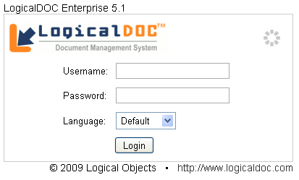Picture 1: Login Form
The form asks for username and password, and an optional language other than the one provided for the user. Simply enter the required information and proceed by pressing the Login button. If the authentication is successful, then you will be taken to the main page; if the login fails you will see an error message and you will be directed to the same form.

Note: Users of the system are responsible to keep their password safe and should change it regularly, i.e. every 6 months. Communication of the password to others undermines the security of the system.

Home Page

Picture 2: Main Page
In the home page there are some controls placed in drop-down boxes:
welcome message, notification of messages from other users (messaging features will be described below), the list of recent documents accessed, the documents downloaded, the tag cloud (which contains the most used tags into the archive).
At the top of the page the navigation menu is placed which lets you access the main areas of the program. You will find the document search-box above the menu.

Document management
Click on Documents, the fourth item in the navigation menu. The central part of the page is now occupied by the documents, which are organized into folders and sub-folders (similar organization in a normal disk of your PC).
Folder navigation is simply done by clicking on the name of the folder in the list of folders on the left side. The user can scroll through the list of documents that are inside the selected folder in 4 possible views:
- Simple: for each document are displayed only the title and the last modified date.
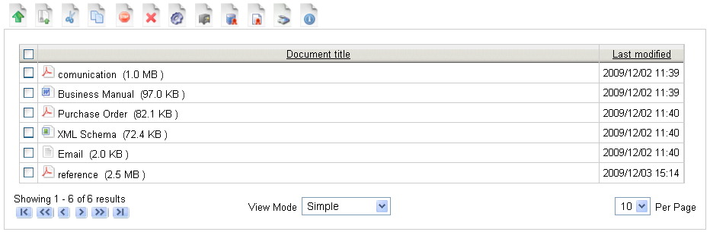Picture 3: Documents and folders (simple)
- Details: for each document are displayed the protocol, the title, the last modified date, the author and size.
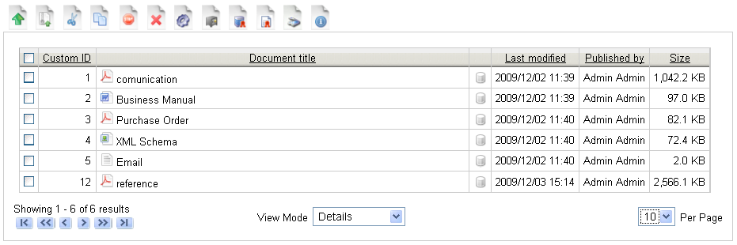Picture 4: Documents and folders (details)
- Medium icons : for each document is displayed an image of medium size.
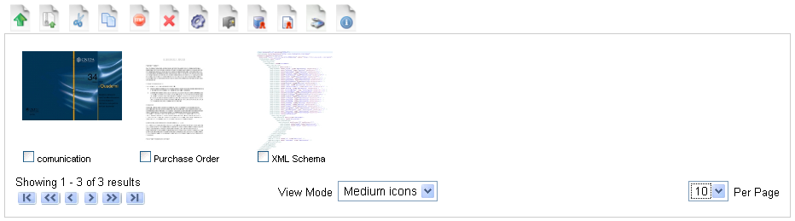Picture 5: Documents and folders (medium icons)
- Large icons : for each document is displayed an image of big size.

Now click on the folder Documents and then on the icon 1.1 (placed on top of the panel containing the list of folders).
Enter "test" as the name of the folder and press the Save button. A message will warn you that a new folder has been created.
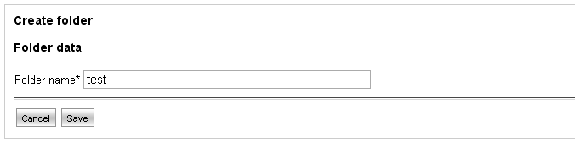Picture 6: Folder creation
You should now see that the new folder has been created. Click on its name in order to enter it. Note that at the top of the main area a so-called ‘breadcrumb’ keeps track of the route of the folder.
Now insert a new document by clicking on the icon 2.1. Initially, you are asked for the file to upload and the language in which the document has been written in.
To upload a file, simply press the Browse button then select a file from your PC and press the Upload button. A progress bar will display the status of the upload process.
The language specification is done through the drop-down list and it is important since it affects the indexing of the documents content. In addition to that, there are two checkboxes available: if the first is checked, LogicalDOC retrieves immediately the tags of the document; if the second is checked, LogicalDOC does the immediate indexing of the document.
Once the document has been uploaded, you can proceed to the next step by selecting the button Next >>>. Some information are extracted, and a form for document editing is displayed for final assessment. At this stage you can change various parameters of the document, but only if you have the editing permission. The page is divided into 3 tabs:
    - General: includes all general information about the document and the most important parameter is Tags, as these can be used later for document searches. Each tag (keyword), in fact, allows classify a document.
    - Source: displays number of fields, including author, source, object and recipient.
    - Template: shows the document template and document custom attributes
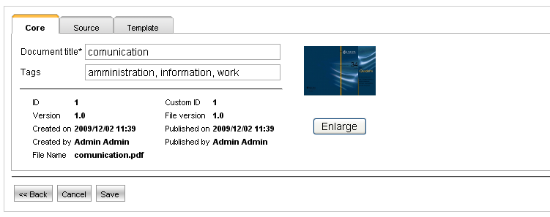Picture 7: Document's editing form
By clicking on Save, the document will be stored and indexed.
Right after the upload, you will be directed to the same folder in which the newly uploaded document is located. You can then download the document by clicking on it.
LogicalDOC will not allow two documents with the same name inside the same folder; for example, if you try to insert a document named "doc" in the "test" folder, and a document named “doc” already exists, the new document will be automatically renamed to "doc(1)".
By right-clicking on the document, a contextual menu will appear. It provides access to major management functions on the single document such as ‘checkout’ or ‘edit’.
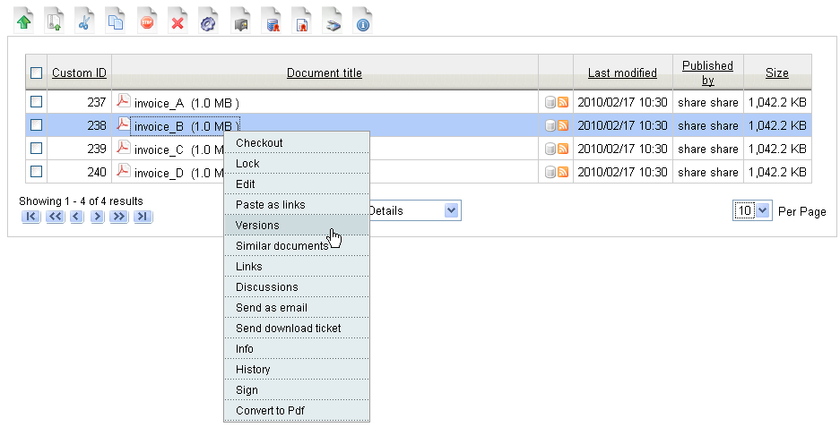Picture 8: Contextual menu

Note: Users should be always very careful when erasing files and folders since the removal of them is not a reversible process and the data will be lost forever. However, in the Enterprise edition, users can recover deleted files.

Document search
In LogicalDOC you can search a document in four different ways:
1. Quick search
2. Advanced search
3. Parametric search
4. Tag search

Quick search
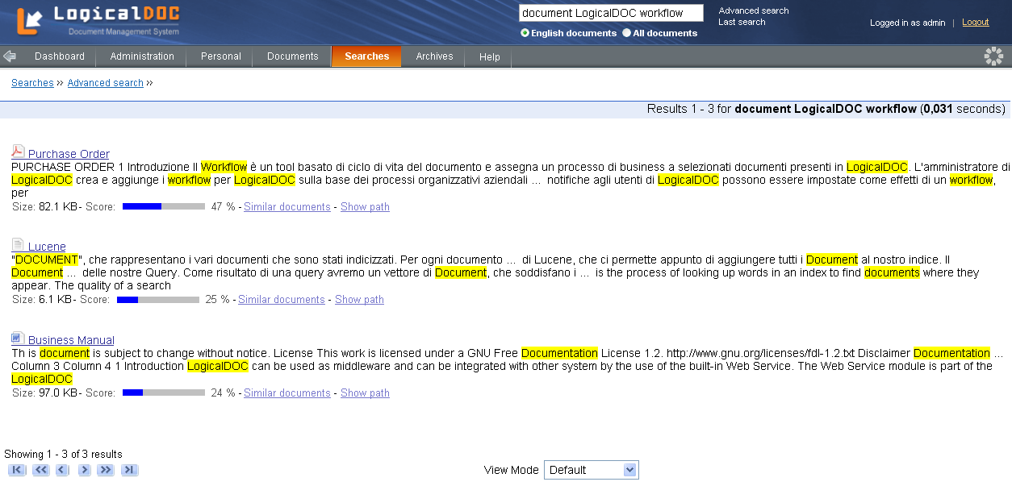Picture 9: Search result
If you remember some words in the text of the document that you have entered, choose one and type it in the search box at top of the page.
By pressing on icon 3.2 system will search for the entered word.
The result is a list of documents sorted by decreasing scores. The score is the relevance of the text with the search words. From this list you should be able to locate the document you looked for.

Advanced search
Picture 10: Quick search
In LogicalDOC, under Searches menu, you can view the advanced search page. This feature allows the user to search for one or more words through different search criteria.
The search is performed on the contents and metadata of indexed documents and only on the checked fields.
In addition, you can restrict your search only to a folder and, eventually, to its subfolders; you can search also among the attributes of a specific template (document type) associated with the searched document.
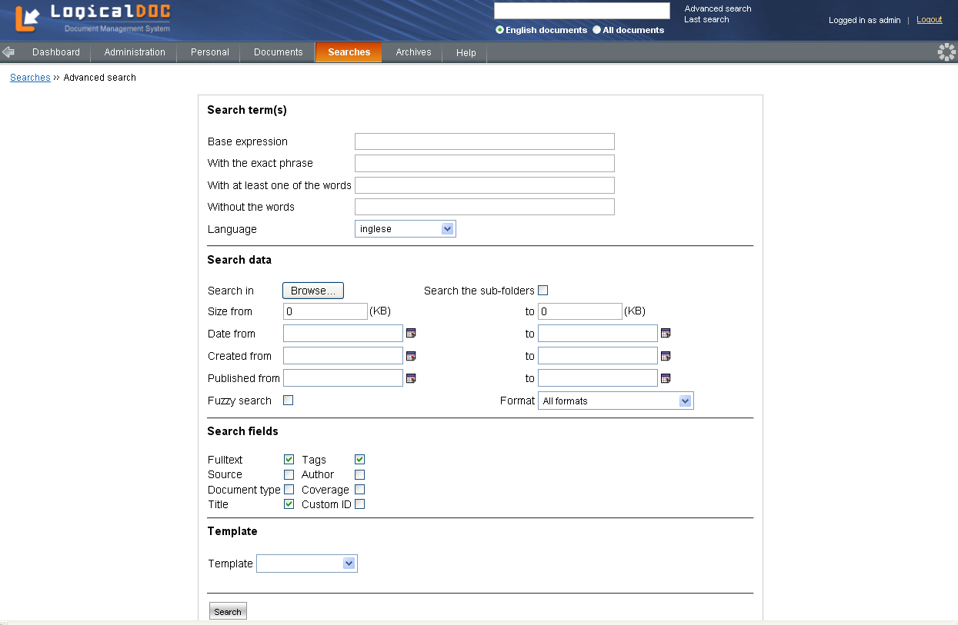Picture 11: Advanced search

Parametric search
In LogicalDOC, under Searches menu you can view the parametric search page. This feature allows the user to search for documents that contain specific values on their metadata. The search is performed only on the metadata of the document and unlike the advanced search, all documents are taken into consideration, including those not already indexed.
First of all, the user can select the template to which must be associated the documents that will be listed by the search.
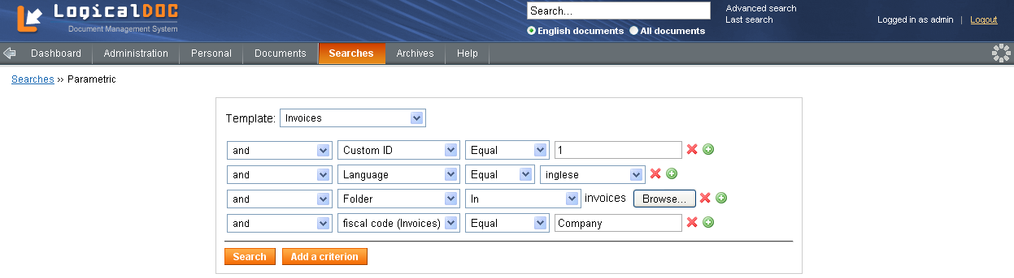Picture 12: Parametric search
To perform a parametric search the user simply adds and remove a search criterion over all the document's metadata. Like a database query, the inserting criteria can be in 'and' or in 'or' with the other ones. The user, in fact, can choose the preferred criteria composition ('and'/'or') through the first scroll menu. In the second scroll menu the user can select the field over will be perform the search. Next, the user can choose the operator (equal, not equal, greater than, lesser than, etc.) and then the field value. In particular, if the user has selected a specific template, all the template's attributes can be selectable into the field scroll menu for another criterion. If the user unselect the template, all its attributes will be no longer on the field list. Similarly to the template field, if the user wants to search all documents with a specific language, the list of all languages will appear in the last scroll menu. Finally, if the user wants to search documents inside a specific folder, he choose the 'Folder' metadata in the field scroll menu and then he select the specific folder clicking on the Browse... button.

Tag search
In LogicalDOC, under Searches menu you can view the tag search page. By selecting a letter, LogicalDOC displays a table with two columns: in the first column there is a list of all the tags that begin with that letter; in the second there is the number of documents associated with that tag. By clicking on a tag, LogicalDOC shows the list of all documents that are associated with that particular tag. Finally, by clicking on icon 3.13, you can view the selected document within its folder.

Folder deletion
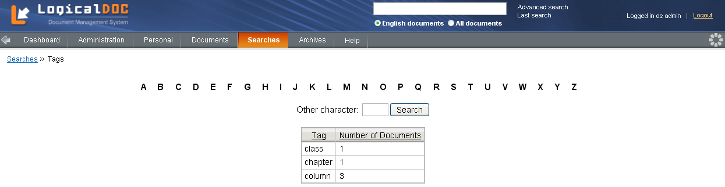Picture 13: Tag search
Let us now become familiar with the operation Delete. You can proceed with the removal of the "test" folder you previously created. A folder can be deleted only if the current user has the deletion permissions on the folder itself, on all its subfolders and on all its documents. Click on the folder "test" and then click on the icon 1.6 which is placed above the folders list.

Program exit
Once the working session is ended, you must click on the Logout link at the right- top area of the page. By pressing on this link, many resources allocated to the current session are released and made available to other users. If you simply close the browser, the session remains open until the end of the timeout, which unnecessarily uses system resources.

Documents
The document management is the main feature of LogicalDOC, it offers all the tools for creating organized archives. In LogicalDOC, metadata (author, creation date, version, custom ID ,...) can be given to better describe the document and also ease the search. By indexing, which can be made upon document-import or through the scheduled task Documents indexing, LogicalDOC is able to pull out content from all documents supported by the application, such as Office, Open Office and Portable Document Format (PDF). Moreover, the Optical Character Recognition (OCR) allows indexing of raster documents, such as TIFF, JPG, PDF.

Note: The OCR feature is included in the Enterprise Edition only. In fact, the Enterprise Edition supports more file formats than the Community Edition; for example, the latest version of Microsoft Office2007 and Autodesk AutoCAD documents are supported only in the Enterprise Edition.

Folders
LogicalDOC places documents into folders. The idea is similar to what is being done in a local hard drive.
Folders are logical collections of documents and are arranged in a hierarchical tree from the Documents folder. Organizing folders in an appropriate and logical manner will enable you to better navigate and find your documents.
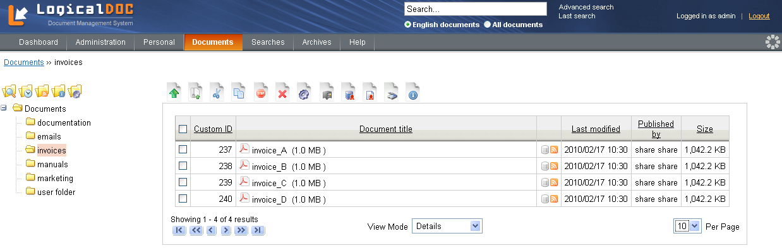Picture 14: A documents folder
In the Administrator -> System -> GUI page the user can choose two different folder representations:
- Simple: folders can be simply navigated through the navigation bar located on the left. There you will see and navigate the folders on which you have visibility.
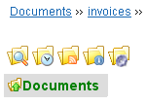
Picture 15: Folders navigation bar
- Tree: folders can be simply navigated through the folder tree model located on the left. This model is very similar to the folders navigation in Windows O.S. and you can visualize the entire folder- tree. This representation is very useful when there are plenty of folders and you want to quickly switch among folders. Selecting one, LogicalDOC displays the documents inside it.
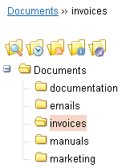
Picture 16: Folders tree model
Notice that, over the folder representation, a so-called breadcrumb (navigation path) is updated as you navigate through the folders and keeps track of your position. You can simply switch between folders using this path.

Folder menu
The user can do different actions for each folder through the folder menu, accessible by right-clicking on the folder name.
Here is the list of the available operations:
1. Search on folder (also through icon 1.1)
2. Folder history (also through icon 1.3)
3. Folder RSS (also through icon 1.4)
4. Create folder
5. Move folder
6. Delete folder
7. Rename folder
8. Bulk export
9. Rights
10. Subscribe folder (also through icon 1.5)
11. Workflow on folder (also through icon 1.6)

Note: The folder menu is viewable only on Tree folder representation. In the Simple folder representation the user cannot operate on folders, he can only see folders and work with the documents inside them.

Search Documents in a Folder
In LogicalDOC you can make an advanced search to look for documents inside a folder also by clicking on the icon 1.1. Then LogicalDOC displays the advanced search page with the search already set on the current folder.
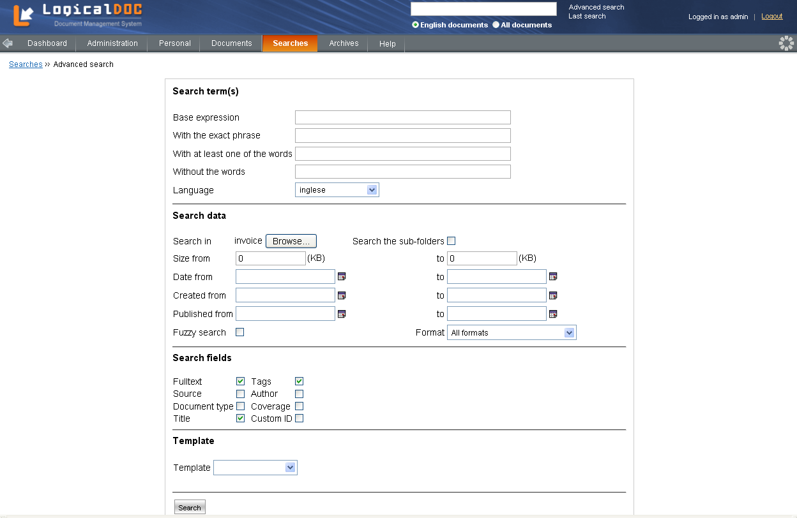Picture 17: Search on documents in a folder

Folder History
In LogicalDOC the user can inspect folder history also by clicking on the icon 1.3. The page lists all the events regarding the current folder, its sub-folders and the documents inside it.

RSS on Folder
In LogicalDOC the user can visualize the feeds RSS associated to the folder also by clicking on the icon 1.4. First time the user tries to access the RSS page, he must provide username and password for the authentication. The page lists, all the events, from the newest to the older one, regarding the current folder, its sub-folders and the documents inside it.
Picture 18: Folder RSS on folder

Folder Creation
In LogicalDOC you can create a new folder. The user has to give a name to the folder and then click the Save button to complete the operation.

Note: The user can also create the folder pressing the 'Enter' keyboard button.

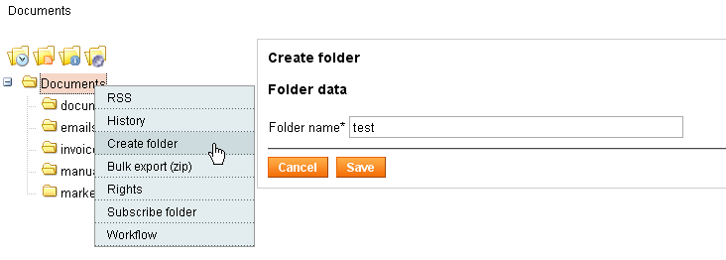Picture 19: Creation of a folder
Note that LogicalDOC does not allow replicated names within the same folder. If you try to insert a folder named "invoice" in the "test" folder, and there already exists a folder named “invoice”, then the new folder will be automatically renamed to "invoice(1)".

Folder Deletion
In LogicalDOC, after a warning message that appears to get your confirmation for deletion, you can delete a folder. However, if the folder contains immutable documents, LogicalDOC doesn't delete the folder, but deletes all documents except immutable ones.

Rename a Folder
In LogicalDOC you can rename a folder. You can change the name of the folder and click the Save button to complete the operation.
Picture 20: Rename a folder

Note: The user can also edit the folder name pressing the 'Enter' keyboard button.

Move a Folder
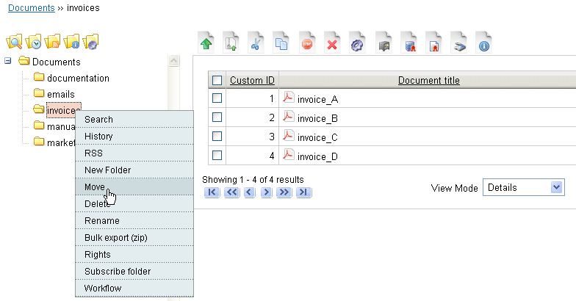Picture 21: Move a folder
In LogicalDOC you can move a folder into another folder by right-clicking on the folder's name and selecting the menu item Move. LogicalDOC displays the operation page in which the user, clicking on Browse... button, can choose the target folder. Then, pressing the Confirm button, the folder is moved into the selected folder.
Picture 22: Select the target folder

Export a Folder in a Zip Archive
In LogicalDOC you can export the content of a folder in a zip format. LogicalDOC displays a window to save the entire content of the folder in a file called ZipExport.zip. This operation can only be done by users that have Bulk Export permission (see “Setting Permissions" paragraph).
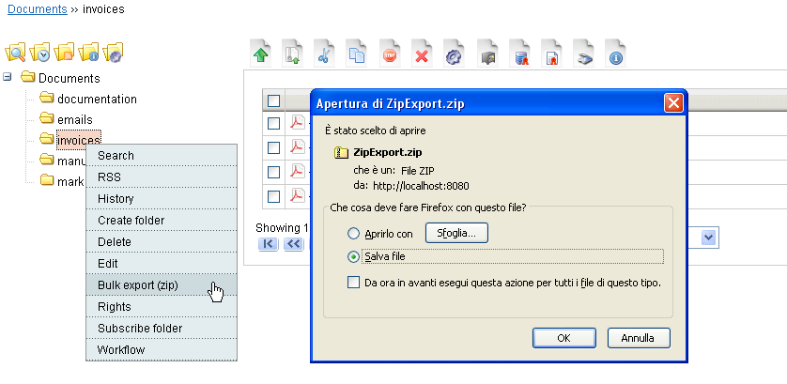Picture 23: Export a folder in a zip archive

Rights setting
You can give permissions on folders to users and groups, which have been created in the system.
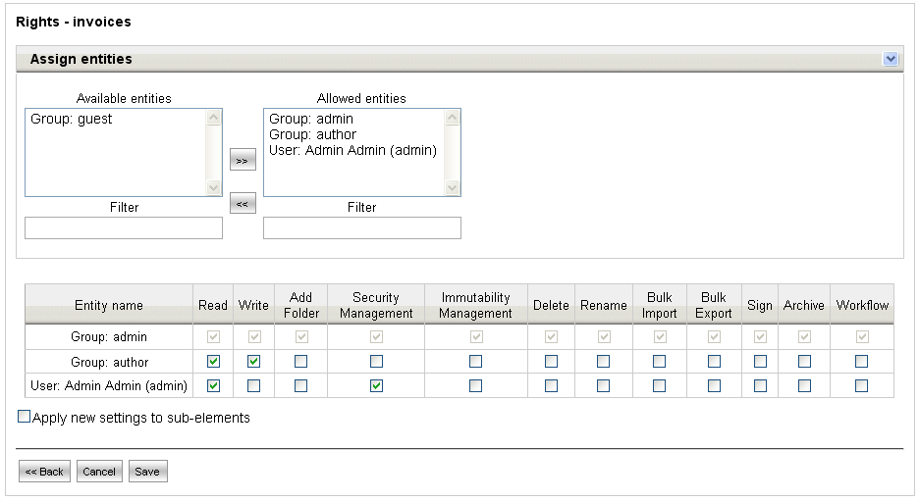Picture 24: Rights setting
The permissions are related to:
• Read
• Write
• Creation of a new folder
• Permissions setting
• Setting a document as immutable
• Deletion
• Editing folder name
• Document import
• Document export
• Sign documents
• Add documents to an existing archive
• Setting workflow operations

The user administrator and the administrator group have all the permissions. By clicking on the bar ‘Assign entities’ you can assign permissions on selected folder to users and groups. Moreover, you can move an entity from the ‘available list’ to the ‘assigned’ list by clicking on >>. By clicking on << you can bring the entity back to the ‘available list’. In order to select multiple entities, hold down the SHIFT key and click on the items you wish to select.

Subscription on Folder
In LogicalDOC the user can subscribe to the selected folder also by clicking on the icon 1.5 and then agreeing to the request of the confirmation message. After that, the user can choose if he wants to be notified of the current folder changes only or also of the direct sub-folders changes. Then the user will be notified by e-mail of any changes by himself and by any LogicalDOC user regarding the selected folders and regarding the documents inside these folders. Accessing the page Personal -> My Subscriptions the user can see the list of all subscriptions.
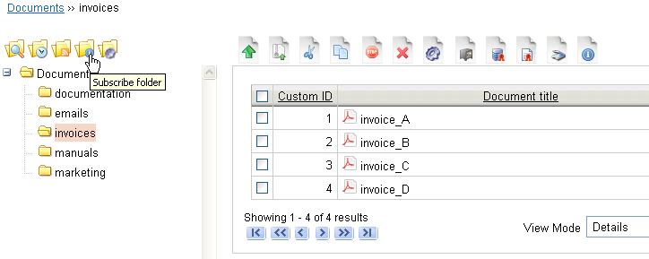Picture 25: Subscription on a folder
Note: All subscriptions are collected at regular intervals by the scheduled task Auditing. The scheduled task Notifier instead at regular intervals sends e-mails to users associated with the subscriptions previously collected. In the Parameters page the user can configure the maximum number of trials to send the notification to a user.

Workflow on folder
In LogicalDOC the user can associate one or more workflows to the selected folder also by clicking on the icon 1.6.
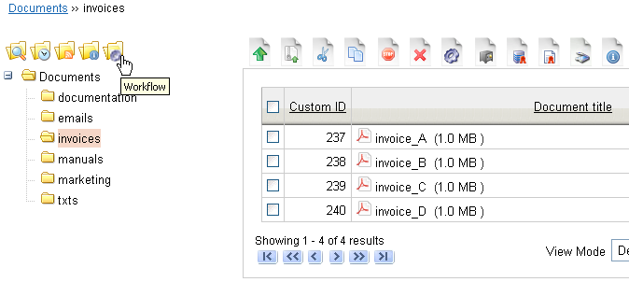Picture 26: Workflow on a folder
LogicalDOC lists all the workflows currently associated to the selected folder. When a user inserts a new document in the selected folder, according to the template of the document, a workflow starts on that document.
Clicking on the icon to the upper left, the user can associate a specific workflow to all the inserting documents that have a specific template. If no template is associated to a workflow, over all the documents without a template or with a template not associated with any workflow, will be started that workflow.
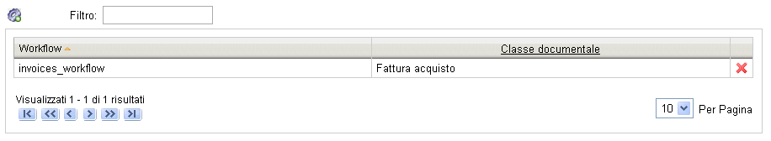Picture 27: Folder Workflows
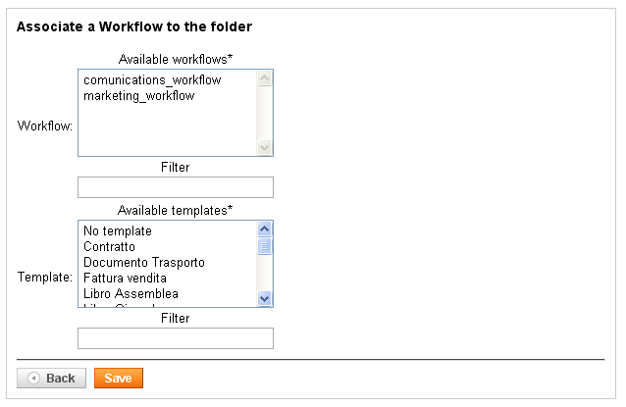Picture 28: Associate workflow on folder

Document creation
To add a new document, the first thing to do is to upload a file by clicking on the icon 2.1.
The upload process requires the specification of the language. In addition, you can request the immediate tags extraction and the indexing of the document. If the document does not specify a title, then the file name itself is used. Pressing button Next>>, opens the importing document info page. This page is divided into two tabs: the first one, Core, allows the user to view and edit all the main informations on the document; the other one, Template, allows the user to associate the document to a template (a drop-down menu lists the templates currently available in LogicalDOC). Pressing the Save button, if no error occurred, the document is inserted within the current folder.
Usually, all invoice documents will be sorted by document title, but you can sort documents according to the fields of the table. In fact, by clicking once on the title of the field you get the ascending order, and by clicking again you get the descending order (upper case and lower case letters are considered different). To describe a document you can define one or more tags, separated by commas. The Tags menu under the menu Searches shows documents grouped by those keywords. You can also create a description of all versions of a document. When you add a document, a version 1.0 is created automatically.
You can also specify certain properties of the document such as Coverage, Language, Source, etc.
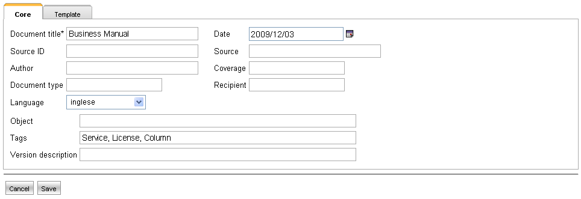Picture 29: Document creation
Important: Usually when a document is inserted, it is not immediately indexed and available for full-text searches. The scheduled task ‘Documents indexing’ scans the documents periodically to make them searchable. You can also force LogicalDOC indexing by checking the box "Immediate indexing" upon uploading a document.

Operations on Document
To access the documents you must select the menu 'Documents'. Next, you will see the tools for navigation and management of the archived documents.
On the left side, the list of all sub-folders of the currently selected folder is displayed. By clicking on a folder, you will see all the documents contained in it in the right panel. Every document is clickable for download.
In some cases you may wish to move a document from one folder to another: in LogicalDOC you can do this by selecting the document and then clicking on icon 2.3. The document will be cut from its location and then you can paste it into the same folder or into another folder by clicking on icon 2.5. Instead, to copy a document and insert it in another folder, the user must click on icon 2.4 and, after he has moved on the destination folder, click on icon 2.5.
If the current user has the immutability permission (see “Setting Permissions” paragraph), he can set a document as immutable. This can be done by selecting the document and clicking on icon 2.6. After specifying the reasons for which you want to do this operation and also after a confirmation message, the document becomes immutable. It cannot be modified or cancelled by anyone anymore.

Import Documents from Zip Archive
In some cases you may want to load an entire folder with documents inside it into the system. This is easy in LogicalDOC. First of all you must create the folder with documents on your PC. Then you must compress the folder using the ZIP format. Finally, the ZIP file must be loaded into LogicalDOC by clicking on icon 2.2. LogicalDOC allows the user to perform a very custom import, because the user can specify the documents language, the document encoding format, the template to which will be associated all documents, apply specific tags to the documents or choose that LogicalDOC must extract the tags from all documents. Then the user select the ZIP archive clicking on 'Browse...' button. A new folder with the same name as the ZIP file will be imported in LogicalDOC. This feature is completely asynchronous, therefore, after launching the import, you may continue to use LogicalDOC without any problems. This operation can only be done by users who have Bulk Import permission (see "Setting permissions" paragraph).
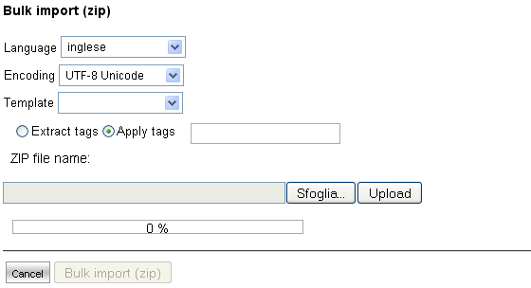Picture 30: Import from zip archive

Start a Workflow
The administrator can start the workflow operations over one or more documents selecting them and then clicking on workflow icon 2.21.
Picture 31: Start a Workflow
After that, LogicalDOC shows a page divided into three tabs:
- Choose a Workflow: the administrator has to select a workflow from the list. The Start Workflow button is disabled, because a workflow is not choosed yet.
- Workflow settings: the administrator can choose the workflow priority (Low, Medium, High) and LogicalDOC shows the workflow description and lists the document associated to the workflow. The Start Workflow button is enabled.
- Workflow Assignment: the administrator can add and remove assignments to the workflow tasks.
Picture 32: Workflow settings
For more details, read the Workflow User Manual.

Insert a document into an export archive
If a user wants to add one or more documents into an export archive (Default or Paper dematerialization), he must select the documents and click on icon 2.11: it opens a page where the user must select an archive from those displayed in the drop-down menu and then click on OK button. After that, LogicalDOC shows the documents list page and, if there aren't errors, it shows a green message with the number of documents added to the selected archive; instead, if one or more documents was already into the archive, it shows an appropriate warning message.

Insert a document into an archive for Paper Dematerialization
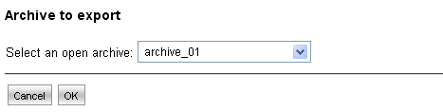Picture 33: Insert into an export archive
If a user wants to add one or more documents into an export archive of Paper Dematerialization type, he must select the documents and click on icon 2.19: it opens a page where the user must select a Paper Dematerialization archive from those displayed in the drop-down menu and then click on OK button. After that, LogicalDOC shows the documents list page and, if there aren't errors, it shows a message reporting the number of documents added to the selected archive; instead, if one or more documents was already into the archive, it shows an appropriate warning message.

Scanning of a document
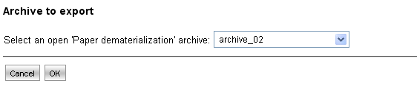Picture 34: Insert into a 'Paper dematerialization' archive
The user can upload into LogicalDOC a scan made by a scanner connected to the computer. By clicking on the icon 2.12, the user visualizes the page to scan a document. The operations to be performed are as follows:
- click the button in the upper left (icon 2.13)
- choose, through the drop-down menu, one of the two scanning options:
      - delete the previous scans, and consider only the following ones
      - append the following scan to those performed previously (recommended if the user wants to create a single document consisting of several scans)
- click OK
- LogicalDOC shows the list of the scanners connected to your computer, so you can choose one and click Select
- now the software, that you usually use to communicate and perform operations with your scanner, starts and you can launch the scan
- LogicalDOC shows the scanned images; you can rotate them through buttons 2.14 and 2.15, and, if you made more that one scanning for a single document, you can scroll through the images with the appropriate buttons 2.16 and 2.17.
- if the scanning is correct, click on button 2.18 to upload the document in LogicalDOC
- choose the document name and its extension (JPG or TIFF).
- if there aren't errors, click on button Next>> and insert the document informations (for example, author, receiver, tags, template) and click on Save button.
- the document is inserted in the current folder and you can see it into the documents list page.
Picture 35: Upload a scanned document

Sign documents
In LogicalDOC the user can sign one or more documents selecting them and then clicking on the icon 2.20. LogicalDOC downloads all the documents files, connects to user's smart-card, and recognizes all the certificates inside it. After that, LogicalDOC visualizes the document sign page: the user chooses the correct certificate among those listed, click on Sign button and enter the PIN of the smart-card. If the PIN is correct, LogicalDOC signs all the documents and displays the result of the operation. If the document is properly signed, you can see the icon 3.14 next to the document in the documents list page (in Details view).

Subscriptions on documents
In LogicalDOC the user can subscribe to one or more documents selecting them, clicking on the icon 2.21 and then agreeing to the request of the confirmation message. After that the user will be notified by e-mail of any changes to the selected documents by himself and by any other LogicalDOC user. Accessing the page Personal -> My Subscriptions the user can see the list of all subscriptions.

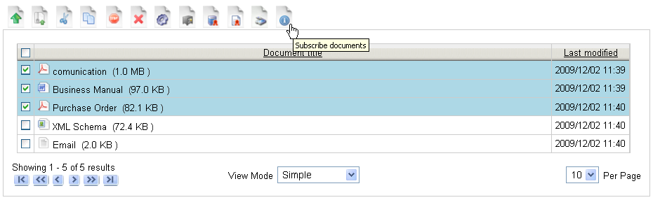Picture 36: Documents subscription
Note: All the subscriptions are collected at regular intervals by the scheduled task Auditing. The scheduled task Notifier instead at regular intervals sends e-mails to users associated with the subscriptions previously collected. In the Parameters page the user can configure the maximum number of trials to send the notification to a user.

Document Shortcut
LogicalDOC allows the administrator to create document shortcuts. Suppose a user A has read and write permissions on the folder F1 and the administrator wants to allow the user to read and/or modify a document in a folder F2 on which the user A has not the read permission. The administrator must copy the document clicking on icon 2.4 and, after he has moved on the folder F1, click on icon 2.23.

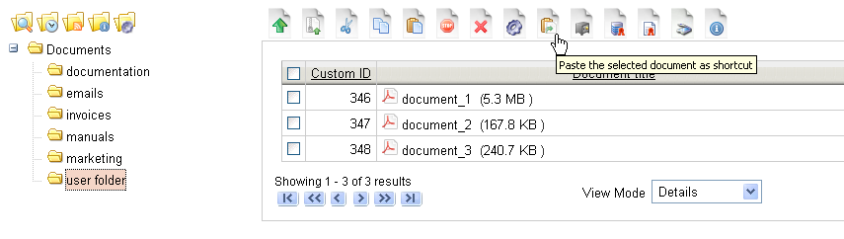Picture 37: Paste as schortcut
Now the user can see the shortcut of the document, on which he can perform all the operations according to the permissions that he has on the folder F1. The operations performed by the user A are carried out directly on the original document placed in the folder F2.

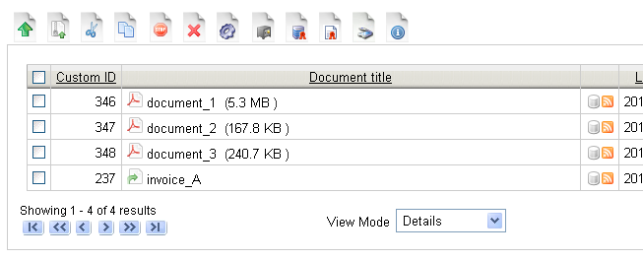Picture 38: Document schortcut

Note: Documents shortcut are identifiable through the icon 2.24. The shortcuts can be searched by all searches available in LogicalDOC.

Contextual menu
You can also use different actions for each document through the contextual menu, accessible by right-clicking on the document.
Here is the list of the available operations:
1. Checkout/Checkin document
2. Lock/Unlock document
3. Edit document
4. Paste as links
5. Versions
6. Similar documents
7. Links
8. Discussions
9. Send as email
10. Send download ticket
11. Info
12. History
13. Sign
14. Convert into Pdf

Checkout/Checkin
LogicalDOC allows you to change the content of a document, which has been imported into the application. You have to select the document by right- clicking on the document's name and then click the contextual menu item Checkout. Then, it appears the message "You have acquired the document. Now you can download to make the changes", click OK, and then you will see the acquisition icon 2.8 next to the document's name.
After downloading and editing of the document, select the document by right-clicking on the document's name and click the contextual menu item Checkin. Then there appears the following screen:

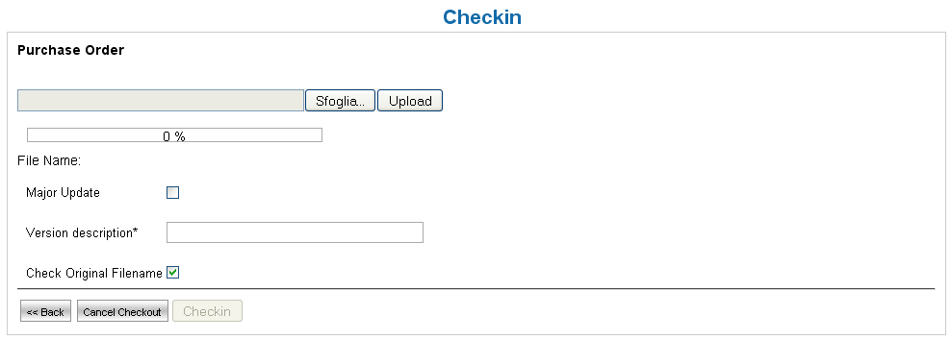Picture 39: Checkin
Now upload the new version of the document by clicking on the Browse... button and selecting the new document. Then click the Upload button. You can choose whether this new document is a major or a minor version by selecting the checkbox Major Update. You must enter a description of the new version and you can ask LogicalDOC to check whether the name of the new version of the document is the same as the previous one by selecting the
checkbox Check Original Filename. Now you can complete the operation by
clicking on the button Checkin.
After the Checkout operation, if the user realizes that he doesn't want to perform the Checkin operation, he can release the document by right-clicking on the document's name and selecting the contextual menu item Unlock.

Lock/Unlock document
If the user wants to avoid that a document may be modified, he must select the document by right-clicking on the document's name and selecting the contextual menu item Lock. If the document is properly locked, you can see the icon 2.9 next to the document in the documents list page (in Details view). Now the document cannot be modified by any user, in fact it is no longer displayed to the user the Edit option in the contextual menu. If a user wants to edit the document, he must select it by right-clicking on the document's name and selecting the contextual menu item Unlock. If the document is properly unlocked, the icon 2.9 is no more next to the document in the documents list page (in Details view).

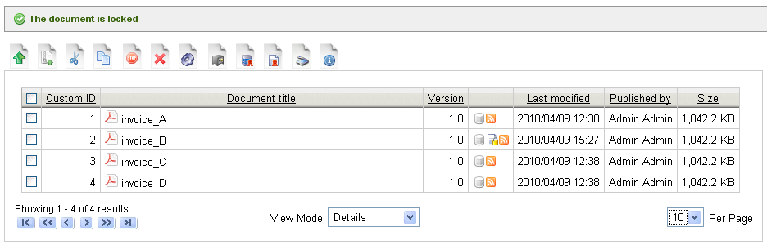Picture 40: Lock a document

Document Editing
The editing page is accessed by right-clicking on the document's name and selecting the contextual menu item Edit. On this page you can edit all properties of a document. The editable properties are: title, tags, the source date, the source ID, the author, the coverage, the type, the recipient, the language, the object and the template (see "Document management" paragraph). To add more tags, you must separate each one with a comma.

Paste as Link
In LogicalDOC you can link documents. If you want to link two documents A and B to a third document C, select A and B and click on icon 2.3 to cut them. Then right-click on document C and select the contextual menu item Paste as links. Now you can see that document C has been linked to documents A and B. The link-icon (icon 2.9) now appears next to the three documents.

Picture 41: Links
Now, by right-clicking on the document's title and clicking the contextual menu item Links, you can see the details of the links you have created.

Picture 42: Links detail

Versions
The user can see the list and the details of all versions of a document by right-clicking on the document's name and selecting the contextual menu item Versions. For each version listed on the page, you can see the user and the event which created the version, the version of the document in LogicalDOC and the version of the document file on the file system, the date and comments. It is also possible to edit a version by entering a comment and, in particular, it is possible to compare two different versions.

Picture 43: Versions
In fact, clicking on Compare, a new page opens where you can see the similarities and differences between the selected version and any other version selectable through the drop-down menu at the top right and which lists all the versions.
Selecting a version on the drop-down menu, LogicalDOC lists, on the left, the current version data and, on the right, the selected version data: the fields and values for which LogicalDOC recognizes any differences are shown in
red.

Picture 44: Compare versions
Note: In the Administration --> System --> Parameters page, setting the value for 'document.maxversions', the user can set the maximum number of versions for each document that must be stored by the LogicalDOC database.

Similar documents
LogicalDOC is able to search documents, which are similar to a selected document. Right-click on the document's name and click the contextual menu item Similar documents. LogicalDOC retrieves the most frequently used words in the document and then makes a full-text search on all documents, which contain those words in the text. On the result page, documents are listed and sorted in descending order according to the frequency of the searched words.

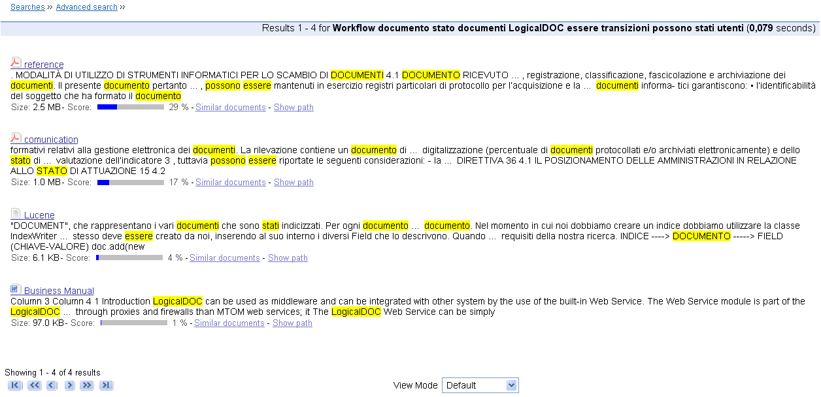Picture 45: Similar documents

Discussion Forum
In LogicalDOC you can create a discussion on a document. Any user can write a comment on a document by selecting it and by right-clicking on the document's name and select the contextual menu item Discussions.

Picture 46: Discussions
You can see at the top of the page the list of previous discussions already initiated on the selected document and on a particular topic; below, instead, you can insert a new discussion by including the topic, the text and by clicking on Start a discussion button. In particular, in the discussions list, the topic is clickable and leads to the details page of the discussion. In this page, at the top, there is the sequence of all comments previously released and related to the selected topic; at the bottom, you can insert a new comment related to the same topic by entering the text and clicking on the Insert a comment button.

Picture 47: Discussion detail

Emailing Document
LogicalDOC allows you to email a document by right-clicking on the document's name and selecting the contextual menu item Send as email.

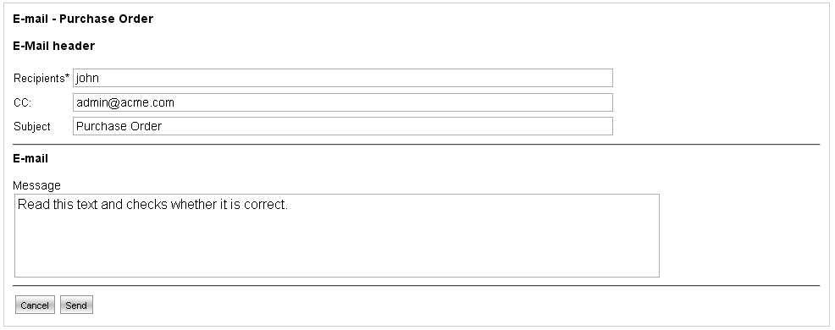Picture 48: Send as email
Then type in the recipient, the subject, the text of the e-mail and click Send. The recipient receives the e-mail with the selected document as attachment.

Attention: in order to use this feature, the SMTP connection needs to be correctly configured by the system administrator.

If the document is too big to be sent, you can use another feature of LogicalDOC; send as download ticket. Right-clicking on the document's name and selecting the contextual menu item Send download ticket. In this case the recipient receives an e-mail without any attachments. The e-mail contains a link, which is the download ticket. Clicking on it, allows the recipient to download the document directly on his PC, without the need to be registered in the LogicalDOC system. In the Recipients field you can enter the email address of one or more receivers separated by a comma.

Attention: for security reasons, the ticket is associated with an expiration time configurable through the global parameter ticket.ttl that you can find on the Parameters page. By default, the ticket is downloadable for 48 hours.

Sign a document
In LogicalDOC you can sign a document by right-clicking on the document's name and selecting the contextual menu item Sign. LogicalDOC downloads the document file, connects to your smart-card, and recognizes the certificates inside it. After that, LogicalDOC visualizes the document sign page: the user chooses the correct certificate among those listed, click on Sign button and enter the PIN of the smart-card. If the PIN is correct, LogicalDOC signs the document and displays the result of the operation. If the document is properly signed, you can see the icon 3.14 next to the document in the documents list page (in Details view).

Convert a document into Pdf format
Picture 49: Sign a document
In LogicalDOC you can convert a odt, doc and docx document into Pdf (Portable Document Format) format by right-clicking on the document's name and selecting the contextual menu item Convert in Pdf. LogicalDOC verify that OpenOffice is properly executed as a service on server port specified into Administration -> System -> Parameters page (pdf.port); if it is not, LogicalDOC visualizes an error message with the request to issue the following command from the command line:

soffice -headless -accept="socket,host=127.0.0.1,port=<port_number>; urp;" -nofirststartwizard

For the correct execution of this command is necessary to move, previously and always in command line, inside the folder program of the OpenOffice folder; for example, typing
cd C:\Program Files\<OpenOffice_folder>\ program.
If the configuration is correct, you can again right-click on the document's name and select the contextual menu item Convert in Pdf: in the next page LogicalDOC visualizes the text message Click here to download the PDF. By clicking on it, you can save the new file in PDF format on your PC.
Picture 50: Convert a document in Pdf format

Personal Data
This section of the manual deals with personal data or information or those functions closely related to the user's profile. The Personal section of the system menu allows you to change your data such as your password etc.

Changing Password
Select the Change password link in Personal section. Fill out the form with the required information and your password will be changed immediately.

For your security, we recommend you to change your password at least once every 90 days. You should keep your password safe and secure and avoid communicating it with others. Otherwise security of your system will be at risk.

Editing Personal Data
The item Edit my data is used to modify your personal data such as name, last name, and so on. A form shows the current value for each user's saved information. Each field is editable for changing and you can confirm all modifications by clicking on the Save button.

Sending and Receiving Messages
LogicalDOC provides a small internal-messaging system that allows users to communicate between each other quickly and without use of e-mail.

Sending a message
In order to send a message, you must know the exact username of the recipient.
Picture 51: Composition of a message

To send a message you must first select the Messages menu and then click on icon 3.1. The edit form is self-explanatory and asks all the necessary information. The field Recipient is mandatory and should be compiled with the username of the user to whom the message is intended.
The field Subject is mandatory and must contain a brief description about the message. The checkbox Confirmation is used to request the system to notify the sender of the message when it is read by the recipient.
At the bottom of the form, a large text field lets you insert the body of the message.

Reading Messages
To read your messages simply select the link Read messages in the home page on the Messages box. This is the brief list of messages received with the specification of subject and sender. Click on the elements to see the complete message.
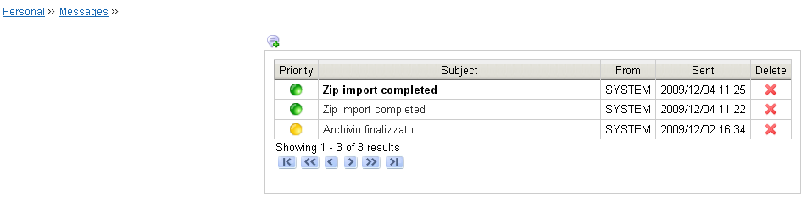Picture 52: Messages list

Note: The messaging system of LogicalDOC is not intended to replace the traditional e-mail, it is a simple tool designed for quick exchange of short and concise messages between the LogicalDOC users. To articulate discussions with many participants, it will be more appropriate to use the traditional e-mail.

My Tasks
In LogicalDOC the user can view all Workflow tasks assigned to him by selecting the menu Personal and then My Tasks.
For more details, read the Workflow User Manual.

My Subscriptions
In LogicalDOC the user can view all his subscription on folders and on document by selecting the menu Personal and then My Subscriptions. The page lists all the subscriptions and for each one shows if it is on folder or on document. Each document can be downloaded. For each subscription LogicalDOC provides also the 'open in folder' feature.

LogicalDOC as a Web Folder
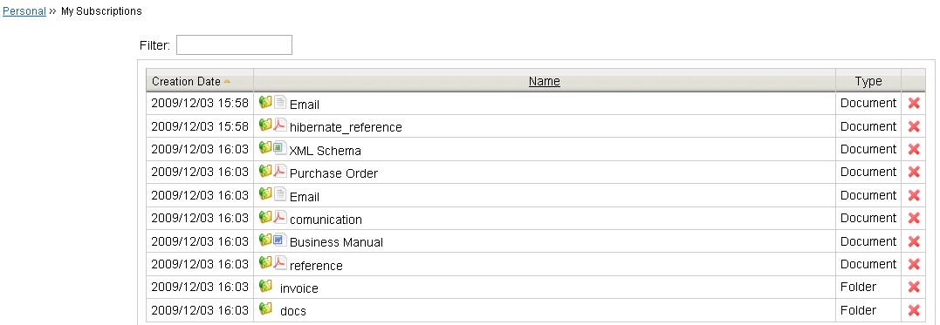Picture 53: 'My Subscriptions' page
It is possible to connect LogicalDOC to a Web Folder on your operating system so you can see, manage, move, copy, save and rename files and folders in LogicalDOC as if they were directly on your personal computer. Below there are the step by step instructions to connect LogicalDOC to a Web folder in Windows and Linux.

Web Folder on Windows
Your Operating System Windows XP or Vista should already have the support for the Web Folder. If not, you must download and install the software update for Web Folders (KB907306) at this link:
http://www.microsoft.com/downloads/details.aspx?displaylang=en&FamilyID=17c36612-632e-4c04-9382-987622ed1d64 .

Now follow these steps :

- Click on start
- Click on My Network Places
- Click on Add a network place

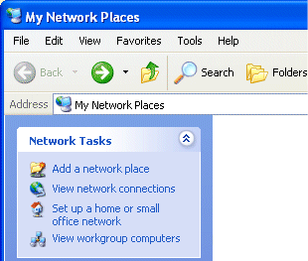Picture 54: Click on "Add a network place"
- Select Next after reading information on wizard.
- The wizard will initially do a brief search for service providers before prompting for which type of network place you wish to add. Choose the default option which says Choose another network location. Specify the address of a Web Site, network location, or FTP site. Once highlighted, choose Next to continue with the wizard.

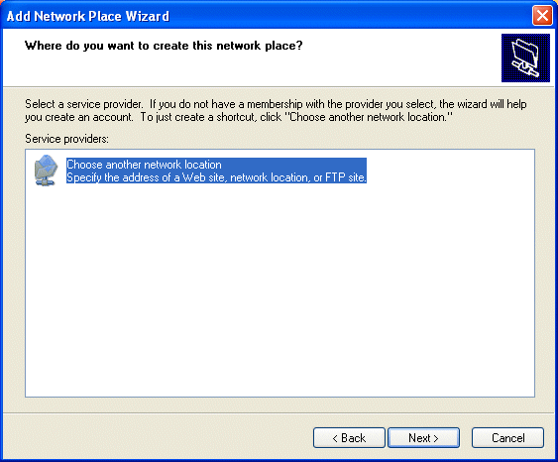Picture 55: Click on "Choose another network location"
- You will be asked to enter the network location. It is: http://localhost:8080/logicaldoc/webdav/store and click on Next.

Picture 56: Enter “http://localhost:8080/logicaldoc/webdav/store”
- You will be prompted for a username and password. Use username and password that you normally use to access LogicalDOC.

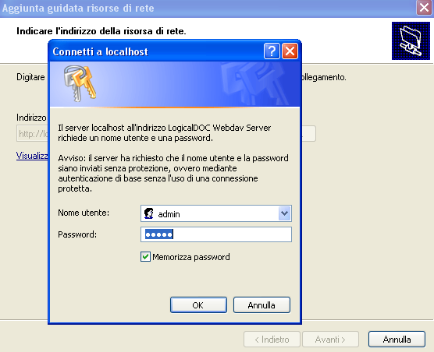Picture 57: Enter your username and password
- You will be prompted to enter a name for the Web Folder. Use LogicalDOC, for example. Then click on Finish.
- The location will be added to your list of Web Folders. Click on the folder and you should be able to see the list of all documents currently included in LogicalDOC.
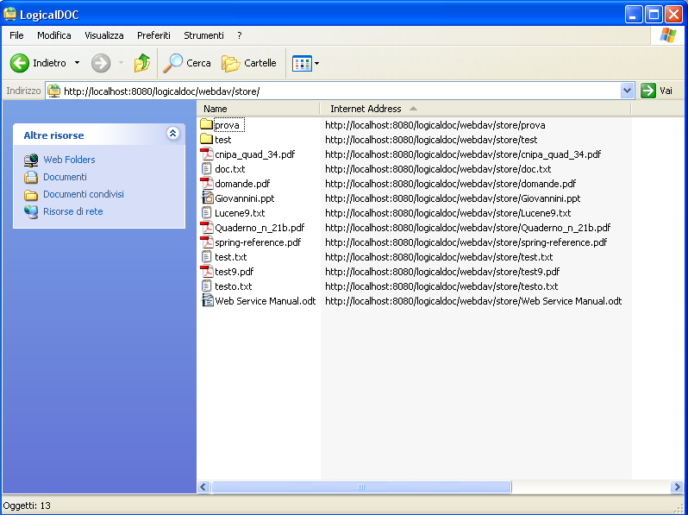Picture 58: List of all documents in LogicalDOC

Web Folder on Linux

Nautilus
This is the easiest way of opening up a WebDAV folder in an Explorer/MAC kind of a view. All you have to do is goto and then provide the below link and press enter.
http://<servername>/dav/<username>/Briefcase
The Briefcase will open up in a new window.

Cadaver
Another great utility is Cadaver, its a simple CLI based tool (that works similar to ftp) for WebDAV. You need install the cadaver package or RPM for this. Then goto the command line and type this:
- cadaver http://<servername>/dav/<username>/Briefcase
- It will prompt you for username and password and after successful login it will then give you the dav prompt
- help command will give you all the commands available at your disposal.

Mount as local folder
This could be one of the most popular way of using WebDAV wherein you can mount the remote folder on a local folder just like any other NFS share. This involves installing a few of the following rpms that provide the functionality for supporting "davfs2" filesystem type. Once these are installed and all dependencies resolved, you can use the following command to mount your briefcase and work as if it is a local folder:

mount -t davfs http://<servername>/dav/<username>/Briefcase /<path to mount>

RPMS to install for your system:
- davfs2-1.2.2-4.el5.rf.i386.rpm
- lwp-1.11-1.i386.rpm
- lwp-devel-1.11-1.i386.rpm
- rvm-1.9-1.i386.rpm
- rvm-devel-1.9-1.i386.rpm
- rvm-tools-1.9-1.i386.rpm
- ncurses-5.5-24.20060715.i386.rpm
- ncurses-devel-5.5-24.20060715.i386.rpm
- rpc2-1.21-1.i386.rpm
- rpc2-devel-1.21-1.i386.rpm
- neon-0.25.5-5.1.i386.rpm
- neon-devel-0.25.5-5.1.i386.rpm

Then "fuse" or "coda" kernel modules or both, you can obtain the latest packages from sourceforge.
- rpmfuse-2.7.3.tgz
- coda-server-6.0.5-1.i386.rpm
- coda-client-6.0.5-1.i386.rpm
- coda-backup-6.0.5-1.i386.rpm

This didn't work on a few of the test systems running RHEL4 U4 & U5 and RHEL5. I am getting down to the cause for this and will update this page as soon as I have any updates.

Ubuntu
To be able to use this on Ubuntu, you have to install the package davfs2. This can easily been done with the command:

apt-get install davfs2
However, you are now able to mount it, but you will not be able to write to the Briefcase. To see how to solve this, go the guide at this link: http://www.howtoforge.com/davfs_ubuntu.

Administration
This chapter will introduce the main functions of administration area. In fact, the administration of LogicalDOC is quite simple and usually it is used primarily to set-up users and groups.
In this new version of LogicalDOC, have been grouped features that relate to the same area in three important sub-menu: System, Client Tools and Security.
Belong to the first group:
- Database maintenance
- Directories
- Last Changes
- Logging
- Search engine
- SMTP
- GUI
- Parameters
- User sessions
- System restart

Belong to the second group:
- Web Service
- Web DAV

Belong to the third group:
- User
- Groups
- Security
- LDAP
- Active Directory

Outside these three groups of features, there are:
- Templates
- Workflow
- E-mail accounts
- Tasks
- Branding
- Localization
- Import folders
- Custom ID

Database maintenance
In LogicalDOC the system administrator can perform maintenance of the database documents by selecting the menu System and then Database maintenance. You can see a page with data regarding the actual size of the documents database, the total number of documents, the size occupied by all the deleted files and the number of deleted files.
Picture 59: Database maintenance
Only the administrators, can use this feature because in LogicalDOC the document deletion is only a logical operation which does not involve a physical cancellation neither from the hard disk nor from the database. The operations that can be done on the documents database are: the physical cancellation of documents and the recovery of logically deleted documents. In the first case, by pressing the Clear Database button, after a warning message, LogicalDOC starts the execution of the task Database Cleaner, which removes physically, and from the database, all the documents previously cancelled only logically. In the second case, by pressing the Restore button, you can recover logically deleted documents: you can see a listing page of all the deleted items. Select the documents you want to restore and press Restore button. These documents will be put back in the same original folder, just like how you retrieve your files from the ‘Trash’ folder on your PC.
Picture 60: Restore deleted documents
Note: We recommend the system administrator to manage the database documents carefully with periodic cleaning, since the logically deleted documents could reach a size that could be too big and it can reduce the disk space.

As mentioned before, there is a scheduled task Database Cleaner that periodically removes all the deleted documents. If you wish to stop this automatic operation, you need to disable the scheduled task in the Tasks list page.

Last Changes
In LogicalDOC the system administrator can retrieve the last events on folders and documents and the last user session activities by accessing the LogicalDOC page Administration -> System -> Last Changes. On this page the user can perform a search to enlist the activities performed on the defined date range and regarding a specific and exact:
- Username
- Session ID
- Event
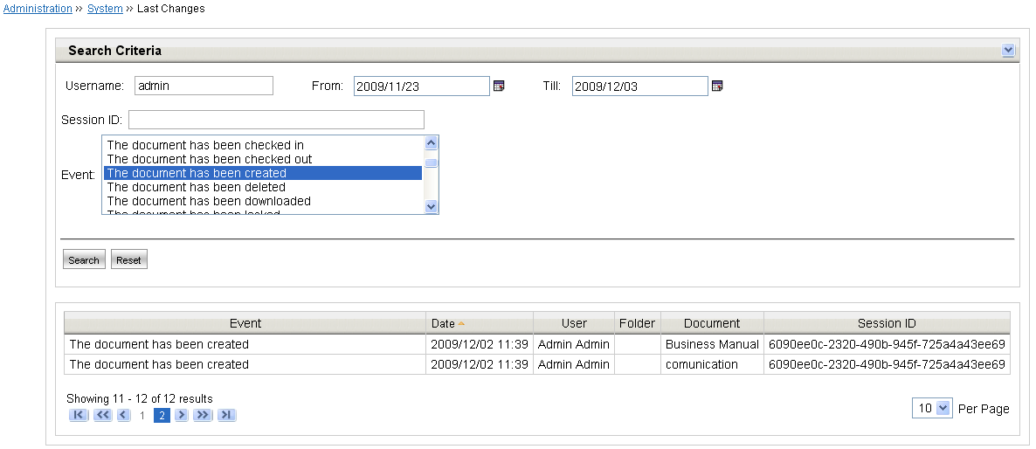Picture 61: Last Changes

SMTP
The user can configure the outgoing mail server parameters accessing the LogicalDOC page Administration -> System -> SMTP. The user, in fact, can set:
- the host or name server
- the default port
- Username
- Password
- the connection security (none, TLS or SSL)
- the secure authentication
- the email sender

GUI
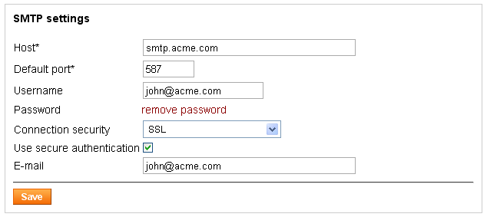Picture 62: SMTP
The user can configure the LogicalDOC graphical interface accessing the LogicalDOC page Administration -> System -> GUI. The user, in fact, can choose:
- the home page displayed after the user login
- the default visualization for documents list page
- the default visualization for documents list after a documents search
- the icon size, quality and scaling when the user chooses the icons visualization for the documents list page
- the number of documents in a single document list page
- the folder representation
- the tag cloud view

Parameters
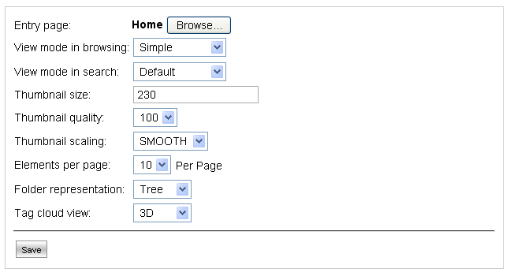Picture 63: GUI
Another system configuration page is Administration -> System -> Parameters. The user can specify:
- the users that must be notificated when a new user is created
- the maximum number of version on a document
- the document start version number
- the time to live of the user history entry
- JDBC settings
- the maximum number of trials to send a notification to a user
- OCR resolution threshold
- OCR text threshold
- server port number on which is listening the Open Office service for the converting document into Pdf format feature
- minutes after which the session times out
- the minimum and maximum tag size
- maximum number of tags into the tag cloud
- download ticket time to live
- workflow handlers definitions
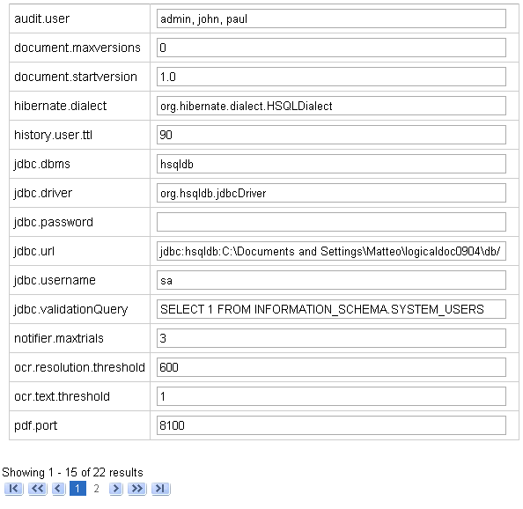Picture 64: Parameters

User sessions
Each user that belongs to the administrator group can visualize the list of all users that are currently working or have been recently worked on LogicalDOC. The system configuration page Administration -> System -> User sessions, in fact, shows the last 50 user sessions. After the authentication, when a user enter in LogicalDOC, the application assigns to the user a unique identifier. In this way the user can always be tracked. This page lists all the user identifiers, the session status (opened or closed), the username, the session creation time, the last session restoration time. Finally, for security and administration reasons, the administrator can kill other opened sessions.

System restart
Picture 65: User sessions
The last system configuration page is Administration -> System -> System restart. By this feature the user administrator can stop and restart the LogicalDOC application. After pressing the System restart button, the user have to manually point the browser to the login page and perform the login again.
Note: Not all the systems make available this feature.

Web Service
Picture 66: System restart
The page Administration -> Client Tools -> Web Service shows all the information regarding the LogicalDOC Web Service feature. The user can visualize the URL on which the Web Service have been installed. Moreover, clicking on the Web Service Descriptor URL, the user can visualize the Web Service WSDL. Finally, through the Status checkbox, the user can enable or disable the Web Service.

WebDAV
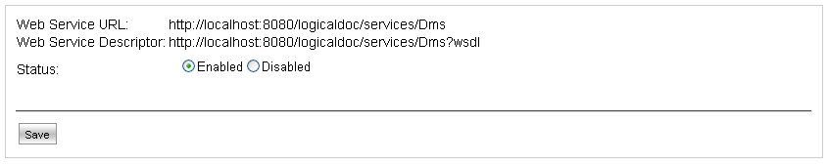Picture 67: Web Service
As explained in chapter 5, using the WebDAV, the user can see, manage, move, copy, save and rename files and folders in LogicalDOC as if they were directly on your personal computer.
The page Administration -> Client Tools -> WebDAV allows the user to manage the LogicalDOC WebDAV feature. The user, through the Status checkbox, can enable or disable the functionality, and he can visualize the URL on which the WebDAV have been installed.
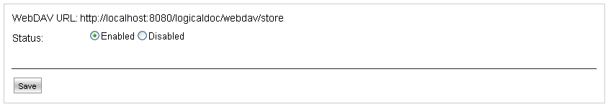Picture 68: WebDAV

Users
By accessing the ‘Administration’ using the menu, you can click on the management of users (sub-menu 'User').
Once you click the User menu, the list of currently existing users is displayed.
LogicalDOC allows you to search and filter a specific user through the
Username text box; It displays the users who contain your typed letters in their names.

Creating a New User
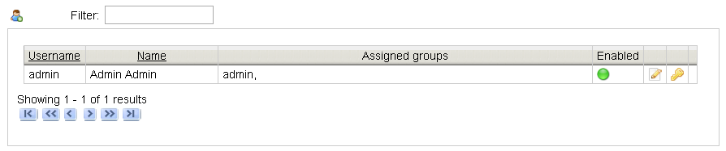Picture 69: Users administration
By selecting the icon 3.3 in the upper left of the first user (on user page), you will see the new user insertion form.
Some data are required and in particular:
1. Username
2. First Name
3. Last Name
4. Language
5. E-mail
6. Groups

Each user can belong to one or more groups, the security policies are always expressed in relation to the groups and never to individual users. If you want to assign a user to a group, you have to move the group from the ‘available’ list to the ‘assigned’ list by clicking the >> button. If you want to bring back a group to the ‘available’ list click on << button. To select multiple groups hold down the SHIFT key and select your groups.
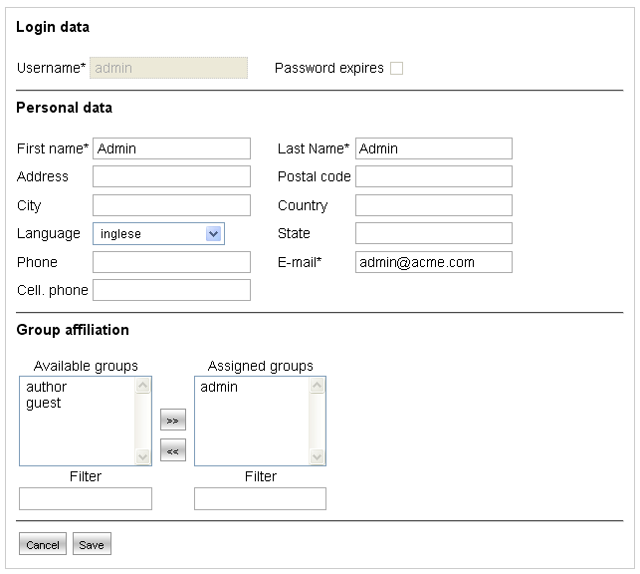Picture 70: New user creation
Note: In LogicalDOC, into Administration -> Security -> Security page (tab Notifications), the administrator can define the users that must be notified when a new user has been created.

There is also the Password expires checkbox that allows to assign a time to live to the user password. After the validation days, when the user tries to access to the system by clicking on Login button, a page appears with the following warning text Your password expired, insert a new one using the form below. The user must type his old password and then type a new password; if the old password entered is correct and the new one has a correct size, then the user can log in into LogicalDOC with the new password.
By default, the password validity time is 90 days, but this configuration parameter value can be modified in Administration -> Security -> Security. In these page you can modify also the password minimum length.
Picture 71: Set a new password
When you click the Save button (assuming all the required information have been correctly entered), a new user is created and added to the database.
Then he receives a welcome e-mail from LogicalDOC containing the username and password created by the system. This password can be changed by the user through the Change Password page (menu Personal Data) and by the Administrator clicking on the icon to 3.4 in the users list page.

Note: The security model implemented by LogicalDOC allows you to express security policies about the visibility and editing. These security policies are expressed in relation to groups and users, so each user inherits the access privileges assigned to all groups he belongs to.

Editing a User
There are three icons next to each user in the users-list by which you can edit user informations, change password or delete him from the system.
By clicking on icon 3.5 LogicalDOC displays the same form for user creation. the only difference is that in this case the form is shown for editing instead of creation.
The icon 3.4 is used to change the password of the user.
Of course, clicking on icon 3.6 leads to deletion of the user.

Groups
By accessing the ‘Administration’ menu, you can click on the management of the groups. As usual, group administration starts from the list of currently existing groups.
LogicalDOC allows you to search and filter a specific group through the
Group Name text box (same as User search).

Creation of a New Group
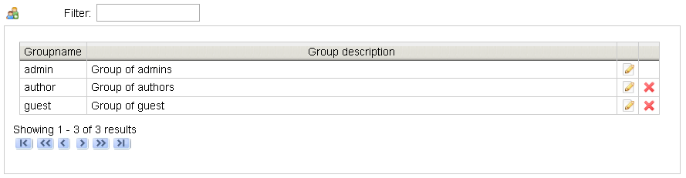Picture 72: Groups Administration
By clicking on icon 3.7 you can create a new group by filling out the form and confirming with the Save button. It is sufficient to specify a name, a description and a parent group. The new group will inherit all the permissions already assigned to the parent group.
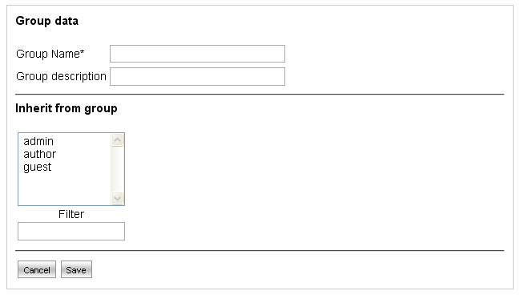Picture 73: New Group's creation

Editing an Existing Group
You can edit your groups using the icon 3.5 in the groups-list.
LogicalDOC allows the user administrator to specify what fields in the edit/insert page can be edited or viewed. You can set preferences on these fields in both upload phase and document-edit:

1. Hidden: the field does not appear to users belonging to the group.
2. Read only: the value of the field cannot be changed by users
belonging to the group.
3. Mandatory: the field must be valued to correctly complete the
saving procedure.

In particular, the Protocol field, by default, is set to read only in both upload and edit pages.

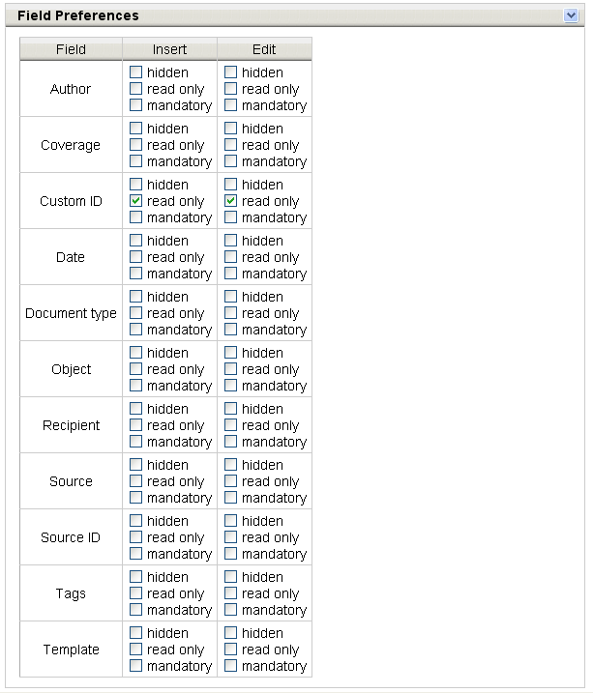Picture 74: Setting preferences on document fields
Note: In LogicalDOC the group is a structural element that is used to assign access privileges. Use groups for the purpose of facilitating the configuration of privileges and not to carry out simple groupings of users. Out of the box there are three groups: admin, author and guest. Introduce new groups only when it is truly necessary.

Security
In LogicalDOC, through the page Administration -> Security -> Security, you can define security policies on menus, passwords and notifications. This page is divided into three tabs. In the first one, Menu, you can determine which entities (users and groups) can see a menu. By clicking the Browse... button, you can see a window that shows all the menus in LogicalDOC. After selecting a menu, press OK then you can see the entities which can see this menu. You can move an entity from the list of those available to the list of those assigned using the >> button. If you want to bring back an entity to the ‘available’ list click the << button. If you want to select multiple entities, hold down the SHIFT key and select your items.
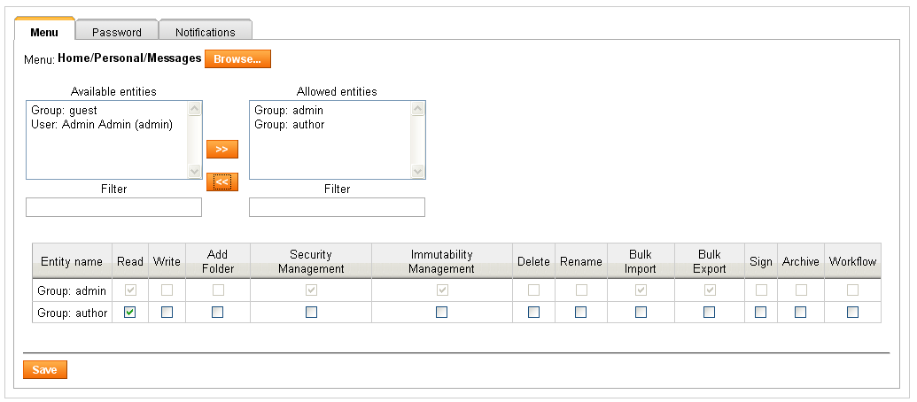Picture 75: Security policies on menus
In the Password tab you can set the minimum password length and its validity time (time to live) in days.
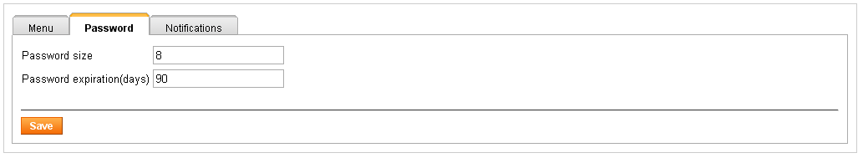Picture 76: Security policies on passwords
In the Notifications tab you can set the name of the users that must be notificated when a new user is created on LogicalDOC.
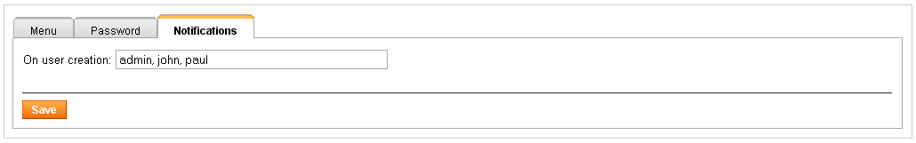Picture 77: Security policies on notifications

LDAP
LogicalDOC is able to handle user authentication interacting with external systems in addition to the standard authentication described above (paragraph Users). In fact LogicalDOC can interact both with an Active Directory system and an LDAP in the same time.
In the page Administration -> Security -> LDAP, you can enable or disable the functionality, set if the implementation must be 'basic' or 'md5' and configure the connection parameters to access into an external authentication system through the LDAP protocol, including:
- URL (including port number in which is listening the authentication system)
- Username
- Password
- Domain name
- DN, where you can define the OU where users are located, for
example OU = Users, DC = domain, DC = dom
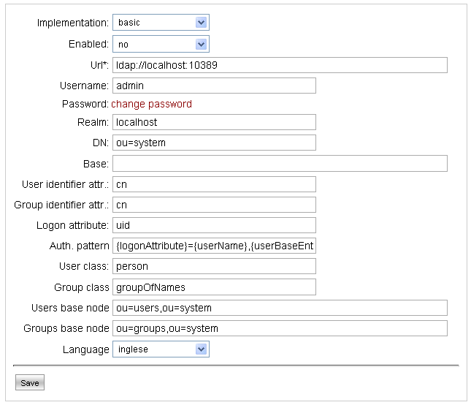Picture 78: LDAP settings

Active Directory
Like in LDAP configuration page, in the page Administration -> Security -> Active Directory, you can enable or disable the functionality, set if the implementation must be basic or md5 and configure the connection parameters to access into the external authentication system, including:
- Domain
- Host
- Port
- Username
- Password
- Users and Groups base node
- Language
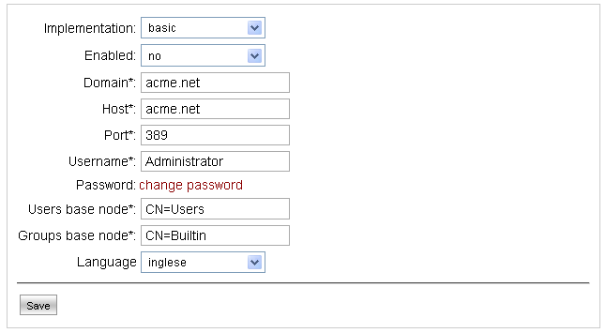Picture 79: Active Directory settings

Template
In LogicalDOC you can define document types, also called templates. Each of them has a name, a description, and one or more attributes. When you upload or edit a document, you can assign to it a template and specify the values for its attributes. For each attribute, the user can specify the name, if it mandatory or not, and the data type (String, Integer, Decimal, Date). In LogicalDOC EE there is an email template with three attributes: from to define the sender, to for the recipient and subject for the subject of the e-mail. Moreover, there are also all the templates useful to create and validate a 'Paper dematerialization' archive. For each of these template, all the mandatory attributes have been already set by default.
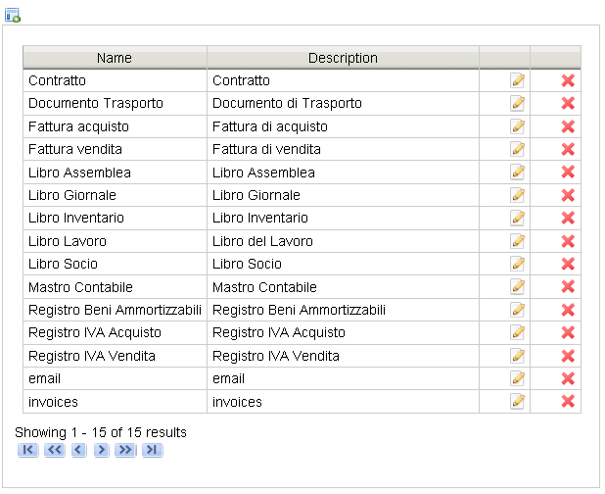Picture 80: Template
Click on icon 3.8 to add a new template:
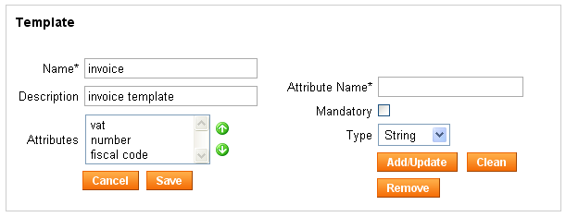
Picture 81: Creatiion of a new template
Each template has a name, a description and one or more attributes. Each attribute has a name, can be mandatory or not, has a type (String, Integer, Decimal, Date) and can be added to the template simply with the Add/Update button. Only when creating a template the user can remove an attribute. During the editing operation the template name and the attributes names and types cannot be modified. The user can assign to an attribute an higher or lower position in the list simply through the arrows viewable on the right.

Workflow
The LogicalDOC administrator can create and configure a new workflow template accessing to the page Administration -> Workflow.
The LogicalDOC feature Workflow is a document life-cycle tool that assigns a business process to selected documents. The LogicalDOC administrator creates and adds workflows based on your organizational business processes. Any LogicalDOC user may be involved in a workflow on a document. Some documents, such as the purchase order, may have complex workflows that involve several people inside your organization.
The workflow consists of Tasks and Transitions, that a document must pass through before the workflow can be considered completed.
- Task: can be defined as a stage in a document’s life- cycle, such a billed, or draft. Each workflow has a starting task, which is the initial task for any document in a workflow.
- Transition: defines how documents move between tasks in the workflow. Transitions are actions that move a document to the next task.
For more details, read the Workflow User Manual.
Picture 82: Workflow

E-Mail accounts
LogicalDOC can store e-mails and their attachments by downloading them from remote e-mail accounts. You can configure a number of e-mail accounts and ensure that they will be regularly inspected by the system search for new posts to be included in as documents.

Account Configuration
Go to the section E-Mails. In this section, by selecting the sub-menu E-Mail accounts you can see the currently existing accounts.
Picture 83: E-mail accounts

In order to create a new account click on icon 3.9:
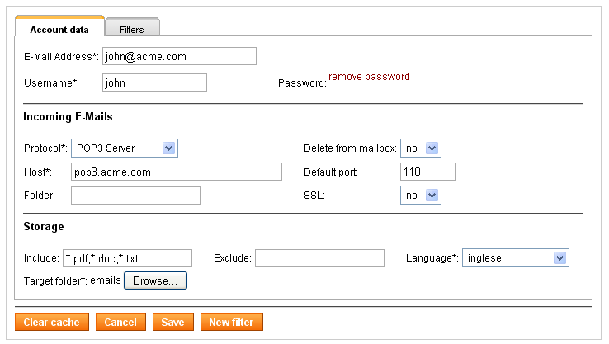Picture 84: E-mail account editing
The edit form is divided into two tabs: Account data e Filters. The first one
allows you to set the normal parameters required for connecting to a POP3 e-mail box. In particular, in the case of IMAP server is possible to specify the folder from which will be retrieved the e-mails. The section Storage collects all information required for processing messages in relation to the documents archive and in particular:
1. Include contains a comma-separated list of extensions, defining the only types of attachment that can be downloaded
2. Exclude contains a comma-separated list of extensions, defining the types of attachment that cannot be downloaded
3. Languages sets the language in which downloaded content will be
analysed by the parser
4. Target folder is the folder where the message and its attachment will
be saved as documents.

The second tab allows you to set one or more e-mail filters. So the user can specify a folder inside LogicalDOC in which will be stored all the e-mails that match the filter.
Picture 85: E-mail filters
The new messages, which arrive in your in-box, will be downloaded and stored as documents in the folder. The same treatment is reserved for the attachments, but they will be stored as documents links to the main document containing the body of the mail message. So if you right-click on the document's name and click the contextual menu item Links, you can see the attachments. By clicking on the Clear cache button, LogicalDOC cleans up its list of downloaded messages and you can re-download all the e-mails in the mailbox through the scheduled task Email Download.

Note: Only active mailboxes will be inspected at regular intervals by the scheduled task Email Download.

Scheduled Tasks
In LogicalDOC there are processes which are performed during normal execution of the program without the intervention of a user. These processes are scheduled tasks since you can schedule their execution.
The section Tasks allows you to schedule the execution of these processes.

List of Scheduled Tasks
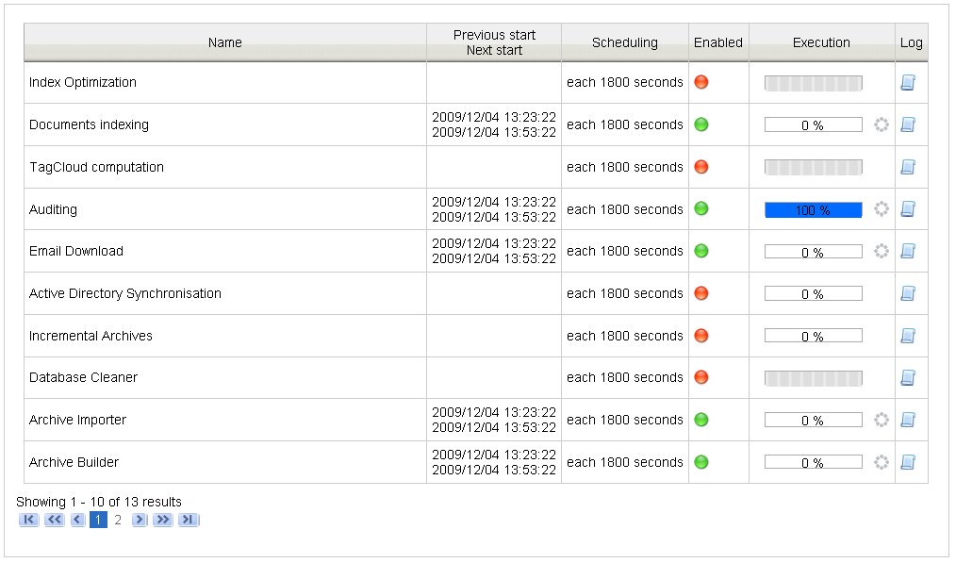Picture 86: Tasks list
The list of scheduled tasks shows all transactions recorded in the system and each of them show:
● Name of the task
● Last moment of execution
● Moment of the next execution
● Indication of scheduling policy (clickable for editing)
● Enabled/disabled flag (clickable to change)
● Progress indicator (clickable for execution)
● Link to access the specific operation log

Each scheduled task can be enabled or disabled. The task can be performed only if it is enabled.

Scheduling
Although the scheduled tasks can be launched whenever you wish, but as the name suggests, they are generally performed on a time schedule.
You can plan the execution of the task by clicking on the link column Scheduling.
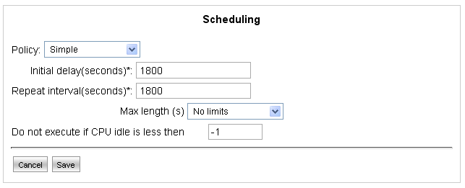Picture 87: Scheduling form
The user can choose the simple or advanced policy. In the second one the execution planning is done by the specification of 6 fields (as in the Unix cron command) listed below:

Field name | Allowed values | Special symbols
Seconds | 0-59 | , - * /
Minutes | 0-59 | , - * /
Hours | 0-23 | , - * /
Day of month | 1-31 | , - * ? / L W
Month | 1-12 | , - * /
Day of week | 1-7 (1=sunday) | , - * ? / L #

Special configurable characters take the following meanings. The character '?' is allowed on the day of the month and day of the week. It is used to define any specific day.

The character '*' is used to specify all the values. For example '*' in the minutes indicates "every minute".
The character ',' is used to specify additional values. For example 2,4,6 on the
day of the week indicates "the day Monday, Wednesday and Friday."

The character '/' is used to specify increments. For example'0/15' in the second indicates "the second 0, 15, 30 and 45" and "5/15" in the same field shows "the second 5, 20, 35 and 50".

The 'L' is allowed for the day of the month and day of the week. This character has a different meaning for the two fields. On the day of the month indicates the last day of the month (January 31, February 28 ...). When used in the days of the week, it indicates the last day of the month xx such as "6L" means "the last Friday of the month."

The 'W' is allowed for the day of the week. It is used to specify the working day(Monday, Friday) closer to the specified day. For example, if you specify "15W" as a day of the month means "the working day closest to 15th of the month." So if 15th is Saturday, it will take Friday the 15th. If the 15th is Sunday, then it will take Monday 16th. If the 15th is Tuesday, it will take Tuesday 15th. The characters' L' and 'W' may be combined in the days of the month and indicate the last working day of the month.

The character '#' is allowed for the day of the week. This character is used to specify the "#th day of the month." For example, the value "6#3" indicates the 3rd Friday of the month.
In addition to the descriptive parameters of scheduling, you can set the specific maximum duration of processing. If this is specified, the procedure will
be automatically stopped after the configured time.

Progress Status and Log
If a task is running you can see it in column Execution and the progression bar will be updated constantly showing the percentage of progress. At the side of this bar, an animated icon indicates that the process is running. This icon is clickable and allows you to stop the execution.
When the task is not running, the same icon appears motionless and by clicking on it you can start the execution.
Each task has also a related log file that can be inspected by clicking on the link Log. This log details how the activity proceeds.

Note: Not all tasks are able to provide the stage of processing. In such cases, the progression bar does not indicate the progression rate and remains undetermined.

Branding
LogicalDOC allows you to modify the layout of the application including for example, the images, css styles and the title. Press the Browse... button and select your branding package in a ZIP extension file and then upload the file. If the operation is successful, in addition to the default package, you will see and select your branding package in the drop-down menu.
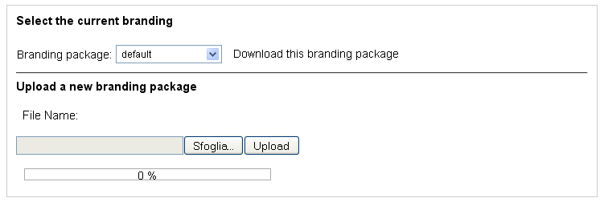Picture 88: Branding
You can change the current branding package simply by selecting it from drop-down menu. By clicking on Download this branding package, you can download the current branding package in a ZIP extension file and use it as a model to produce a change.

Localization
Periodically the LogicalDOC Team releases some localization update packages. In Administration -> Localization page the user can upload one of this package. After the upload process, the user have to press the Load button. LogicalDOC loads the package and, after restarting the system, the user can view all the LogicalDOC labels perfectly updated.

Import folders
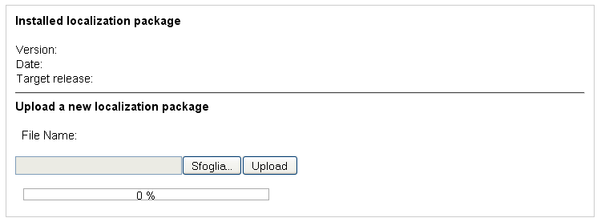Picture 89: Localization
By installing LogicalDOC over a network made up by other computers which share folders, you can automatically import all remote documents. This feature works with all standard Windows shares and with all shares handled by SAMBA servers that you can configure on UNIX / Linux. You can also import automatically all the documents that are into local folders of your PC.
From the administration, select Import folders. In this section you can see the currently configured remote and local folders. On the top left there are two icons: the first one 3.12 lets you import documents from a remote folder, the second one allows you to import documents from a local folder on the server / computer that hosts LogicalDOC. The setup and editing pages for both folder types are identical, but to import documents from local folder you don't have to provide any username and password. The user can also enable, disable or delete each folder. Moreover, clicking on button 'test', it also possible to verify if the configured folder is still existing and it is reachable by LogicalDOC.
Picture 90: Remote and local folders list

Configuring Remote folders

Each element contains the address of the remote folder and some controls used to edit the data.
You can edit all the information by clicking on the icon 3.5; By clicking on the icon 3.10 you can change the status in enabled/disabled; obviously by clicking on the icon 3.6 you can cancel the share. On the top left there is the icon 3.12 to insert new folders, by clicking on this icon the insertion/editing form is shown.

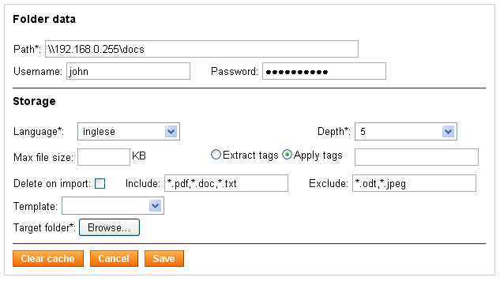Picture 91: Shared folder editing
The upper part of the form lets you enter your connection data of the folder and in particular:
● Location on the remote computer
● Username (optional)
● Password (optional)

The remote location is the folder that is shared on the remote computer. You can copy and paste the path displayed in the Windows Explorer.
The picture shows an example configuration of the remote folder \\192.168.0.225\docs.
If the remote folder is protected, you can also set username and password for authentication.
The bottom part of the form allows you to set the information for the storage of
documents:
● Language in which documents will be imported
● Depth level
● Maximum file size
● Extraction of keywords from documents
● Documents deletion during import
● Allowed extensions (comma-separated list)
● Not Allowed extensions (comma-separated list)
● Template of the imported documents
● Folder of the documents archive in which to save documents

Once the settings are saved, the remote folder and all its sub-folders up to the specified level of depth, will be explored searching for documents at regular intervals. Only documents with allowed extension will be indexed and included in the target folder.
It is important to consider the fact that all sub-folders of the remote folder will be replicated also in the LogicalDOC archive.
By clicking on the Clear cache button, LogicalDOC retrieves again all the documents in the remote folder.

Note: The active remote and local folders only will be inspected at regular intervals by the scheduled task Folders Import .

Custom ID
LogicalDOC allows you to set a custom ID with a configurable schema on a document. In the Custom ID menu pages you can define the schema that will be associated to a template. In particular, by default, in LogicalDOC the default template has the schema <id>; whereas the email template has an empty schema.
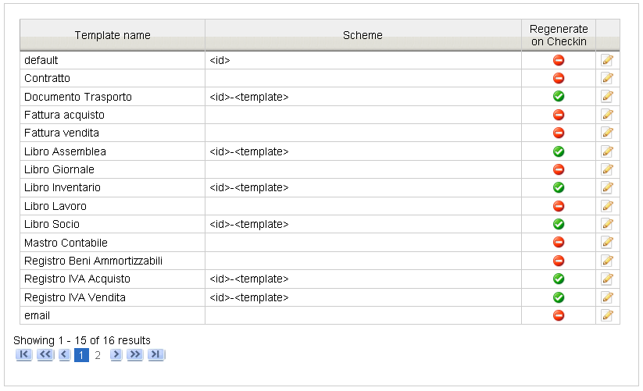Picture 92: Custom ID
By clicking on the icon is 3.5 you can see the schema edit page. There is an explanation of the tokens that can be used to compose the schema. Using the checkbox Regenerate on Checkin you can ask LogicalDOC to regenerate the custom ID of a document on which you have done the check-in operation.
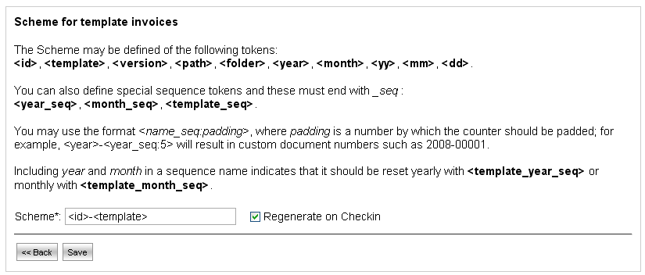Picture 93: Schema edit page

