Spectrum Web App Hardening

Num | ID | Name | Rule
1 | 2305152 | ABDELRHMAN ISLAM | POINT:A
2 | 2305184 | MOHAMED ADEL | POINT:B
3 | 2305153 | ABDELRHMAN ELSAYED | POINT:C

INDEX | CONTENT
0 | Clone and run
1(A) | Dynamic Testing
2(B) | Static Analysis with Semgrep
3(C) | Fix & Harden

Step 0 :
Clone and run the vulnerable Node.js/Express app locally
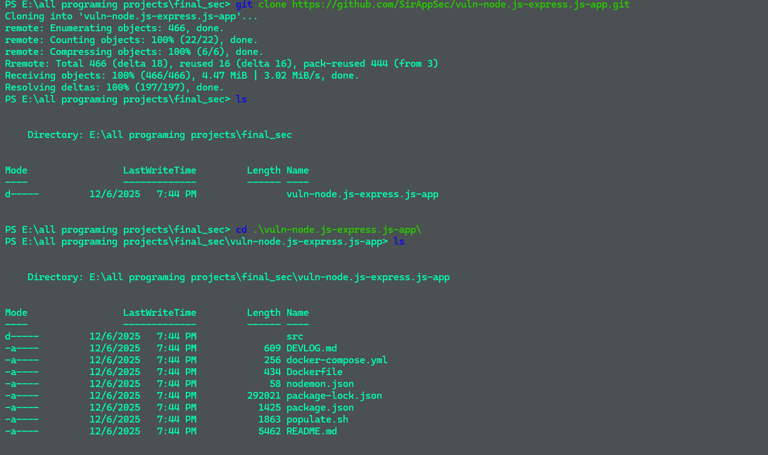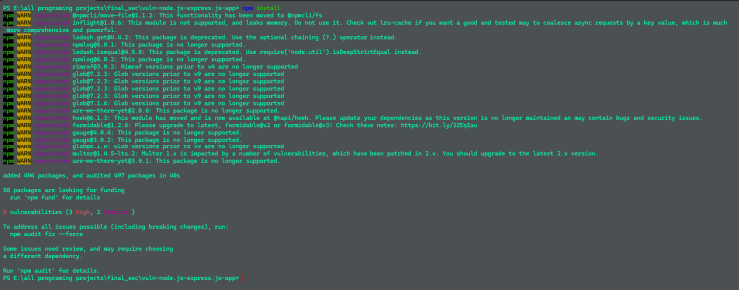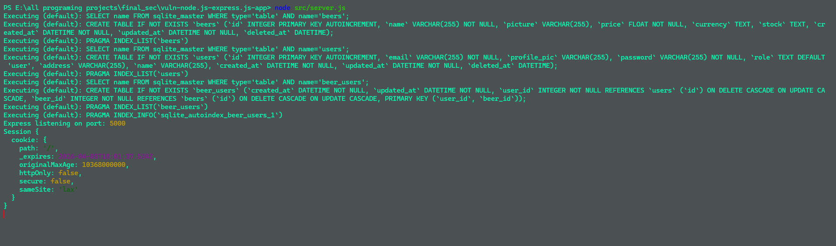

And finally run app locale is done

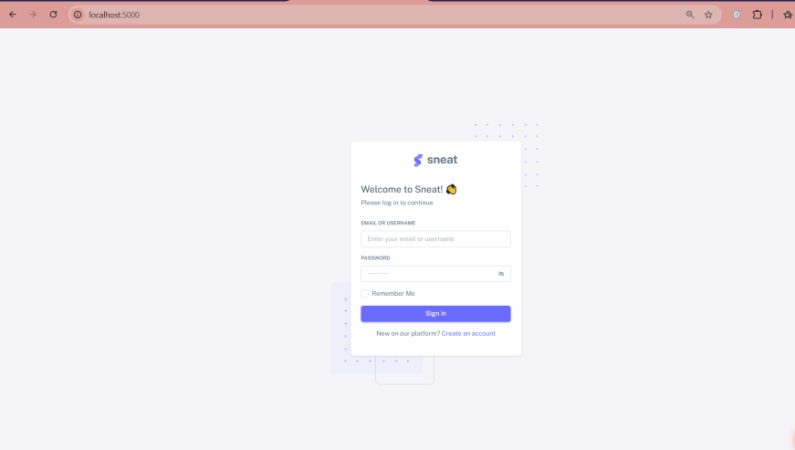

Phase A – Dynamic Testing (DAST) :

A1. Automated Scan :

Zap discover:

URLs / Endpoints:
/index.html
/auth-forgot-password-basic.html
/robots.txt
/sitemap.xml
/
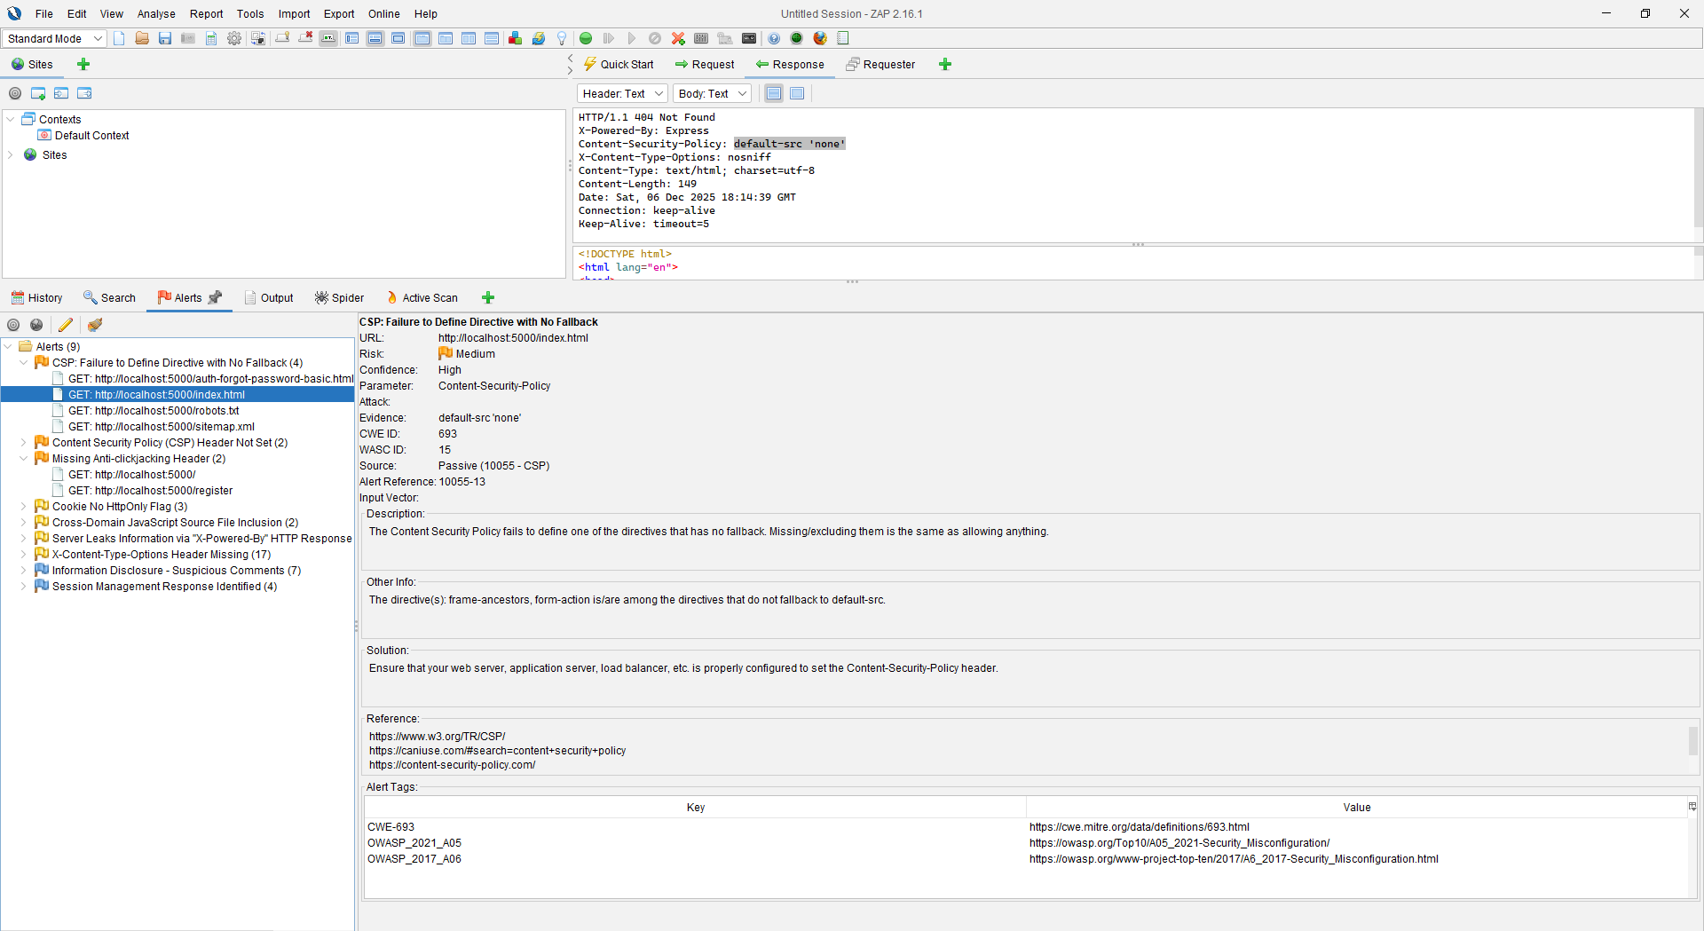

OWASP ZAP reported the following potential security issues:
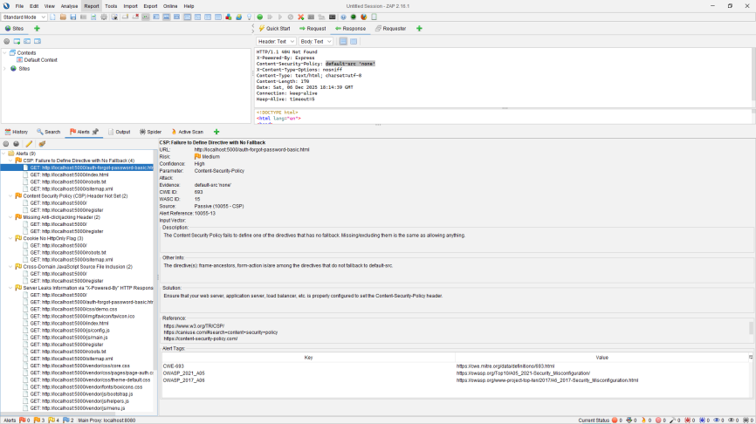
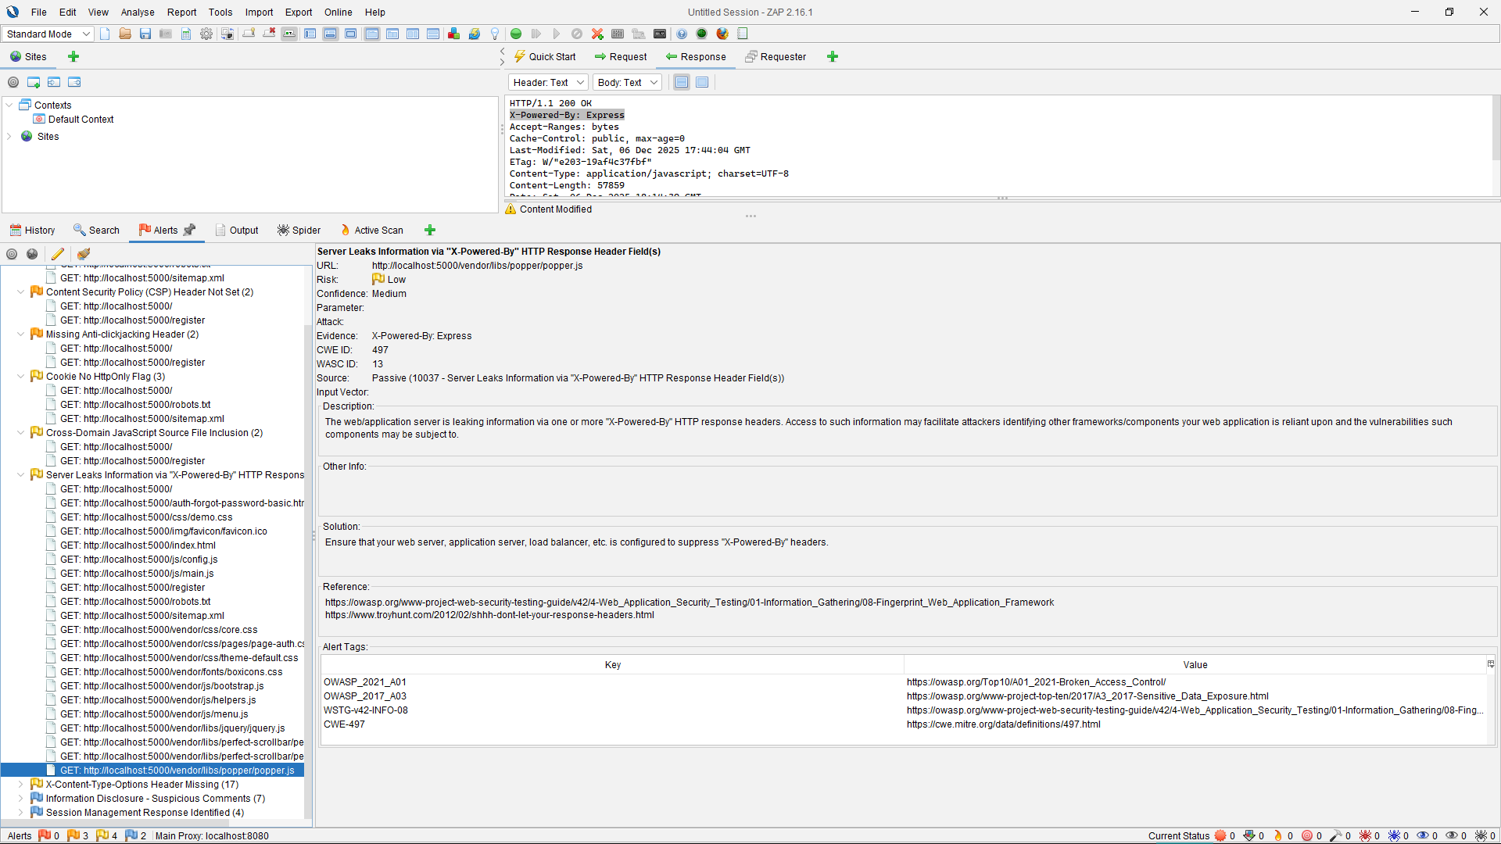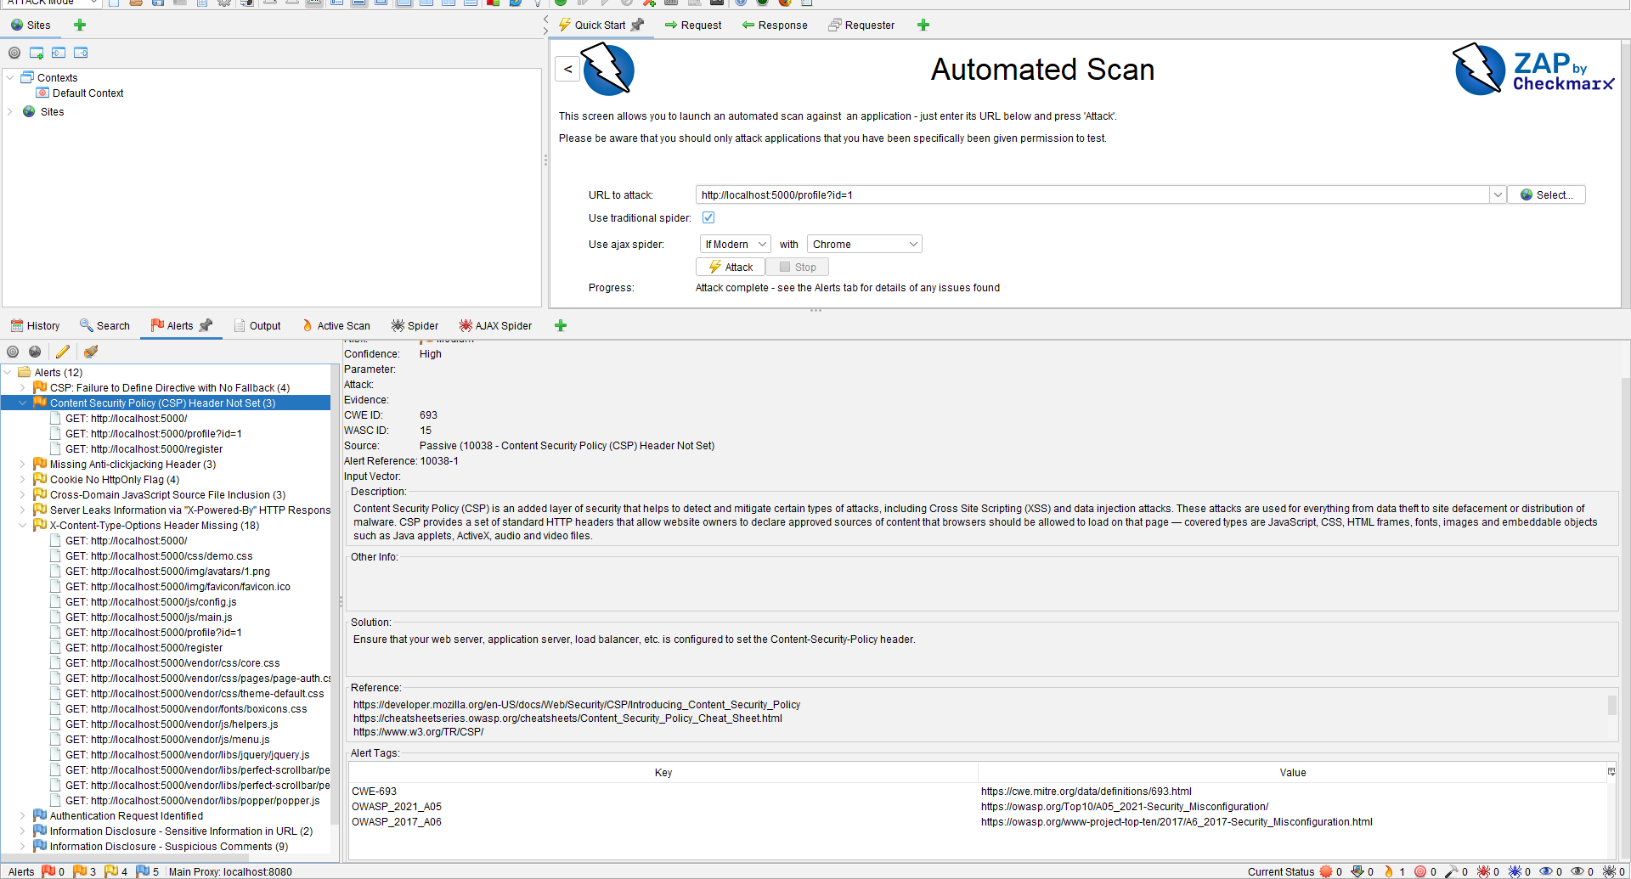
Content Security Policy (CSP) Misconfiguration
Issue: CSP header is present but missing important directives (no fallback).
Risk Level: Medium
Description:
The Content-Security-Policy header is not properly configured. Missing directives such as frame-ancestors and form-action may allow clickjacking or injection attacks.
OWASP Category:
A05 – Security Misconfiguration

Missing Anti-Clickjacking Header
Issue: X-Frame-Options header not set.
Risk: Medium
Impact:
The application may be embedded in a malicious iframe, enabling clickjacking attacks.
OWASP Category:
A05 – Security Misconfiguration

Missing Security Headers
Examples:
X-Content-Type-Options header missing
Cookie HttpOnly flag not set
Impact:
Increases the risk of MIME sniffing and client-side attacks.
OWASP Category:
A05 – Security Misconfiguration

Information Disclosure
Issue: Server information leaked via headers
Impact:
Reveals backend technology stack, which can assist attackers in crafting targeted exploits.
OWASP Category:
A05 – Security Misconfiguration
Role of Automated Scan:
These findings were later used as hints for manual testing in Phase A2 which resulted in multiple confirmed high-impact vulnerabilities such as XSS IDOR RCE SSRF and others

A2. Manual Testing & PoCs:
The testing was conducted using a web browser and curl commands to manually craft HTTP requests and observe server responses

V1 – Insecure Direct Object Reference (IDOR)
Endpoint:
GET /profile?id={id}
PoC:
http://localhost:5000/profile?id=2
http://localhost:5000/profile?id=3
http://localhost:5000/profile?id=4
Result: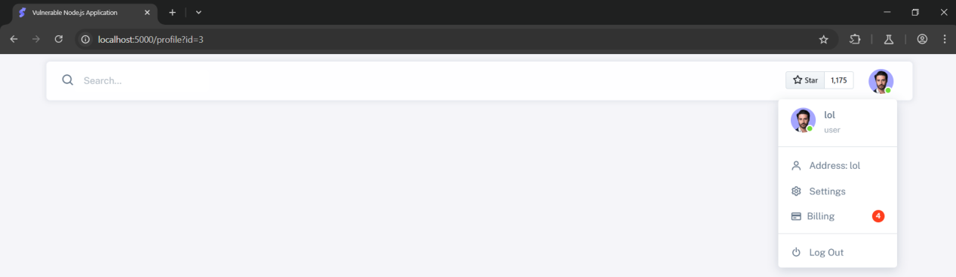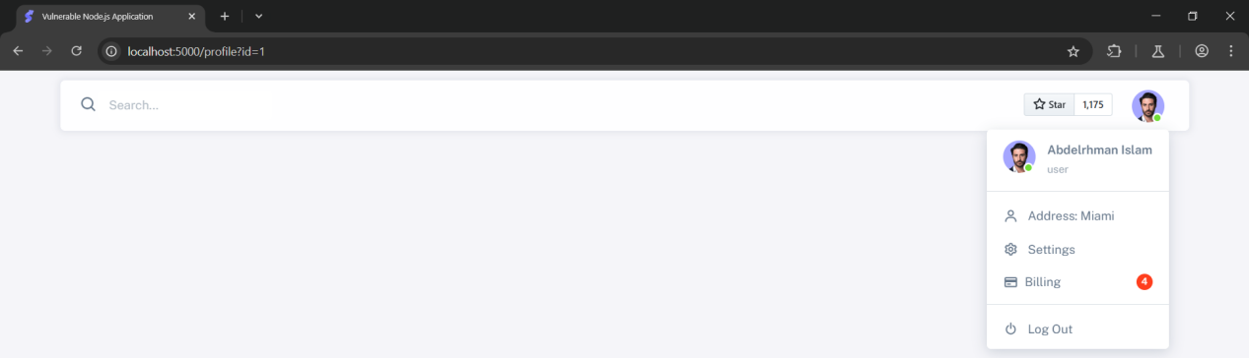
The application allows accessing other users’ profiles by changing the id parameter without authorization
Impact:
An attacker can view sensitive information of other users

V2 – Reflected Cross-Site Scripting (XSS)
Endpoint:
GET /profile?id=
PoC:
http://localhost:5000/profile?id=<script>alert(22)</script>
Result: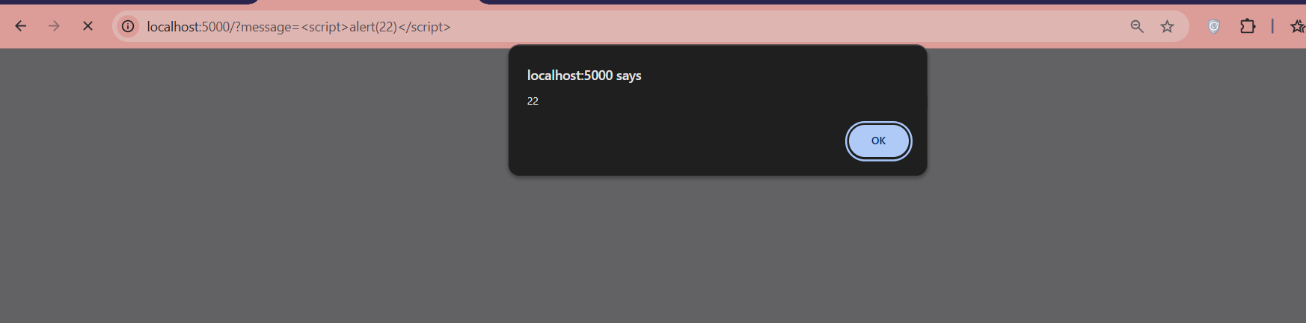
The JavaScript payload is executed in the victim’s browser.
Impact:
An attacker can execute malicious scripts, steal session data, or perform actions on behalf of the user.

V3 – Open / Insecure Redirect
Endpoint:
GET /v1/redirect/?url=
PoC:
http://localhost:5000/v1/redirect/?url=https://evil.com
Result: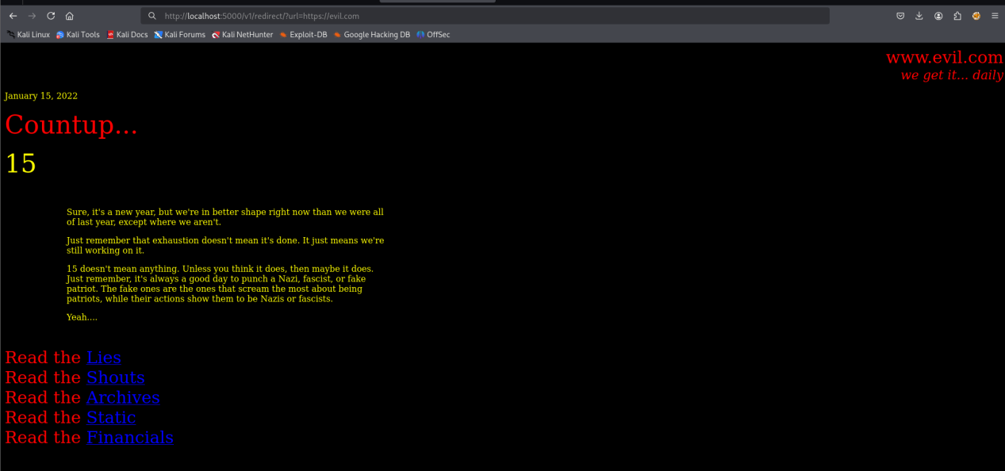
The application redirects users to an arbitrary external URL without validation
Impact:
This can be abused for phishing and social engineering attacks.

V4 – Server-Side Template Injection (SSTI)
Endpoint:
GET /?message=
PoC:
http://localhost:5000/?message={{7*7}}
http://localhost:5000/?message={{range.constructor("return global.process.mainModule.require('child_process').execSync('id')")()}}
Result: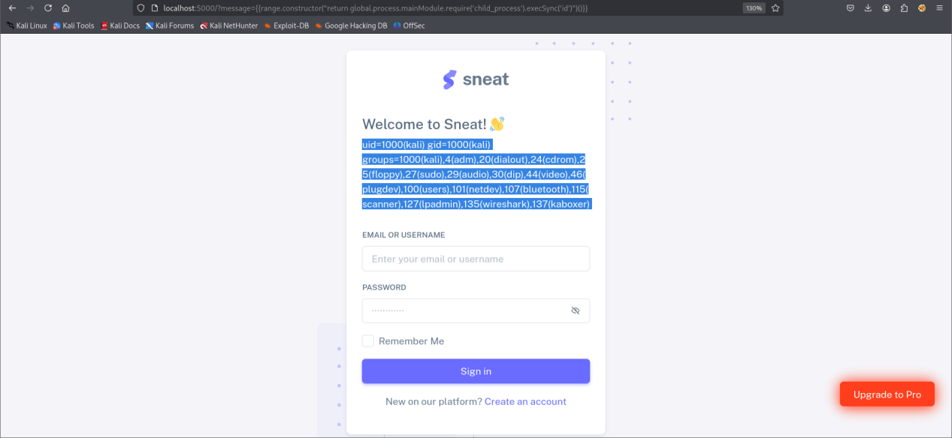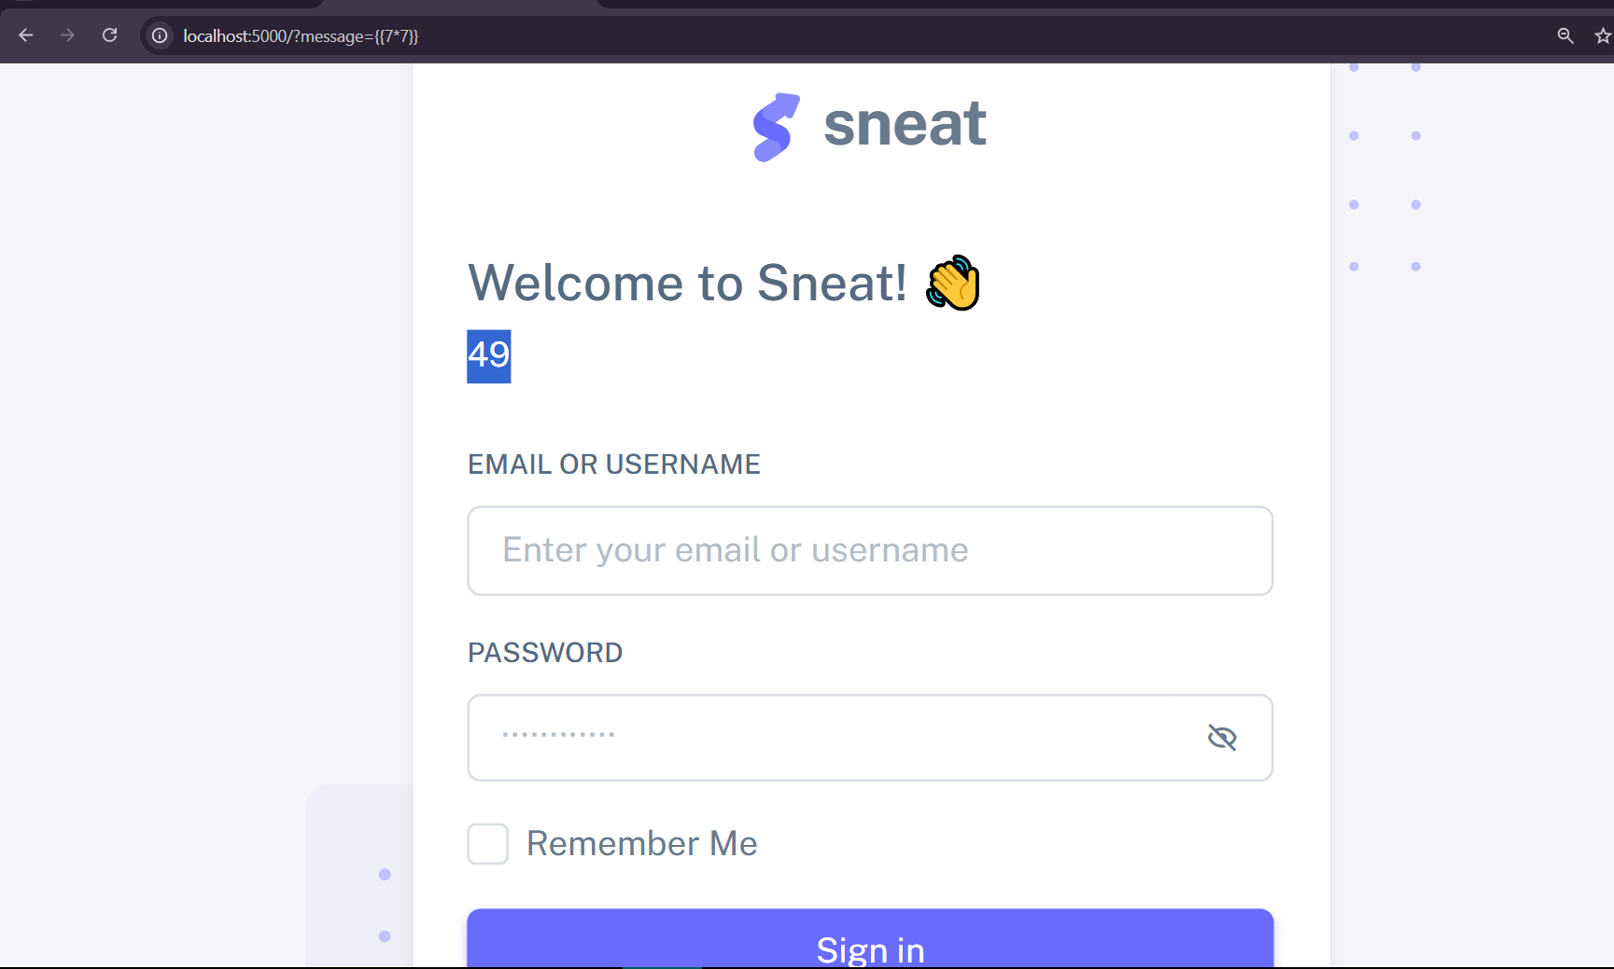
Template expressions are evaluated on the server.
Impact:
This vulnerability can lead to full remote code execution.

V5 – Remote Code Execution (RCE)
PoC:
curl "http://localhost:5000/v1/status/bud%20|ls"
curl "http://localhost:5000/v1/status/bud%20|%20id"
Result: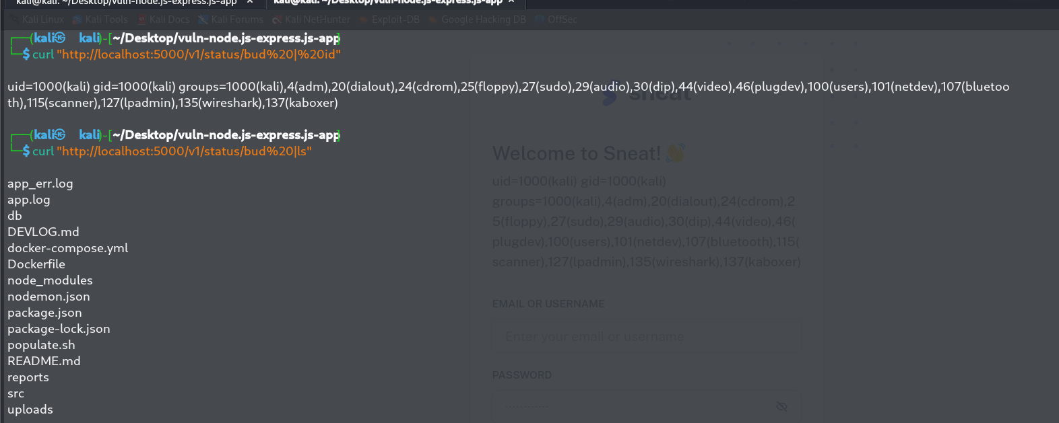
Arbitrary system commands are executed on the server.
Impact:
An attacker can fully compromise the server

V6 – Path Traversal
Endpoint:
GET /v1/beer-pic/?picture=
PoC:
http://localhost:5000/v1/beer-pic/?picture=../../../../../../../etc/passwd

Result: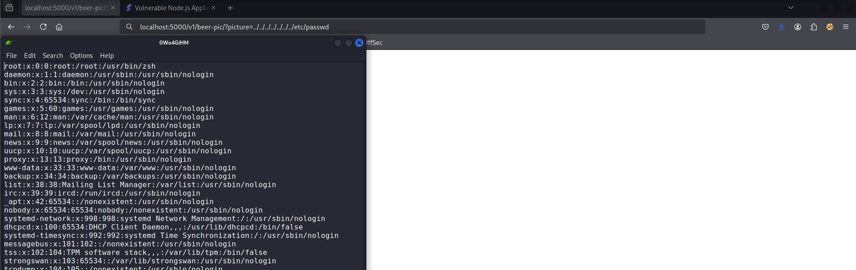
Sensitive system files can be read.
Impact:
Disclosure of sensitive server information.

V7 – XML External Entity Injection (XXE)
Endpoint:
POST /v1/admin/new-beer-xml/
PoC:
curl -X POST http://localhost:5000/v1/admin/new-beer-xml/ \
-H "Content-Type: multipart/form-data" \
-F "file=@xxe.xml"
Result:
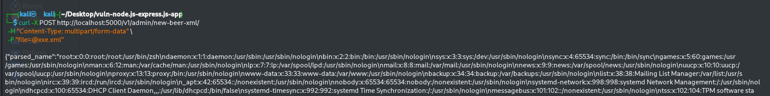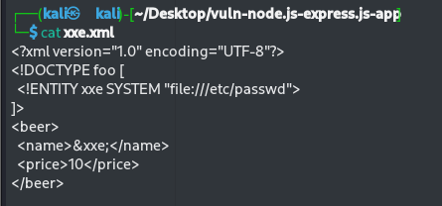
External XML entities are processed by the server
Impact:
File disclosure and potential server-side request forgery.

V8 – Server-Side Request Forgery (SSRF)
Endpoint:
GET /v1/test/?url=
PoC:
curl "http://localhost:5000/v1/test/?url=http://[::1]"
Result:
The server makes requests to internal resources.
Impact:
An attacker can access internal services and metadata.

V9 – Mass Assignment & Privilege Escalation
Endpoint:
PUT /v1/user/{id}
PoC (Vertical Privilege Escalation):
curl -X PUT "http://localhost:5000/v1/user/1" \
-H "Content-Type: application/json" \
-d '{"role":"admin"}'
PoC (Horizontal Privilege Escalation):
curl -X PUT "http://localhost:5000/v1/user/2" \
-H "Content-Type: application/json" \
-d '{"password":"HACKED_BY_ABDO_ISLAM"}'

Result:
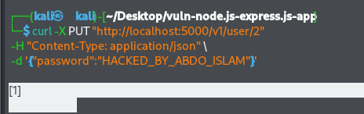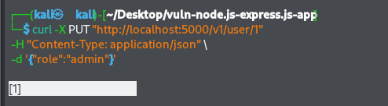
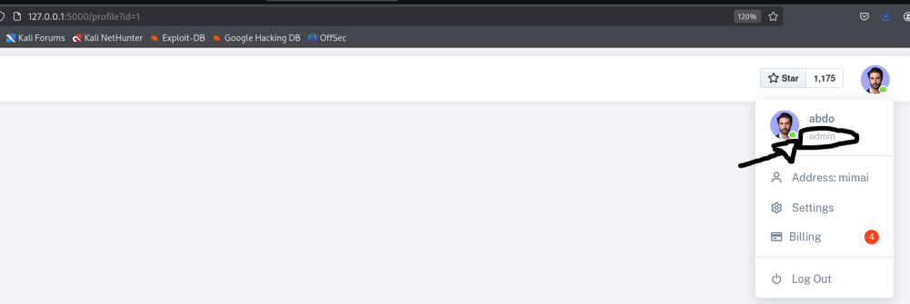
The application allows modification of sensitive fields without authorization
Impact:
An attacker can fully compromise user accounts and gain administrator privileges.
A3. Map Vulnerabilities to OWASP Top 10 :
ID | Endpoint | OWASP Top 10 Category | Impact Summary
V1 | GET /profile?id= {id} | A01 – Broken Access Control | Allows unauthorized users to access other users’ profiles by modifying the ID parameter.
V2 | GET /profile?message= | A03 – Injection (XSS) | Enables execution of arbitrary JavaScript in the victim’s browser, leading to session hijacking or data theft.
V3 | GET /v1/redirect/?url= | A01 – Broken Access Control | Permits redirection to untrusted external sites, enabling phishing and social engineering attacks.
V4 | GET /?message={{...}} | A03 – Injection (SSTI) | Allows server-side template injection, potentially leading to
V5 | GET /v1/status/{input} | A03 – Injection (RCE) | Enables execution of arbitrary system commands on the server, resulting in full server compromise.
V6 | GET /v1/beer-pic/?picture= | A01 – Broken Acess Control | Allows reading sensitive system files through directory traversal.
V7 | POST /v1/new-beer-xml/ | A05 – Security Misconfiguration (XXE) | Processes external XML entities, enabling file disclosure and internal network access.
V8 | GET /v1/test/?url= | A10 – Server Side Request Forgery (SSRF) | Allows attackers to force the server to send requests to internal or restricted resources.
V9 | PUT /v1/user/{id} | A01 – Broken Access Control A04 – Insecure Design | Enables mass assignment and privilege escalation, allowing attackers to modify other users’ data and gain admin privileges.

Phase B – Static Analysis with Semgrep (SAST) :

B1: Run Semgrep with Existing Rules

I ran Semgrep using the standard rulesets for Javascript, Node.js, and OWASP Top 10.
Command: semgrep --config "p/javascript" --config "p/nodejs" --config "p/owasp-top-ten" --json

Findings: The baseline scan found 16 issues, successfully identifying XSS and Path Traversal, but missing logic bugs like IDOR, RCE, and Mass Assignment.

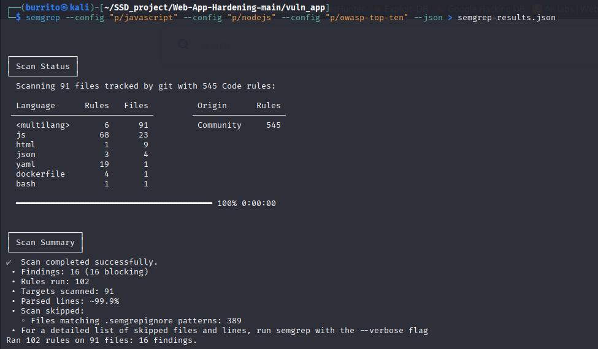
B2. Map DAST → Semgrep → Code
ID | Endpoint | OWASP Top 10 Category | File:Lines | Semgrep Rule
V1 | GET /profile?id= {id} | A01 – Broken Access Control | Src/router/routes/frontend.js :105 | Custom Rule Planned
V2 | GET /profile?message= | A03 – Injection (XSS) | Src/router/routes/frontend.js  :17 | javascript.express.security.express-insecure-template-usage
V3 | GET /v1/redirect/?url= | A01 – Broken Access Control | Src/router/routes/system.js  :37 | javascript.express.security.audit.express-open-redirect
V4 | GET /?message={{...}} | A03 – Injection (SSTI) | Src/router/routes/frontend.js  :17 | javascript.express.security.express-insecure-template-usage
V5 | GET /v1/status/{input} | A03 – Injection (RCE) | Src/router/routes/system.js  :15 | Custom Rule Planned
V6 | GET /v1/beer-pic/?picture= | A01 – Broken Acess Control | Src/router/routes/order.js  :33 | javascript.express.security.audit.express-path-join-resolve-traversal
V7 | POST /v1/new-beer-xml/ | A05 – Security Misconfiguration (XXE) | Src/router/routes/admin.js  :50 | Custom Rule Planned
V8 | GET /v1/test/?url= | A10 – Server Side Request Forgery (SSRF) | Src/router/routes/system.js  :84 | Custom Rule Planned
V9 | PUT /v1/user/{id} | A01 – Broken Access Control A04 – Insecure Design | Src/router/routes/user.js  :160 | Custom Rule Planned
B3. Custom Semgrep Rules

I wrote a custom configuration (semgrep-rules/custom-rules.yaml) to detect the specific patterns used in this application, specifically targeting the logic bugs missed by the baseline scan.

Custom Rules Scan Results:
My custom rules successfully detected 10 findings, covering all missing vulnerabilities including the RCE, XXE, Mass Assignment, and IDOR

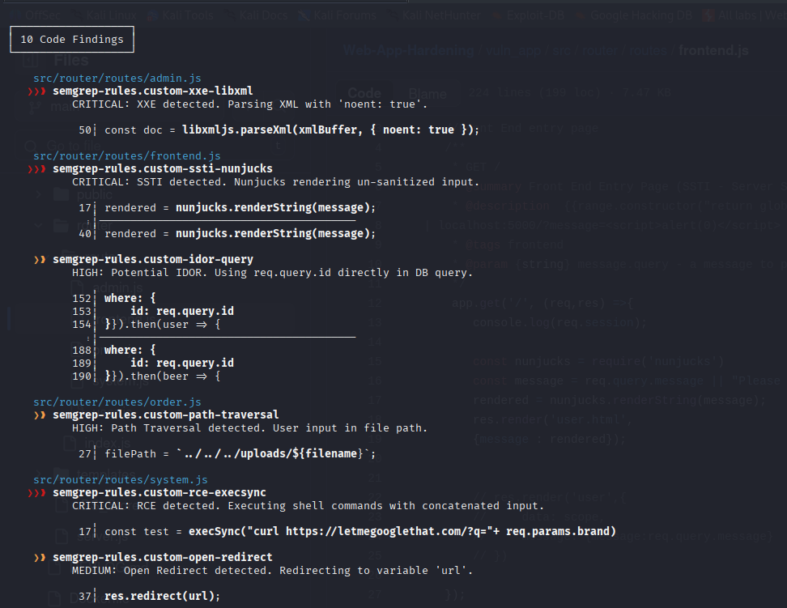

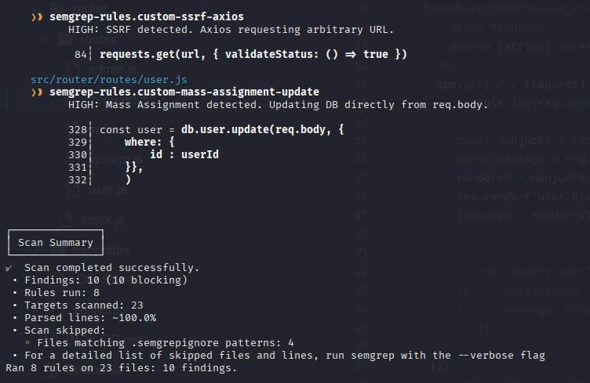
Phase C – Fix & Harden

C1: Implement Fixes

ID | Vulnerability | File + line(s) | High-level change | Why this is more secure
V1 | IDOR | src/router/routes/frontend.js  :135 | Added a session validation check: if (req.query.id !==req.session.userId)  Before the database query. | It ensures that the user requesting the data is the same user authenticated in the current session.
V2 | Reflected XSS | src/router/routes/frontend.js  :16 | Removed nunjucks.renderString and passed message directly to res.render as a local variable | By using the view engine correctly, the input is treated as data rather than executable code, preventing script execution.
V3 | Open Redirect | src/router/routes/system.js  :37 | Implemented a check: if (url.startsWith(‘/’)) before the redirect function | This forces the application to treat the URL as a relative path, preventing redirection to external malicious domains.
V4 | SSTI | src/router/routes/frontend.js  :16 | Removed the inline template rendering function renderString | User input is no longer evaluated by the template engine, preventing server-side code execution via template logic.
V5 | RCE | src/router/routes/system.js  :15 | Removed child_process.execSync entirely. Replaced with an array whitelist check ([‘bud’, ‘coors’]). | It eliminates the sink that executes shell commands. Input is strictly validated against a safe list of known values.
V6 | Path Traversal | src/router/routes/order.js  :27 | Implemented path.basename(filename and path.join(). | Path.basename strips directory traversal characters (../), ensuring files can only be read from the intended directory.
V7 | XXE | src/router/routes/admin.js  :50 | Change XML parsing configuration from {noent: true} to {noent: false}. | Explicitly disabling entity expansion prevents the XML parser from resolving external entities or local files.
V8 | SSRF | src/router/routes/system.js  :84 | Added an allowlist of permitted domains and removed arbitrary request.get. | The server now only processes requests to pre-approved URLs, preventing it from acting as a proxy to internal networks.
V9 | Mass Assignment | src/router/routes/user.js  :328 | Removed direct usage of req.body. Explictly destructured input (const { name } = req.body) | Only specific, safe fields are passed to the database update function. Sensitive fields like role or password are ignored during updates.

C2: Re-run DAST on Fixed App

Vulnerability | Attack payload | Result Before Fix | Result After Fix
RCE | Get /v1/status/bud|ls | Server executed ls and returned file list. | Server returned "Status: Unknown or invalid brand".
Path traversal | Get .../beer-pic?picture=../..etc/passwd | Server returned contents of /etc/passwd. | Server returned "error" (file path sanitized).
SSTI | Get /?message={{7*7}} | Server calculated math and displayed 49. | Server displayed literal text {{7*7}}.
IDOR | Get /profile?id=2 | Displayed User 2's private profile. | Redirected to "Error: You can only view your own profile."
Mass Assigment | PUT /v1/user w/ role:admin | User role updated to Admin in DB. | User role remained unchanged (input ignored).

Screenshots after fix

SSTI
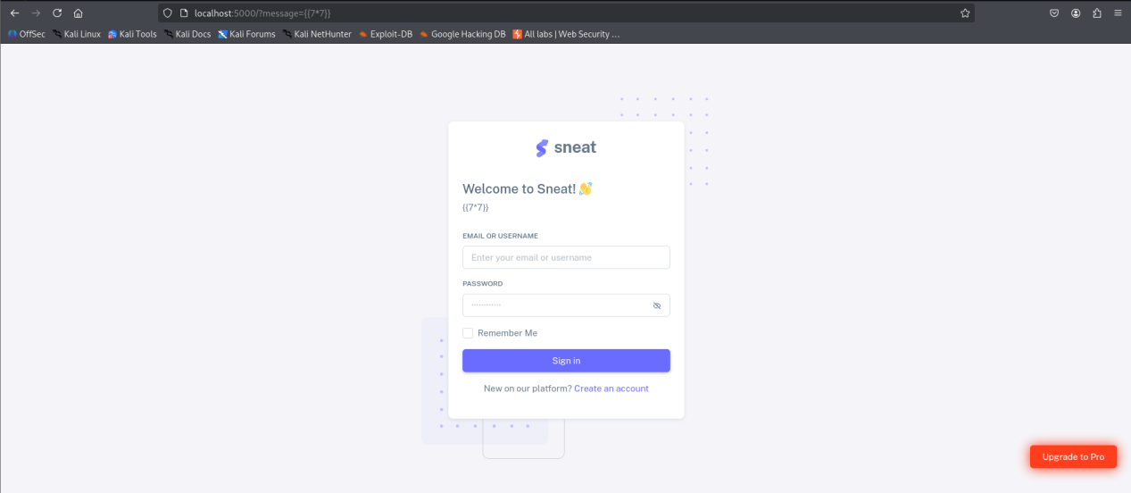

Path Traversal

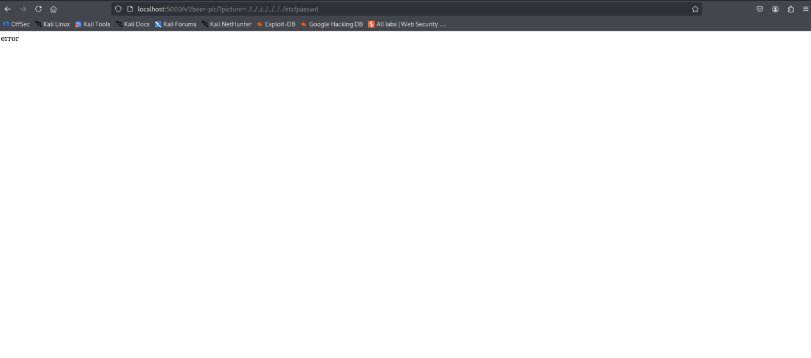
C3: Re-run Semgrep (Built-in + Custom Rules)

I re-ran the static analysis using the custom ruleset developed in Phase B (semgrep-rules/custom-rules.yaml).
Summary
- Before Fixes: Semgrep detected 10 Findings (High/Critical severity).
- After Fixes: Semgrep returned 0 Findings.
Detailed Notes on Fixed Findings
- RCE Rule: Previously matched execSync in system.js. After removing the function call and using a whitelist, the rule no longer matches.
- SSTI Rule: Previously matched renderString in frontend.js. The code now passes data securely to res.render, removing the vulnerable pattern.
- Path Traversal Rule: Previously matched unsafe string interpolation. Usage of path.basename and path.join breaks the vulnerable pattern.
- Mass Assignment Rule: Previously matched db.user.update(req.body). The fix explicitly defines variables (const { name }...), so the rule no longer sees a mass assignment pattern.
- SSRF Rule: Previously matched requests.get(url). The fix uses the Axios config object syntax inside a validation block, which does not match the insecure pattern.
SAST Evidence:
