**Unsteady MHD flow of a Viscoelastic fluid past over a permeable boundaries with the external impact of magnetic field**

Sajjan Lal

Department of Applied Science (Mathematics)

Feroze Gandhi Institute of Engineering & Technology, Raebareli (U.P.) India

([slmauryafgiet@rediffmail.com](mailto:slmauryafgiet@rediffmail.com))

**ABSTRACT-** The present work investigates the unsteady flow of a viscoelastic and viscous incompressible fluid passes through an oscillating infinite vertical porous plate with the impact of transverse magnetic field. The obtained governing equations are simplified by Finite Difference Technique. The velocity, temperature and concentration profiles are analyzed graphically by the effect of numerous flow parameters.

**Keywords:** MHD flow, Viscoelastic fluid, Porous plate, unsteady flow.

**2010 Mathematics Subject Classification:** 92C10.

**I. INTRODUCTION**

The study of heat and mass transfer with chemical reaction plays an important role in the field of chemical and hydrometallurgical industries.Raju et al. (2019) studied the flow of Visco-elastic fluid passes through infinite vertical porous plate in the influence of uniform temperature, thermal radiation and specific diffusion. Raghunath et al. (2016) investigated the visco-elastic fluid of unsteady MHD flow past an infinite oscillating porous plate in slip flow regime. Kane et al. (2020) depicts the unsteady fluid flow between two moving parallel porous plates in influence of inclined applied magnetic field. Damseh and Sannak (2010) studied the unsteady free convection flow of viscoelastic and viscous incompressible fluid passes through continuous moving vertical porous plate with the effect of first-order chemical reaction. Sharmin and Alam (2017) depicted MHD flow of Viscoelastic Fluid passes through an Infinite Oscillating Porous Plate with Thermal Diffusion and Heat Source. Uwanta et al. (2011) studied the flow Viscoelastic fluid passes

through infinite vertical plate with heat dissipation. Gedik et al. (2012) depicts the unsteady flow of two-phase fluid past in circular pipes in the presence of external electrical and magnetic fields. Reddy et al. (2015) studied the Magneto hydrodynamics free convective fluid flow passes through a semi-infinite vertical porous plate with chemical reaction and heat absorption. Ahmad and Das (2013) investigate the mass transfer of MHD flow past an embedded vertical porous plate in a porous medium in a slip flow regime with chemical reaction and thermal radiation. Biswas et al. (2018) studied Magneto hydrodynamics free convective and heat transfer flow through a vertical porous plate in the presence of chemical reaction. Makinde and Mhone (2005) studied oscillatory MHD flow and heat transfer in a channel filled with porous medium. Fenuga et al. (2018) studied the effects of mixed convection and Navier slip on a chemically reactive heat and mass transfer magneto hydrodynamics fluid flow over a permeable surface with convective boundary conditions. Ram and Mishra (1977) investigated an unsteady MHD flow through porous media. Moniem and Hassanin (2013) depict solution of MHD Flow passes through a vertical porous plate with oscillatory suction. Kumar et al. (2010) studied reliable magnetohydrodynamics steady flow through channels permeable boundaries and solved the governing equation by Finite difference technique. Kumar et al. (2010) studied Perturbation technique to unsteady MHD periodic flow of viscous fluid through a planer channel.

**II. FORMULATION OF THE PROBLEM** Consider MHD flow of viscoelastic and viscous incompressible fluid passes through an oscillating infinite vertical porous plate. Let u*, v* and w* are the velocity components along x*, y* and z* axis respectively. A magnetic field of uniform strength is applied along z*- axis. The suction or injection velocity at the plate is assumed to be and pressure in the fluid is taken as constant. The governing equations of the problem under the boundary layer and Boussinesq approximations can be written as the following form;

= 0 ... (1)

+ … (2)

(3)

… (4)

… (5)

Equation (1) implies that

... (6)

Where be positive constant and negative sign is taken as the suction is along the porous plate.

Adding Equations (2) and i(3), taking

+ (7)

Corresponding boundary conditions are

…(8)

Mean free path is , where coefficient of Maxwell’s reflection.

Introducing non dimensional quantities:

The governing equations reduce to the following equations;

... (9)

….(10)

(11)

Where, Hartmann number , Permeability parameter , Rarefaction parameter , Prandtl number , Schmidt number , Elastic parameter , Chemical reaction parameter , Heat Source parameter , Grashof number

Suction / injection velocity, Mass Grashof number.

**III. SOLUTION OF THE PROBLEM**

Solve the non-linear partial differential equations (9)-(11) under the conditions (8) by applying Finite Difference Technique.The accuracy is increased by increasing the discretization points at some given points. The equations (9)-(11) can be descritized as following.

 , , .

**IV. RESULTS AND DISCUSSION**

The effect of various parameters such as Prandtl number (Pr), Modified Grashof Number (Gm), Grashof number (Gr), Chemical reaction parameter (Kc), Schmidt number (Sc), Elastic parameter (Rc), Magnetic parameter (M) and porosity parameter (K) on Velocity profile has been observed. Figure1-8 depicts that the velocity components u and v decrease with increasing value of Pr, K, Rc and Kc while increase with increasing value of M and Gm. The velocity components u decrease and v increase with increasing value of as Gr and Sc. Figure 9-11 depicts that the increasing values of Pr and reduce the temperature profile. Figure 12-13 depicts that concentration profile reduces with increasing value of Elastic parameter (Rc) and Chemical reaction parameter (Kc).

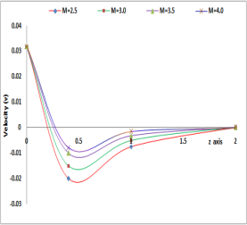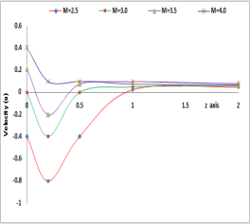

**Figure 1:** The effect of Magnetic parameter (M) on the velocity Profile.

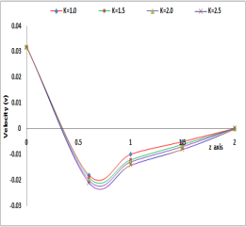

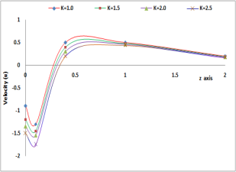

**Figure 2:** The effect of porosity parameter (K) on the velocity Profile.

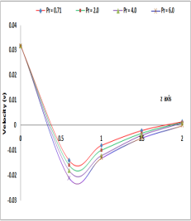

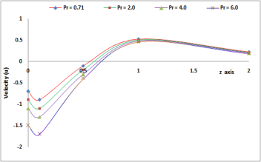

**Figure 3:** The effect of Prandtl number (Pr) on the velocity Profile.

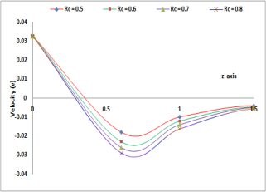

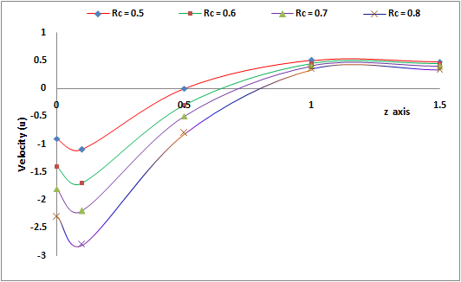

**Figure 4:** The effect of Elastic parameter (Rc) on the velocity Profile.

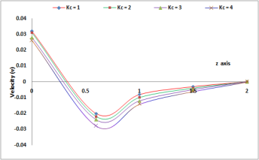 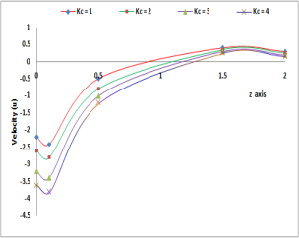

**Figure 5:** The effect of Chemical reaction parameter (Kc) on the velocity Profile.

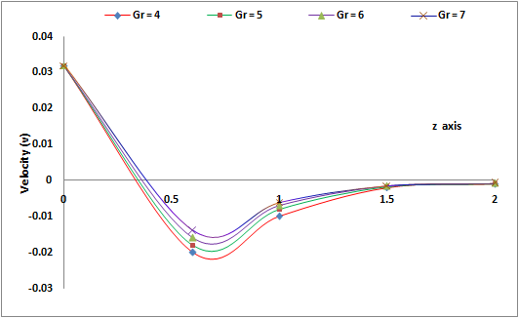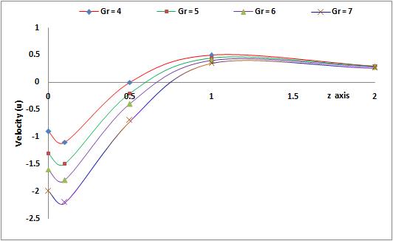

**Figure 6:** The effect of Grashof number (Gr) on the velocity Profile.

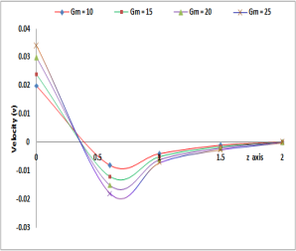 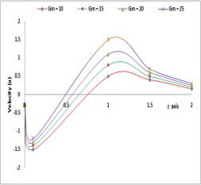

**Figure 7:** The effect of Grashof Number (Gm) on the velocity Profile.

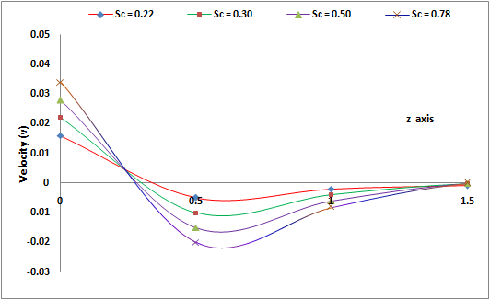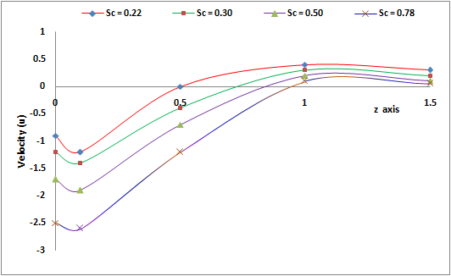

**Figure 8:** The effect of Schmidt number (Sc) on the velocity Profile.

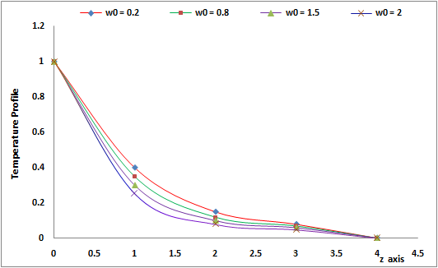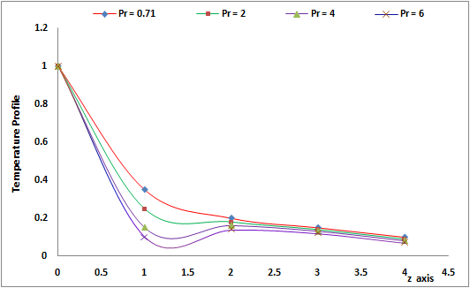

**Figure 8:** The effect of Prandtl number (Pr) & on the temperature profile.

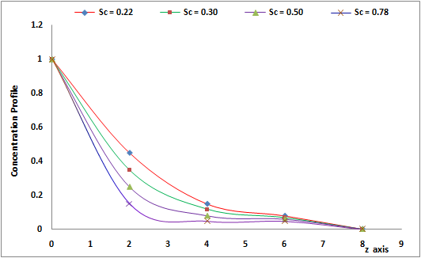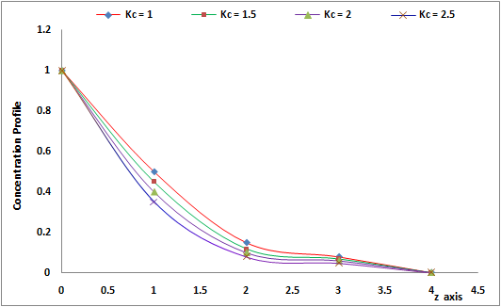

**Figure 8:** The effect of Chemical reaction parameter (Kc) & Schmidt number (Sc) on the concentration profile.

**V. CONCLUSION**

The present work, the impact of flow parameters on unsteady MHD flow has been investigated. The velocity profile decreases with increasing value of K, Pr, Rc, Kc while increases with increasing value of Magnetic parameter (M) and Schmidt number (Sc). The temperature profile decreases with increasing value of Pr, S and. The concentration profile reduces with increasing values of Chemical reaction parameter (Kc) and Schmidt number (Sc).

**References:**

1. Raju, V. N.; Hemalatha, K. and Babu, S. V., MHD Viscoelastic Fluid Flow Past an Infinite Vertical Plate in the Presence of Radiation and Chemical Reaction International Journal of Applied Engineering Research, 14(5), (2019),1062-1069.
2. Raghunath, K.; Krishna, M. V., Prasad, R. S. and Raju, G. S. S. Heat and Mass Transfer on Unsteady MHD Flow of a Visco-Elastic Fluid Past an Infinite Vertical Oscillating Porous Plate, British Journal of Mathematics & Computer Science, 17(6), 1-18.
3. Kane, I.; Kinyanjui, M. and Theuri, D. Unsteady Fluid Flow Between Two Moving Parallel Porous Plates in Presence of Inclined Applied Magnetic Field, Journal of Applied Mathematics & Bioinformatics, 10(1), (2020), 31-49.
4. Damseh, R. A. and Sannak, B. A., Visco-elastic fluid flow past an infinite vertical porous plate in the presence of first-order chemical reaction, Appl. Math. Mech. -Engl. Ed. 31(8), (2010) 955–962.
5. Sharmin, F. and Alam, M. M., MHD Viscoelastic Fluid Flow along an Infinite Oscillating Porous Plate with Heat Source and Thermal Diffusion, AMSE IIETA publication-2017-Series: Modelling B, 86(4), (2017), 808-829.
6. Uwanta, I. J., Isah, B. Y. and Ibrahim, M.O., Viscoelastic Fluid Flow past an Infinite Vertical Plate with Heat Dissipation, International Journal of Computer Applications, 36(2), (2011), 17-24.
7. Gedik, E., Kurt, H., Recebli, Z. and Kecebas, A., Unsteady flow of two-phase fluid in circular pipes under applied external magnetic and electrical fields, International Journal of Thermal Sciences, 53, (2012), 156-165.
8. Reddy, G.V.R., Shekhar, K.R. and Sitamahalakshmi, A., MHD free convection fluid flow past a semi-infinite vertical porous plate with heat absorption and chemical reaction, Int. J. Chem. Sci., 13(1), (2015), 525-540.
9. Ahmad, N. and Das, K. K., MHD Mass Transfer Flow past a Vertical Porous Plate Embedded in a Porous Medium in a Slip Flow Regime with Thermal Radiation and Chemical Reaction, Open Journal of Fluid Dynamics, 3, (2013), 230-239.
10. Biswas, R., Afikuzzaman, M., Mondal, M. and Ahmmad, S.F., MHD free convection and heat transfer flow through a vertical porous plate in the presence of chemical reaction, Frontiers in Heat and Mass Transfer, 11, (2018),1-10.
11. Makinde, O.D. and Mhone, P.Y., Heat transfer to MHD oscillatory flow in a channel filled with porous medium, Romanian Journal of Physics, 50(9-10), (2005), 931-938.
12. Fenuga, O. J., Safiu, M.A. and Omowaye, A. J., Effects of mixed convection and Navier slip on a chemically reactive heat and mass transfer MHD fluid flow over a permeable surface with convective boundary conditions, Journal of Physical Mathematics, 9(4), (2018), 1-9.
13. Ram, G. and Mishra, R. S., Unsteady flow through magnetohydrodynamic porous media, Indian Journal of Pure and Applied Mathematics, 8(6), (1977), 637–647.
14. Moniem, A. A. and Hassanin, W. S., Solution of MHD Flow past a vertical porous plate through a porous medium under oscillatory suction, Applied Mathematics, 4, (2013), 694–702.
15. Kumar, A., Saket, R. K., Varshney, C. L. and Maurya, S. L., Finite difference technique for reliable MHD steady flow through channels permeable boundaries, International Journal of Biomedical Engineering and Technology, 4(2), (2010), 101-110.
16. Kumar, A., Varshney, C. L. and Lal, S., Perturbation technique to unsteady MHD periodic flow of viscous fluid through a planer channel, Journal of Engineering and Technology Research, 2(4), (2010), 73-81.