Smart Intelligent Application for Women and Children Safety

Nanda R.Wagh¹,Dr.Sanjay R.Sutar²
¹DBATU Lonere,India, ²DBATULonere,India
¹nrwagh17@gmail.com, ²srsutar@dbatu.ac.in

ABSTRACT- In Global scenario, Women and Children Safety is most crucial issue. Crime against Women and Children has increased at rapid rate. National Crime national crime record bureau (NCRB) report 39000 crime cases in 2019.The WHO and NCRB states that 35% of the Women and Children are physically harassed at Public places. Growth of any Nation is dependent of growth of Women and Children so technology must be applied for resolution of the prime Global Societal issue. Machine Learning and Multi-Sensor fusion most efficient techniques utilized to develop Women and Child Security System. Information fusion technique compute information gathered by multiple, and eventually heterogeneous sensors to generate inference not obtainable with single sensor. This paper gives detail various Women and Child Security Systems methodologies, Algorithms, architectures, models. In addition, highlighted proposed system with Intelligent behavior and analysis of unsupervised decision making. We will prove our concepts and algorithm for sensor fusion and Machine Learning by considering women and Child security as an application. Women and Children safety is a very important issue due to rising crimes against women and children these days. To resolve this issue, we propose a GPS based women and Children safety system that has dual security feature. This device consists of a system that ensures dual alerts in case a woman and children if harassed. Machine Learning is most efficient technique for classification of safe and dangerous zone. GPS is utilized to detect location of victim and GSM is used for communication purpose. There are various performance parameters associated with application such as reliability, computational time, accuracy, latency, response time. The proposed system is experimented with mobile multi-sensor for sending victims exact location.
Keywords: information fusion, sensor fusion, Machine Learning, Neural Network, Location Detection.
2010 Mathematics Subject Classification : 68W99,92C42.

1. INTRODUCTION

Information Fusion is a technology which integrates the data from multiple heterogeneous or homogeneous sources and produces better result than sum of their individual results [1][2][3]. Information Fusion or Sensor Fusion system is used to solve problems in various domains like Artificial Intelligence, Cognitive Computing, Neural Network, Machine Learning, and Soft Computing. Basically, problem is divided into four sections: a) Collect the observations or data from multiple heterogeneous or homogeneous sources. b) Extract the required

information (data analysis, filtering and estimation). c) Draw some logical inferences
(based on some comparisons and evaluation) and d) Make some adequate and good decisions. Information Fusion system have several applications in above specified domains ranging from home automation, military applications, health care, remote sensing to space science. As per problem classification system should make accurate intelligent decisions for applications. To make intelligent decisions at final phase, we have to take special care while fusing the data and generating inference parameter upon fusion result. Several standard techniques are available to fuse the information like Bayesian network, Dempster shaper theory, Kalman filter, center limit theorem, fuzzy logic, and neural network. Some of these techniques are supervised and some are semi supervised. Getting the motivation from our peripheral nervous system, human brain as central processing element, senses input from our five senses such as test, vision, hearing, smell, touch, and take the intelligent supervised or unsupervised decisions. Proposed system provides a novel unsupervised algorithm to fuse the information from various homogeneous or heterogeneous sources and make the intelligent decisions by generating inference parameter. System mainly focuses on reducing conflicts and uncertainty from real time sensory data and makes the accurate and intelligent decisions as per applications.

In Current Era, Women’s and Children safety is a very important issue due to rising crimes against women and child. To resolve this issue, we propose a GPS based Women and Child safety system that has dual security feature. This device consists of a system that ensures dual alerts in case a woman and child if harassed. This system can be turned on by a woman in case she even thinks she would be in trouble. It is useful because once an incident occurs with a woman she may or may not get the chance to press the emergency button. In a button press alerting system, in case a woman/child is hit on the head from behind, she may never get the chance to press panic button and no one will know she is in trouble. Our system solves this problem. This device is to be turned on in advance by a woman/child in case she is walking on a lonely road or some dark alley or any remote area. Only the woman/child authenticated to the devices can start the system by fingerprint scan. Once started the devices requires the woman/child to constantly scan her finger on the system every 1 minute, else the system now sends her location to the authorized personnel number through SMS message as a security measure and also sounds a buzzer continuously so that nearby people may realize the situation. In this case even if someone hits the woman or the woman falls down and get unconscious, she does not need to do anything, the system does not get her finger scan in 1 minute and it automatically starts the dual security feature. This device will prove to be very useful in saving lives as well as preventing atrocities against women and child. The device uses GPS sensor along with a GSM modem, LCD display, LED’s and microcontroller-based circuit to achieve the system goal. The data collection from various sensors such temperature, blood pressure, voice sensor is collected and stored on Web Server or Cloud. If all parameter crosses threshold value, victims GPS location will be sent through GSM module to parents and registered contact list.

  - Fundamental Concept of Information Fusion

Through the years different terminologies have been used to describe the process of information fusion as per architectures, methodologies and applications namely data fusion, sensor fusion, data aggregation, multisensory integration, information integration. The relationship between multi-sensor/sensor fusion, multi-sensor integration, data aggregation, data fusion, and information fusion [4] is depicted in Figure 1. The fusion is a system of combination of integrate, join or combine two or more things to give reliable, robust and unbiased decision rather than uncertain decisions. In simple mathematics, we can express fusion process as average.

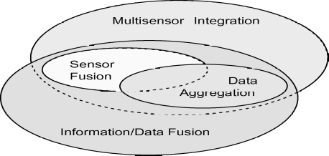

Figure 1. The relationship between multi-sensor/sensor fusion, multi-sensor integration, data aggregation, data fusion, and information fusion.

The Author [7] defined information fusion perfectly as it is a “supervised or semi supervised transformation of information from various sources into single parameter for effective unsupervised decision making.” The input to the information fusion process is processed data, and sources for the input could vary from sensors, images, databases to information generated by humans. Sensor fusion is a subset of information fusion and obtains the data from sensory resources. Sensor fusion provides the better results, analysis, performance and decision making due to various types of sensors. The sensors have different strength and weaknesses, the strength of one type can reimburse for the weakness of other type. Extra sensors could work as backup if other fails [6]. Data aggregation is subset of information fusion whereas the objective is to summarize or reduce the data volume [7]. The process of Multi sensor integration represents the application of information fusion and to make inferences using sensory devices. Some basic fundamental concepts of information fusion are depicted in Figure 2. It depicts input sources to information fusion process, why we need information fusion, benefits, applications, models of information fusion. As we have seen that input sources for information fusion can vary, it can be sensory input or images. The improvement in accuracy and intelligent decisions making is the main objectives of information fusion. Information fusion is performed by taking the unprocessed data from sensor as input and converts it into knowledge. That will be useful to take intelligent, reliable and accurate decisions.

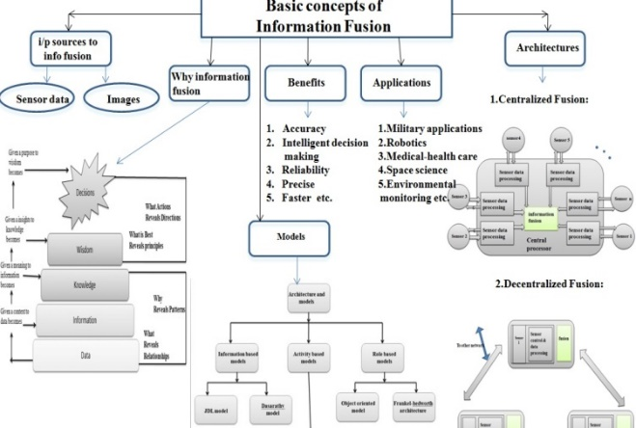

Figure 2. Basic fundamental concepts of information fusion

Information fusion is beneficial to improve the accuracy, reliability and decision making by reducing uncertainty. Its results are more precise, faster. Additionally, information fusion provides one more benefit as the strength of one type source can compensate for the weakness of another type. In network communication, overall communication load is reduced by avoiding the transmission of redundant messages through Information fusion [4][16]. Major aim of Information fusion is object detection, classification, tracking and estimation tasks in different application domains. Now a days it is widely used in military, space science, medical-health care and environmental monitoring applications. Information fusion architectures are useful to understand that how to place sensor nodes in information fusion system centralized or distributed or combination of both. There are some existing popular models which guide to design information fusion system. The evolution of models and architectures for information fusion system design is described in reference [4][5]. Taxonomy of models depicted in Figure 2. There are several models, for our proposed system we used JDL model to fuse the data from various sources and dassarthy model for decision making. Two levels are considered as data-in –information-out and information or feature-in-decision-out for this system [1].

EXISTING SYSTEM

The existing Women and Children security system developed by various researcher can be classified into four different classic categories

2.1 Mobile Based Android Apps

Khoya-Paya, Abhaya, SafetyPin, TellTail, FightBack, Women Empower, On Watch, VithU are various popular Women and Children safety app that sends alters to the Victim’s Family, Friends and Police. The alters sending starts by pressing panic button or by shaking mobile phone.

2.2 Micro-controller Based Prototype

Raspberry Pi, Arduino Uno, ATMega328, ARM7 controller with GPS-GMS integrated module with panic button. The alter system communication start as panic button pressed then alters are sent to the Victim’s Family, Friends and Police. Some papers deep reviews are as follows: -

1.A Novel Approach to Provide Protection for Women by using Smart Security Device

This paper provides security device for women. It uses Arduino controller and sensors such as temperature, flex sensor, MEMS accelerometer, Pulse rate sensor, sound sensor, a buzzer, LCD, GSM and GPS to Senses body parameters and then perform tasks as per application objectives such as – body temperature detection, voice detection, flex motion detection, sudden fall detection, pulse rate detection of victim, activation of buzzer, send panic message to registered contacts. This system is depending on pulse rate and there may be possibilities of false notifications [35].

2. Smart Intelligent System for Women and Child Security
This is portable device to provide security for women by using Pressure switch, GSM800, GPS, Microcontroller Arduino[34]. When pressure switch activated by user it performs tasks like - send panic message, share location and call to registered numbers, if not answered redirect to police. This system is huge in size to carry and immediate response is not possible with this approach.

3. Smart watch for women’s

security IOT concept watch me
Watch to provide women security. Use of GPS, GSM, sensors. Tasks can be detected heartbeat, automatic call to registered number, detect nearby police station and make ring. Idea is represented not implemented. Heart rate may increase due to some non-emergency situations.

2.3 Internet of the Things (IOT) and Micro-controller Integrated System

The Micro-controller system is integrated with IOT Web Server, Cloud Server. Victim’s all evidences and geospatial locations are stored at Web Server. The alters are sent to the Victim’s Family, Friends, NGO and Police.

2.4 Artificial Intelligence (AI), Machine Learning (ML), and Deep Learning (DL)
Paradigm Based System

As existing techniques AI,ML,DL proven it identity the all field of life. The Intelligence related papers and AI based Women Safety system are as follows:

1. A Very Brief Introduction to Machine Learning with Applications to Communication Systems
After the “AI winter” of the 80s and the 90s, enthusiasm for the utilization of information driven Artiﬁcial Intelligence (AI) strategies has been consistently expanding in various building ﬁelds, including speech and image analysis [1]. As informational indexes develop, utilizing machines to take in important examples from organized information can be very ground-breaking. The volume of information is too enormous for complete investigation, and the scope of potential connections and connections between dissimilar information sources are unreasonably extraordinary for any expert to test all speculations and determine all the worth covered in the information. AI (ML) is perfect to open doors for covered exploiting the opportunities in big Data. Machine learning is an application of artificial intelligence (AI) that provides systems the ability to automatically learn and improve from experience without being explicitly programmed. Machine learning focuses on the development of computer programs that can access data and use it learn for themselves [12]. So as to ﬁx the thoughts, it is helpful to present the AI technique as an option in contrast to the ordinary building approach for the plan of an algorithmic arrangement.

2. A Dynamic Weight Determination Approach Based on the Intuitionistic Fuzzy Bayesian Network and Its Application to Emergency Decision Making
In this paper author provided Dynamic decision-making approach to handle unpredictable emergency events. And their Reliability of decision results are based on current situations and historical data [11]. With the help of data Calculates accurate decision matrix. Author mainly focused on Bayesian network, decision process, intuitionistic fuzzy sets as key concepts. We identified some gaps with proposed system as this might have Potential information loss in transformation process and it may lead to delays in emergency decision making.

3. Deep Learning Fusion Conceptual Frameworks for Complex Human Activity Recognition Using Mobile and Wearable Sensors

This paper provides approach to recognize human activities in ubiquitous computing and HCI.[12][14].They get data using appropriate sensors. Mainly focus on feature extraction and Uses Statistical features, Deep learning, multi sensor fusion, human activity monitoring, machine learning. It helps to reduce computation time and enhance accuracy [8][26].
We identified as this solution is difficult to feature extraction and recognize complex human activity recognition

4. All in one Intelligent Safety System for Women Security
This provides information regarding various tools for Women Security. Auto receiving call, GPS, GSM, Spy camera detection, intrusion detection, call 100 or emergency numbers, generate shock in self-defense, alarms are some highlighted features of these tools. Implemented with android app or Arduino based approach. But it takes Maximum time to operate and there are chances of Data loss.

5. Identifying interactions for
information fusion system design
using machine learning
techniques

This mainly focuses on Statistical analysis to exploit interactions between elements to improve IFS design and its performance. As per analysis this paper has limitations as system consumes memory and takes much time to respond [26].

6. NB-CNN Deep Learning-Based Crack Detection Using Convolution Neural Network and Naïve Bayes Data Fusion

The CNN algorithm needs lots of training data to make training converge and over fitting. It provides greater accuracy in result within less amount of time. It is efficient to process big data [17].

7. Enabling Explainable Fusion in Deep Learning with Fuzzy Integral Neural Networks
A novel NN architecture with a gradient descent-based optimization solution that mimics the Choquet integral for information aggregation. Accuracy is less [12][14]

3. PROPOSED SYSTEM
The novelty of proposed system is system integrates App, IOT, Controller Prototype with Machine Learning neuro-centric approach. The proposed system consists of Sensor Module which has multiple sensors, Arduino Uno-AT Mega Controller, GPS+GSM Module, Fingerprint module, Buzzer module and LCD Display module which is call as Smart Band for Women and Child Safety. The Real-Time sensor data collected through multiple sensor. The standard set of data can be generated with multiple parameters. Then data can be stored on Cloud or Web Server. The multiple parameter of sensor data is analyzed using Machine Learning and Deep Learning approach CNN (Convolution Neural Network). When the threshold value of temperature, heart-beat, blood pressure, emotion and scream of victim in combination changes then GPS+GSM module get self- activated. The communication is performed using GSM module and Victim’s GPS location is sent through SMS system to multiple nearby police stations, parents, friends and favorites list of NGO The Clustering, unsupervised technique used for location classification. Nearest registered contacts will be predicted and communicated with accuracy.

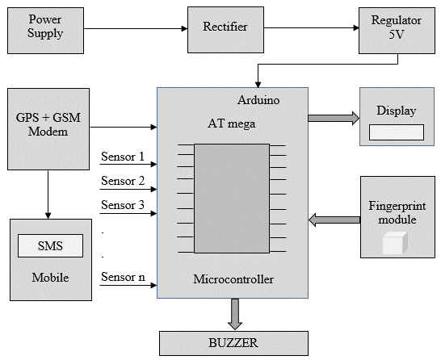

Figure 3. The Working of the Proposed System

The Figure 3 represent the working of the proposed system. The safe or dangerous Zone prediction can be performed using GPS data sets and with multiple parameters. The Women or Child Victim, when enters into some lonely, dark area, Women or child proves his identity by Fingerprint module. If there is attack on the victim, thus all values such temperature, blood pressure and voice of victim changes. If the threshold value crossed, then based on that GPS communication module (GSM) send Victim’s GPS location is sent through SMS system to multiple nearby police stations, parents, friends and favorites list of NGO. The buzzer system is activated immediately, thus nearby people can listen and look and resolve the matter for Victim Safety.

4. EXPERIMENTAL RESULTS

The research objective achieved through the implementation of Multi-sensor and GSM-GPS module integrated with ATMega328.The protype, Mobile Sensor App independent testing has been done. The ECG, Emotion GPS, AReM Human Activity Recognition (HAR) Data Set usability in research. The prototype and Mobile Sensor App represented.

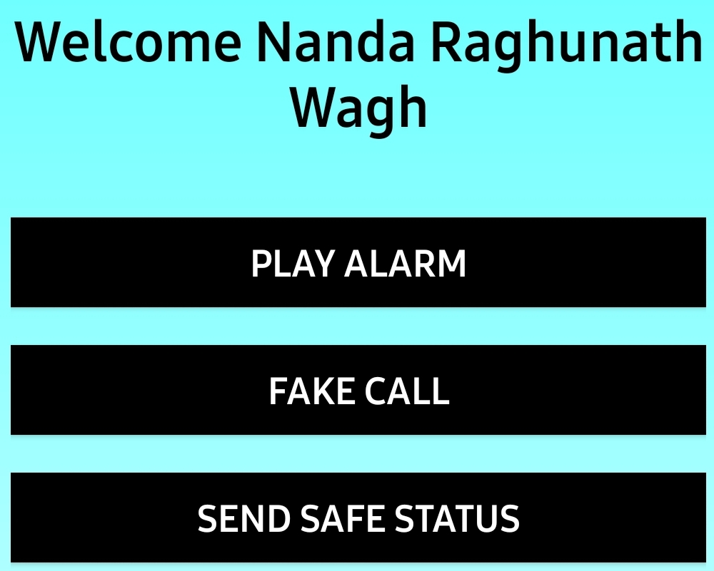

Figure 4.1 A. Rescuer Mobile App for Women and Child Safety

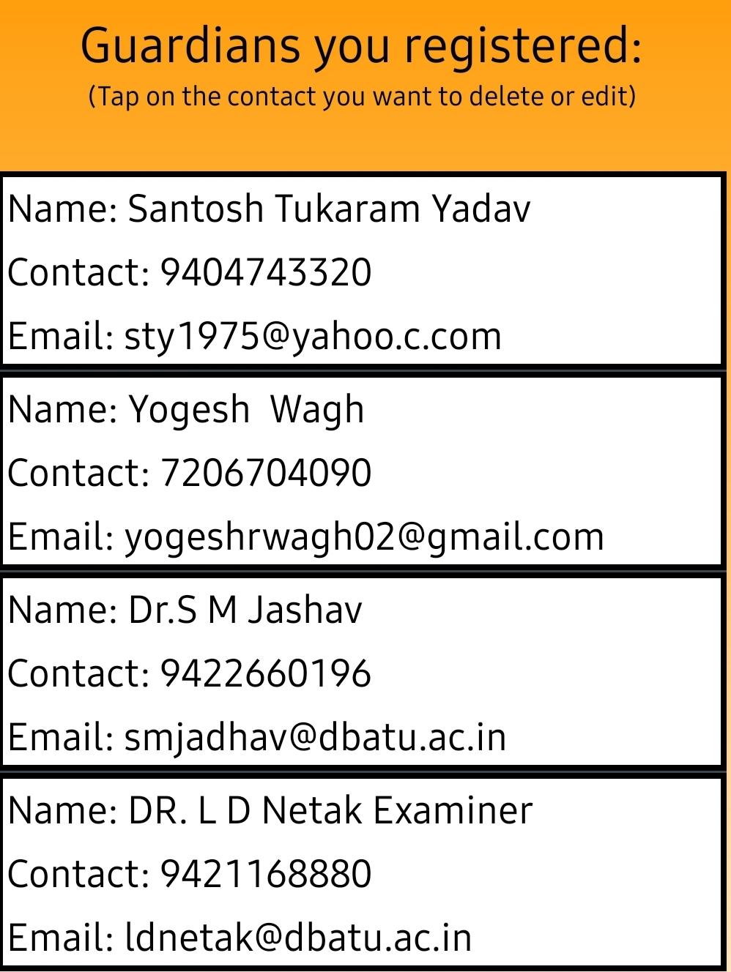

Figure 4.1 B. Rescuer Mobile App for Women and Child Safety

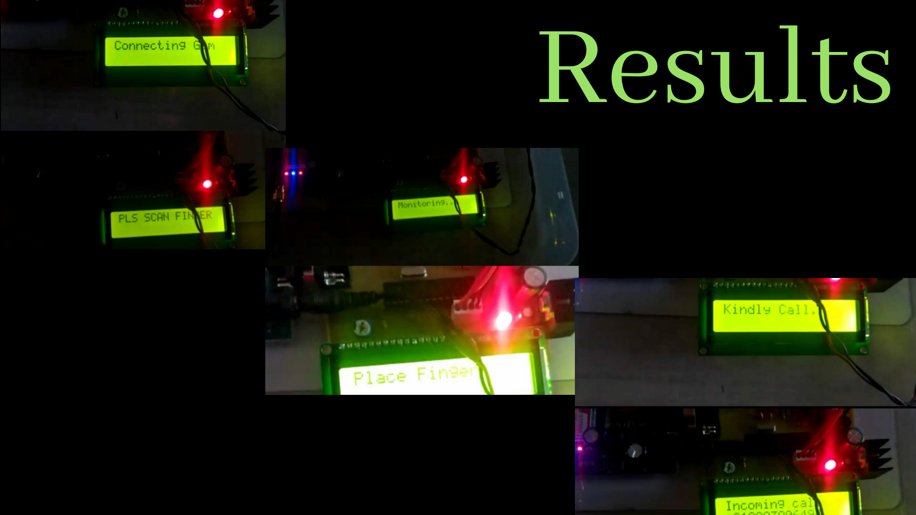

Figure 4.2. Prototype for Women and Child Safety

5. CONCLUSION

This paper represents the insight’s on various existing systems of Child and Women Safety. The innovative and intelligent MLDL approach for Women and Children Safety implemented using Sensor Module Prototype, Mobile Sensor App and Machine Learning algorithm. Interesting future work will be proposed using an unsupervised, reliable and accurate decision-making algorithm for Women and Children Safety by using deep learning techniques [8]. The accuracy of the system will be dependent on algorithm and classifier selection [17].

REFERENCES

- Olin H.Bray, “Information Integration for Data Fusion”, Strategic business development sandianational laboratories1997.
- Bahador Khaleghi, Alaa Khamis, Fakhreddine O. Karray, “Information Fusion:Multisensor data fusion: A review of the state-of-the-art” , sciversesciencedirect ,Elsevier 2011.
- Eduardo f. Nakamura,antonio a. F. Loureiro federal university of minas gerais –ufmgand alejandro c. Freryfederal university of alagoas – ufal , “information fusion for wireless sensor networks: methods, models, and classifications” , acm computing surveys, vol. 39, no. 3, article 9, publication date: august 2007.
- Ren C. Luo, Fellow, IEEE, and Chih-Chia Chang, “Multi-sensor Fusion and Integration: A Review on Approaches and Its Applications in Mechatronics”, IEEE transactions on industrial informatics, vol. 8, no. 1, february 2012.
- Feng Zhao,Leonidas J. Guibas, “Wireless Sensor Networks” , Elsevier.
- Zhi-Jun Lua,b, Qian Xiangb , Lan Xub, “An Application Case Study on Multi-sensor Data fusion System for Intelligent Process Monitoring”,Science Direct.
- Sourabh Vora ,AkshayRangesh,andMohan M. Trivedi, “Driver Gaze Zone Estimation using Convolution Neural Networks: A General Framework and Ablative Analysis,” Vol.24,No.4,October 2018.
- Daniee Ravi,Charence,Fani Dligianni,Melissa Berthelot,Javier,et al , “ Deep Learning for Health Informatics,”IEEE Journal of Biomedical and Health Informatics,Vol.21,No.1,January2017.
- S.AlirezaFayazi,ArdalanVahidi, “Mixed Integer Linerar Programming for Optimal Scheduling of Autonomous Vehicle Intersection Crossing, ” IEEE Transaction on Intelligent Vehicles,Vol.20,No.2,October 2018.
- Osvaldo Simeone, “A Very Brief Introduction to Machine Learning With Applications to Communication Systems,” IEEE Transactions on Cognitive Communications and Networking 2018.
- ZhinanHao, Zeshui Xu, Senior Member, IEEE, Hua Zhao, Hamido Fujita “A Dynamic Weight Determination Approach Based on the Intuitionistic Fuzzy Bayesian Network and Its Application to Emergency Decision Making”, IEEE Transaction 2017
- Nweke Henry Friday, Ghulam Mujtaba, Mohammed Ali Al-garadi, Uzoma Rita Alo.“Deep Learning Fusion Conceptual Frameworks for Complex Human Activity Recognition Using Mobile and Wearable Sensors”, 2018 IEEE
- Kalpanaseelam, K.Prasanti ,“A Novel Approach to Provide Protection for Women by using Smart Security Device”, 2018 IEEE
- Muhammad Aminul Islam, Derek T. Anderson, Anthony J. Pinar, Timothy C. Havens, Grant Scott, James M. Keller. “Enabling Explainable Fusion in Deep Learning with Fuzzy Integral Neural Networks”, IEEE Transaction 2019
- Chule Yang, Yufeng Yue, Jun Zhang, Mingxing Wen and Danwei Wang. “Probabilistic Reasoning for Unique Role Recognition Based on the Fusion of Semantic-Interaction and Spatio-Temporal Features”, IEEE Transaction 2018
- Fu-Chen Chen and Mohammad R. Jahanshahi “NB-CNN Deep Learning-Based Crack Detection Using Convolutional Neural Network and Naive Bayes Data Fusion”, IEEE Transaction 2017
- Ali K. Raz, Paul Wood, Linas Mockus, James Llinas, and Daniel A. DeLaurentis. “Identifying interactions for information fusion system design using machine learning techniques”, 2018 IEEE.
- Prof. Sunil K Punjabi, Prof.SuvarnaChaure, Prof.Ujwala Ravale, Prof.Deepti Reddy. “Smart Intelligent System for Women and Child Security”, 2018 IEEE
- Helen, M. Fathima Fathila, R.Rijwana, Kalaiselvi.V.K.G. “A Smart Watch for Women Security based on IOT concept Wach Me”, 2017 IEEE.
- Dantu Sai Prashanth, Gautam Patel, Dr.B.Bharathi, “Research and development of a mobile based women safety application with real-time database and data-stream network”, 2017 IEEE
- Saad Ahmed Akash, Md. Al-Zihad, TarnalAdhikary, Md. AbdurRazzaque, ArifaSharmin “HearMe: A Smart Mobile Application for Mitigating Women Harassment”, 2016 IEEE
- G.C. Harikiran, Karthik Menasinkai, SuhasShirol, “Smart Security Solution for Women based on Internet of Things (IOT)”, 2016 IEEE.
- Glenson Toney, Dr.FathimaJabeen, Puneeth S, “Design and Implementation of Safety Armband for Women and Children using ARM7” 2015 IEEE
- Abhijit Paradkar, Deepak Sharma “All in one Intelligent Safety System for Women Security”, 2015 IEEE
- KapilBakshi, KiranBakshi,“Considerations for Artificial Intelligence and Machine Learning: Approaches and Use Cases”, IEEE 2018.
- Mohammed Ali Al-Garadi, Amr Mohamed, Abdulla Al-Ali, Xiaojiang Du, Mohsen Guizani “A survey of machine and deep learning methods for IOT security”, 2018 IEEE.
- Ling Guan, Lei Gao, Nour El Din Elmadany, Chengwu Liang ,“Statistical machine learning vs deep learning in information fusion; competition or collaboration”, 2018 IEEE
- Ming Guo, Zhelong Wang, Ning Yang, Zhenglin Li, Tiantian. “A Multi-sensor Multi-classifier Hierarchical Fusion Model Based on Entropy Weight for Human Activity Recognition Using Wearable Inertial Sensors”, IEEE Transaction 2018
- Minh Pham, Dan Yang, Weihua Sheng “A Sensor Fusion Approach to Indoor Human Localization Based on Environmental and Wearable Sensors”, IEEE Transaction 2018.
- Prakash B. Gohain, Sachin Chaudhari, Visa Koivunen. “Cooperative Energy Detection with Heterogeneous Sensors under Noise Uncertainty SNR Wall and use of Evidence Theory”, IEEE Transaction 2018.
- Madeena Sultana, Padma Polash Paul, Marina L. Gavrilova. “Social Behavioral Information Fusion in Multimodal Biometrics”, IEEE Transaction 2017.
- Guangxu Li, Gang Kou, and Yi Peng “A Group Decision Making Model for Integrating Heterogeneous Information”, IEEE Transaction 2016.
- Helly Patel , Parth Lathiya , Bhoomit Patel , Hirpara Nidhi , Divya Ebenezer,” An Novel Approach of CNN - Machine Learning Model integrated with Android for Women’s Safety (SAS) ,International Journal for Research in Applied Science & Engineering Technology (IJRASET) ISSN: 2321-9653; Volume 8 Issue II Feb 2020.
- Sruthi CK1, Mridul K, Zayan K, Ashin V, Sreehari K, “AI BASED WOMEN SECURITY SYSTEM”,International Journal of Scientific Research and Review,

