A Review on Clustering Routing Protocols for Wireless Sensor Networks

¹Rakesh Kumar Yadav, ²Rajendra Prasad Mahapatra
^{1,2}Department of Computer Science & Engineering, SRM Institute of Science & Technology,
NCR Campus Modinagar, Ghaziabad, India
* Corresponding author’s Email: rkycse@gmail.com, mahapatra.rp@gmail.com

ABSTRACT- Sensor clustering is commonly used in large networks. Wireless sensor networks have proven that cluster networks, also known as hierarchical networks, are more scalable; provide greater reliability, better coverage, better fault tolerance and energy efficient. Furthermore, it is argued that clustering can be considered as a graph-splitting problem with some additional restrictions, as the size and geometry of the resulting graph (clusters) are not known in advance. The issue of classification route for WSN has been extensively investigated, and many protocols have been developed. In this article, we present a highly relevant overview of the Cluster Routing Protocol based on the heuristic approach to wireless sensor networks. Furthermore, comparing these protocols under different assumptions for cluster routing protocols.
Keywords: Routing protocols, Wireless sensor networks, graph-splitting problem, hierarchical networks, clustering.
2010 Mathematics Subject Classification: 03C65, 60H20, 60H40, 60H35.

- INTRODUCTION

Clustering sensors is as a rule received in wide scale systems. It is demonstrated that the cluster based systems, too known beneath the names of various hierarchical networks, are more versatile, give more unwavering quality, superior scope, fault tolerance and are energy efficient. However, the hierarchical routing steering issue for WSNs has been examined a part and numerous protocols have been developed. These protocols incorporate heuristic and Meta heuristic based approaches. Here, we display a comprehensive audit of the foremost pertinent cluster based routing protocols. Applications running on WSNs require organize with a long lifetime. To extend arrange life expectancy, clustering is the foremost broadly utilized method for effectively managing network energy consumption and scalability. In addition, in WSN, a low power clustering methods is still a prime challenge that would permit a critical improvement of the lifetime. In WSNs, strategies of clustering comprise of dividing to arrange with a shifted number of sensor groups known clusters. In every cluster, a head called CH is chosen either in a disseminated way by sensors themselves or by a centralized control method. In each cluster, sensors accumulate information and send them to their related CHs. The CH sums all gotten information and send them to the BS. The BS is the data collection center situated away from the nodes and is considered to be fixed which receives data from all the CHs and end user access that data. The CH nodes really act as bridge from sensor nodes and BS in ref. [1]. Ultimately, clustering the network greatly minimizes number of communication to the BS, thereby increases the network lifetime. Generally WSNs include massive amount of sensor nodes in a large area and BS located faraway from sensor nodes. Therefore, partitioning the whole community into one of kind clusters replaces the only hop lengthy away transmission through multihop quick distance to information transfer. So because of this, reduce the EC for DC, offers adjusting load and scalability when the device size grows. Primarily based at the mode of verbal exchange, the clustering schemes may be single hop cluster or multihop cluster [2], show in figure 1 and figure 2 hence. In single hop cluster the CHs directly communicates with the BS. This leads to the higher energy consumption in CHs, since BS is far away from the sensor field.
Preferred multi-hop communication architecture is to achieve energy efficiency. The data is forwarded to BS using intermediate CHs. Based on the clusters hierarchy, the clustering procedures can too be partitioned into single-level or multilevel clustering. The framework architecture of multilevel hierarchical clustering is outlined in mentioned figure 3.

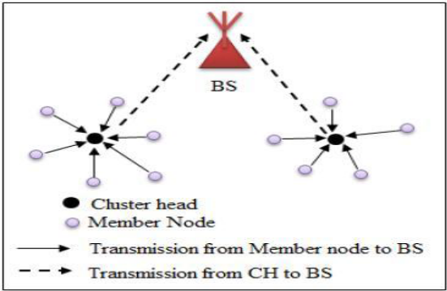

Figure 1. Single Hop Clustering

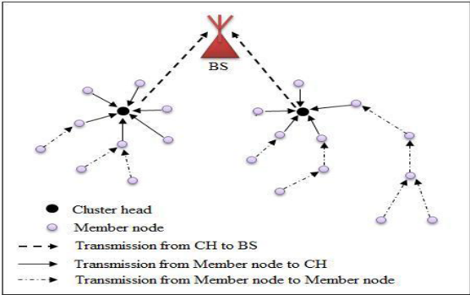
Figure 2. Multi-Hop Clustering

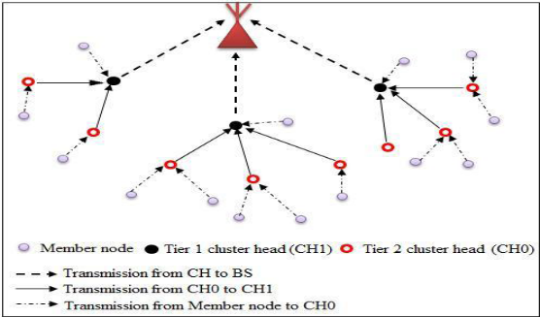

Figure 3. Multilevel Hierarchical Clustering

Research works in the last several years have explored several techniques in hierarchical or cluster based protocols. Clustering is a power efficient communication scheme utilizing by the sensors to report their distinguished data to the BS.
Our work is organized as follows. Section 2 presents the literature review of hierarchical routing protocol with summary table that compares many surveyed protocols. Section III, finally conclude the survey.
- LITERATURE REVIEW
The whole network is partitioned in to clustered layers in hierarchical manner. Nodes are assembled in to clusters and CH is made capable to acquire, mixture and ahead records to the BS. Multi-hop transmission is utilized between CH and BS is used to preserve a strategic distance from long transmissions. Numerous techniques are offered in writing to form it more energy efficient, few are them is tested here. Heinzelman [3], proposed, Low energy adaptive clustering hierarchy (LEACH) is a widely applied protocol in WSN. Low energy adaptive clustering hierarchy centralized (LEACH-C) [4] is the altered adaptation version of LEACH. It employments the BS for cluster arrangement though in LEACH each hub self configures them in to cluster. Power efficient gathering in sensor information system (PEGASIS) in ref. [5], is based on chain-based topology in which a chain of sensor hubs is built in a greedy approach. In expansion, PEGASIS works well with static hubs but in terms of mobility not good. In ref. [6], authors developed protocol based on hierarchical clustering for responsive systems in which hubs respond instantly to sudden and exceptional changes within the environment. In ref. [7], creators presents a centralized clustering based routing protocol (BCDCP) which utilizes a high-energy BS to set up clusters and steering ways, execute randomized revolution of CHs, and carry out other vitality seriously tasks. The prime thought in BCDCP is the arrangement of adjusted clusters. In ref. [8], author’s proposed a CH reappointment routing method (LEACH-R), it deals with the disadvantage that CH frequently built cluster and consumes lots of energy. In ref, [9], authors proposed Power Aware Cluster Based Routing (PACBR) protocol for WSN deals with the life span of the network. The outcomes demonstrate that the algorithm works more productively than other existing algorithms and furthermore expands arrange lifetime. In ref [10], creators propose a clustering strategy that uses the hybrid-CS Detecting for SNs. An information social affair tree spreading over all CHs is developed to transmit information to the sink by utilizing the CS technique and proved better than other existing schemes. In ref. [11], authors proposed CH-LEACH and present structures, conspires and assess, where proposed work displays a decrease in EC over conventional schemes. In ref. [12], creators exhibits an enhanced optimized cluster structure routing strategy called Dynamic K value LEACH (DK-LEACH), and that targets lessening EC inside the uneven energy conveyed WSNs. Over discourse, different cluster-based plans are created but few are them examined for this work, and their rundown is displayed in table 1. Diverse strategies are utilized to urge energy proficiency and improve lifetime of arrange but also have a few restrictions which must be tended to. In expansion, issues such as irregular determination of CH, energetic reconstruction and re-election of CHs, Clusters, uneven dissemination of hubs frequently leads to hotspot issue e of messages are recognized and tended to within the proposed strategy.

Table1. Summary of Cluster-based Routing Schemes
Protocol | CH selection  Approach | Type | Merits | Demerits
LEACH [3] | Probabilistic | Distributed | Nodes similarly offers burden up somewhat. | Communication in inter-cluster is based on single-hop
LEACH-C [4] | Probabilistic | Centralized | Global perspective on the whole network | Overhead present in network
PEGASIS [5] | Non-probabilistic | Distributed | One hop correspondence. | High topology alteration overhead
TEEN  [6] | Probabilistic | Distributed | EC of this protocol is lesser than in proactive methods | If limits HT and ST are not gotten, the hubs never convey.
BCDCP  [7] | Iterative | Centralized | The BS performs all the severe Uniformly distribution of clusters and each CH utilizes the equal amount of energy | Due to centralized algorithm, it is not suitable for large networks
LEACH-R  [8] | Probabilistic | Distributed | CH reappointment method is proposed | Overhead increased due to a CH reappointment routing policy
PACBR  [9] | Probabilistic | Distributed | Selects a CH in various groups before beginning each round of conglomeration and sends information to BS. | Delay and furthermore diminishes arrange lifetime.
HYBRID-CS [10] | Probabilistic | Distributed | Hybrid CS to structure a bunching based information accumulation technique, to diminish the DTs in WSNs. | Security Transmission isn't considered.
CH-LEACH  [11] | Probabilistic | Distributed | Implanting Centralized k-Means algorithm for longer life of Net. | Not suitable for large scale networks
DK-LEACH  [12] | Probabilistic | Distributed | Energy dissipation is balanced | An arbitrary Area extension doesn't guarantee a productive energy balance.

- CONCLUSION
In over talk, displays a short presentation of WSNs routing schemes, features and thoughts of clustering, has been analyzed. In the majority of the current routing strategies, various schemes have been made to enhance energy proficiency from different hierarchical clustering protocols. For such work fixates on hierarchical clustering technique, thus the design difficulties of various hierarchical clustering have been analyzed.
REFERENCES
Furthermore, the arrangement issues and asks about difficulties of different hierarchical clustering methodologies are talked about, focal points and destinations of clustering. In arrange to supply power efficient, load adjusted, scalable and adaptive schemes, a few energy points were distinguished within extant energy proficient plans, and at last, presents the overview and outline of cluster based energy conserving routing protocols.

- Jan, B., Farman, H., Javed, H., Montrucchio, B., Khan, M., and Ali, S., “Energy Efficient Hierarchical Clustering Approaches in Wireless Sensor Networks: A Survey,” Hindawi Wireless Comm. and Mobile Computing, pp.1-14, 2017.

- Sabri, A., and Al-Shqeerat, K., “Hierarchical Cluster-Based Routing Protocols for Wireless Sensor Networks – A Survey,” IJCSI International Journal of Computer Science Issues, 11(1), pp.93-105, 2014.

- Heinzelman, W.R., Chandrakasan, A., and Balakrishnan, H., “An Application- Specific Protocol Architecture for Wireless Microsensor Networks,” in IEEE Transactions on Wireless Communications, 1(4), pp. 660-670, October 2002.

- Zhao, F., Xu, Y., and Li, R., “Improved LEACH Routing Communication Protocol for a Wireless Sensor Network”, International Journal of Distributed SensorNetworks, 2012. pp.1-6, 2012.

- Lindsey S., and Raghavendra, C. S.,"PEGASIS: Power-Efficient Gathering in Sensor Information Systems," in Aerospace Conf. Proc. IEEE, pp. 1-6, 2002.

- Atif, K., Jaffar, M., Javaid, N., Saqib, Qasim, M. N., U., and Khan, Z. A., “Performance Analysis of Hierarchical Routing Protocols in Wireless Sensor Networks”, 7thInt. Conf. on Broadband, Wireless Computing, Communication and Applications, Victoria, BC, 2012, pp. 620-625. pp.1-6, 12-14 Nov. 2012.

- Muruganathan, S. D., Ma, D. C. F., Bhasin, R. I., and Fapojuwo, A. O., “A Centralized Energy Efficient Routing Protocol for Wireless Sensor Networks,” published in IEEE Radio Comm., Univ. of Calgary, pp.S8 –S13, March 2005.

- Li, Y. Z., Zhang, A. L., and Liang, Y. Z., “Improvement of Leach Protocol for Wireless Sensor Networks,”3rd International Conference on Instrumentation, Measurement, Computer, Communication and Control, IEEE, pp.322-326, 2013.

- Das, A., Chaki, R., Biswas, A., “Power Aware Cluster Based Routing (PACBR) Protocol for Wireless Sensor Network,” IFIP International Federation for Information Processing, pp. 289-300, 2013.
- Xie, R., and Jia, X., “Transmission- Efficient Clustering Method for Wireless Sensor Networks Using Compressive Sensing,” IEEE Transactions on Parallel and Distributed Systems, 25(3), pp.806-815, 2014.

- Abushiba, W., Johnson, P., Alharthi, S., and Wright, C., “An Energy Efficient and Adaptive Clustering for Wireless Sensor Network (CH-leach) using Leach Protocol,” 13th Int. Comp. Engg. Conf.(ICENCO), Cairo, pp. 50-54, 2017.

- Dig, X. X., Ling, M., Wang, Z. J., and Song, F. L.,“DK-LEACH: An Optimized Cluster Structure Routing Method Based on LEACH in Wireless Sensor Networks,” 96(4), pp 6369–6379, 2017.

