Computational and Mechanical study of Arterial Blood Flow in the presence of Porous effects
Anil Kumar
Department of Applied Sciences (Mathematics)
Chandigarh Engineering College Landran, Mohali Punjab (INDIA)
Email : dranilkumar73@rediffmail.com

Abstract
This paper presents is a computational modeling and mechanical study of the arterial blood flow with porous effects which have been derived from the Navier-Stokes equations and some assumptions. The governing equations are solved by finite difference method. A little change on the cross-sectional value makes vast change on the blood flow rate. The effects of a porous effects have been used to control the flow, which may be useful in certain cholesterol cases, hypertension etc.

Keywords: Mathematical modeling, Arterial flow, Standard finite difference method,
permeability parameter.

I. INTRODUCTION
In recent times, many medical diagnostic devices especially those used in diagnosing cardiovascular disease make use of porous effects. The interaction between these induced currents and the applied porous effects produces a body forces (known as the Lorentz force) which tends to retard the movement of blood (Sud and Sekhon, 1989). Kuipers et al. (2007) investigated the influence of static on cardiovascular and sympathetic function at rest and during physiological stress and also investigated the influence of static porous wall on pain perception during noxious stimuli.
II. COMPUTATIONAL MODEL
The model approach is to use the two-dimensional Navier-Stokes equations and continuity equation for a Newtonian and incompressible fluid in cylindrical coordinate:
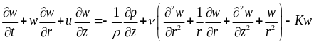 (1)
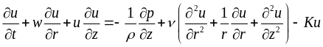
(2)

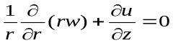 (3)
Where P is the pressure and  is the density v is the kinematic viscosity. For convenience we define a new variable, which is the radial coordinate, η [Kumar and Saket (2008)]:
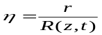 (4)
where R(z, t) denotes the inner radius of the blood vessel. Assuming that P is independent of the radial coordinate, η, then the pressure P is uniform within the cross section (P = P(z, t)) [Kumar ( 2011,2013)].
Hence
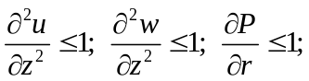
Using simple algebra to change the variable such as
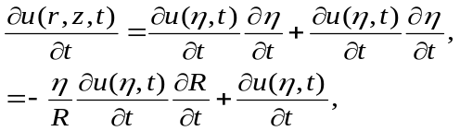
The equations (1), (2) and (3) can be written in the new coordinate (η, z, t) as given below:

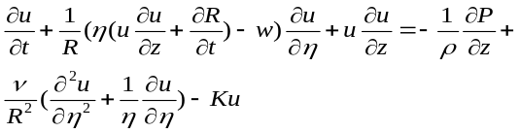 (5)
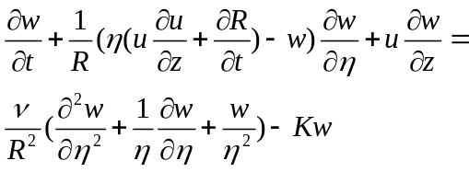,
(6)
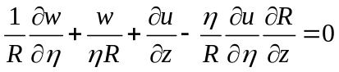,
(7)
Where K the permeability parameter. The velocity profile in the axial direction, u(η,z,t), is assumed to have the expression in the polynomial form below:
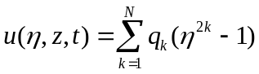, (8)
Than the velocity profile in the radial direction is
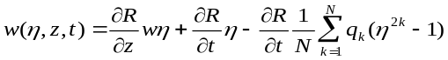
(9)
Choose N = 1 to simplify (8) and (9), so that
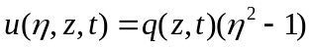, (10)

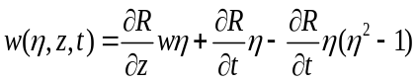, (11)
Then, when equations (10) and (11) are substituted into equations (5) and (7), we will get the dynamic equations of q(z, t) and R(z, t), are:
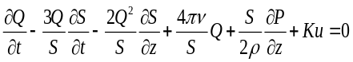, (12)
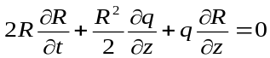 (13) Now, the cross-sectional area S(z, t) and blood flow Q(z, t) are defined as:
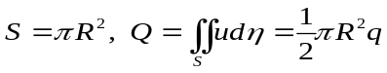,
We can use these definitions to express equations (12) and (13) in terms of Q(z,t) and S(z,t):
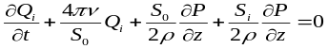 (14) 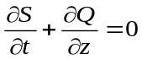. (15)
III COMPUTATIONAL PROCEDUERE
The solutions for the cross-sectional area of the artery and its corresponding blood flow can now be obtained by solving the governing equations (14) and (15). The system of equations (14)-(15) are nonlinear partial differential equations. The discretized using the following difference formula is as given below:
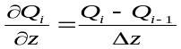 and 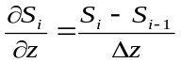,
Where Δz=L/(N−1) ,than the equations of difference equations becomes:
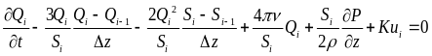, (16) 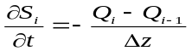, (17)
where i= 1, 2, …. k, N. Here, the pressure gradient 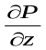 is kept constant and the value is prescribed. The discretization of the artery model is depicts of figure 1 as given below:

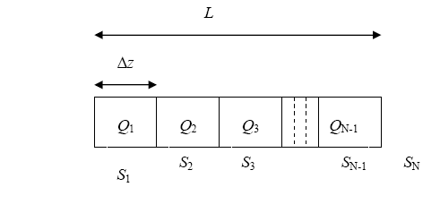
Figure 1 Discretization of the arterial flow
model
The governing equations by linearizing equation form (16):
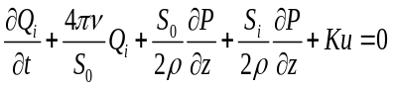, …. (18)
We notice that the difference equations (17) – (18) can be written in the form, 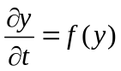
where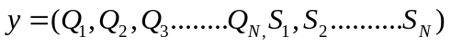
and f(y)=
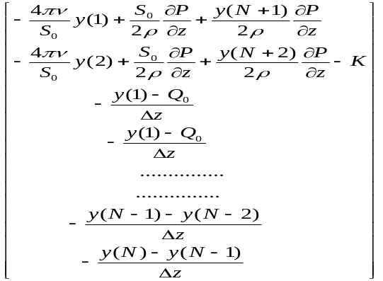
The simplest and fast way to solve such problem is by using MAT Lab built-in function ODE45, which is based on Runge-Kutta method.
IV. RESULTS AND DISCUSSIONS
The present algorithm is economical and efficient, having a sharp convergence. Since we consider arteries in a diastole condition only, the chosen time span is 0.2 seconds. 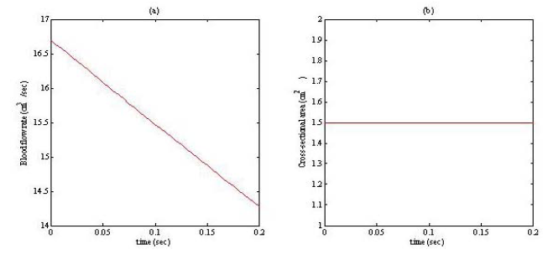
Fig. 2: (a) is the blood flow rate against time
(b) is the cross-sectional area against time.

Figure 2 depicts the blood flow rate and cross-sectional areas for each node. It is observed that the results for Q₁, Q₂ and Q₃ are almost the same as depicted in Figure 2(a). Similarly, the values of S₁, S₂ and S₃ in Figure 2(b) are very close and it is almost a constant. As we can see, the value for the blood flow is decreasing from its initial value. This is also the case for the cross-sectional area, although it decreases in smaller range as depicts in figure 3.

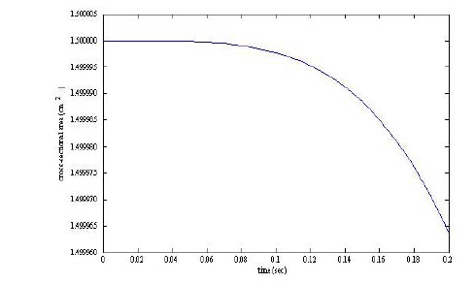
Fig. 3: The cross-sectional area against time
From figure 4, shows that the value of cross-sectional area is smaller, the blood flow rate is decreasing slower than the blood flow rate at a normal condition which implies that when the cross-sectional area is decreased, the blood flow is increased.
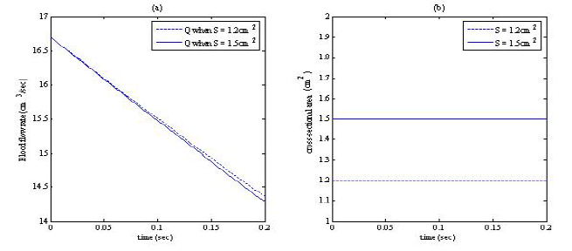
Figure 4: Comparison graph for blood flow
with different value of cross-sectional
area with porous effects.

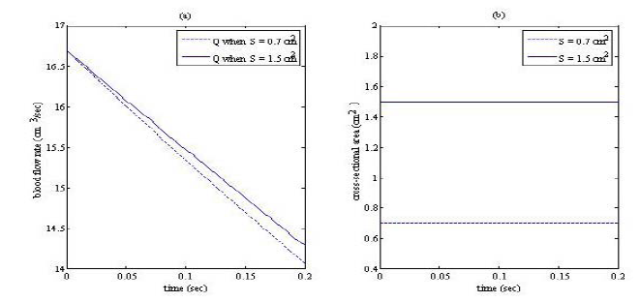
Figure 5: Comparison of Q at normal cross-sectional area and much smaller cross-sectional area.
As shown in Figure 5 above, when the value of cross-sectional area is below 0.8 cm², the blood flow rate decreases faster that the normal rate. Figure 6 depicts s the value of blood flow rate when the cross-sectional area is in range of between 0.1 cm² to 0.8cm².
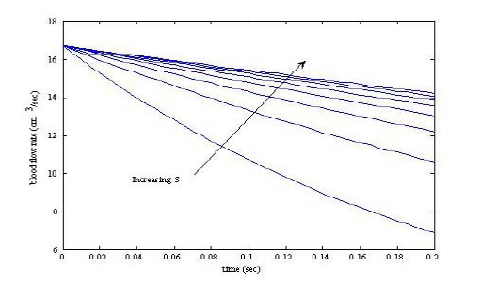
Fig. 6: Blood flow rate when the cross-sectional area is in range of between 0.2 cm² to 0.8cm² K=2.

V. CONCLUSION
The present algorithm is economical and efficient, having a sharp convergence. In this paper, we have derived a mathematical model that can represent the blood flow in the stenosed arteries with porous effects. Models of this type clearly have an important role to play in the formation of health care policy.
REFERENCES
- Sud, V. K. and Sekhon, G. S. 1989. Blood flow through the human arterial system in the presence of a steady magnetic field. Phys. Med. Biol.vol 34(7) pp. 795-805.
- Kuipers, N. T., Sauder, C.L. and Ray, C. A. 2007. Influence of static magnetic fields on pain perception and sympathetic nerve activity in humans. J. Appl. Physiol., Vol. 102, pp. 1410-1415.
- Kumar, A., Varshney, C.L. and Sharma, G.C (2004): Performance modeling and analysis of blood flow in elastic arteries, Applied mathematics and mechanics, Vol. 26, No. 3, pp. 345-354.
- Anil Kumar Gupta (2013): Performance modeling and mechanical behaviour of blood vessel in the presence of magnetic effects, African Journal of Basic & Applied Sciences 5 (3): 149-155.
- Anil Kumar Gupta (2011): Performance and analysis of blood flow through carotid artery, International Journal of Engineering and Business Management vol. 3( 4) pp 1-6.
- Anil Kumar, and R K. Saket (2008) : Reliability of convective diffusion process in porous blood vessels, International journal of chemical product and process modeling, vol.(3)(25).

