**2.1 transmission media and bit streaming**

**Name _____________ class______________**

1. Write down five signal transmission media, do not look at the following parts.
2. (a) Give **three** benefits of fibre-optic cable over copper cable.

(b) Give **two** benefits of copper cable over fibre-optic cable.

Advantages of copper cable

Advantages of fibre-optic cable

1. Three methods of connecting devices include fibre-optic cables, copper cables and radio waves. The table below gives descriptions relating to these connection methods.

Tick (✓) one box on each row to show the method that best fits each description.

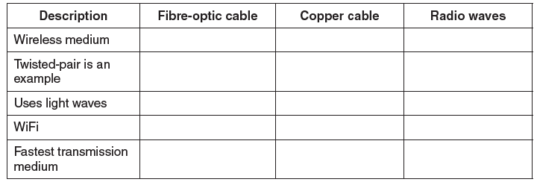

3. (a) Explain the term bit streaming.

___________________________________________________________________

___________________________________________________________________

___________________________________________________________________

(b) A person watches a film streamed from a website on a tablet computer.

**(i)** Give **two** benefits of using bit streaming for this purpose.

___________________________________________________________________

___________________________________________________________________

___________________________________________________________________

___________________________________________________________________

**(ii)** State **two** potential problems of using bit streaming for this purpose.

___________________________________________________________________

___________________________________________________________________

___________________________________________________________________

___________________________________________________________________

**(c)** Explain the terms on-demand bit streaming and real-time bit streaming.

___________________________________________________________________

___________________________________________________________________

___________________________________________________________________

___________________________________________________________________

___________________________________________________________________

___________________________________________________________________

___________________________________________________________________

___________________________________________________________________

___________________________________________________________________