**2.2 internet and WWW**

**Name _____________ class______________**

1. **(a)** Telephone calls can be made by using:

• conventional telephones (using the Public Service Telephone Network (PSTN) system) over a wired network

• a computer, equipped with speakers and microphone, connected to the Internet

Put a tick (✓) in the correct column to match each description to the appropriate communication method.

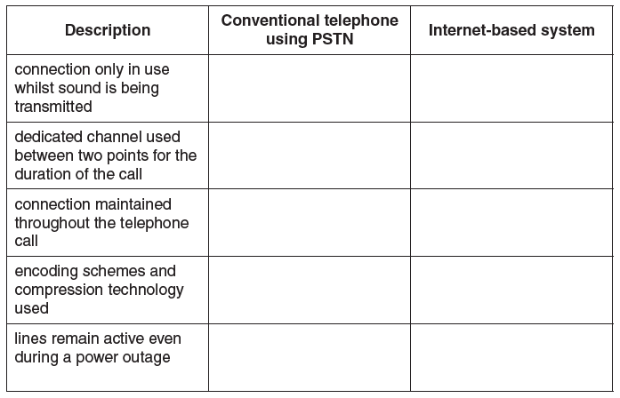

**(b)** Distinguish between the Internet and the World Wide Web (WWW).

______________________________________________________________

______________________________________________________________

______________________________________________________________

______________________________________________________________

______________________________________________________________

______________________________________________________________

______________________________________________________________

______________________________________________________________

______________________________________________________________

**(c)** Name the hardware device that is being described:

**(i)** A device that transfers data from one network to another in an intelligent way. It has the task of forwarding data packets to their destination by the most efficient route.

_________________________________________________________________

**(ii)** A device used between two dissimilar LANs. The device is required to convert data packets from one protocol to another.

_________________________________________________________________

**(iii)** A device or software that provides a specific function for computers using a network. The most common examples handle printing, file storage and the delivery of web pages.

_______________________________________________________________