**2.4 IP addressing**

**Name _____________ class______________**

Access to World Wide Web content uses IP addressing.

**(a)** State what IP stands for.

__________________________________________________________________

**(b)** The following table shows four possible IP addresses.

Indicate for each IP address whether it is valid or invalid and give a reason.

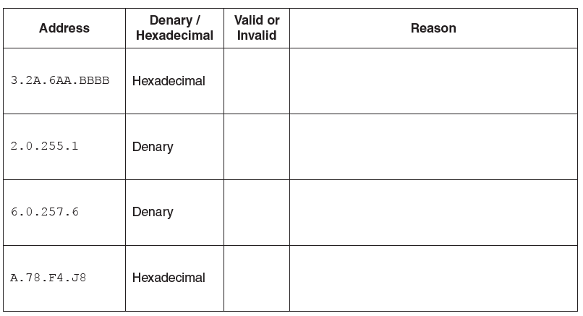

**(c)** Describe **two** differences between public and private IP addresses.

__________________________________________________________________

__________________________________________________________________

__________________________________________________________________

__________________________________________________________________

__________________________________________________________________

__________________________________________________________________

__________________________________________________________________