**Input device — Sensor**

**Name** **class**

1.Name a suitable sensor for each of the following applications.

Choose a different sensor in each application.

(i) control of a central heating system

___________________________________________________________________

(ii) operation of automatic doors

___________________________________________________________________

(iii) detection of intruders

___________________________________________________________________

(iv) monitoring of a greenhouse environment

__________________________________________________________________

2.Vehicles passing over a bridge are detected automatically using sensors and a computer.

1. What sensors could be used?

__________________________________________________________________

1. 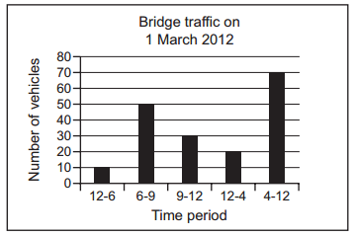The graph below shows the number of vehicles counted during certain periods of the day. This graph is produced automatically at the end of each day.

A record is created each time a vehicle is detected. These records are processed to generate the graph and for other purposes.

What data need to be stored in each record?

____________________________________________________________________

1. State two other methods of automatic data capture. In each case, name an application which would use this method.

Method 1 ____________________________________________________________

Application 1

____________________________________________________________________

____________________________________________________________________

Method 2 ____________________________________________________________

Application 2

____________________________________________________________________

__________________________________________________________________

3. A chemical company uses pipes to transfer hazardous liquids. To protect the workforce, each pipe is inside a protective pipe.

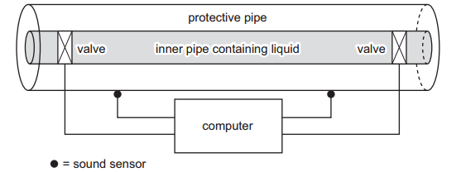

Sensors are used to detect the sound of any liquid dripping into the protective pipe.

Actuators operate the valves that regulate the flow of liquid through the inner pipe.

This system is controlled by a computer.

1. Describe how the sensors, actuators, valves and computer are used to monitor and control the liquid in the pipe.

____________________________________________________________________

____________________________________________________________________

____________________________________________________________________

____________________________________________________________________

____________________________________________________________________

__________________________________________________________________

1. Give two advantages of using this computer-controlled system rather than visual

checks by the workforce.

____________________________________________________________________

____________________________________________________________________

____________________________________________________________________

__________________________________________________________________