**3.3 Memory and data storage**

**class___________ name _______________**

1. There are two types of RAM: dynamic RAM (DRAM) and static RAM (SRAM).

Write down the features of each type

DRAM

_____________________________________________________________________

_____________________________________________________________________

_____________________________________________________________________

_____________________________________________________________________

SRAM

_____________________________________________________________________

_____________________________________________________________________

_____________________________________________________________________

_____________________________________________________________________

2. Describe the differences between RAM and ROM.

_____________________________________________________________________

_____________________________________________________________________

_____________________________________________________________________

_____________________________________________________________________

_____________________________________________________________________

_____________________________________________________________________

3. Computer memories are measured in terms of the number of bytes.

(a) (i) What is meant by the term byte?

_____________________________________________________________________

(ii) What is meant by a Gigabyte?

_____________________________________________________________________

(b) Flash memories and CD-RWs are used as backing media for computers.

Give two differences between these two media.

1____________________________________________________________________

_____________________________________________________________________

_____________________________________________________________________

2____________________________________________________________________

_____________________________________________________________________

_____________________________________________________________________

4.(a) Describe **two** differences between Blu-ray discs and DVDs.

1____________________________________________________________________

_____________________________________________________________________

_____________________________________________________________________

2____________________________________________________________________

_____________________________________________________________________

_____________________________________________________________________

(b) Describe **two** differences between DVD-R and DVD-RAM.

_____________________________________________________________________

_____________________________________________________________________

_____________________________________________________________________

_____________________________________________________________________

_____________________________________________________________________

5. Describe the main differences in the way the following back up systems store data:

-Memory sticks

-CD-RW(writers)

-Hard disk (drive)

**_____________________________________________________________________**

**_____________________________________________________________________**

**_____________________________________________________________________**

**_____________________________________________________________________**

**_____________________________________________________________________**

**_____________________________________________________________________**

**_____________________________________________________________________**

**_____________________________________________________________________**

**6 (a)** There are two types of RAM: dynamic RAM (DRAM) and static RAM (SRAM).

Five statements about DRAM and SRAM are shown below.

Draw a line to link each statement to the appropriate type of RAM.

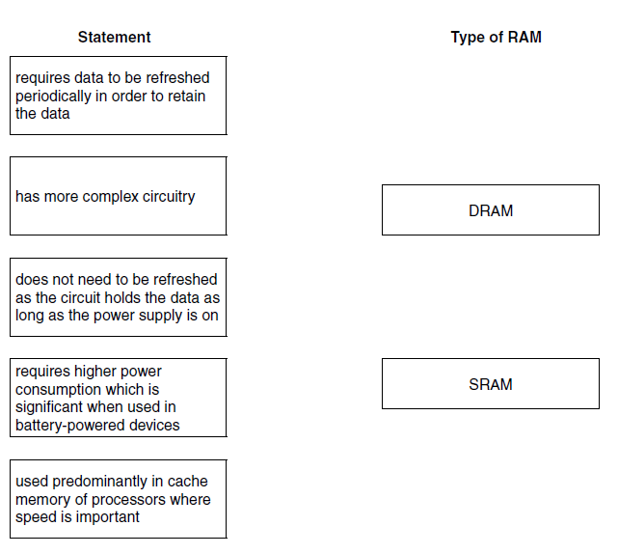

**(b)** Describe **three** differences between RAM and ROM.

**(c)** DVD-RAM and flash memory are two examples of storage devices.

Describe **two** differences in how they operate.

**7 (a)** Examples of primary and secondary storage devices include:

• hard disk

• DVD-RW

• flash memory

For each device, describe the type of media used.

Hard disk

DVD-RW

Flash memory

**(b)** Describe the internal operation of the following devices:

DVD-RW

DVD-RAM